TO: Agency WPV Coordinators

FROM: Donna Hoskins-Helm, Workplace Support Services Division

DATE: June 19, 2009

RE: Workplace Violence Incident Reporting Guide

In an effort to improve reporting capabilities, the Office of Administration has refined the workplace violence reporting system. Your agency should continue to use the assigned user name and password in order to access the database.
When entering data into the online report system, data fields identified with a red asterisk (*) are required fields and must be completed in order for the report to be accepted by the system. Please obtain the required information before attempting to enter a report.
Because not all information may be available or accurate at the time the initial report is transmitted, you may create a password to edit or update the existing record at a later date.
To support a unified approach to data entry, an explanation of each data field is provided below. For questions on completing and transmitting workplace violence reports, please contact Susan Moravetz, Office of Administration, Workplace Support Services Division at (717) 787-8575.

Attachment

Guidelines for Completing the Workplace Violence Online Incident Report
During the pre-population stage, please identify any perpetrators and victims who are commonwealth employees by their employee number. The information entered at this stage will populate to the corresponding data fields. Be sure the persons identified as Perpetrator 1, 2, and 3; Victim 1, 2, and 3; and Investigator 1, 2, and 3 are used consistently throughout the report. (Refer to screen print #1.) In the event an incident involves more than three perpetrators or victims, please contact the Workplace Support Services Division at (717) 787-8575.
Perpetrator 1 Employee Number
This field is required only if Perpetrator 1 was a commonwealth employee. Leave blank if not applicable.
Perpetrator 2 Employee Number
This field is required only if Perpetrator 2 was a commonwealth employee. Leave blank if not applicable.
Perpetrator 3 Employee Number
This field is required only if Perpetrator 3 was a commonwealth employee. Leave blank if not applicable.
Victim 1 Employee Number
This field is required only if Victim 1 was a commonwealth employee. Leave blank if not applicable.
Victim 2 Employee Number
This field is required only if Victim 2 was a commonwealth employee. Leave blank if not applicable.
Victim 3 Employee Number
This field is required only if Victim 3 was a commonwealth employee. Leave blank if not applicable.
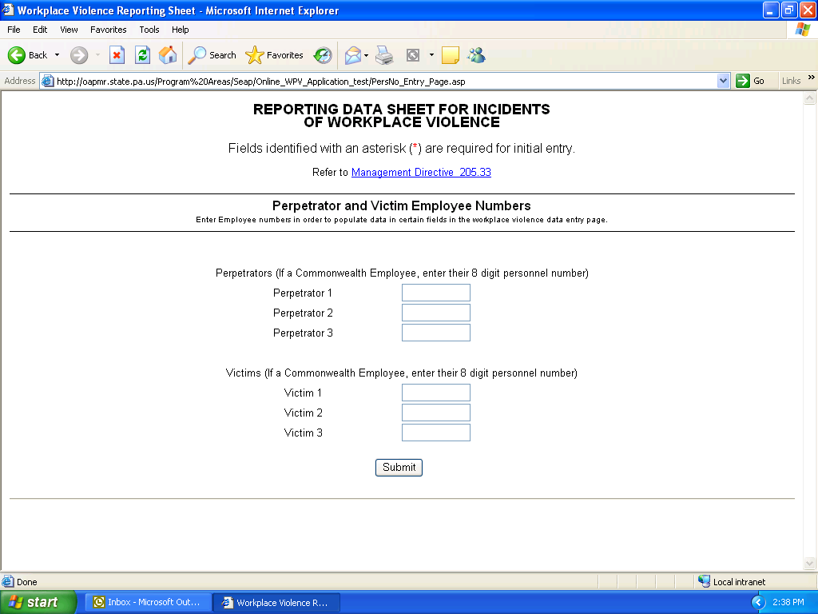
Screen print #1.
After clicking the submit button, you will be directed to the body of the form where the following information will need to be entered.
- Agency Name: required field (Screen print #2.)
Use the drop down menu to select the name of the agency in which the incident took place, even if it did not involve employees of that agency. If the incident took place at a location that is not commonwealth owned or leased property, enter the agency of the involved employees. The agency selected should match the agency of the employee conducting the incident investigation.
- Street Address: required field (Screen print #2.)
Enter the street address of the location where the incident occurred. Please do not use post office box numbers. Include the building name, floor number, and room number if applicable.
- Municipality: required field (Screen print #2.)
Enter the name of the city or town where the incident occurred.
- County: required field (Screen print #2.)
Enter the county name where the incident occurred.
- Date of Incident: required field (Screen print #2.)
Enter the date that the incident occurred using mm/dd/yyyy format.
- Time of Incident: required field (Screen print #2.)
Enter the time that the incident occurred using military time.
- Day of the Week: required field (Screen print #2.)
Use the drop down menu to select the day of the week that the incident occurred.
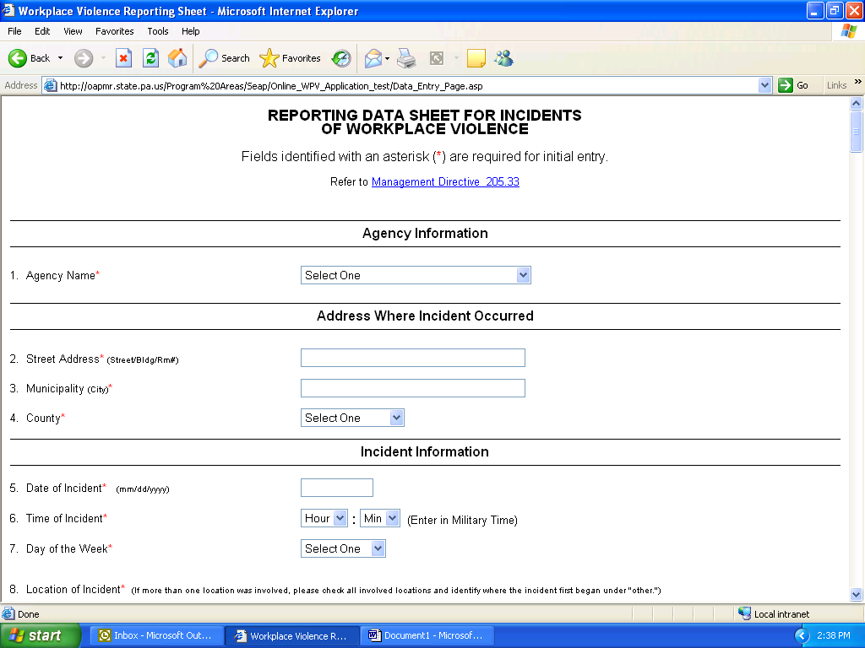
Screen print #2.
- Location of Incident: required field (Screen print #3.)
Use the drop down menu to select the location where the incident occurred. Should a single incident involve more than one location, please select a primary and secondary location. Then use the “other” text box to identify where the incident first began and list additional involved locations.
- Type of Violence: required field (Screen print #3.)
Use the drop down menu to select the specific type of incident that occurred. Should a single incident involve more than one specific type of violence, please select a Choice 1 and a Choice 2. Then use the “other” text box to identify additional acts or specify a type of act not available in the drop down list.

- Type of Personal Threat (Screen print #3.)
This field is required only if “Personal Threat” is selected for “Type of Violence”. Use the drop down menu to select the specific type of threat. Use the “other” text box to specify a type of threat not available in the drop down list.
- Type of Bomb Threat (Screen print #3.)
This field is required only if “Bomb Threat” is selected for “Act of Violence”. Use the drop down menu to select the specific manner in which the threat was made. Use the “other” text box to specify a manner not available in the drop down list.
- Weapon Involved: required field (Screen print #3.)
Select “Yes” or “No” as appropriate.
- Type of Weapon (Screen print #3.)
This field is required only if “Yes” was selected in the previous question. Use the drop down menu to select the specific type of weapon used. Use the “other” text box to specify a type of weapon not available in the drop down list.
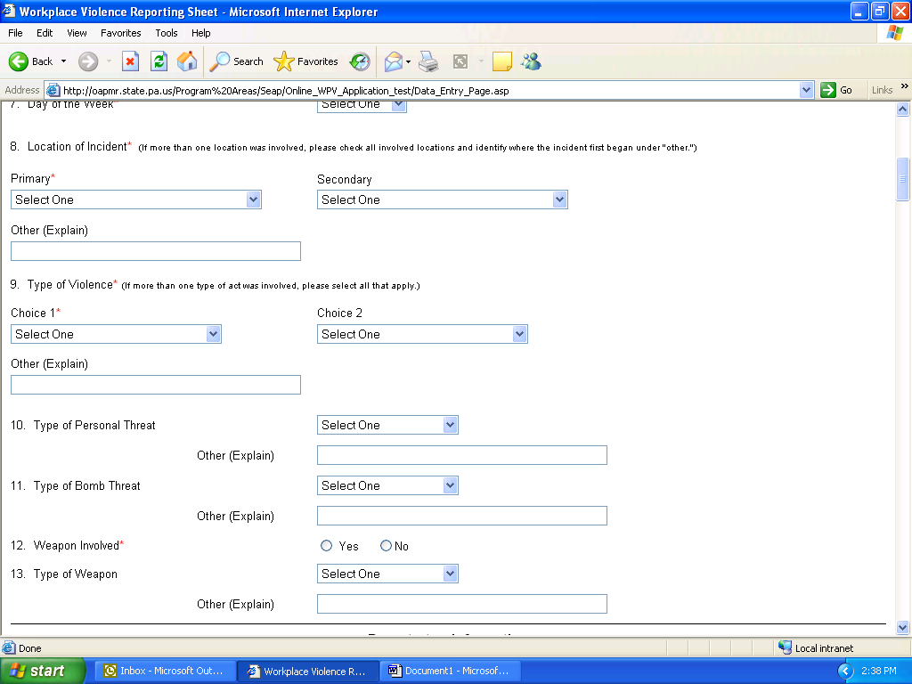
Screen print #3.
- Number of Perpetrators (Screen print #4.)
Use the text box to specify the total number of perpetrators involved.
- Number of Females (Screen print #4.)
Use the text box to specify the number of female perpetrators involved.
- Number of Males (Screen print #4.)
Use the text box to specify the number of male perpetrators involved.
- Perpetrator(s) Information (Screen print #4.)
Identity: required field
Use the drop down menu to select the identity of the perpetrator involved. The person identified as Perpetrator 1, 2, and 3 should be used consistently throughout the report. Leave Perpetrator 2 and 3 blank if not applicable.
Gender
Select “Female” or “Male” as appropriate
Name
Use the text box to identify Perpetrator. If the employee number was entered during the pre-population stage, it should be completed for you. Leave blank if not applicable.
Employee Number
This field is required only if Perpetrator was a commonwealth employee. If the employee number was entered during the pre-population stage, it should be completed for you. Leave blank if not applicable.
Job Code and Title
This field is required only if Perpetrator was a commonwealth employee. If the employee number was entered during the pre-population stage, it should be completed for you. Leave blank if not applicable.
Org ID and Name
This field is required only if Perpetrator was a commonwealth employee. If the employee number was entered during the pre-population stage, it should be completed for you. Leave blank if not applicable.
Supervisor or Management Level Employee
This field is required only if Perpetrator was a commonwealth employee. Select “Yes” or “No” as appropriate. Leave blank if not applicable.
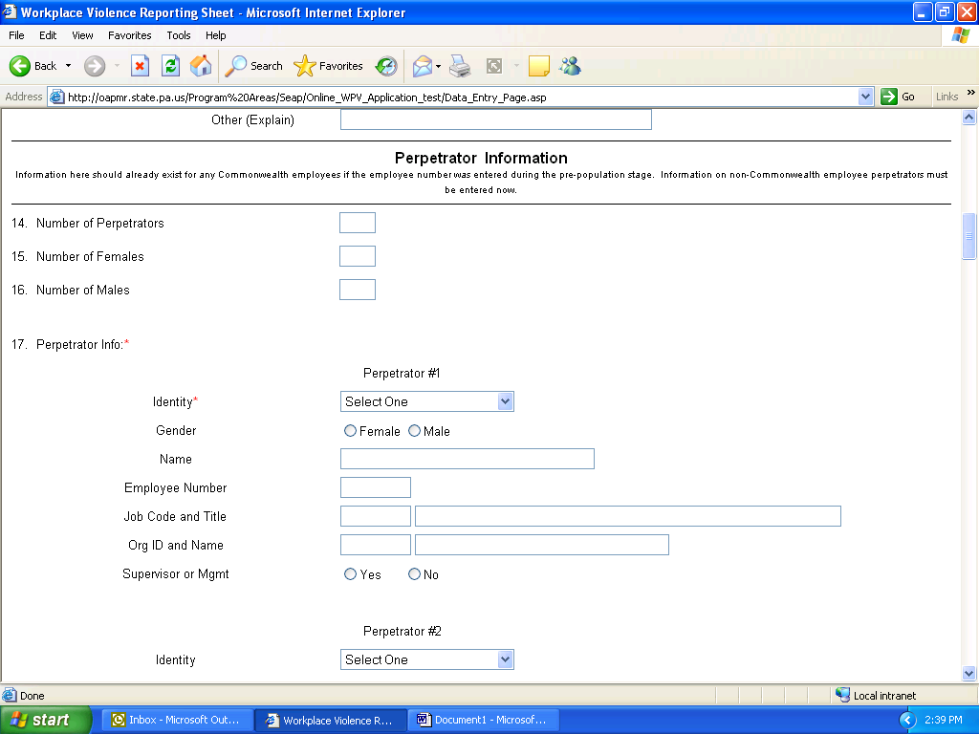
Screen print #4.
- Number of Victims: required field (Screen print #5.)
Use the text box to specify the total number of victims involved.
- Number of Females: required field (Screen print #5.)
Use the text box to specify the number of female victims involved.
- Number of Males: required field (Screen print #5.)
Use the text box to specify the number of male victims involved.
- Victim Information (Screen print #5.)
Identity: required field
Use the drop down menu to select the identity of the victim involved. The person identified as Victim 1, 2, and 3 should be used consistently throughout the report. Leave Victim 2 and 3 blank if not applicable.
Gender
Select “Female” or “Male” as appropriate
Name
Use the text box to identify Victim. If the employee number was entered during the pre-population stage, it should be completed for you. Leave blank if not applicable.
Employee Number
This field is required only if Victim was a commonwealth employee. If the employee number was entered during the pre-population stage, it should be completed for you. Leave blank if not applicable.
Job Code and Title
This field is required only if Victim was a commonwealth employee. If the employee number was entered during the pre-population stage, it should be completed for you. Leave blank if not applicable.
Org ID and Name
This field is required only if Victim was a commonwealth employee. If the employee number was entered during the pre-population stage, it should be completed for you. Leave blank if not applicable.
Supervisor or Management Level Employee
This field is required only if Victim was a commonwealth employee. Select “Yes” or “No” as appropriate. Leave blank if not applicable.
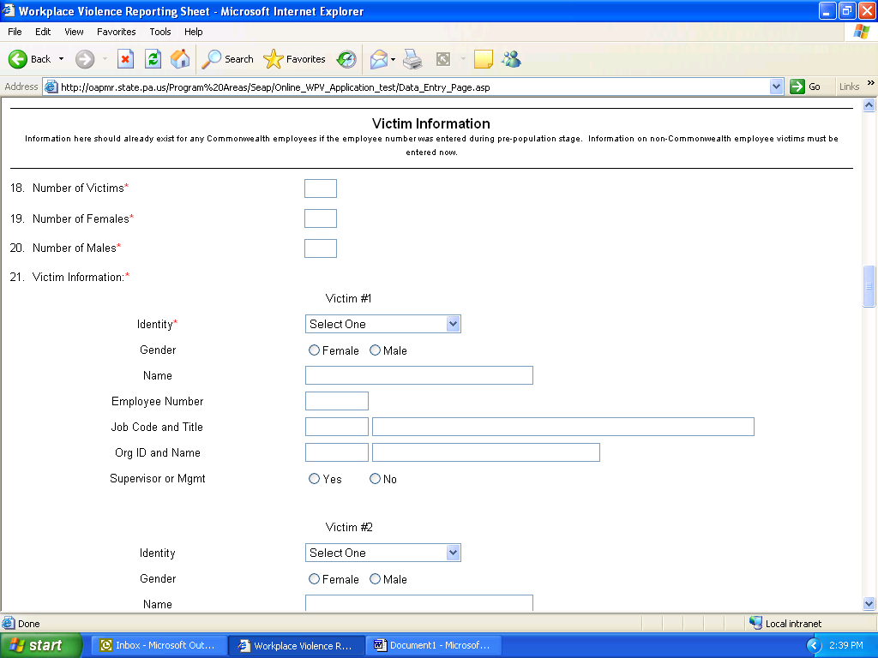
Screen print #5.
- Witnesses: required field (Screen print #6.)
Select “Yes” or “No” as appropriate to indicate if witnesses were present or not. Maintain a list of names and phone numbers separate from this report.

- Incident Involved Death: required field (Screen print #6.)
Select “Yes” or “No” as appropriate to indicate if the incident resulted in any deaths.
- Incident Involved Injury: required field (Screen print #6.)
Select “Yes” or “No” as appropriate to indicate if there were any injuries that required medical attention.
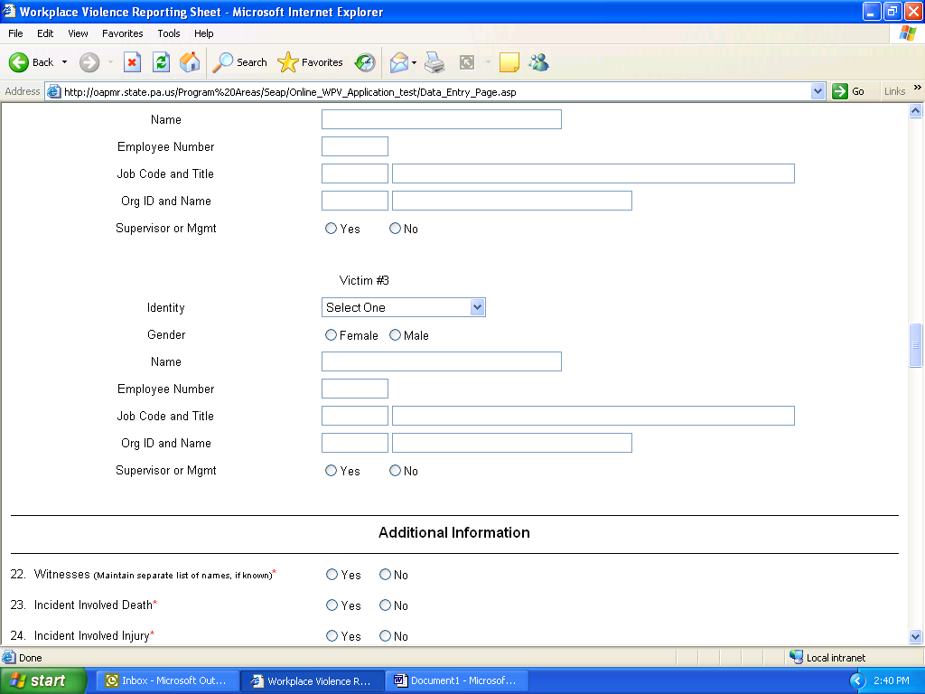
Screen print #6.
- Describe Injuries Suffered (Screen print #7.)
This field is required only if “Yes” was selected for question 24, “Incident Involved Injury”. Use the text box to describe the nature of the injuries sustained and what medical action was taken.
- Work-Related Injury Report or W/C Claim Filed (Screen print #7.)
This field is required only if “Yes” was selected for question 24, “Incident Involved Injury”. Use the drop down menu to select the appropriate response.
- Description of Incident: required field (Screen print #7.)
Use the text box to describe the nature of the incident and include other relevant information. If there are more than three victims, identify here.
- Law Enforcement Officials Contacted (Screen print #7.)
Select “Yes” or “No” as appropriate.
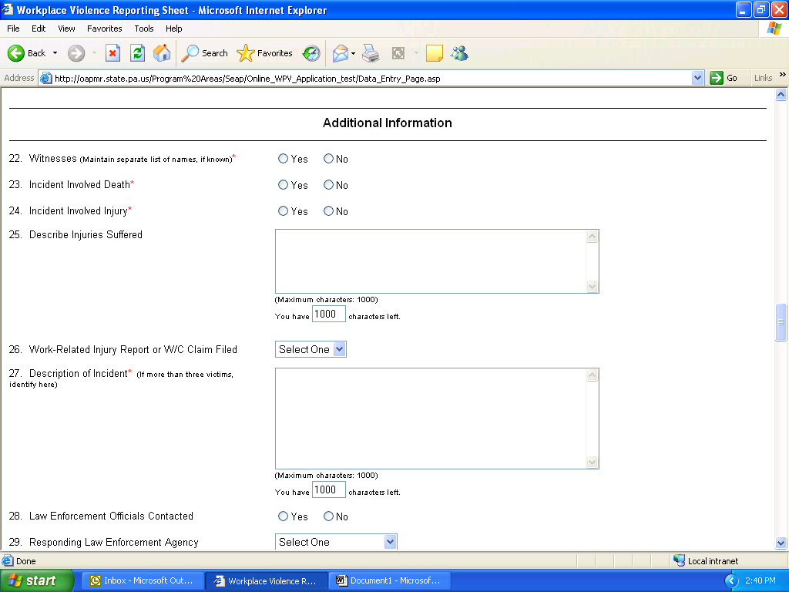
Screen print #7.
- Responding Law Enforcement Agency (Screen print #8.)
This field is required only if “Yes” was selected for question 28, “Law Enforcement Officials Contacted”. Use the drop down menu to select the type of agency. Use the “other” text box to specify an agency not available in the drop down list.
- Was Anyone Arrested (Screen print #8.)
Select “Yes” or “No” as appropriate.
- SEAP Contacted by Agency: required field (Screen print #8.)
Use the drop down menu to select the appropriate response.
- Safety Plan Implemented (Screen print #8.)
Select “Yes” or “No” as appropriate.
- Safety Plan Details (Screen print #8.)
Use the text box to describe the safety plan. Leave blank if not applicable.
- Other Relevant Data (Screen print #8.)
Use the text box to describe any additional factors that are related to the incident such as media coverage, structural damage, or impact on agency services. Leave blank if not applicable.

- Completing On-Site Report Completed By (Screen print #8.)
  - Name: required field
Use the text box to identify the person who prepared the original report at the incident location. In most cases, this will not be the same person as the individual who is inputting the information into the online report.
  - Job Title
Use the text box to identify the job title of the person who prepared the original report at the incident location. In most cases, this will not be the same person as the individual who is inputting the information into the online report.
  - Phone Number: required field
Use the text box to list the phone number using a ###-###-#### format.
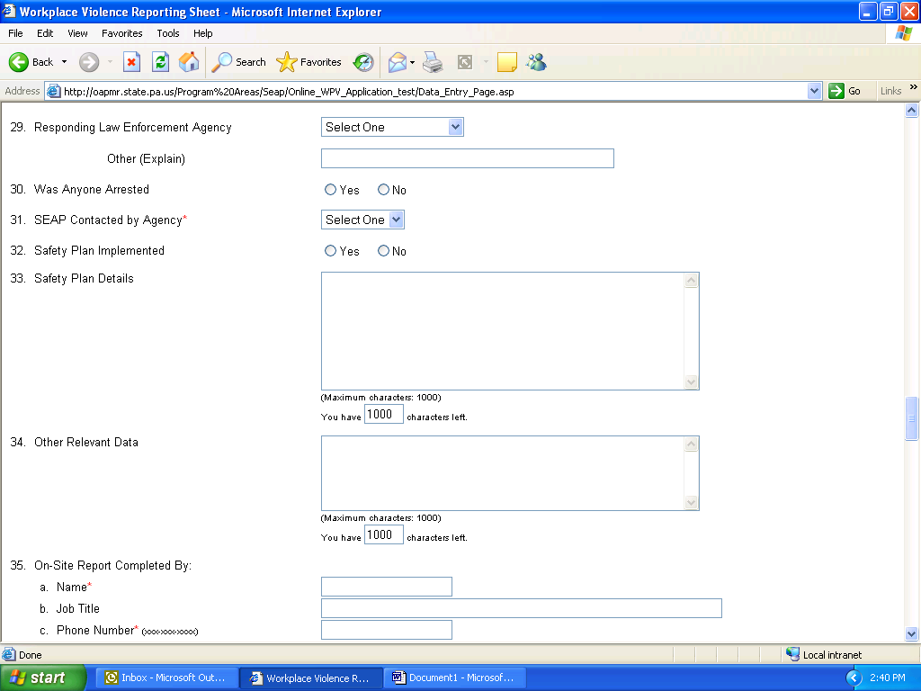
Screen print #8.
- Date of On-site Report (Screen print #9.)
Use the text box to enter the date the initial report was completed using mm/dd/yyyy format. This date may be different from the date the information is entered into the online database system but should match the date of the incident.

- Your Personal Info (Screen print #9.)
  - Your Name: required field
  - Your Job Title
Use the text box to identify your job title.
  - Your Phone Number: required field
Use the text box to list your phone number using a ###-###-#### format.
At this point in the form, you have the opportunity to create a password and save and close your progress. This is also the point in the form that you will indicate that the status of the form is “Pending”, meaning there is more information to be gathered to complete it, or “Complete” meaning you have the information to complete the rest of the form. If you submit a form as “Pending”, you will need to use the password and access the form and update it to reflect additional information as it becomes available and to confirm the outcome of the investigation. In addition, you can generate a paper summary of the individual record for your own internal use.
- Investigation Confirmed that Workplace Violence Occurred: required field when the status of the form is selected “complete”. (Screen print #9.)
Select “Yes” or “No” as appropriate.
- Investigation Confirmed that Inappropriate Workplace Behavior Occurred: required field when the status of the form is selected “complete”. (Screen print #9.)
Select “Yes” or “No” as appropriate.
If Perpetrator 1 was a commonwealth employee, complete questions 40 through 44. Leave blank if not applicable.
- Discipline Applied (Screen print #9.)
Select “Yes” or “No” as appropriate.
- If Yes, What Level Applied (Screen print #9.)
This field is required only if “Yes” was selected in question 40, “Discipline Applied”. Use the drop down menu to select the type of discipline.
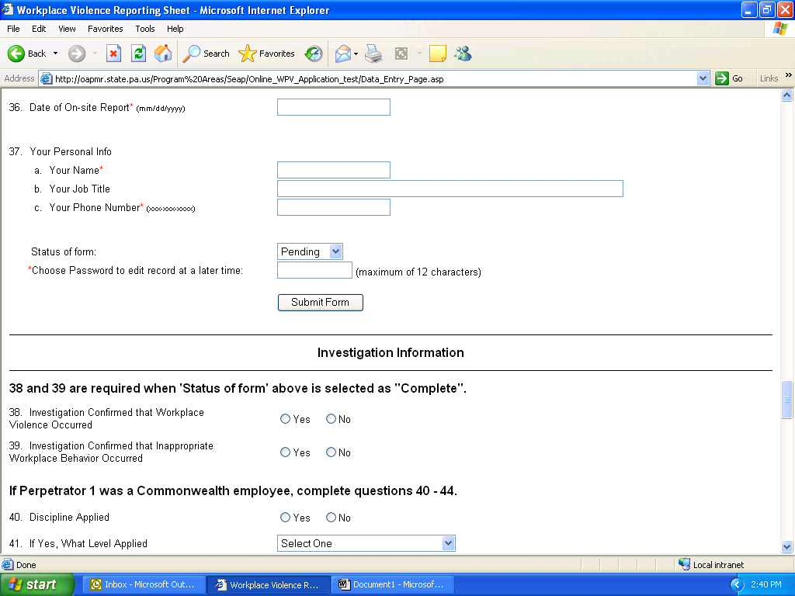
Screen print #9.
- Final Warning Given (Screen print #10.)
Select “Yes” or “No” as appropriate to indicate if a final warning was issued in conjunction with discipline.
- Grieved or Appealed (Screen print #10.)
Select “Yes” or “No” as appropriate to indicate if the employee grieved or appealed the discipline.
- Discipline Sustained as Issued (Screen print #10.)
Select “Yes” or “No” as appropriate to indicate if the discipline was sustained in whole. If the discipline was sustained in part, this answer should be marked as “No”.
- Discipline Modified (Screen print #10.)
This field is required only if “No” was selected for question 44, “Discipline Sustained as Issued”. Use the text box to describe in what manner the discipline was modified.
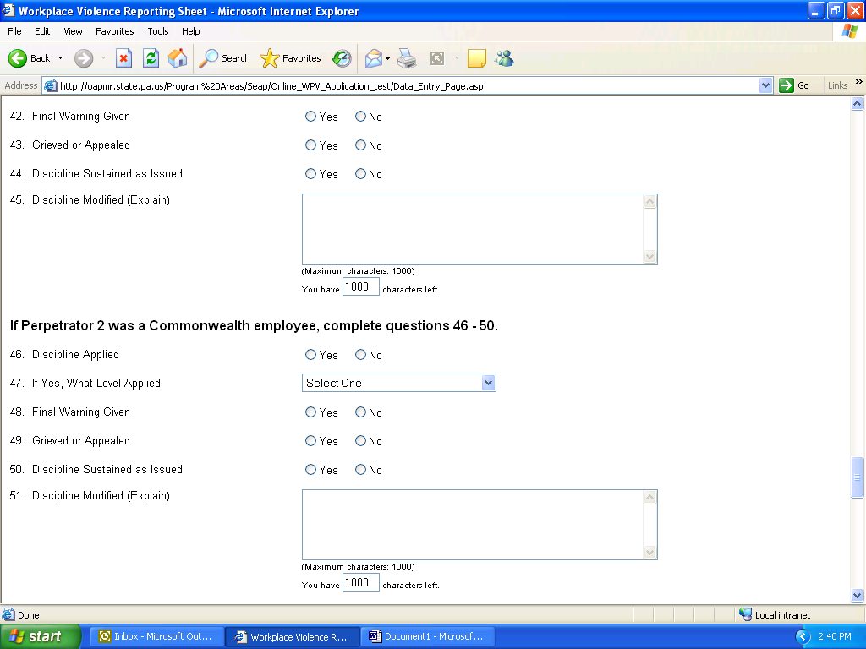
Screen print #10.
If Perpetrator 2 was a commonwealth employee, complete questions 46 through 50 in the same manner as above. Leave blank if not applicable.
If Perpetrator 3 was a commonwealth employee, complete questions 52 through 56 in the same manner as above. Leave blank if not applicable.
If “Yes” was selected for question 28, “Law Enforcement Officials Contacted”, complete questions 58 and 59. Leave blank if not applicable.

- Result of Police Investigation (Screen print #11.)
This field is required only if “Yes” was selected for question 28, “Law Enforcement Officials Contacted”.
- Were Charges Pressed (Screen print #11.)
Select “Yes” or “No” as appropriate.
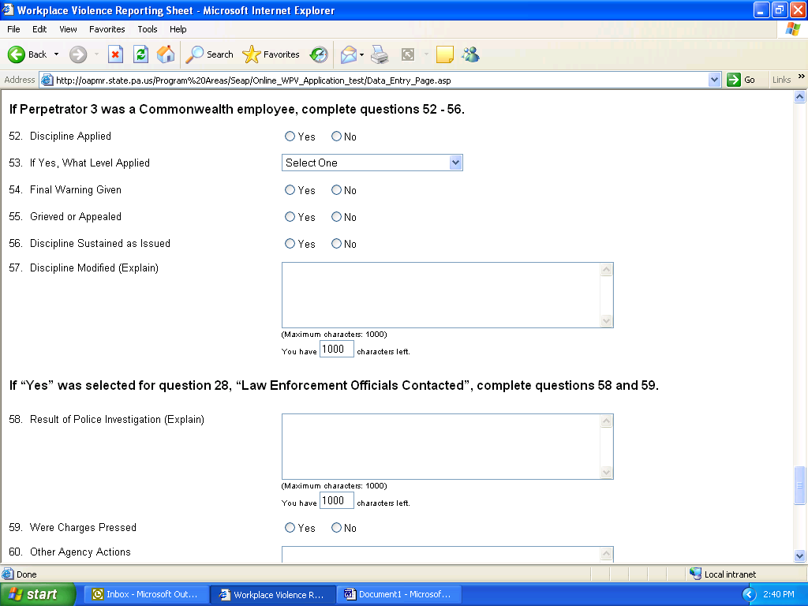
Screen print #11.
- Other Agency Actions (Screen print #12.)
Use the text box to describe any other actions taken by the agency not already explained.
- Date Investigation Completed (Screen print #12.)
Use the text box to enter the date the investigation was completed using mm/dd/yyyy format. This date may be several months after the initial data was entered into the online database system.
- Person(s) Completing WPV Incident Investigation (Screen print #12.)
a. Name: required if form status is “Complete”
Use the text boxes to identify the employees who conducted the investigation. The person identified as Investigator 1, 2, and 3 should be used consistently. If more than three people were involved, additional names can be documented in question 60, “Other Agency Actions”.
b. Job Title
Use the text boxes to identify the job titles of the employees listed above. Ensure the person identified as Investigator 1, 2, and 3 is used consistently.
Leave Investigator 2 and 3 blank if not applicable.
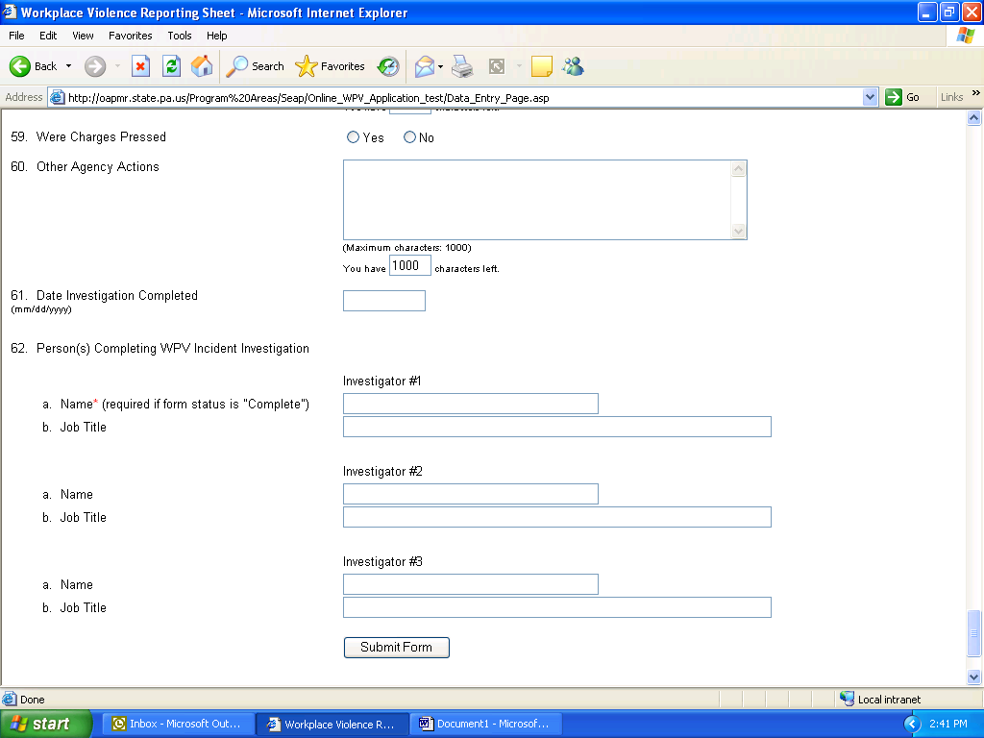
Screen print #12.
For questions on completing and transmitting workplace violence reports, please contact Susan Moravetz, Office of Administration, Workplace Support Services Division at (717) 787-8575.

