Bureau of Talent Acquisition
Revised 09/2023
Hiring Manager’S Guide

Contents
General Hiring Process 2
Things for a Hiring Manager to Think about before Posting a Vacancy………………….3
Civil Service-Covered Positions 4
Internal Recruitment Methods 4
External Recruitment Methods 5
Selective Certifications 6
The Rule of Three 7
Alternative Rules……………………………………………………………………………………………………8
Determining your Rule of Three 8
Veterans’ Preference on Civil Service External Lists……………………………………………..10
External Vacancy-Based postings 11
Non-Civil Service Positions 13
Posting Methods 13
Additional Considerations for your Candidate Pool 14
Requirements 14
Posting Length 14
Veterans’ Preference 15
After the Posting Closes (Civil and Non-Civil Service Positions) 15
Referrals 15
Interviews………………………………………………………………………………………………………….……15
Submitting a Selected Candidate 16
Appendix: 18
Appendix 1: Submitting a “Post a Vacant Position Request” ServiceNow Ticket..18
Appendix 2: Hiring Process Flow Chart up to Posting Closes………………………………20
Appendix 3: Candidate Referral Email………………………………………………………………….21
Appendix 4: Hiring Process Flow Chart after the Posting Closes 23
Appendix 5: Frequently Used Hiring Process Acronyms 24
Appendix 6: Bureau of Talent Acquisition Contact Information…………………………..25

General Hiring Process

Below is an outline of the general hiring process. Please see the rest of this guide for more detailed information on each part of the process. Additionally, contact your agency HR with any questions.

- Hiring Manager submits a “Post a Vacant Position” ServiceNow ticket through the Employee Resource Center.
- Ticket is assigned to an Agency HR Analyst.
- Agency HR Analyst contacts the supervisor/HR liaison to discuss posting options.
- Agency HR Analyst completes necessary documentation (e.g., Job Posting Form) and creates and routes the requisition through the approval process in NEOGOV.
- Posting Development staff drafts the posting and prepares either the civil service exam or non-civil service evaluation questions.
- Posting is open for application. Time frames for job postings depends on internal vs. external posting, civil service vs. non-civil service, or collective bargaining agreement provisions.
- Evaluation staff reviews the applications and determines eligibility for the position. They also issue scores for any civil service ratings of experience and training.
(Goal: 5 business days)

8. Agency HR Analyst provides the supervisor/HR liaison with appointable
candidates to interview and assists with scheduling interviews, if needed.

9. Hiring Manager conducts interviews and selects candidate(s)
and provides the Agency HR Analyst with the completed selection packet.

10. Agency HR Analyst:
- reviews the selection
- obtains complement approval
- ensures legal appointment
- completes review of official personnel file (OPF)
- completes salary review
- informs the supervisor when they can extend a verbal conditional offer
(1-7 days for complement approval depending on how the position is funded)
11. Agency HR Analyst
- conducts the appropriate background checks
- performs experience/education verifications
- extends the final offer
- coordinates the start date
- initiates the E-PAR

- HR Service Center staff processes the E-PAR. (a minimum of 14 days in advance of effective hire date is required to allow for processing)
Hire is complete! Onboarding begins.

Things for a Hiring Manager to Think about before Posting a Vacancy

The following are items Hiring Managers should consider prior to submitting a “Post a Vacant Position” ServiceNow ticket.

- The online position description for all position(s) must be reviewed and updated within the last year, which includes ensuring the job title and duties are accurate.

- Begin establishing an interview panel and compile interview questions.

- Work with members of your interview panel to select and reserve potential interview dates for quick scheduling.

- All external postings must include selling language regarding the position. The Hiring Manager may provide input if they would like.

Civil Service-Covered Positions
Within the commonwealth, positions are either civil service or non-civil service. This is determined by the agency and/or the job classification. If you have questions about this, talk with your Agency HR Analyst. For more information about non-civil service positions, please see page 12.

The next several pages provide information specific to civil service-covered positions only (not necessarily applicable to non-civil service positions).

Internal Recruitment Methods

When posting a civil service position, the Hiring Manager may choose to include any or all of the following internal recruitment methods on the posting. In addition to meeting the minimum experience and training requirements (METs) for the job, an applicant must meet one of the recruitment methods listed on the job posting to be an eligible candidate.

  - Promotion without Examination: To promote a qualified regular status civil service employee, based on meritorious service and seniority, into a higher-level position within a job series or from a position that is in a logical occupational, functional, or career development relationship to the higher-level position.

For example, an Accountant 1 may be eligible for an Accountant 2 position through promotion without examination.

  - Reassignment: Only current civil service employees in the same agency who hold the same or similar job title, with the same maximum salary and comparable minimum qualifications, will qualify for reassignment.

For example, an Accountant 2 with the Department of Labor & Industry may be eligible for another Accountant 2 position with another office/bureau/division within the Department of Labor & Industry through reassignment.

  - Transfer: Only current civil service employees who hold the same job title will qualify for transfer to another agency.

For example, an Accountant 2 with the Department of Labor & Industry may be eligible for another Accountant 2 position with the Department of Transportation through transfer.

  - Voluntary Demotion: The movement of a qualified regular or probationary civil service status employee who requests movement to a job title with a lower maximum hourly salary.

For example, an Accountant 1 may be eligible for a Fiscal Assistant position through voluntary demotion.

  - Reinstatement: Former civil service employees may only be reinstated to the job title from which they resigned. Current civil service employees are not eligible through reinstatement.

For example, an employee who was a regular civil service status Accountant 2, but either left commonwealth service entirely OR took a non-civil service position may be eligible to be reinstated to an Accountant 2 position.

  - When a candidate is interviewed from any of the above recruitment methods, everyone within that recruitment method must be interviewed.

For example, if you decide to interview one candidate from the reassignment group, you must interview all of the candidates who are eligible under reassignment.

  - There is no veterans’ preference for civil service internal postings.

Note:

Seniority: If the civil service position is union-covered, please contact your Agency HR Analyst or Employee Relations department for additional information about seniority bidding rights and/or collective bargaining unit provisions relating to job postings.

External Recruitment Methods

Formerly referred to as civil service lists, these certifications are generated from applicants who apply to an external posting. Current commonwealth employees may also apply to external postings.

- Code 11 – Employment Certification: All candidates (commonwealth employees AND non-commonwealth employees) who have passed and received a score and met the METs for the job title. (Note: this certification will always be sent to Hiring Managers)

- Code 12 – Agency Employee Certification: Regular and probationary civil service and non-civil service employees of the agency who passed and received a score for a BTA-administered exam and met the METs for the job title.
- Code 14 – Interagency Employee Certification: Regular and probationary civil service and non-civil service state employees and civil service local government employees (who participate in our merit system) who passed and received a score for a BTA-administered exam and met the METs for the job title.
- CODE 22 – Veterans’ Preference Certification: All veteran candidates who have passed and received a score and met the METs for the job title. (Note: this certification will always be sent)

  - For the external recruitment methods listed above, you may use the Rule of 3, or request an alternate rule (greater than 3), to determine your candidate pool.

  - See page 8 for additional information on alternatives to the Rule of 3.

Selective Certifications

Selective certification criteria refers to civil service positions for which an agency has demonstrated clearly and objectively that criteria such as age, medical or physical standards, special experience, training, licensure, knowledge, skills, or abilities are essential to the performance of the duties and responsibilities of the position and are required at the time of hire.

For example, being able to speak Spanish fluently may be selective certification criteria for an Income Maintenance Caseworker.

Agencies must provide justification for the requirement of selective criteria.

Note: At your request, the Agency HR Analyst will place this information on the job posting form. For requests based on compliance with a specific regulation, either cite or attach a copy of the regulation to the ServiceNow ticket. If the request is being made due to race, gender, age, or language requirements, provide the total estimated client population and how many clients meet the criteria identified (if applicable), as well as the total number of employees in the agency or at the location of the vacancy and how many of those employees meet the criteria identified.
- The Bureau of Talent Acquisition (BTA) must approve all selective certification requests prior to the position being posted.

- If approved, selective certification criteria applies to both internal AND external postings if the position is posted both interally and externally.

Similar to external recruitment methods, selective certifications have specific coded certification lists that are generated from applicants who apply to an external posting AND meet the selective certification criteria.

- CODE 37 – Selective Employment Certification: Candidates (commonwealth employees AND non-commonwealth employees) who passed and received a score and met the METs for the job title and additional specific job criteria or possess special knowledge, skills, or abilities essential to the performance of certain jobs, as approved by BTA, in accordance with the Merit System Employment Process Guide.

- CODE 38 – Agency Selective Employee Certification: Regular and probationary civil service and non-civil service employees of the agency who passed and received a score for a BTA-administered exam and met the METs for the job title and additional specific job criteria or possess special knowledge, skills, or abilities essential to the performance of certain jobs, as approved by BTA, in accordance with the Merit System Employment Process Guide.
- CODE 39 – Interagency Selective Employee Certification: Regular and probationary civil service and non-civil service state employees and civil service local government employees (who participate in our merit system) who passed and received a score for a BTA-administered exam and met the METs for the job title and additional specific job criteria or possess special knowledge, skills, or abilities essential to the performance of certain jobs, as approved BTA, in accordance with the Merit System Employment Process Guide.

The Rule of Three

- The Rule of Three will apply to all civil service lists unless an alternative hiring rule was requested.

- An agency will interview and may choose from among the three highest-ranking available candidates on a referral list.
- The Rule of Three may consist of more than three candidates when tie scores exist with the third eligible candidate in the Rule of Three.

- The Rule of Three may consist of fewer than three candidates if no additional names are on the referral list.

  - The Rule of Three (or alternative) may be affected after the candidate memo is sent due to the following:

- Reconsiderations – Applicants who are deemed ineligible for a posted civil service position or disagree with their score may request a reconsideration of eligibility decision and/or score within five (5) business days of the date of the notice of examination results. If an applicant’s reconsideration is successful, they will be referred. If the candidate is within the hiring rule, they must be considered until someone is placed in “Hired” status in NEOGOV.

- Reposting – A job posting may be reposted once at the agency’s request. Eligible candidates from a reposting are added to your existing list. Previous applicants do not need to reapply.

- Veterans’ Preference – A candidate may be granted veterans’ preference after the initial list is issued. However, if another candidate is already in “Offered” status in NEOGOV, you may proceed with the hire.

Alternative Rules

An agency may request an alternative to the Rule of Three (greater than three) by adding a comment on the ServiceNow ticket or communicating that information to the Agency HR Analyst. All requests provided to the Agency HR Analyst for an alternative to the Rule of Three must be made in advance and included on the requisition.

For example, if you anticipate a small candidate pool, you may want to request a Rule of Five or a Rule of Seven to have more candidates to consider.

Determining your Rule of Three

The Rule of Three typically includes the top three available candidates on a certification.

If a candidate removes themselves from consideration, you may request additional candidates to be interviewed. It is at the agency’s discretion whether or not to consider additional candidates. Contact your Agency HR Analyst for more information.

All candidates in the rule must be interviewed unless there is a veteran within the rule. If there is a veteran in the Rule of Three, only that veteran or any veteran on the list may be considered.

Your Rule of Three may include more than three candidates if a tie score exists with the third candidate in the rule.

For Example
Name | Total score
Miles | 100  #1
Evans | 95  #2
Thomas | 85  #3
Smith | 85
Jones | 80  Not in the rule of 3
Jackson | 75

Name | Total score
Miles | 100
Howe | 100  All these candidates are your rule of 3
Gonzales | 100
Patel | 100
Brown | 100
Evans | 95  Not in the rule of 3
Thomas | 85
Smith | 85

Veterans’ Preference on Civil Service External Lists

Veterans’ preference provides for preferential treatment of veterans and spouses of deceased or disabled veterans, provided they have met the posting requirements and have a passing exam score.

Candidates with veterans’ preference receive ten (10) additional points to their exam score; have mandatory appointment preference over non-veterans when their names appear together within the Rule of Three (or alternative rule) on a referral list; and at the discretion of an agency and may be given preference for selection regardless of their rank on the referral list.

How to Identify a Candidate who has Received Veterans’ Preference

- Candidates who have both a “V” in the Vet Indicator column and

- Candidates who have the ten (10) additional points to their exam score

- Candidates who have an “X” in the Vet Indicator column do not have veterans’ preference.

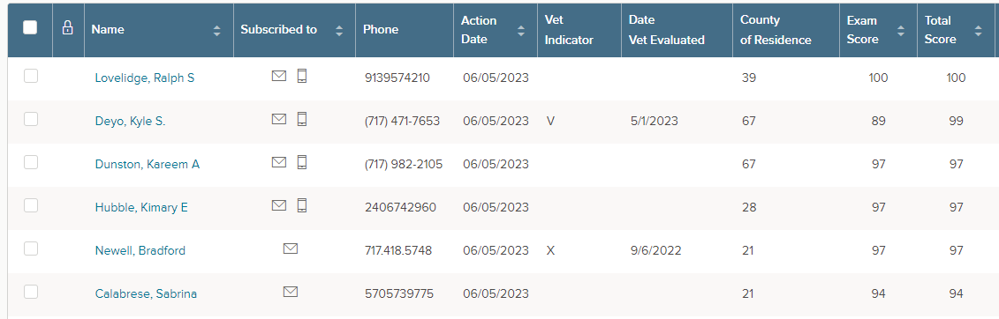

If the veteran(s) within the rule withdraws from consideration, you may request additional candidates to be interviewed. It is at the agency’s discretion whether or not to consider additional candidates. Contact your Agency HR Analyst for more information.

External Vacancy-Based Postings

Experience and Training (E&T) Exam

An E&T exam is an evaluation of an applicant’s experience and training which provides a score for external, vacancy-based postings. In the past, there was one exam per job title and those who passed the exam were put on a list. Vacancy-based E&T exams allow an agency to tailor an exam to meet the specific needs of their vacancy.

- It is possible there may not be an existing E&T exam for the job title you are posting and one will need to be created.

- It is also possible to have more than one version of an E&T for one job title. In these cases, Agency HR Analysts can provide multiple versions of E&T exams to determine if an existing E&T will work for a particular vacancy posting.

- There may be an existing E&T that requires modification for a particular vacancy. Notify the Agency HR Analyst to request an examination modification via the job posting form (JPF), include:

- Reason(s) for modification
- Supervisor of vacancy
- Supervisor job title and email

Hiring Managers should not modify the E&T exam themselves. Rather, an Exam Developer will reach out to assist Hiring Managers with modifications.

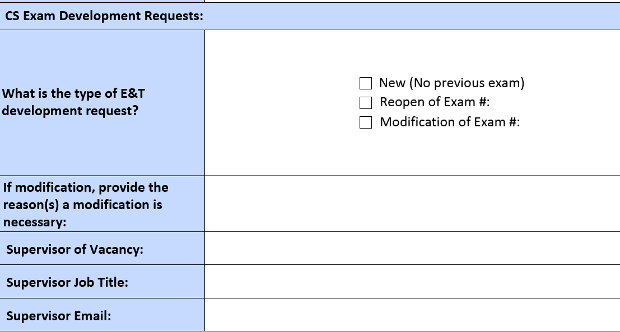
Prior to any job posting development, the Agency HR Analyst will send Hiring Managers a copy of the JPF to ensure all information is accurate and determine if changes are needed.

Non-Civil Service Positions
Within the commonwealth, positions are either civil service or non-civil service. This is determined by the agency and/or the job classification. If you have questions about this, talk with your Agency HR Analyst. For more information about civil service positions, please see page 4.

The next several pages provide information specific to non-civil service positions only.

Posting Methods

- Internal: The position will be posted for current commonwealth employees, including both civil service and non-civil service. This vacancy posting will only be found on the internal page of the commonwealth’s employment website. The posting can be restricted to candidates within a specific agency. All candidates who meet the Minimum Experience and Training (METs) requirements are considered with only the following differentiations, when applicable:

  - Seniority: The position is open for candidates who meet criteria as established in the appropriate collective bargaining agreement (CBA).

For example, union-covered positions where seniority bidding exists.

  - Non-Seniority: The position does not have candidates with seniority rights according to the CBA or is a management or non-represented position, and therefore, all other current commonwealth employees who meet any other posting restrictions are considered.

- External: The position will be posted for anyone to apply. This vacancy posting will only be found on the external page of the commonwealth’s employment website. There is no exam, therefore, candidates are not scored and ranked on a list like civil service external postings. Candidates either meet the METs or they do not.

  - Interns: These positions are considered external vacancies. These vacancy postings will only be found on the Internships & Apprenticeships page of the commonwealth’s employment website.

- Hiring Managers must select to post a position either internally OR externally.

- Limited exceptions will be made for union contractual obligations.

Additional Considerations for your Candidate Pool

Although most classifications have MET requirements, Hiring Managers can request that no MET review is conducted on candidates for non-civil service positions. This will result in all applicants passing through to interview regardless of whether they meet the requirements.

After a list of eligible candidates is received, the Hiring Manager may request the remaining applicants be referred for interview. This request can be for all or select applicants.

Requirements

In addition to METs, Necessary Special Requirements (NSRs), and/or Conditions of Employment (COEs) that are specified within the job specification, the Hiring Manager may also request the following on their vacancy posting:

- Additional Requirements: These are must have additional criteria. When additional requirements are included on the posting, applicants are reviewed for METs, NSRs, COEs, and additional requirements. If the applicant does not meet all of these requirements, they are not referred for interview.

- Preferred Qualifications: These are qualifications that the Hiring Manager would prefer a candidate to have but are not required for the candidate to be referred for interview. All veteran candidates must still be considered even if they do not have these preferred qualifications, but they do meet all other posting requirements.

Information pertaining to whether an applicant has the additional requirements or preferred qualifications will be gathered by supplemental questions on the application. The applicant’s answers to these questions on non-civil service postings are not scored.

Posting Length

Postings are open for a maximum of five (5) days unless contractual obligations require a longer posting OR if the position is difficult to fill and additional recruitment efforts are needed. Be sure to refer to any applicable collective bargaining agreement for additional posting requirements.

Veterans’ Preference

This process is established in HR-TM002 for the application of the Veterans’ Preference Act, 51 Pa.C.S. §§ 7101.1-7111, for non-civil service appointments within the commonwealth.

Veteran candidates who apply for non-civil service positions shall receive an interview if they meet the METs and all other required qualifications (experience, education, academic success, training, certifications, proficiencies, etc.). These qualifications must be clearly identified on the job posting.

Veteran candidates who possess the qualifications and whom the Hiring Manager would like to select are processed in the same manner through background checks.

If, after interviewing a veteran candidate, it is determined the candidate does not possess the qualifications required for appointment to this non-civil service position, the Hiring Manager must complete a Non-Civil Service Veteran Non-Selection form and submit it for approval through their agency HR Office. No offer of employment, to the veteran or any non-veteran candidate, may be extended while the agency is reviewing the form.

After the Posting Closes (Civil and Non-Civil Service Positions)
Once the posting closes, the Evaluation Division completes the review of all applications submitted for the posting and determines eligibility of applicants.

Referrals

Your Agency HR Analyst will send a referral packet email to the Hiring Managers listed on the ServiceNow ticket. In NEOGOV, all Hiring Managers will be added to the requisition to provide access to candidate applications on the “Candidates” tab.

Interviews

Two options may be used to schedule interviews:

  - Interviews may be set up through NEOGOV using the self-scheduling tool.

    - Self-scheduling allows candidates to select their own interview time based on the available dates/times provided by the interview panel.

    - To request assistance setting up self-scheduling, complete and return the Self Scheduling Request form provided in the referral email. The completed form should be sent to your Agency HR Analyst.

    - Self-scheduling may also be set up using the instructions attached in referral packet the email.

  - Candidates may be contacted directly to schedule interviews.

Multiple attempts MUST be utilized in scheduling interviews.

Interviews should be completed within 15 business days.

Interview panels must consist of two (2) but no more than three (3) people.

Once candidate(s) have been selected, the Hiring Manager may choose to conduct a reference check. Reference checks are optional. However, if conducting a reference check, it should be limited to one (1) professional reference and only one (1) attempt to contact should be made to keep the hiring process moving.
Prior to proceeding with the next step in the hiring process, Hiring Managers must obtain approval for the selected candidate(s) according to their organization’s requirements. Contact your Agency HR Analyst for guidance.

Submitting a Selected Candidate

Reply to the referral packet email from the Agency HR Analyst or email your Agency HR Analyst and attach:

- Completed Candidate Memo and Interview Summary.

- Documentation to support candidates who did not show, are no longer interested, etc.

The Agency HR Analyst will:
- Review the selected candidate to ensure a legal appointment.

- Move the selected candidate to offered status (answer pending) in NEOGOV.

- Review the Official Personnel File (both for civil service and non-civil service) if the selected candidate is a current employee.

- Determine appropriate salary placement, which may include completing a salary determination worksheet, when applicable.

- Complete additional complement check, if required by your agency.

Once all the steps above are complete, the Agency HR Analyst will provide the Hiring Manager:

- Conditional Job Offer Script to complete the verbal conditional job offer.

- E-PAR worksheet for completion of Parts 1 and 2.
You must use the Conditional Job Offer script provided when you make the conditional job offer to the candidate. The script must be read as written, in its entirety. No exceptions.

Hiring Manager will:

- Return the completed E-PAR worksheet to the Agency HR Analyst if the candidate accepts conditional offer.

The Agency HR Analyst will:
- Send the Hiring Manager an email, “(Candidate(s) Name) paperwork has been submitted to the Background Check and Hire Division (BCHD) for the required background checks/approvals. You will be contacted by BCHD regarding the final job offer.”
Throughout each stage of the hiring process, the Agency HR Analyst will update the ServiceNow ticket. The submitter of the ticket will be able to see the status updates.

Appendix:

Appendix 1: Submitting a “Post a Vacant Position Request” ServiceNow Ticket

Steps to submit a ServiceNow ticket to “Post a Vacant Position Request:”

  - Go to MyWorkplace.

  - Click “Employee Resource Center.”

  - Click “AskHR” (located on the left).

  - Click “Services for Managers” (located on the left).

  - Click “Post a Vacant Position Request.”

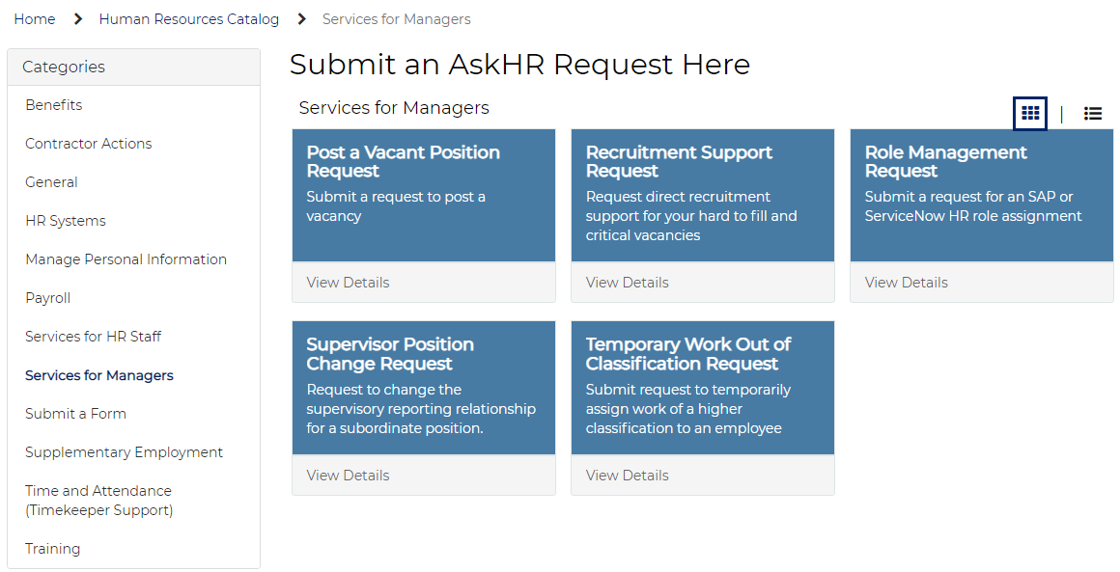

Be sure to add any necessary and/or additional comments, as well as attachments to the ServiceNow ticket, including:

- Whether to post internally or externally (include recruitment options).

- # of days to post.

- Work hours.

- E&T number – For civil service external postings, the Agency HR Analyst may provide the current E&T to determine if it is still appropriate or a modification is needed.

- Preferred hiring rule for civil service external posting.

- Any internal approval to post received.
When another vacancy occurs for the same job classification and all vacancies are performing the same duties, if the referral list is not expired and you have program approval, you may add to the existing ticket.

Appendix 2: Hiring Process Flow Chart up to Posting Closes

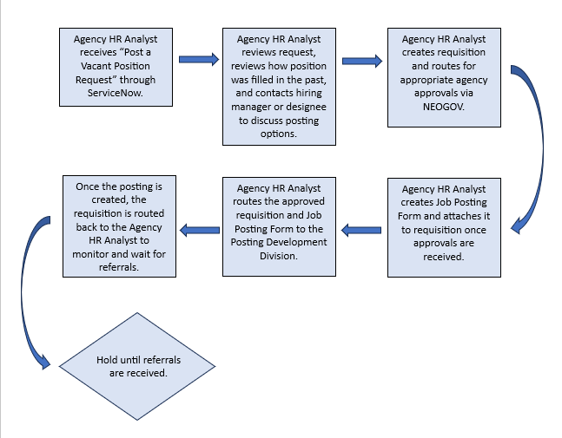

Appendix 3: Candidate Referral Email
SAMPLE REFERRAL EMAIL
Hello!
Candidates are ready to be interviewed for the vacant position(s) listed below. Please read this entire email as it contains important information related to the interviews.

Org | 00196300 ST Div Elect Vtr Rgstrtn
Job Name | Administrative Officer 1
Position Number | 50347164
Req Number | I-2023-48962  N-2023-48963
Posting Dates | 4/24/23-5/3/23
Referral expiration date | 9/25/23

- Candidate Memo and Interview Summary: Your candidate list is attached.

- Viewing applications: You have been added to the requisition in NEOGOV as a hiring manager. This means that you can view candidate applications online at https://neogov.pa.gov/.

- Scheduling interviews: You can use one of two methods to schedule interviews:
  - Interviews can be set up through NEOGOV using self-scheduling. Self-scheduling allows candidates to select their own interview time based on the dates/times provided by the interview panel. If you would like assistance setting up self-scheduling, please complete the attached form and return it to me. You can also set up self-scheduling yourself using the attached instructions. (NOTE: multiple attempts MUST be utilized in scheduling interviews)
  - You can contact candidates directly to schedule interviews.
  - See the attached “Interview Pointers” document for more details on setting up interviews.

- Interview panel and questions: Work through your chain of command to have your interview panel and questions approved. If you need assistance with how to develop interview questions, reach out to me. See the attached “Interview Pointers” document for more information.

- After the interview:
  - Panel decides on the selected candidate.
  - Once candidate(s) have been selected, the hiring manager may choose to conduct a reference check. Reference checks are optional. However, if conducting a reference check, it should be limited to one (1) professional reference and only one (1) attempt to contact should be made to keep the hiring process moving.
  - Get approval for your selected candidate by your chain of command according to your organization’s requirements.

- Submitting your selected candidate: Send the following information to your Agency HR Analyst after you have secured internal approval to proceed with your selection. Remember It is your responsibility to secure all internal approvals on your selection prior to sending your selected candidate to me.
  - Completed Candidate Memo and Interview Summary
  - Documentation to support candidates who did not show/no longer interested/etc.
  - For NCS position(s) only: Approved NCS Vet Pref Non-Selection Form (if applicable)

- Conditional Offer
  - You will be notified when a verbal conditional offer can be made using a supplied script
  - You will need to complete an ePAR worksheet, which will be provided at that time.
- Final Approvals
  - Once the Background Check and Hire Division have final approvals, you will be contacted to coordinate a start date
  - At this time, you can notify internal, non-selected candidates if you want.

- After the Position is Filled
  - Hiring managers are responsible for appropriate record retention of interview notes. Retain all interview notes in a confidential and secure location for four years.
  - Non-selection notices will be sent to unsuccessful candidates the Wednesday after the effective date of the selected candidate.

Collette Rebuck (she/her)
Human Resource Analyst, Bureau of Talent Acquisition, Intake Division
PA Office of Administration | Talent Management Office
1121 Strawberry Square Harrisburg, PA 17128
Phone: 717-787-1554
Email: corebuck@pa.gov
www.oa.pa.gov
www.employment.pa.gov

- Conditional Offer
  - You will be notified when a verbal conditional offer can be made using a supplied script.
  - You will need to complete an ePAR worksheet, which will be provided at that time.
- Final Approvals
  - Once the Background Check and Hire Division have final approvals, you will be contacted to coordinate a start date.
  - At this time, you can notify internal, non-selected candidates if you want.

- After the Position is Filled
  - Hiring managers are responsible for appropriate record retention of interview notes. Retain all interview notes in a confidential and secure location for four years.
  - Non-selection notices will be sent to unsuccessful candidates the Wednesday after the effective date of the selected candidate.

Appendix 4: Hiring Process Workflow after Posting Closes
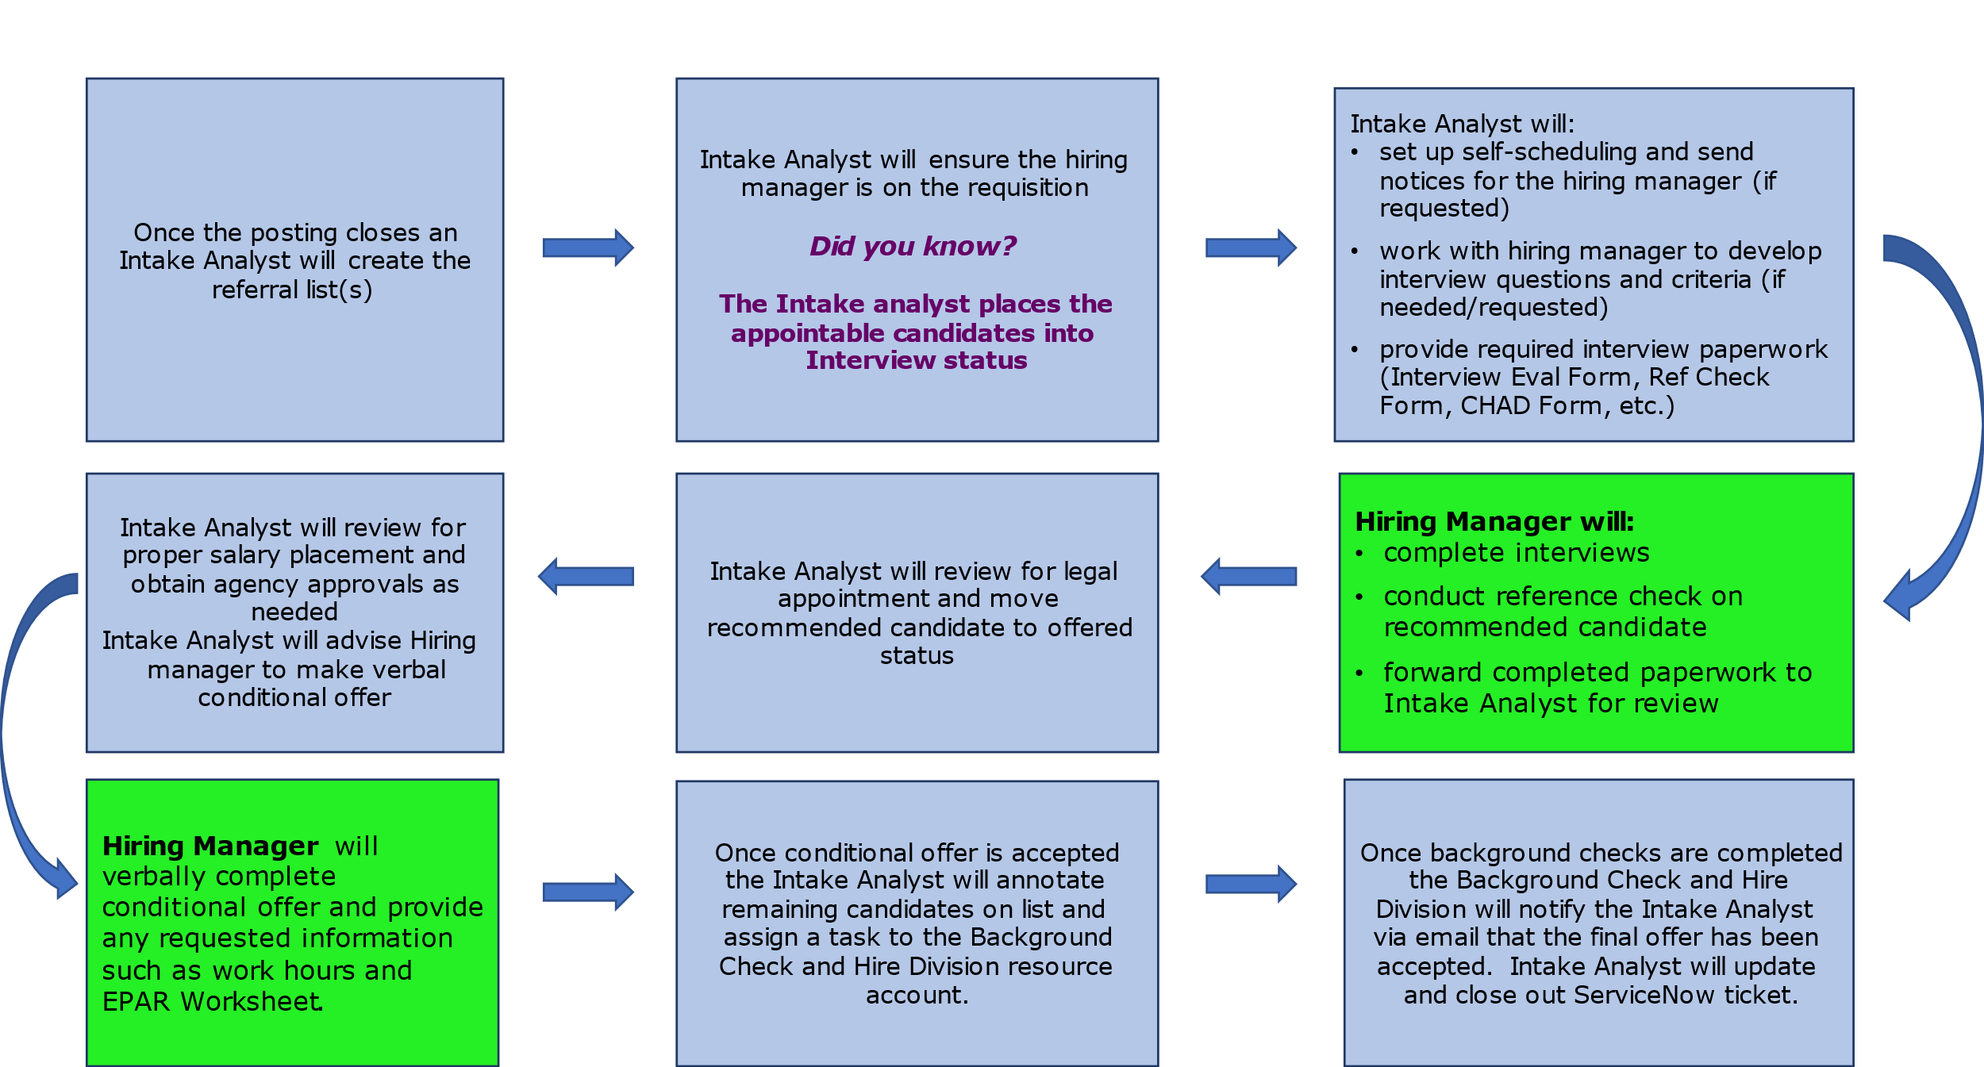

Appendix 5: Frequently Used Hiring Process Acronyms:

Acronym | Meaning
ATA | Approve To Appoint
AATM | Appointment Above the Minimum
BCHD | Background Check and Hire Division
BU | Bargaining Unit
CAR | Complement Action Request
CAR-A | Complement Action Request - Annuitant
CBA | Collective Bargaining Agreements
CS | Civil Service
CJO | Conditional Job Offer
E | External
EE | Employee
E-OPF | Electronic Official Personnel File
E-PAR | Enterprise Position/Personnel Action Request
E&T Exam | Experience & Training Exam
FCH | Fair Chance Hiring
HM | Hiring Manager
HQ | Home Headquartered
I | Internal
IUO | Internal Use only
JPF | Job Posting Form
MB | Merit Based
MET | Minimum Experience and Training
MOU | Memorandum Of Understanding
NCS | Non-Civil Service
PATCH | Pa Access to Criminal History
PD | Position Description
Req | Requisition
RJO | Rejected Job Offer
SL | Senior Level
SN | ServiceNow

Appendix 6: Contact Information

Bureau of Talent Acquisition
  - Bureau Director – Lydia White
  - Bureau Duties:
- Responsible for guiding job filling process.
- Determines eligibility for veterans’ preference, establishes eligibility lists, and refers candidates.

Posting Development Division
  - Division Chief – Jenine Hartman
  - Division Duties:
- Prepares all vacancy postings and creates/modifies civil service exams.

Evaluation Division
  - Division Chief – Angel Nieves
  - Division Duties:
- Evaluates all internal/external applications to determine eligibility of applicants.
- Processes requests for reconsideration of ineligibility.

Background Check and Hire Division
  - Division Chief – Amanda Crawford
  - Division Duties:
- Conducts audits on selections to ensure legal appointments.

