As you may have discovered, there is no ‘AGE’ field in IRIS. However, using the expression below, you can calculate a person’s age in your query design.

Simply type or paste the following into the ‘Field:’ row of your query design grid to retrieve a person’s age:

AGE: Left((Date()-([BIRTH_DT]))/365.25,2)

However, you must make sure your query is using a view that contains the BIRTH_DT field, since the above expression references it: [BIRTH_DT].

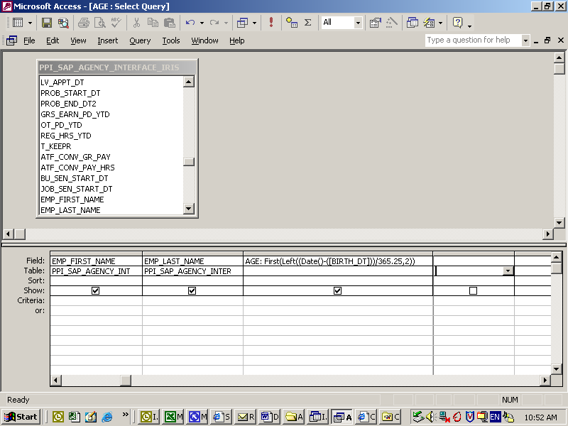

If you are using the ‘Totals’ function, you must change ‘Group By’ to ‘First’ in the ‘TOTAL:’ row:

