Agency Quick Guide for Completing Mass E-PAR Spreadsheets (Hire and Separation Actions Only)
Contents
Mass Spreadsheets General Information 2
Hints Tab 2
Spreadsheet Protection 2
Spreadsheet Validations 2
Color Key 2
Spreadsheet Completion 3
Submitted E-PAR Addition to Mass Spreadsheet 3
HRSC Use Only Field 3
Non-Submitted E-PAR Additions to Mass Spreadsheet 3
Mass E-PAR Submission 4
Mass E-PAR Field 4
Requestor 4
HR Office Submission 5

Mass Spreadsheets General Information

Hints Tab
The “Hints Hire&Rehire and Sep” Tab has been provided for reference during the creation of the Mass Hire and Separation spreadsheets. It provides simple reminders and information regarding the color coding of the Mass spreadsheets. To begin filling out a Mass spreadsheet select the “Hire&Rehire” or “Separation” Tab at the bottom of the Workbook.

Spreadsheet Protection
To prevent the unauthorized editing of the workbook all spreadsheets within the workbook have been password protected. To the greatest extent possible, fields that should not be edited have been locked and/or hidden from view. Note: The addition of fields and/or the modification of locked column/rows may result in invalid data being passed to the E-PAR system; OR, prevent the successful upload of the spreadsheet. Spreadsheets submitted with improper formatting and/or missing required information may be returned to the Agency without action.

Spreadsheet Validations
To ensure consistent and accurate information is submitted, where possible, validations have been added to the spreadsheet. Such validations include (but are not limited to), dropdown lists where only specific values can be submitted, minimum lengths for fields requiring a specific number of characters/digits (Personnel Number, SSN, Position Number etc.), Dates required in mm/dd/yyyy format.
- Should a validation error be triggered, review the instructions provided in the warning, click the Cancel button to clear the invalid entry, then re-enter the information per the validation error’s instructions.

Color Key
– Required Fields throughout the spreadsheet are highlighted in Yellow. Prior to submission, the spreadsheet should be reviewed, to ensure that all required fields are completed for all submitted actions.
Re d – HRSC Only Field should only be completed by the designated HRSC Rep responsible for the Mass E-PAR process

Spreadsheet Completion

Submitted E-PAR Addition to Mass Spreadsheet
Mass Spreadsheets (Hire and Separation) will need to be attached to a submitted E-PAR. The information regarding the person for whom the submitted E-PAR is created for must be placed in Row #3 of the Spreadsheet. Adding this information to any other row in the worksheet will result in a duplicate E-PAR being created for the already-submitted E-PAR and an E-PAR failing to be created for the record entered into Row #3.
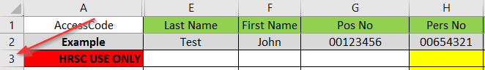
- Requestors and/or HR Offices should begin entering data in cell E3 (Last Name).
- Ensure ALL required fields are completed. Failure to submit all required fields for all records may result in the Mass E-PAR request being returned to the HR Office without action, or, errant PARs being created in the system.

HRSC Use Only Field
At no point, should anyone other than the designated HRSC Representative responsible for the Mass E-PAR process enter the Accesscode into cell A3 on the spreadsheet (HRSC USE ONLY cell). An error entering the accesscode will result in ALL E-PARs generated having errors.

Non-Submitted E-PAR Additions to Mass Spreadsheet
Mass Spreadsheets (Hire and Separation) permit for the addition of up to 1000 requests which will have E-PAR’s automatically generated after the HRSC processes the submission.
Beginning in Column E, data should be entered for all actions needing creation.
- Repeating cell functionality remains active in the spreadsheet. Allowing for numerous fields to be populated by ‘dragging’ contents down a column:
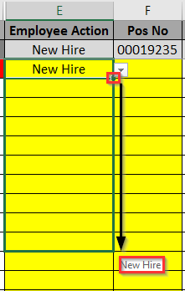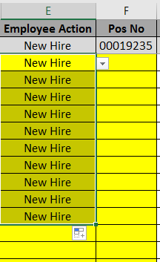
- While copy and paste functionality is operational, extreme caution should be used when copying and pasting into the spreadsheet as it bypasses validation functionality.
  - Failure to populate all required fields and/or pasting the incorrect data into fields may result in inaccurate E-PAR’s being generated and/or the return of the Mass E-PAR request to the HR Office without action.

- Should 1001 or more Mass Actions be needed, additional spreadsheets should be created. For each additional spreadsheet created, a different E-PAR will need to be submitted in the E-PAR application and its information should be added to Row #3 of each spreadsheet, as specified above.

- When saving the spreadsheet, ensure the file type of the saved document is “.xlsx”. Any other file type will result in errors when the HRSC representative attempts to upload the spreadsheet for processing.

Mass E-PAR Submission

Mass E-PAR Field
A new field has been added to the Fill a Vacant Position and Separation E-PAR Application pages. If a Mass E-PAR spreadsheet is being attached, the field below should be checked to indicate to HR Office and HRSC that this E-PAR is part of a mass request.

Requestor
Once the Mass E-PAR Spreadsheet is complete and saved to the Requestor’s computer, it must be attached to the submitted E-PAR using the E-PAR Application. This is completed by clicking the “Attach Documents” link within the E-PAR Application:
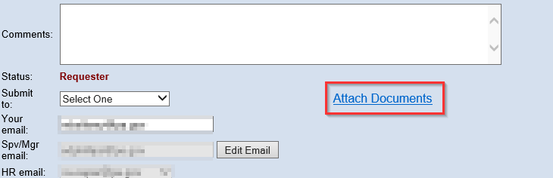

Then browsing to, attaching and submitting the spreadsheet:
The E-PAR should then be submitted as per normal procedure.

HR Office Submission
Upon receiving a Fill a Vacant Position or Separation E-PAR, the HR Office Reviewer should verify if the “This E-PAR is being submitted as part of a Mass E-PAR request” checkbox is checked.
If it is checked the HR Representative should view the attachments and review the mass spreadsheet:
In the event that the “This E-PAR is being submitted as part of a Mass E-PAR request” checkbox is not checked, but a Mass E-PAR Spreadsheet is located in the View Attachments section of the E-PAR, the HR Office Representative should check the “This E-PAR is being submitted as part of a Mass E-PAR request” checkbox and proceed to review the attachment as described below.
- The fields on the Mass E-PAR Spreadsheet completed by the requestor should be reviewed for accuracy and completeness.
  - The HR Office Reviewer may complete/correct any fields that the reviewer failed to complete correctly, or (as per agency direction/procedures), return the E-PAR request to the requestor, while providing comments indicating the needed updates.
- If updates are made to the spreadsheet by the HR Office Reviewer, they should save a copy locally and make updates to the saved copy.
- Once the updates to the spreadsheet are complete and saved, the HR Office Reviewer will upload their saved copy using the Attach Documents link on the E-PAR form.
- Once the HR Office’s spreadsheet is loaded, the spreadsheet attached by the Requestor should be deleted (using the View Attachments link on the E-PAR); leaving only one version of the spreadsheet attached to the E-PAR.
- The E-PAR should then be submitted to the HR Service Center following normal procedures.

