For agencies that wish to add a contractor into Kronos for record keeping purposes, the Contractor’s information must first be established in SAP. After the Contractor’s information has been added to SAP, the Contractor’s information will transfer to Kronos during the nightly transports.

Procedures to add a New Contractor to Kronos:
- Agency* obtains the completed Commonwealth Contractor or Consultant User Agreement from the contracting agency (*in most cases, this is the supervisor’s responsibility).
  - Agency provides a hard or electronic copy of ​Management Directive 205.34 Amended - Commonwealth of Pennsylvania Information Technology Acceptable Use Policy to the contracting agency.

  - The new Contractor completes and signs the User Agreement (Enclosure 3 of Management Directive 205.34).

  - The Agency HR Office maintains a copy of the signed User Agreement for each new contractor.

- Upon receipt of the completed User Agreement, the Agency submits an AskHR request via the Employee Resource Center to ‘Grant Contractor Credentials’ under the Contractor Actions Categories.
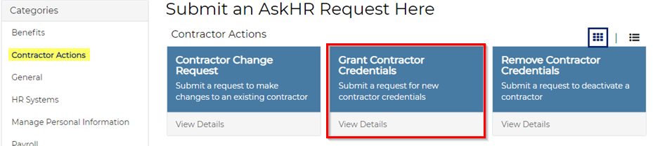
  - The information within the Ask HR Request is used to establish the new Contractor’s personnel and position number within SAP. An email is sent to the Agency Contact providing the assigned case number, and again when the new contractor’s credentials have been processed. In most cases, all information needed to complete the form can be found by accessing the ‘My Organization’ tile within Employee Self-Service (ESS).

  - Upon creation of the new Contractor’s account in SAP, a CWOPA account will automatically be generated. The new Contractor is required to successfully complete the LSO Security Awareness Training and other required LSO courses before access can be granted (note, if access to other systems is required, additional forms may be needed before access can be granted).

  - Upon creation of the new Contractor’s account in SAP, the new Contractor’s information will transfer into Kronos the day after they are established in SAP, provided the Contractor is assigned to a Kronos Participating Org Unit (or an Org below the Kronos Participating Org) via their Position. Note: A Kronos Participating Org is an Org which assigned to the YPC>TL_KRONOS_PRT_COPA role in SAP.

Note: A similar process must be followed for separating contractors by submitting an AskHR request to “Remove Contractor Credentials”.

Where to Get Help
Questions related to Management Directive 205.34 should be directed to ra-ITCentral@pa.gov.

All other questions should be directed to OA, Time Services via an HR/Pay Help Desk Request in the time category or call the HR Service Center, Time Services team at 877.242.6007, Option 2. Timekeepers and field time advisors should direct any questions related to this information to their central agency time advisor.

