Important Information Related to the Statute of Limitations

To facilitate the archiving strategy, the number of retroactive changes in SAP must be limited. The “Earl.pers. RA date” and the “Earl.pers.rec.date” on IT0003 prevent SAP from retroactively processing to dates prior to the date set. The date is reset every March to meet the W2 Statute of Limitation guideline of 3 years, 3 months, and 15 days.

- Retroactivity for Payroll processing in SAP is prevented by the Earliest Personal Retroactive Accounting Date (Earl.pers. RA date) set on Infotype 0003. See below.

- Retroactivity for Time processing in SAP is prevented by the Earliest Personal Recalculation Date (Earl.pers.rec.date) set on Infotype 0003. See below.

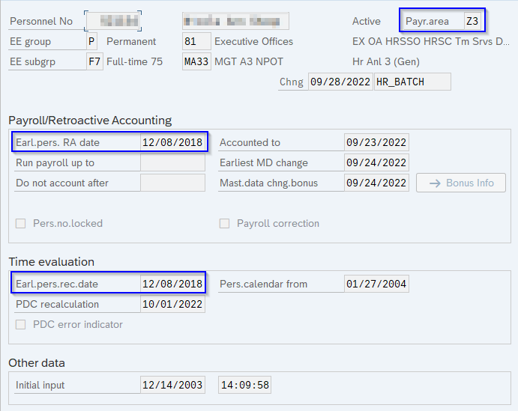

- The “Earl.pers. RA” and the “Earl.pers.rec” dates may not always agree with the date set for the Statue of Limitations.

- The “Earl.pers.rec” date is set to the payroll area the employee is in when the date is reset. Therefore, if an employee transferred to an agency with a different payroll area during the last year, it is critical that IT0003 is viewed to identify the current “Earl.pers.rec.date”.

- It is the responsibility of the time advisor to ensure all errors are reviewed and corrected to avoid the need for retroactivity prior to the “Earl.pers. RA date” and the “Earl.pers.rec.date”.

- Retroactive changes should NOT be entered in SAP; this includes CATS, prior to the “Earl.pers. RA date” and the “Earl.pers.rec.date” on IT0003. All requests for changes prior to this date(s) must be supported by an HR/Pay Help Desk Request (in the Time category) or an E-PAR.

- If a user does enter information in SAP with an effective date prior to the “Earl.pers. RA date” and the “Earl.pers.rec.date” on IT0003, the user will be alerted with a message indicating that the change is too far in the past. See below:

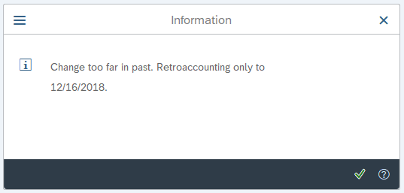

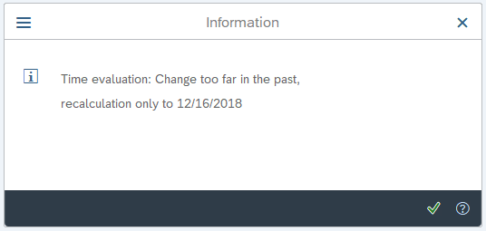

  - Users should immediately cancel out of the transaction and if appropriate, submit an HR/Pay Help Desk Request in the Time category to have the changes/updates entered in SAP by OA-HRSC.

  - Users will not be alerted with a message indicating that the change is too far in the past when entering information in CATS. CATS will still update; however, it will not correct the error.

- If a user makes changes to a record prior to the “Earl.pers. RA date” and/or the “Earl.pers.rec.date”, the employee will appear on a spool report run by IES. The report will identify the changes made, the date and time the changes were made, and who made the changes. If the OA-HRSC determines that an HR/Pay Help Desk Request was not submitted to support the record on the spool report, the agency time advisor will be contacted.

Where a Change is Applicable

OA-HRSC will only correct SAP history (with effective dates prior to the “Earl.pers. RA date” and/or the “Earl.pers.rec.date”) for changes due to:

- Mandates by Court Orders or Awards

- Contractual Entitlements

- Exceptional circumstances mutually approved by the Office of Administration, BCPO and the agency central HR office.
Errors that benefited the employee:

Errors from before the earliest recalculation date that benefitted the employee (i.e., overpayments, incorrect quota, seniority, leave service credit adjustments etc.) will not be corrected unless the amount of pay/leave is extraordinary, and the ticket will be returned to the requestor without action.

Errors that disadvantaged the employee:
In scenarios where an employee is due $10 or more due to changes prior to the “Earl.pers. RA date” and/or the “Earl.pers.rec.date”, OA-HRSC will create a ServiceNow case and work closely with BCPO.
Quota information will not update unless the absence type does not require time evaluation to run (i.e., holiday, military, compensatory) to increase the quota. Changes for many of the absence types that impact quota will require manual quota corrections which will be entered by OA-HRSC. Error/warning messages for dates prior to the “Earl.pers. RA date” and/or the “Earl.pers.rec.date” will always remain on the Time Evaluation Messages Display. Time evaluation will NOT retro to reevaluate the record and remove the error, even if the error is corrected.
Reminders:
- Only audit time records for separating employees back to the “Earl.pers. RA date” and/or the “Earl.pers.rec.date”.

- Absence and attendance errors for separated employees should not be reviewed or corrected after the “Q” record has been unlocked, unless the error was identified due to a BCPO audit or a post audit completed by Bureau of Quality Assurance, in which case, the error(s) must be resolved. Attendance corrections can be made to the timesheet (CAT2) for separated employees even if there is an unlocked “Q” separation record.

