Please distribute this alert to any users within your agency who are responsible for absence and attendance entry in SAP.

Absences Related to COVID-19

- Information regarding the use of absences related to COVID-19

The instructions below regarding how to use the Influenza box and Other Remarks would apply to any absence entries related to COVID-19.

Administrative Leave

SAP configuration has been updated to allow the use of Administrative absence (ADMN) for employees who are quarantined and unable to telework due to COVID-19. This release from work with pay should only be used after the Supervisor consults with HR to confirm that no type of work can be performed at home.

Absence Entry via ESS

When entering ADMN absences via ESS, users should select the applicable relationship using the influenza box in the Remarks section of the screen.

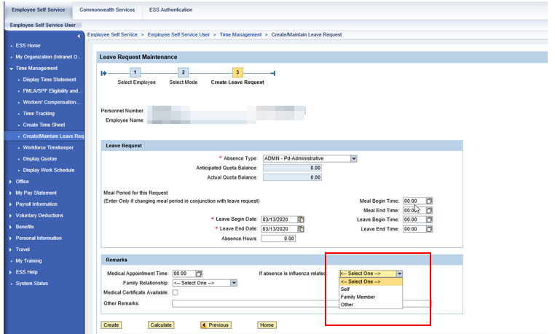

In addition, in Other Remarks: enter ‘COVID-19.’

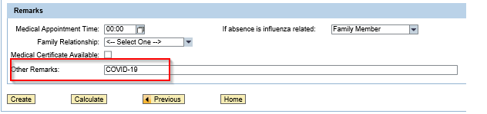

ADMN Absence Entry via SAP/PA61-IT2001:

Enter ADMN absences via SAP/PA61-IT2001:

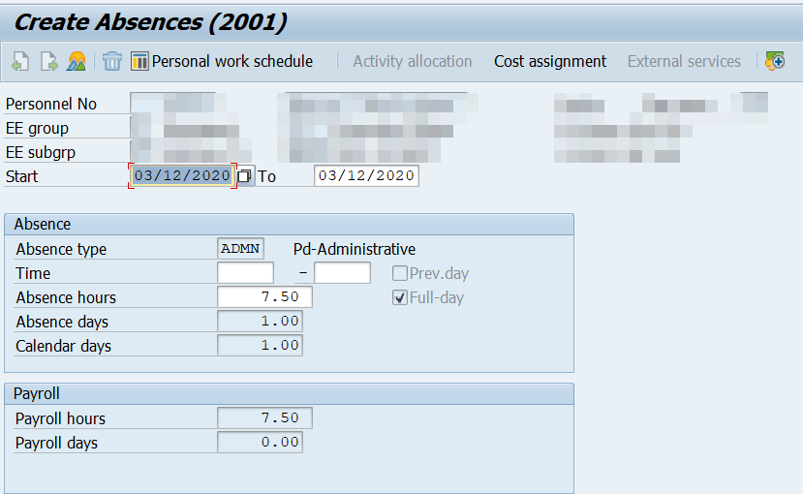

Before selecting the Save icon, users must enter ‘COVID-19’ via Edit>Maintain Text.
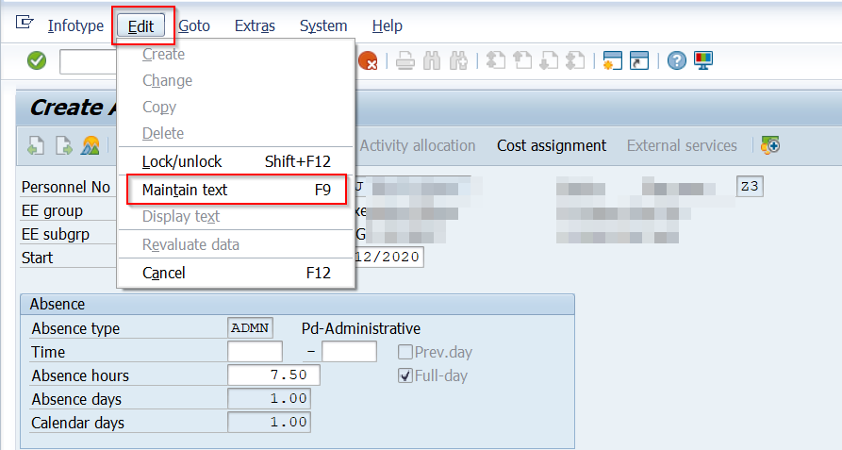

Enter COVID-19 and select the Save icon:

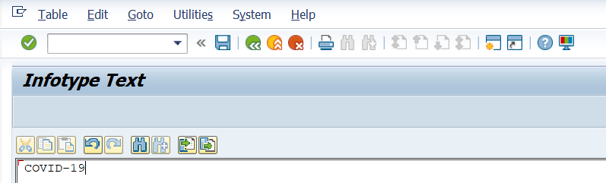

Select the Save icon in IT2001. The influenza indicator box will be presented, and users should select the appropriate reason and then select the green check mark in the Influenza Box to save the absence:

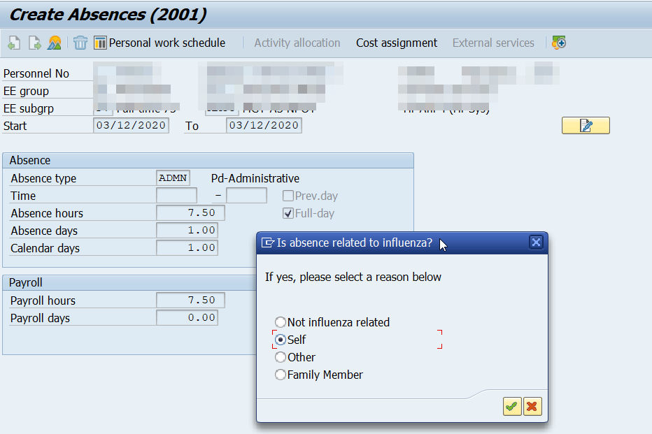

Paid Office Closing (POC) and COVID-19:

In the event that the Office of Administration announces an office closing in a region, county, facility or otherwise, and a supervisor determines that an employee cannot telework or perform any type of work that contributes to agency operations, POC Pd-Office Closing absences should be entered by the employee/supervisor via ESS/SSS. The instructions above regarding how to use the Influenza box and Other Remarks would apply as well.

If ESS/SSS is not available, paper leave slips (Form STD-330) should be completed for POC-PD-Office Closing absence(s). “COVID-19” should be entered in the Remarks section of the paper leave slip and provided to time staff for entry in SAP.

NOTE: Paid Office Closings (POC) related to COVID-19 must be entered for all affected employees, even though POC is usually only entered for wage employees or non-essential employees who work overtime or out of class within the same week as the office closing.

Kronos/ZIPY/POS Absence Remarks and Influenza Box Process:

For agencies utilizing either Kronos, ZIPY (DOT) or POS (PLCB) systems the process for adding remarks and marking the Influenza box is different from the process outlined above. Because these systems were not originally configured to capture data using the Influenza Box, time staff will need to directly update IT2001 to add Remarks and select the appropriate reason in the Influenza Box. Use the following process:

- Change the ADMN or POC absence that was transferred to IT2001 from Kronos/ZIPY/POS.
- Add the remark, “COVID-19”, using Edit>Maintain Text
- Select the Save icon on IT2001, which will present the Influenza Box. Select the appropriate reason and then select the green check mark in the Influenza Box to save the absence.

Questions?
If you have any questions, please submit an HR help desk ticket in the time category. You may also call the HR Service Center’s Time Services Division at 877.242.6007, Option 2.

