Please distribute this alert to any users within your agency who are responsible for time administration.

SAP Configuration Updated to Automatically Generate Mandated Wage Types for Walk Time (DOC Only)

- Information related to an SAP configuration update to automatically generate mandated wage types for walk time (DOC Only)

Walk time is always considered mandated and is not subject to the 10% cap on voluntary overtime that was implemented for some job classes as part of SERS Act 5 Pension Reform.

SAP configuration has been updated to automatically generate mandated wage types for walk time entries beginning June 1, 2019. Therefore, time staff no longer need to designate walk time and associated shift differential as “X-Mandated OT” on CATS. Any walk time and associated shift differential for hours worked prior to June 1, 2019 must be manually designated with “X-Mandated OT”. Note: Hours recorded on CATS for June 1, 2019 which are PDI’d to May 31, 2019 still require the “X-Mandated OT” designation.

IMPORTANT: If overtime and associated shift differential is voluntary, the walk time and its associated shift differential must be entered separately from the overtime and associated shift differential.

Example: Overtime is from 1400-1600 and employee walks from 1600-1604.

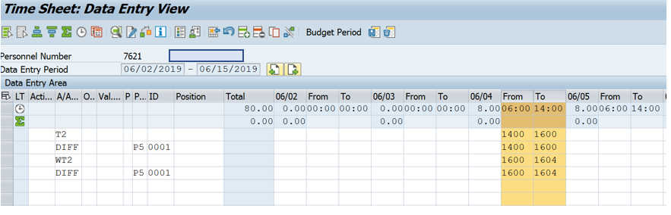

Questions?
Field time advisors should direct any questions related to this alert to their Central Agency Time Advisor. Central Agency Time Advisors may submit questions via an HR help desk ticket in the time category or call the HR Service Center, Time Services team at 877.242.6007, Option 2.

