An updated version of SAP GUI is being rolled out to agencies in phases. This guide is designed to assist timekeepers with the differences between screens in the previous versions and the newest version of SAP GUI.

**Updated Features of SAP GUI 7.60**

* Contemporary look
* Updated elements
* Enhanced Toolbars and Menu Options
* Modernized Screen controls (Buttons, Tabs, Navigations)

**Screenshots Showing the Differences Between 7.50 and 7.60**

**Main Screen**

SAP GUI 7.50

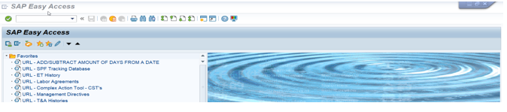

SAP GUI 7.60

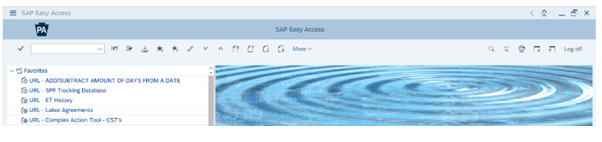

**Menu Bar**

SAP GUI 7.50

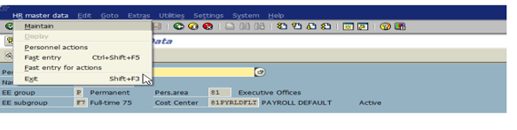

SAP GUI 7.60

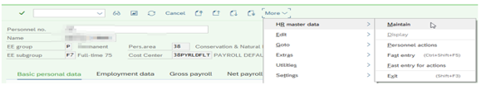

**Display Time Data (PA51)**

SAP GUI 7.50

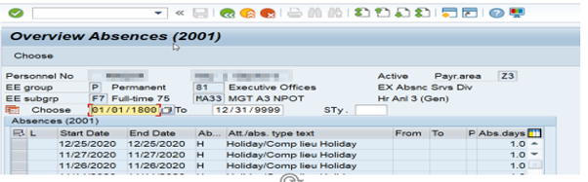

SAP GUI 7.60

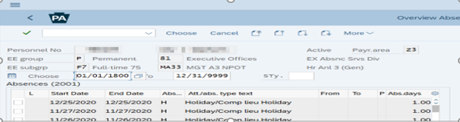

**Timesheet Initial Screen (CAT2)**

SAP GUI 7.50

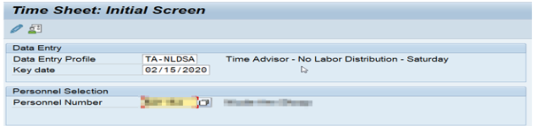

SAP GUI 7.60

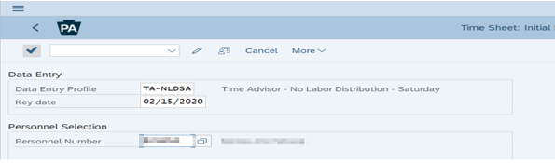

**Timesheet Initial Screen (CAT2)**

SAP GUI 7.50

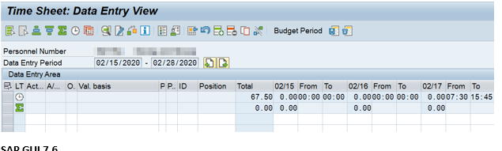

SAP GUI 7.60

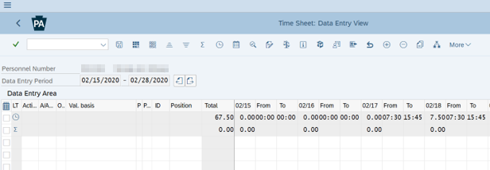

**Workflow**

SAP GUI 7.50

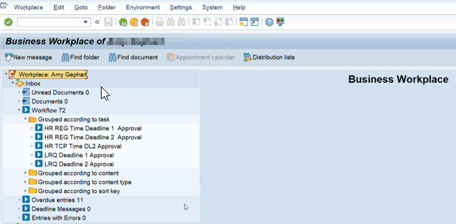

SAP GUI 7.60

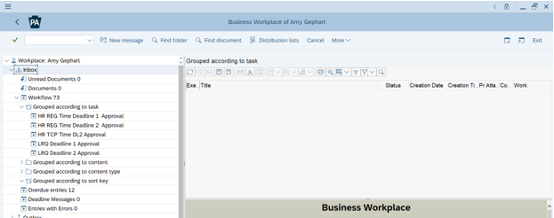

**FMLA Workbench**

SAP GUI 7.50

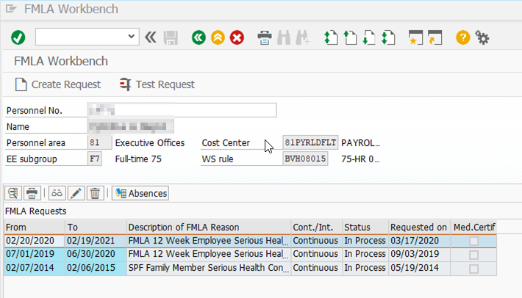

SAP GUI 7.60

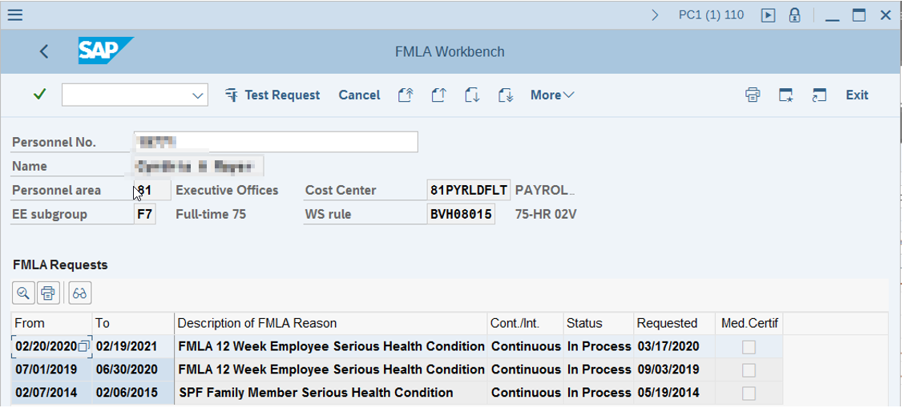

**Cross Reference**

| **SAP GUI 7.50 Icon** | **Quick Info Text** | **SAP GUI 7.60 Icon** | **Function** |
| --- | --- | --- | --- |
|  | ***Enter*** |  | Confirms the data you selected or entered on the screen. Has no save function. |
|  | ***Command field*** |  | Enables commands, such as transaction codes, to be entered. |
|  | ***Save*** |  | Saves your work. Has the same function as ***Save*** in the ***Edit*** menu. |
|  | ***Back*** |  | Returns to the previous screen without saving any data. If there are mandatory fields on the screen, these must be filled first. |
|  | ***Exit*** |  | Closes the current function without saving data. Returns to the initial or main screen. |
|  | ***Cancel*** |  | Closes the open application without saving data. Has the same function as ***Cancel*** in the ***Edit*** menu. |
|  | ***Print*** |  | Prints data on the current screen. |
|  | ***Search*** |  | Searches for requested data on the current screen. |
|  | ***Find Next*** |  | Searches further for requested data on the current screen. |
|  | ***First Page*** |  | Goes to the first page. |
|  | ***Previous Page*** |  | Scrolls to the previous page. |
|  | ***Next Page*** |  | Goes to the next page. |
|  | ***Last Page*** |  | Goes to the last page. |
|  | ***Create New Session*** |  | Creates a new SAP session. Has the same function as ***Create Session*** in the ***System*** menu. |
|  | ***Creates a shortcut*** |  | Enables you to create a shortcut on your desktop to an SAP report, transaction, or application. |
|  | ***Help*** |  |  |
|  | ***Customizing local layout*** |  | Enables you to set your own display options. |
|  | ***Overview*** |  | Displays an overview of records |
|  | ***Change Record*** |  | Allows user to change selected record |
|  | ***Display Record*** |  | Allows user to display selected record |
|  | ***Copy Record*** |  | Enables user to copy selected record |
|  | ***Delimit Record*** |  | Establishes the End Date of a record |
|  | ***Display Text*** |  | Displays attached text |
|  | ***Different Payment*** |  | Enables you to apply costing to Infotypes |
|  | ***Next Record (Bypass)*** |  | Navigates to the next record |
|  | ***Previous Record*** |  | Navigates to the prior record |