Please distribute this alert to any users within your agency who use the Insight Module in the NEOGOV Applicant Tracking System.

Summer 2023 NEOGOV Insight Enhancement Release – Physical Address in Job Postings & Insight Modernizations
On Wednesday, July 19th between 7 pm – 10 pm EST, NEOGOV will be releasing an enhancement to the Insight module in NEOGOV.
As part of the enhancements, a “Physical Address” field will be added to the Add/Edit Job Posting page. At this time, the Commonwealth will NOT be utilizing this feature. Please leave the “Physical Address” field blank for all job postings.
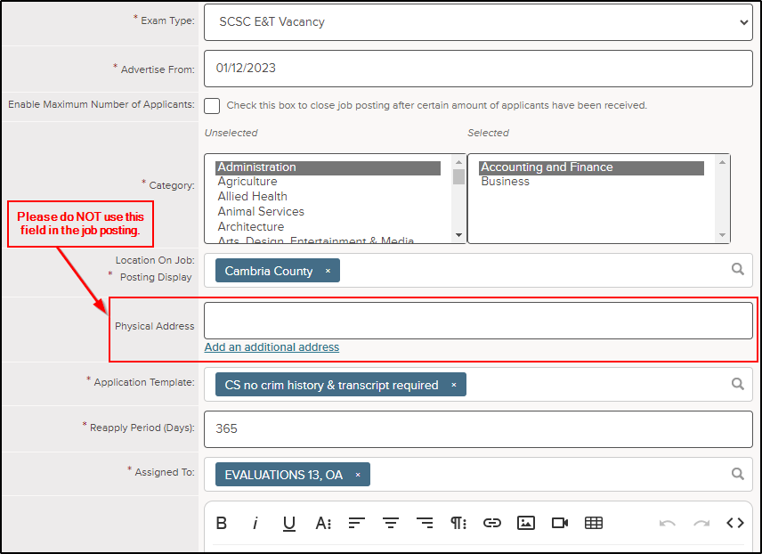

Additionally, several “Insight modernizations” will be included, which are minor usability improvements like new sorting and filtering options on grid pages. The overall Insight functionality remains largely unchanged.
Upon navigating to the Menu Pages listed below, users will see that the “Insight Modernization” release has updated the look and feel of these areas in Insight.

Modernized “Tests” Menu Pages | Navigation to Modernized “Tests” Menu Pages
Raters and Proctors | Insight Dashboard → Tests Menu → Raters and Proctors Add/Edit
Test Locations | Insight Dashboard → Tests Menu → Test Locations Add/Edit
Oral Exams | Insight Dashboard → Tests Menu → Oral Exams → View Dates and add/edit
Performance Exams | Insight Dashboard → Tests Menu → Performance Exams → View Dates and add/edit

Modernized “Applicants” Menu Pages | Navigation to Modernized “Applicants” Menu Pages
Print Apps | Insight Dashboard → Applicants Menu → Print Apps →  List/Batch/Download PDF/Print apps
Applicant Search | Insight Dashboard → Applicants Menu → Applicant Search
Improvements:
- The Applicant Search page now features additional search and filter options, including email address
- A new column selector on search results grid

Modernized “Lists” Menu Pages | Navigation to Modernized “Lists” Menu Pages
Offers | Insight Dashboard → Lists Menu → Offers
Eligible | Insight Dashboard → Lists Menu → Eligible
Referred | Insight Dashboard → Lists Menu → Referred

Modernized “Jobs” Menu Pages | Navigation to Modernized “Jobs” Menu Pages
Job Specs | Insight Dashboard → Jobs Menu → Job Specs
Exam Plans | Insight Dashboard → Jobs Menu → Exam Plans
Positions | Insight Dashboard → Jobs Menu Positions → View Import History

Modernized Insight Admin Pages | Navigation to Modernized Insight Admin Pages
Insight Users | Admin → Insight Users
OHC Users | Admin → OHC Users

Modernized Insight Admin Definition Tables | Navigation to Modernized Admin Definition Tables
Search Locations | Admin → Definition tables → Search Location and Add/Edit
Application Template - AWQ | Admin → Definition tables → Application Template → Choose AWQ
Application Templates - Active/Inactive Postings | Admin → Definition tables → Application Template → Active and Inactive Postings
Job Types | Admin → Definition tables → Job Type and Add/Edit
Panel Templates | Admin → Definition tables → Panel Templates and Add/Edit
Exam Types | Admin → Definition Tables → Exam Types and Add/Edit

Questions?
If you have any questions regarding the Summer 2023 NEOGOV Insight Enhancement Release – Physical Address in Job Postings & Insight Modernizations, please submit an HR/Pay Help Desk ticket under the ‘HR Application Support’ category.

