Please distribute this alert to any users within your agency who use the NEOGOV, Applicant Tracking System.

January 2021 NEOGOV Enhancements

- Information regarding the January 2021 release of enhancements to the NEOGOV Applicant Tracking System.

The following enhancements were released to Career Pages the evening of January 26, 2021 and are currently in effect for all applicants.

Career Pages: Email Verification for Applicants
All applicants will be required to verify their email address before applying to any job on the Governmentjobs.com platform. Applicants will be prompted to verify their email address upon logging into their account and will need to enter a six-digit verification code sent to their email address.

If the applicant ignores the prompt and does not complete the verification upon log in, they will be required to perform the verification when submitting their next job application. Applicants will be prompted again to verify their email address when they reach the “Certify” section of the application and will need to enter a six-digit verification code sent to their email address before they can submit the application.

This verification must only be done one time unless there is a change to the email address associated with the applicant account. Applicants will be required to perform a verification of the email address associated with their applicant account each time the email address is changed.

Applicant Login Verification
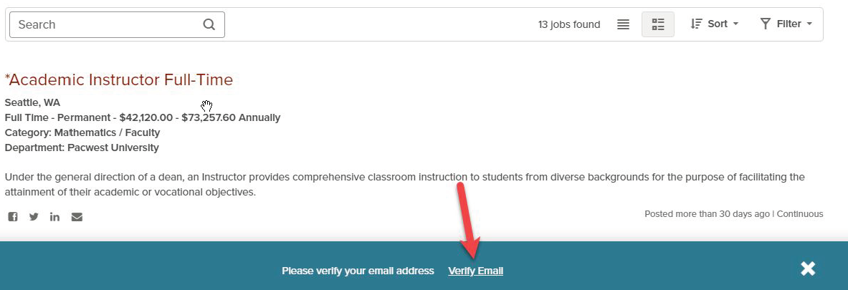

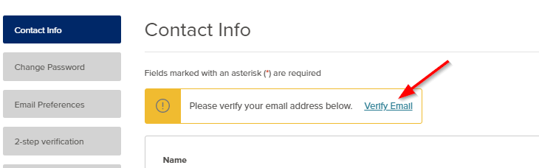

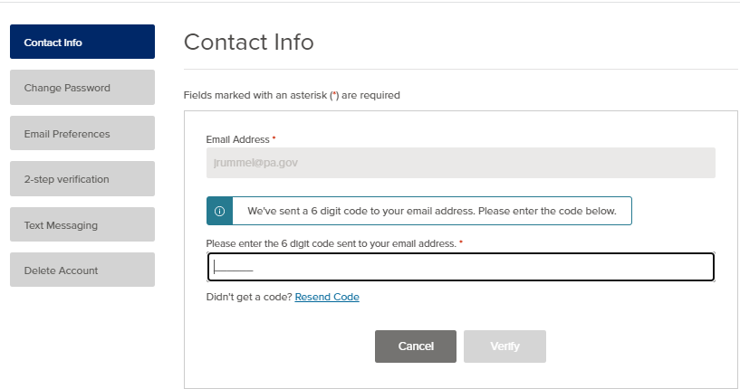

Job Application Verification
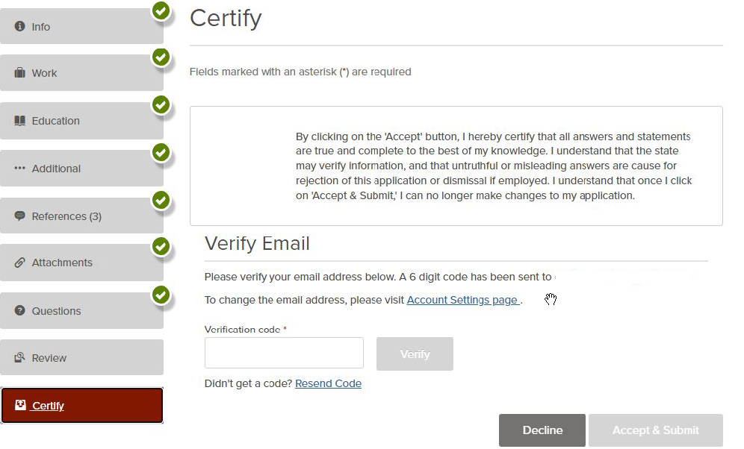
Career Pages: Two-Step Verification for Applicants
All applicants will have the option to enable a two-step verification process. The two-step verification is an optional feature that is disabled by default and can be activated within the applicant account settings.

When the two-step verification is enabled, applicants will be required to enter a six-digit code sent to their email address to verify their identify. Verification will be required when logging in from a new device, new web browser, or if logging in after 30 days of inactivity.

Applicant Account Settings
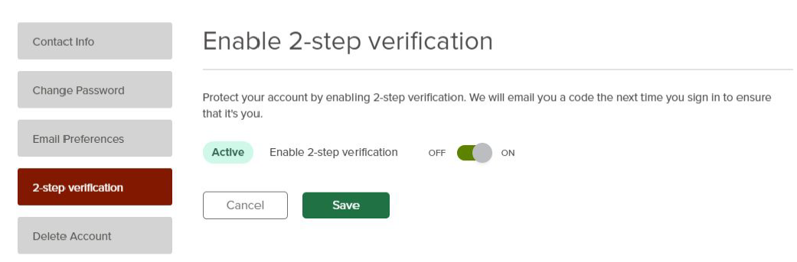

Questions?
If you have any questions regarding the January 2021 NEOGOV Enhancements, please submit an HR/Pay Help Desk ticket under the ‘HR Application Support’ category.

