Please distribute this alert to any users within your agency who use the NEOGOV, Applicant Tracking System on a regular basis.

Agency Name Change – Parole Board

- Information regarding a change to the agency name for department codes 25 and 25SL.

Effective October 26, 2020, the agency name for department codes 25 and 25SL will change in NEOGOV Insight and Online Hiring Center (OHC) from “Board of Probation and Parole” to “Parole Board”.

This change is in accordance with Executive Board Resolution OR-20-015 which authorized the renaming of the agency on September 3, 2020 from “Pennsylvania Board of Probation and Parole” to “Pennsylvania Parole Board”.

The change will automatically update the department name on all exam plans, postings and requisitions that are associated with department codes 25 and 25SL.

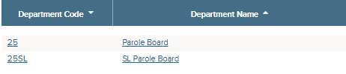

Information regarding the agency name change in SAP can be found in PA Alert 2020-20 (Agency Name Change – Parole Board).

Questions?
If you have any questions regarding the Agency Name Change – Parole Board, please submit an HR/Pay Help Desk ticket under the ‘HR Application Support’ category.

