Please distribute this alert to any users within your agency who are responsible for organization management and use the NEOGOV, Applicant Tracking System.

Position Review Indicator

- Information regarding implementation of the Position Review indicator in SAP and NEOGOV.

As announced in TA Alert 2020-07 (Requisition and Hire Form – Custom Field and Approval Group Changes), a new field, “Position Review”, was added to the requisition form and is associated with an SAP Task indicator. Effective immediately, NEOGOV users will begin to see updates to this requisition field.

The “Position Review” field will indicate if the position requires a reclassification due to changes in duties, responsibilities, functions, organizational structure, etc., that were previously identified while the position was actively filled. This field should always be reviewed as part of the standard classification review that is performed prior to positions being posted and filled.

The “Position Review” field is linked to an SAP Task assigned by the OA-Bureau of Organization Management and will automatically populate via the position control interface when a position is selected on the requisition form. The field is also viewable within the “Position Detail” screen.

The “Required” option will be automatically checked if the position has an active “Position Review” task in SAP. “Required” means the position has been marked for review upon being vacated by the incumbent and requires reclassification before being backfilled. Further action, as described below, should be taken in conjunction with the OA-Bureau of Organization Management in instances where the requisition indicates a Position Review is required.

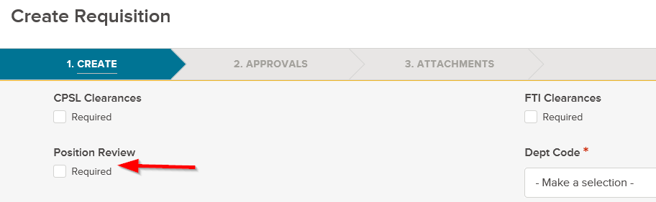

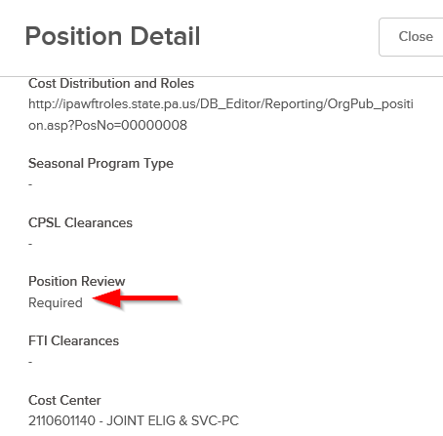

Delivery Center and agency human resource staff who perform classification reviews must always review this field prior to approving any requisition. If the “Required” option within the “Position Review” field is checked, further action is needed to reclassify the position and request removal of the SAP task indicator. The following scenarios can be used as a general guide for determining what action(s) to take when completing the approval step in NEOGOV:
- “Required” box unchecked:
  - Perform standard classification review. No additional action is required for the “Position Review” indicator.
  - Approve requisition if no other changes are required.

- “Required” box checked:
  - Position recently reclassified and “Position Review” indicator was not inactivated in SAP:
    - Perform standard classification review.
    - Submit a “Position Review” E-PAR to the OA-Bureau of Organization Management to delimit the task.
    - After the task is inactivated in SAP, uncheck the field in NEOGOV and approve requisition if no other changes are required.

  - Position was not recently reclassified and “Position Review” indicator active in SAP:
    - Perform standard classification review.
    - Deny requisition at approval step and route back to requestor.
    - Requestor should cancel requisition.
    - Delivery Center or agency human resource staff should reclassify the position or submit an E-PAR to the HR Service Center to process the change.
    - After the position is reclassified in SAP, submit a “Position Review” E-PAR to the OA-Bureau of Organization Management to delimit the task.
    - After the position is reclassified and task inactivated in SAP, submit a new requisition under appropriate job. (Note: Overnight processing is required for the updates to pass to NEOGOV)
The “Position Review” indicator will be closely monitored by the OA-Bureau of Organization Management to ensure positions are being posted and filled with the correct job classification.

Further communication will be distributed by the OA-Bureau of Organization Management to Delivery Center and agency classification staff. Please refer to the below link for instructions on how to submit Position Review E-PAR requests.

Position Review E-PAR Submission Guide

Questions?
If you have any questions regarding the Position Review Indicator, please submit an HR/Pay Help Desk ticket under the ‘HR Application Support’ category.

