Please distribute this alert to any users within your agency who use the NEOGOV, Applicant Tracking System on a regular basis.

Requisition and Hire Form - Custom Field and Approval Group Changes

- Information regarding changes to custom fields and approval group names on requisition and hire forms.

Effective Monday, June 1, 2020, users will see several changes to the custom fields and approval groups on requisition and hire forms.

New Custom Fields
The requisition form will include four new custom fields. These fields are linked to the position control interface and will automatically populate when a position is selected. The data associated with these fields will also be viewable within the position details. Information regarding each new field is outlined below.

Please note these fields will be active on Monday, 06/01/2020, however, they will not begin to auto-populate within the NEOGOV system until Tuesday, 06/02/2020, due to the interface run schedule.

Field Name | Field Type | Field Location | Required/ Optional | Field Description
Cost Center | Text | Requisition | Optional | Displays the cost center assigned to the position (e.g. 6738311000 - Div of Nursing Care).
CPSL Clearances | Checkbox | Requisition | Optional | Indicates if the position requires clearances under the Child Protective Services Law. The “Required” box will be checked if the clearance qualification(s) are assigned to the job or position in SAP.
FTI Clearances | Checkbox | Requisition | Optional | Indicates if the position requires clearances as a result of access to Federal Tax Information. The “Required” box will be checked if the clearance qualification(s) are assigned to the job or position in SAP. Special Note: This field should remain unchecked until further notice. The FTI Clearances process is pending implementation. Further information will be distributed at a later date.
Position Review | Checkbox | Requisition | Optional | Indicates if the position requires a classification review. The “Required” box will be checked if the position has an active “Position Review” indicator in SAP. Special Note: This field should remain unchecked until further notice. The Position Review process is pending implementation. Further information will be distributed at a later date.

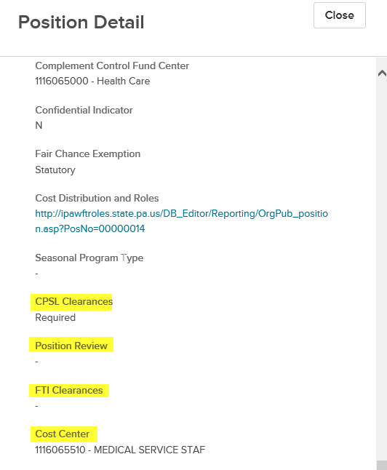

Revised Custom Fields
Several custom fields on the requisition and hire form that are linked to the position control interface will be changing to a dropdown format. The format change will control the input of values and ensure consistency when the fields are manually completed. Information regarding each revised field is outlined below.

Please note the fields will need manual completion on Monday, 06/01/2020. The values will not begin to auto-populate within the NEOGOV system until Tuesday, 06/02/2020, due to the interface run schedule.

Furthermore, the format on the current custom fields could not be changed due to system restrictions. The new dropdown fields will replace the current text fields. This means the values associated with these fields will no longer be visible on requisition and hire forms that were created prior to the switchover on Monday, 06/01/2020.

The new dropdown fields will remain blank until a user is required to update them when making a change to the requisition or hire form. The blank fields will not prevent approvers from taking action to approve or deny requisition and hire forms that are routing through the approval process.

Field Name | Field Location | Required/Optional | Field Description
Barg Unit | Hire Form | Required | Indicates the bargaining unit assigned to the position. The dropdown field includes a list of bargaining unit codes (e.g. A1, A2, F4).
Dept Code | Hire Form | Required | Indicates the department assignment for the position. The dropdown field includes a list of department codes (e.g. 10, 10SL, 11, 11SL).
Location | Hire Form | Required | Indicates the headquarter county assigned to the position. The dropdown field includes a list of county names (e.g. Allegheny, Cumberland, Dauphin)
Pay Scale | Hire Form | Required | Indicates the pay scale group assigned to the position. The dropdown field includes a list of pay scale group values (e.g. CO35, ST08, XH99)
Barg Unit | Requisition | Required | Indicates the bargaining unit assigned to the position. The dropdown field includes a list of bargaining unit codes (e.g. A1, A2, F4).
Confidential Indicator | Requisition | Required | Indicates if the position is designated as confidential. The dropdown field includes the values ‘Y’, ‘N’ and ‘C’.  ‘Y’ – Indicates position is confidential.  ‘N’ – Indicates position is not confidential.  ‘C’ – Indicates local government position is confidential. This value should only populate or be selected for local government positions/vacancies.
Dept Code | Requisition | Required | Indicates the department assignment for the position. The dropdown field includes a list of department codes (e.g. 10, 10SL, 11, 11SL).
Fair Chance Exemption | Requisition | Optional | Indicates if the position is exempt from Fair Chance Hiring policy. The dropdown field includes a list of exemption types (i.e. Statutory or Policy)
Pay Scale | Requisition | Required | Indicates the pay scale group assigned to the position. The dropdown field includes a list of pay scale group values (e.g. CO35, ST08, XH99)
Type Svc | Requisition | Required | Indicates the service type assigned to the position. The dropdown field includes the values ‘C’, ‘N’, ‘S’ and ‘U’.  ‘C’ – Civil Service  ‘N’ – Non-Civil Service  ‘S’ – Senior Management Service (SMS)  ‘U’ - Unclassified

Inactive Custom Fields
The “Pay Group” field on the requisition and hire form will be inactivated and removed from the position control interface. The field duplicates information available in the “Pay Scale” field as it currently populates with numeric value (e.g. 5) of the pay scale group.

Approval Group Name Changes
The previous “SCSC” approval groups will be renamed to “OA”. There are no changes to agency approval workflows or the approvers associated with the affected approval steps.

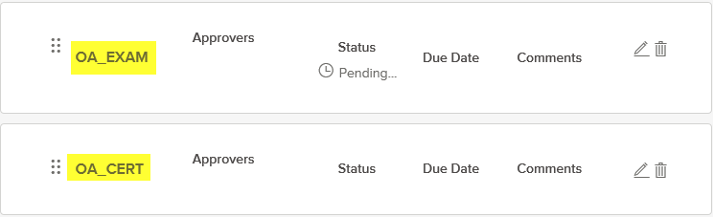

Questions?
If you have any questions regarding the Requisition and Hire Form - Custom Field and Approval Group Changes, please submit an HR/Pay Help Desk ticket under the ‘HR Application Support’ category.

