Please distribute this alert to any users within your agency who use the NEOGOV, Applicant Tracking System on a regular basis.

OHC Calendar Integration

- Information regarding the release of calendar integration for Online Hiring Center (OHC) users.

Please read the following information carefully if utilizing OHC candidate self-scheduling functionality for phone or in-person interviews.

Automated notifications have been developed for interviewers (i.e. raters) assigned to interview steps on the OHC referred list. This new feature will deliver automated email notifications to users when an interview is scheduled by an applicant and include a link for the user to upload the appointment to their personal calendar.

Please note the calendar integration is not fully operational for Commonwealth of Pennsylvania users. The “rater” permission required for this enhancement to function is not currently assigned to OHC users. Consequently, raters cannot be assigned to the interview step. Changes are being made to the OHC user integration to begin assigning this permission. Further information will be distributed when calendar integration is fully operational and available for use.

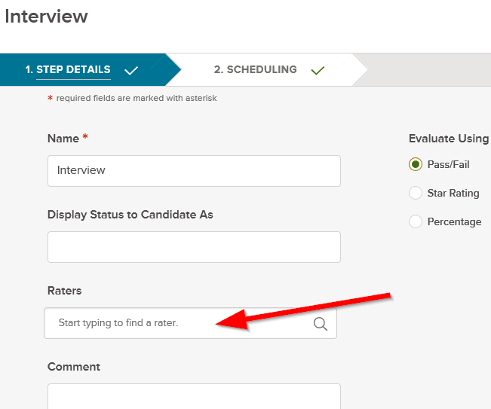
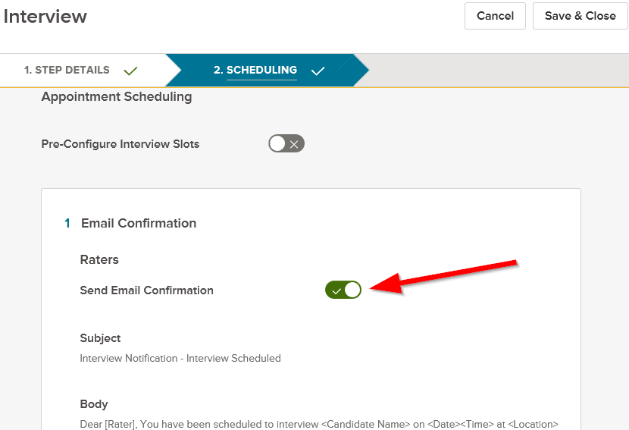

Questions?
If you have any questions regarding the OHC Calendar Integration, please submit an HR/Pay Help Desk ticket under the ‘HR Application Support’ category.

