Please distribute this alert to any users within your agency who use the NEOGOV, Applicant Tracking System on a regular basis.

Requisition Form – Changes to Civil Service Preference Type Field

- Information regarding changes to the “CS Exam List-Preference Type” field on the requisition form.

Effective Monday, March 9, 2020, users will see additional selections in the “CS Exam List – Preference Type” field. The new selections pertain to hiring for Local Government entities and should not be utilized to fill vacancies for state employment.

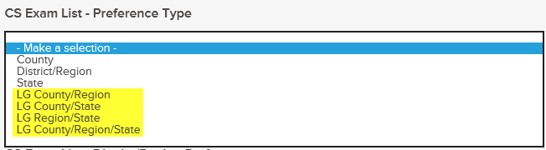

Questions?
If you have any questions regarding the Requisition Form – Changes to Civil Service Preference Type Field, please submit an HR/Pay Help Desk ticket under the ‘HR Application Support’ category.

