Please distribute this alert to any users within your agency who use the NEOGOV, Applicant Tracking System on a regular basis.

HRDC Positions Transitioned to Business Area 81

- Information regarding the transition of Human Resource Delivery Center positions to Business Area 81.

All filled and vacant Human Resource Delivery Center positions will reflect in Business Area 81 as of November 2019. Any pending requisitions for HRDC positions submitted prior to the position’s transition to Business Area 81 must be cancelled and resubmitted under the new Department and Division.

If the requisition is not recreated under the appropriate organization within Business Area 81, users will receive an incurable error when generating the hire form for selected candidates. This error will not allow users to proceed with the hire action and will prevent them from submitting the request. This system validation serves as a safeguard to block users from submitting hire action requests with positions that might no longer be valid.

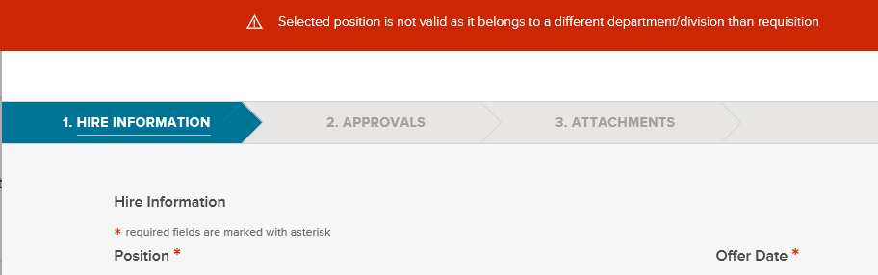

Users can utilize the copy function to expedite the recreation of requisitions. This will simplify the process and eliminate the need to complete each field on the requisition form.

After copying the requisition, users will need to update the Department/Division field and reselect the position(s) in the Position field.

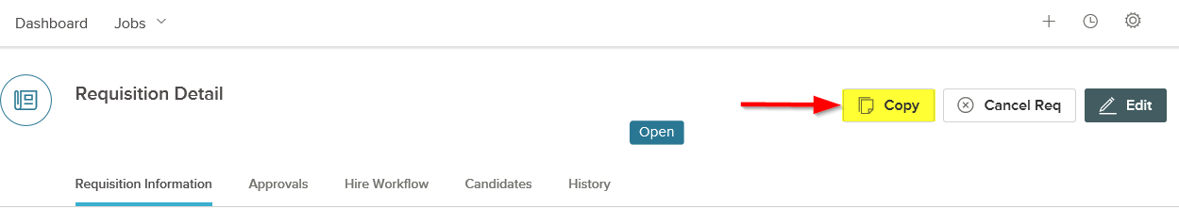

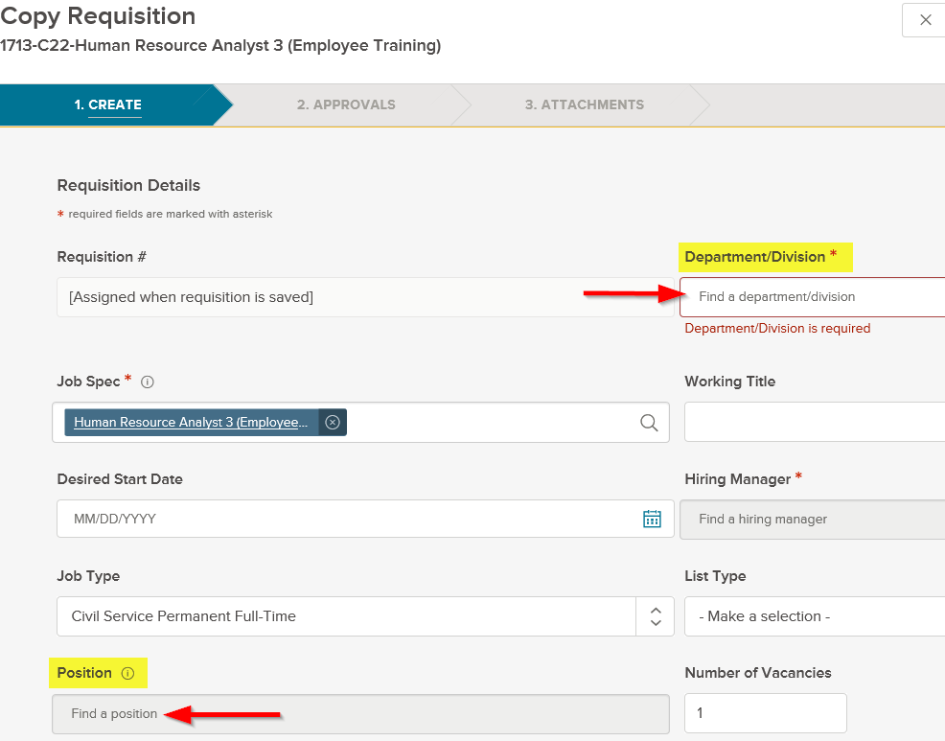

The requisitions will not need to route through any approvals assuming all necessary approvals were obtained on the initial requisition. However, the requisition number for the cancelled requisition should be added in the comments field.

If the requisition is for an external posting, users should notify the Bureau of Talent Acquisition (BTA) at the email address, ra-cs-vpapa@pa.gov, after the requisition has been submitted. BTA will link the requisition to the exam plan and refer candidates if required. Otherwise, Insight Users must assign the requisition(s) to the applicable exam plan and refer candidates as appropriate.

Please keep in mind the requisitions for Business Area 81 cannot be created until the day after the position has officially transferred in SAP. Overnight processing is required for the change to appear in NEOGOV. The final transfer dates are as follows:

Pay Area Z1: Effective 11/03/2019
Pay Area Z2/T2: Effective 11/02/2019
Pay Area Z3/T3: Effective 11/09/2019

Questions?
If you have any questions regarding the HRDC Positions Transitioned to Business Area 81, please submit an HR/Pay Help Desk ticket under the ‘Applications Support’ category.

