Please distribute this alert to any users within your agency who use the NEOGOV, Applicant Tracking System on a regular basis.

June 2019 NEOGOV Enhancements

- Information regarding the June 2019 release of enhancements to the NEOGOV, Applicant Tracking System.

Effective June 12, 2019, date validations have been added to the Offer and Hire Forms in the Online Hiring Center (OHC). The validations ensure the Offer Response Date and Date Offer Accepted do not precede the Offer Date and do not occur after the Start Date.

The following validation rules have been added:
- Offer Form: Offer Response Date field must be equal to or greater than the Offer Date.
- Hire Form: Date Offer Accepted field must be equal to or greater than the Offer Date.
- Hire Form: Date Offer Accepted field must be equal to or less than the Start Date.

An error message in red text will display below the field if the date entered violates a validation rule. Users will not be able to save and submit the form until the error has been resolved.

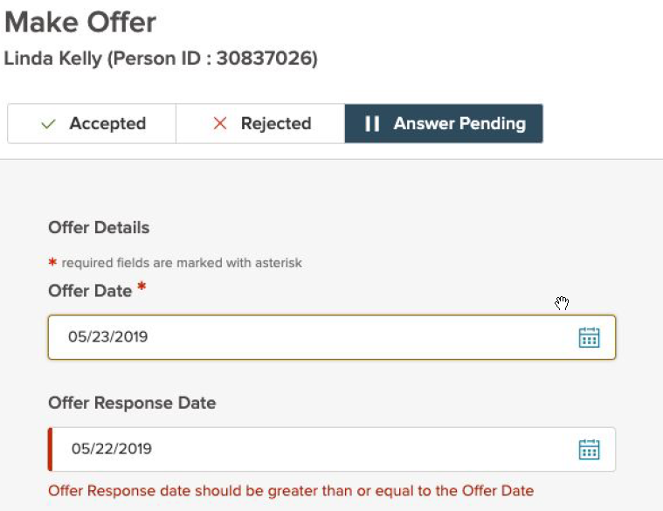

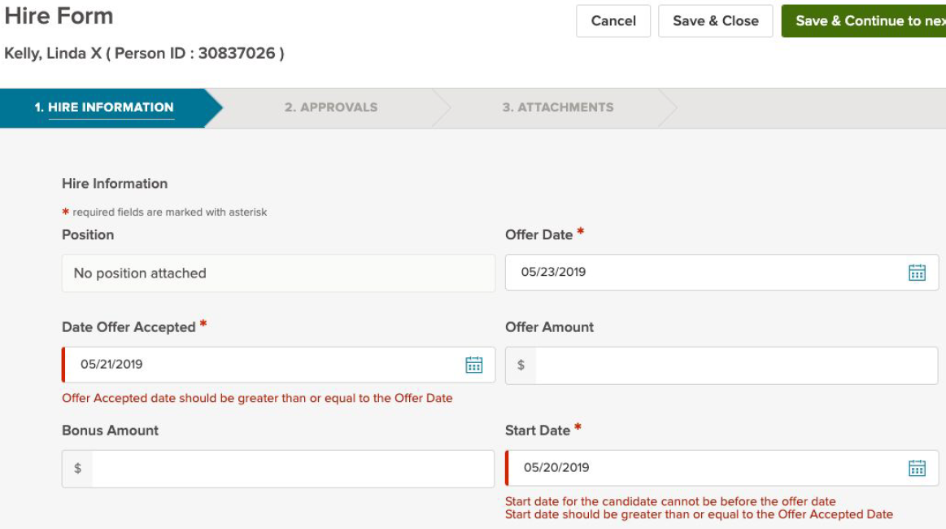

Questions?
If you have any questions regarding the June 2019 NEOGOV Enhancements, please submit an HR/Pay Help Desk ticket under the ‘Applications Support’ category.

