Instructions for NEOGOV Insight Enhancement Recruitment Closeout Automation
The recruitment closeout automation feature allows Insight users to closeout all activities either after authorizing a hire or by selecting “Closeout Recruitment” on the exam details page.
Below is an example of an exam plan with the Closeout Recruitment button. If the exam plan does not have the button, automated closeout is not available.
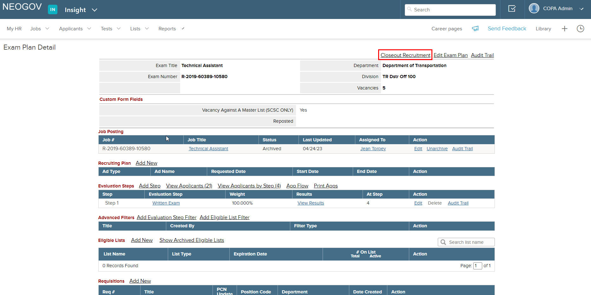
Upon selecting “Closeout Recruitment”, if all hires have not yet been authorized, the following pop-up will appear. You will not be able to perform automated close out without authorizing all hires.
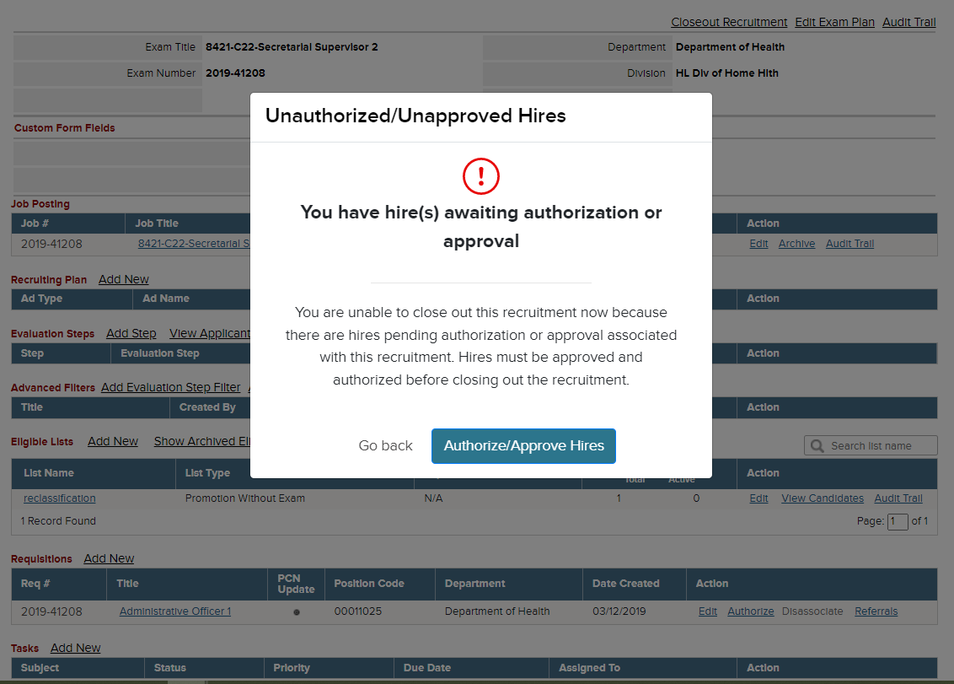
Selecting “Authorize/Approve Hires” will take you to the Awaiting Authorization section of the Insight hires page where you can search for the hires that need authorized and complete the action.
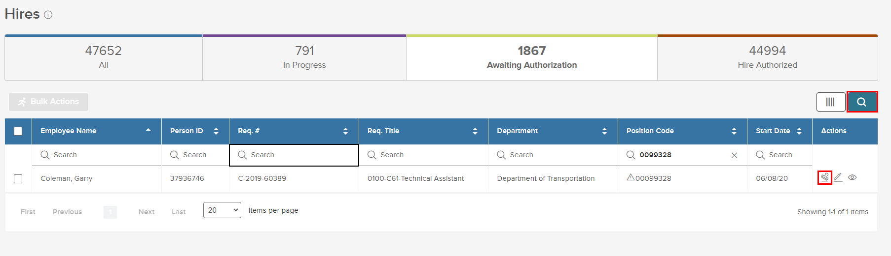
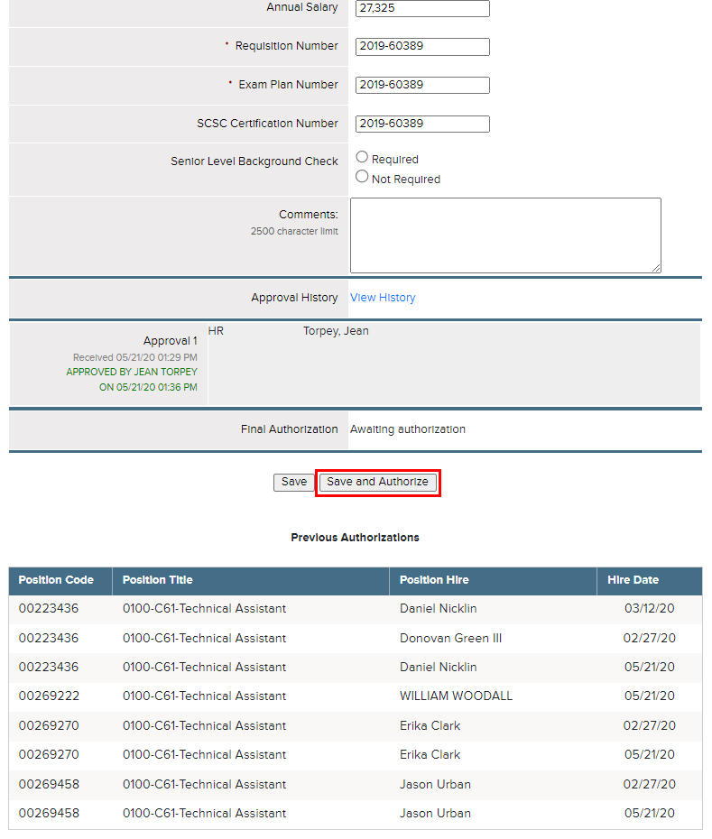
Once you authorize the hire, you will see the following pop-up. If you select “Yes, Closeout Now”, you will either see the Recruitment Closeout page or you will be instructed to authorize any additional hires before closing out.
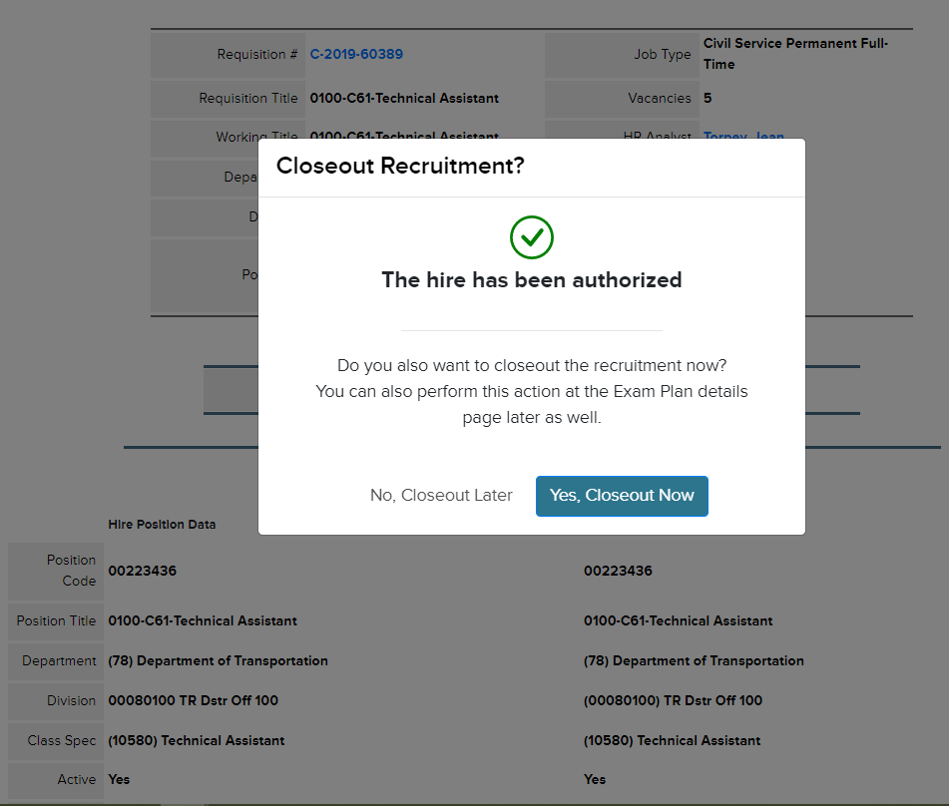
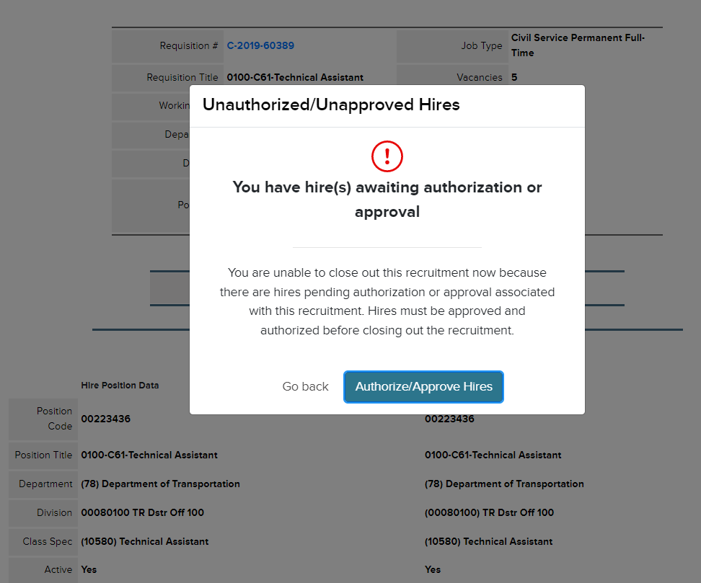
Once all hires are authorized, the recruitment closeout will show any available closeout actions. 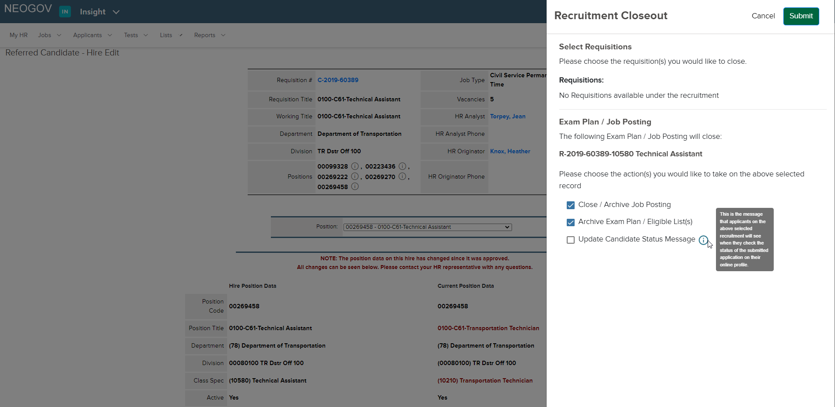

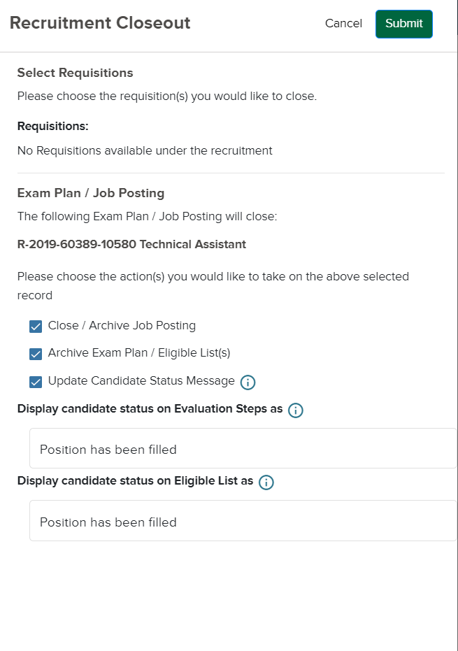
Upon submitting the closeout action, you will see the following alert:
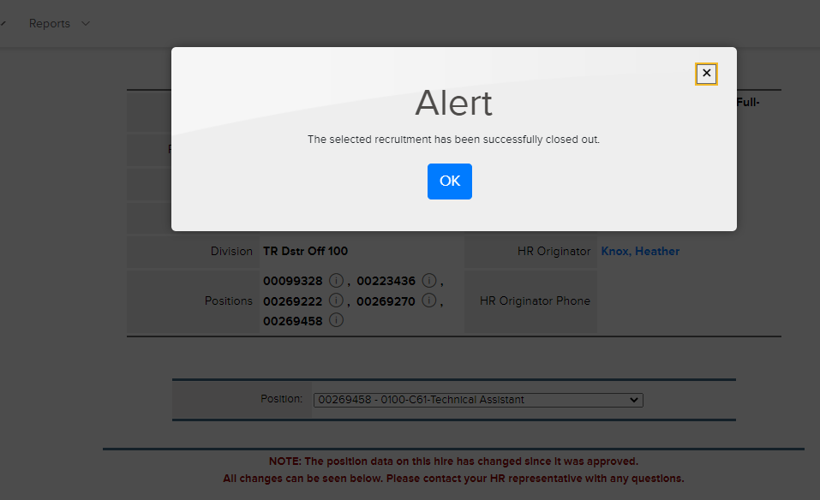
Here is another example of a recruitment closeout page with more actions available:
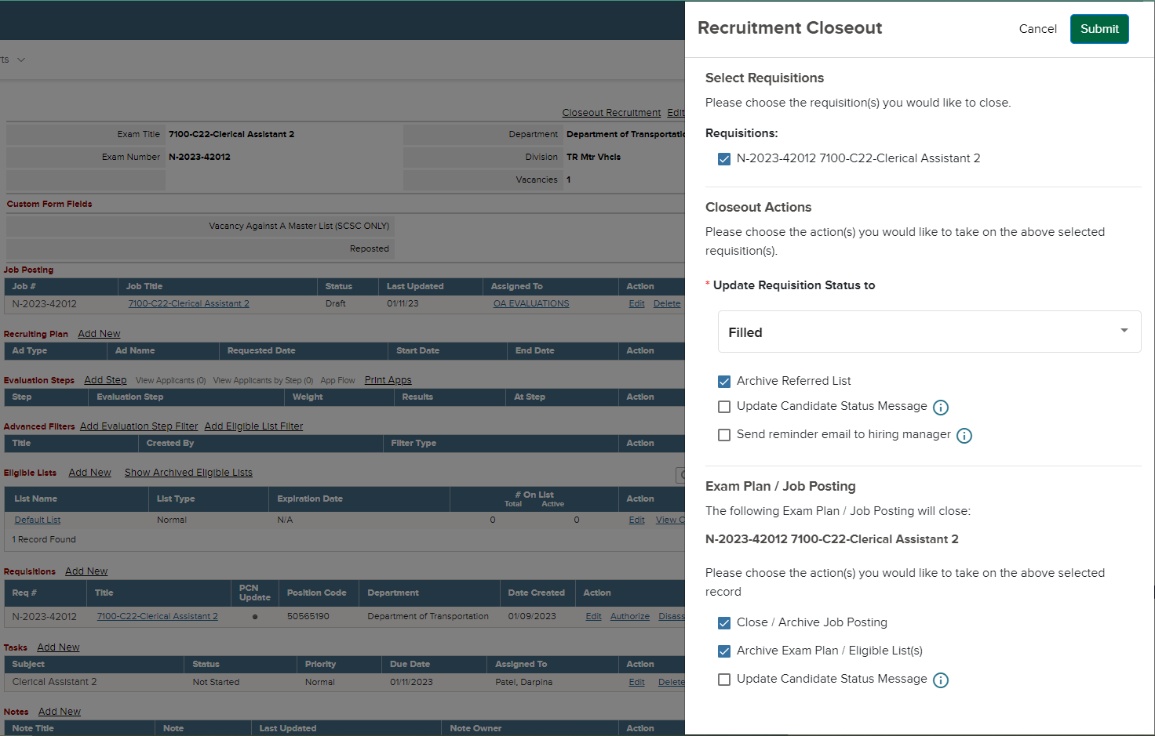
Because the hires were authorized in the above example, recruitment closeout could be performed from the exam plan details page.
If there were more requisitions available, you could choose to select one or more req to complete actions individually or all at once.
The full list of possible actions in the closeout recruitment feature include:
- Update requisition status to filled or canceled
- Close the job posting
- Archive the job posting, exam plan, eligible list(s), and referred list(s)
- Send a customized reminder to your hiring manager if there’s information you want to communicate relating to the closeout process
- Update the status message that applicants can view in their profile to let them know that the selection process has concluded
These options will vary based on what closeout actions have already been performed.
If you have any questions regarding the Recruitment Automation Closeout feature, please submit an HR/Pay Help Desk ticket under the ‘HR Application Support’ category.

