Applicant Notices Report Instructions
Issued 07.19.2019

Insight users now have access to an Applicant Notices Report to help track and analyze notices sent to applicants. This new report has several features for users, which includes the ability to filter notices based on the following parameters:
- Notices Sent From (i.e. Insight or OHC)
- Date Range
- Notice Type (i.e. Candidate or Talent Search)
- Notice Template Name
- Department
- Job Spec
- Requisition
- Exam Plan
- Step Name (only available after selecting an Exam Plan filter)

This set of instructions will walk through how to access and use the following Applicant Notices Report features:
- Accessing the report
- Filtering the report
- Creating and saving report views
- Scheduling automated exports and emails
- Exporting the data to a PDF, Excel, or CSV file

If you have any additional questions regarding the Applicant Notices Report, please submit an HR/Pay Help Desk ticket under the “Applications Support” category.

1. Accessing the Report

The Applicant Notices Report is located within the standard reports section of NEOGOV Insight, under the applicant category.

First, navigate to the standard reports section of NEOGOV Insight.
Navigation: Insight > Reports > Standard

Within the standard reports section, there are three different ways to access the report:
- Filter the “All Categories” dropdown to “Applicant”
- Type “Applicant Notices” into the search box
- Look for “Applicant Notices” within the “Report Title” column

See Figure 1 for more details.

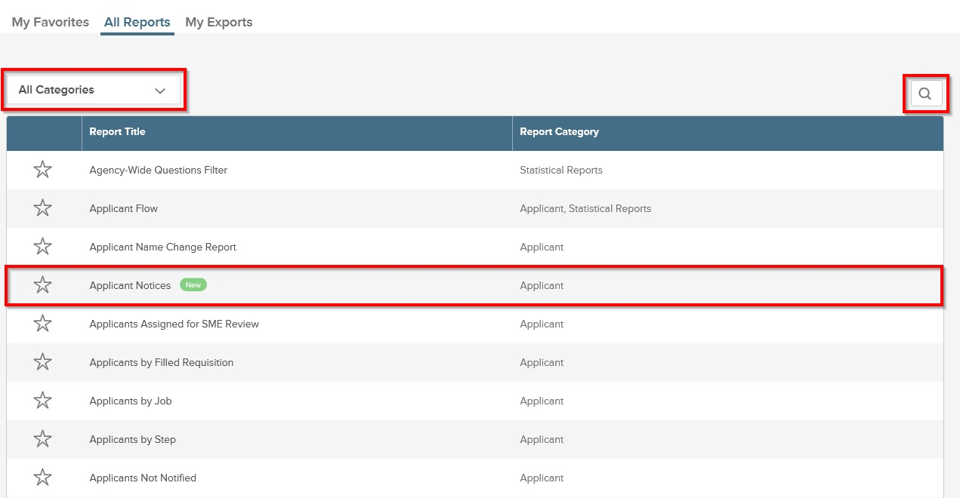
Figure 1

2. Filtering the Report

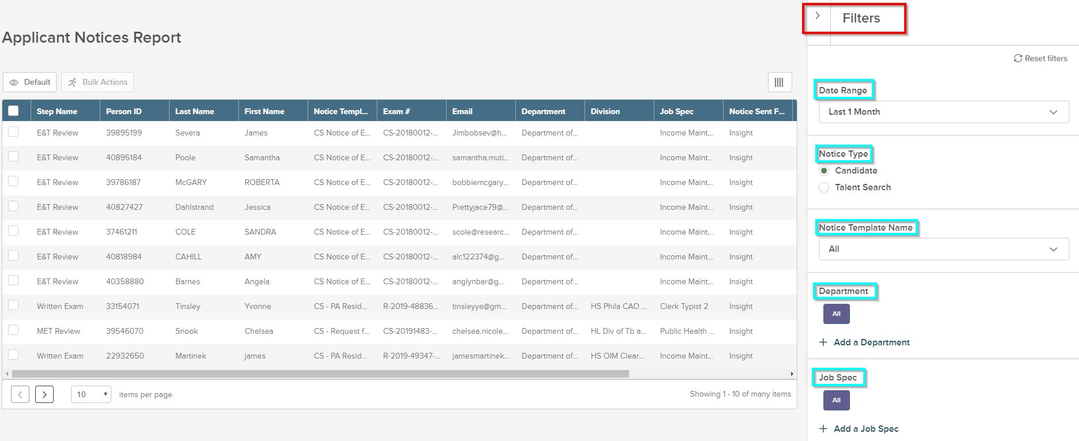
Once you have navigated to the Applicant Notices Report, you will see a Filters tab in the upper right-hand corner of the screen. You will need to click on the arrow to view all the filter options. See Figure 2.
Figure 2

As shown in Figure 2, users can filter the Applicant Notices Report by categories including date range, notice type, departments, job spec, etc. Please note that once a user changes any of the listed filters, the data displayed will be immediately updated to reflect the filter changes. There is no limit on how many filtered views a user can apply at a time.

3. Creating and Saving Report Views

In addition to the applicable filters, users will also be able to create and save new reporting views on the Applicant Notices Report. To create a new view, users will start by clicking the “Default” button, located below the report title, which is also highlighted in Figure 3.

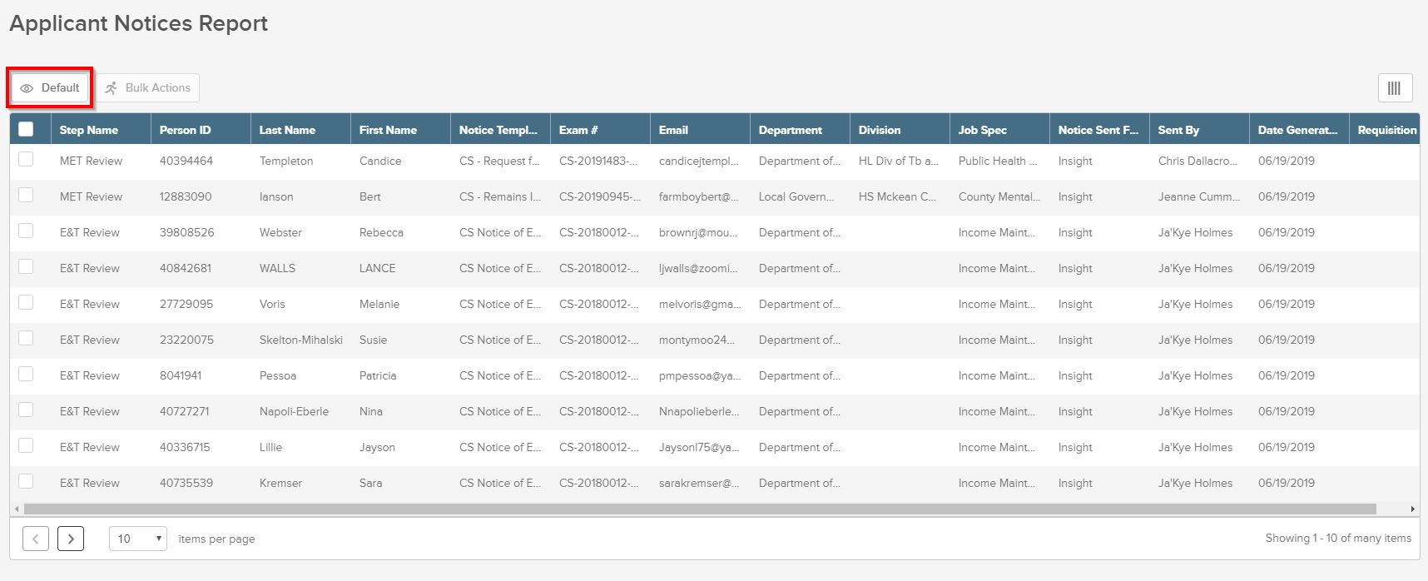
Figure 3

After selecting the “Default” button, users will have the option to either create a new view or continue using the view selected as the Default View, as shown in Figure 4.

Figure 4
If the user opts to create a new view, they will be prompted to name their view. Within the “Grid View Editor,” users have the option to make the new view their default view or make the view public. Once the user is done creating the report view, they must hit the “Save” button in the upper right-hand corner of the screen. See Figure 5.

Figure 5

4. Scheduling Automated Reports and Emails

Users can also schedule exports of their reports through the “Schedule Export” option located in the “Grid View Editor.”

To start scheduling automated reports, the user must select “On” in the “Schedule Export” option.

Once “On” is selected, users will have the ability to specify the export type (CSV, Excel, or PDF), as well as the export frequency and additional criteria for repetition. The user must then save the selected settings by clicking the “Save” button in the upper right-hand corner of the screen. Please note that filling out the export information will send the report to the NEOGOV account of the user accessing the report once the report is finished.

See Figure 6 for more details.

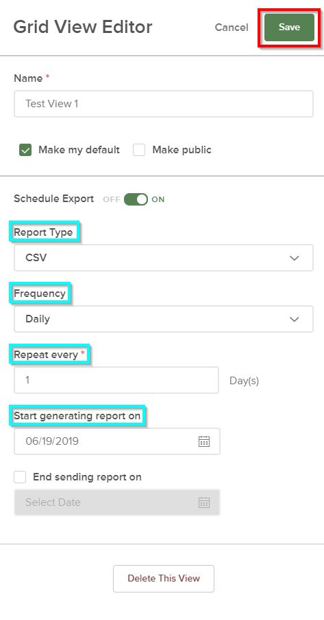

Figure 6

5. Exporting the Data

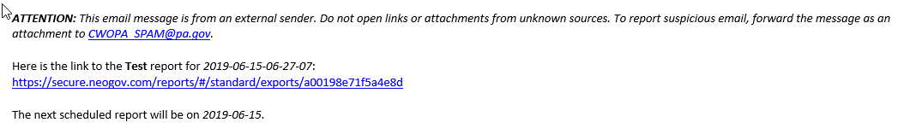
After the user schedules automated reports and emails (see 4. Scheduling Automated Reports and Emails for further instruction), the user will receive an email with the link to the scheduled report, as shown in Figure 7.
Figure 7

Additionally, the user can access this report in NEOGOV by navigating to the “My Exports” tab under the “Standard Reports” section.
Navigation: Insight > Reports > Standard > My Exports

See Figure 8 for more details.

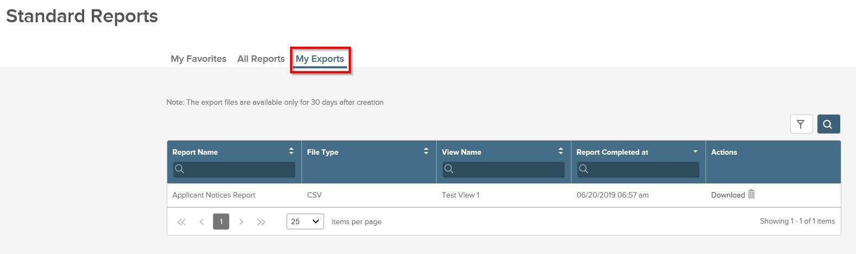
Figure 8

Once the user has navigated to the “My Exports” tab, a list of recent exports and scheduled reports will appear. These reports are displayed by name, file type, view name, and date completed. To export any report into a separate file, click on the “Download” button listed under “Actions,” see Figure 9.

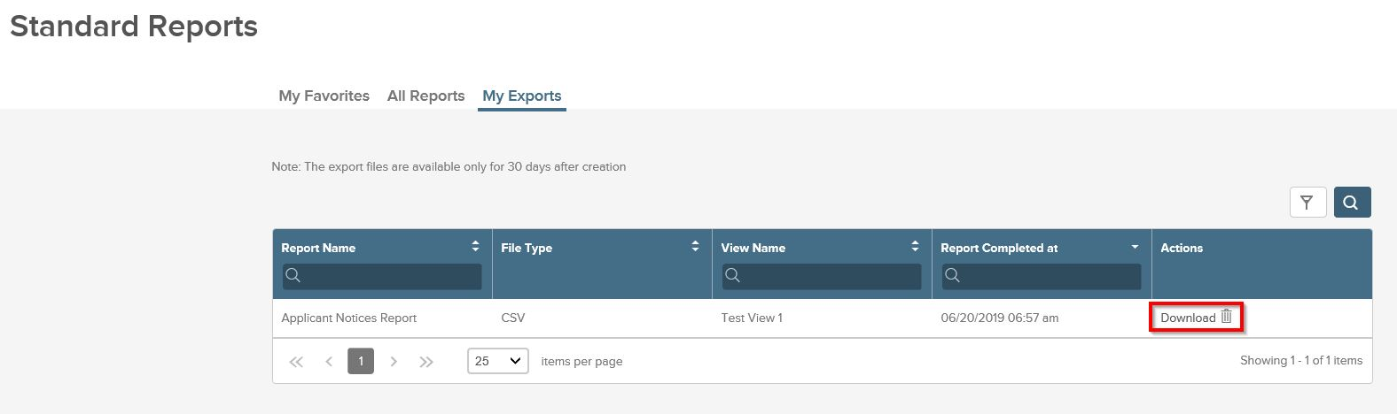
Figure 9

Please note that the export files are only available to be exported for 30 days after their original creation date.

