Please distribute this alert to any users within your agency who are responsible for FMLA Administration.

FMLA Reporting Time Type 5151 (FMLA Abs Hrs Taken) Updated to Include ECC Absence Type and to Remove WRI Absence Types

- Information regarding an update to the FMLA Reporting Time Type 5151 to include ECC Absence Type and to Remove WRI Absence Types

Time Type 5151, FMLA Absence Hours Taken (FMLA Abs Hrs Taken) tracks all approved FMLA related absences in SAP. It can be used to view the overall FMLA usage for a specific period via the PT_BAL00 report. Results generated via the report will reflect FMLA absence hours used on a daily basis but does not identify to which event the absence is linked in the FMLA Workbench (PTFMLA).

Due to COVID-19, Time Type 5151 was updated to include the Emergency Childcare (ECC) absence type. Please keep in mind that the Emergency Sick Family (ESF) absence type is only linked to the FMLA-Emergency Childcare Event if used during the first 10 days of the entitlement and will NOT be reflected in Time Type 5151 when running the PT_BAL00 report. If the ESF absence type is linked to an FMLA-Emergency Childcare Event, the ESF usage will need to be manually calculated.

When updating configuration to include the ECC absence type in Time Type 5151, it was discovered that Work Related Injury (WRI) absence types (IO, AI, etc.) were reporting as an FMLA related absence. WRI absences do not reduce an employee’s FMLA entitlement. SAP configuration has been updated to remove all WRI absence types from Time Type 5151. Since Time Type 5151 is not used to determine an employee’s remaining FMLA entitlement, usage of WRI absences did NOT have a negative impact on employees.

To review FMLA related absences in SAP using Time Type 5151, via the PT_BAL00 Report, follow the below instructions.
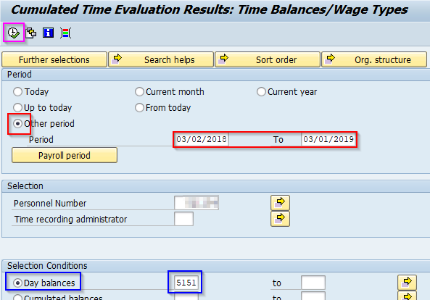
- Choose the Period to be reviewed. If using the Other period option, enter the begin and end date of period to be reviewed.

- Enter the EE’s Personnel Number. It is best to only review one EE at a time.

- Select the Day Balance radio button and enter “5151” in the time type field.

- Execute (F8) the report

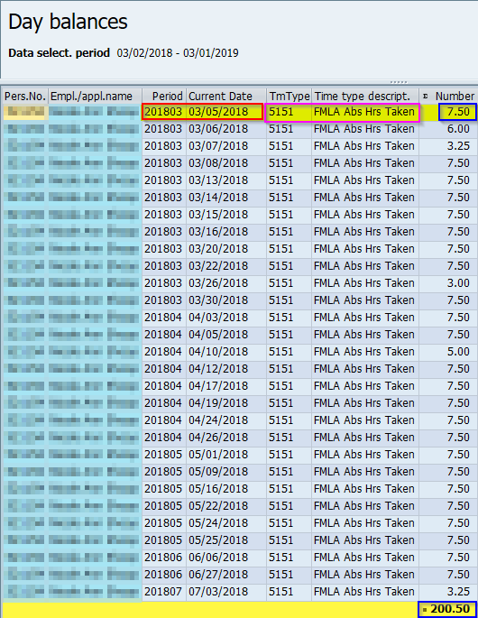
In this example, the employee used a full day of leave (7.50 hours) for an FMLA related absence on 3/5/2018 and used a total of 200.50 hours for FMLA related absences from 3/2/2018-3/1/2019.

Note: You can compare the results against PA51, IT2001 or the PTFMLA transaction for the same date(s).

Reminder: If the EE used ESF during the first 10 days of the childcare event, the ESF absence hours taken during the period in review would need to be manually added to the total hours taken.

Questions?

Policy - please email ra-oaleave@pa.gov
Systems - please submit an HR help desk ticket in the time category or call the HR Service Center, Time Services team at 877.242.6007, Option 2.

