Please distribute this alert to any users within your agency who are responsible for personnel administration and processing human resource transactions.

Infotype 0210 (Withholding Info W4/W5 US) Enhancements

- Information regarding system enhancements to Infotype 0210 (Withholding Info W4/W5 US)

Effective December 6, 2021, SAP users will see a new version of infoytpe 0210 (Withholding Info W4/W5 US) when creating or copying records via PA40 (Personnel Actions) and PA30 (Maintain HR Master Data) transactions and when displaying records via a PA20 (Display HR Master Data) transactions. These system enhancements were implemented based upon the Tax Cuts and Jobs Act (TCJA) passed into law by the Federal Government.
The main enhancements on the infoytpe 0210 are the addition of two new radio buttons:
- Allowance Withholding (Original)
- Redesigned (TCJA)

The version of infotype 0210 for records with a start date prior to 01/01/2020 will display with the ‘Allowance Withholding (Original)’ radio button indicator selected.
The version of infotype 0210 for records with start date on or after 1/1/2020 will display with the ‘Redesigned (TCJA)’ radio button indicator selected.
Validations are in place to prevent using the ‘Allowance Withholding (Original)’ radio button for effective dates after 12/31/2019.
Below is a screenshot of the “before” and “after” versions of the infotype 0210 reflecting changes to the layout for records effective 1/1/2020 or later.

IT0210 (Before) | IT0210 (After)
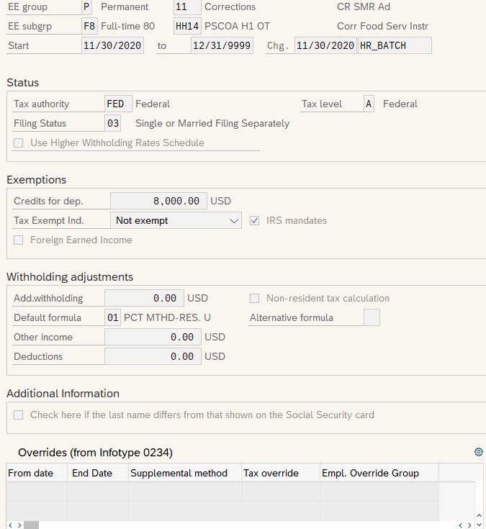 | 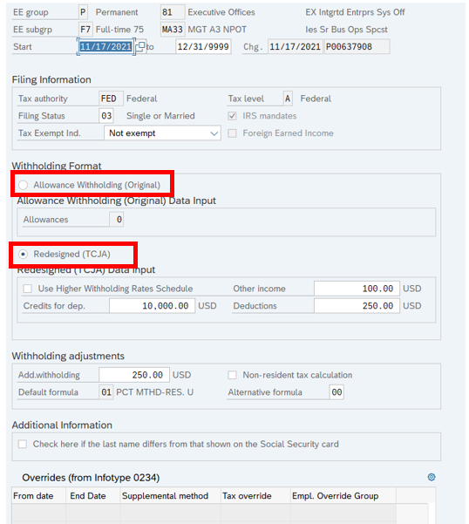

In addition to the new radio buttons, the following modifications have also been made to infotype 2010:

- “Status” section updated to “Filing Information” section
- “Tax Exempt Indicator” field moved under “Filing Information” section
- “Exemptions” section deleted
- “Withholding Format” section created with “Allowance Withholding (Original)” indicator field (selected prior to 1/1/2020)
- “Allowance Withholding (Original) Data Input” section created with the “Redesigned (TCJA)” indicator field (selected on or after 1/1/2020)
- “Redesigned (TCJA) Data Input” section created
- “Credits for dep.” field moved under “Redesigned (TCJA) Data Input” section

Below is an enlarged screenshot of the infoytpe 0210 with all the enhancement modifications outlining the two major enhancements.
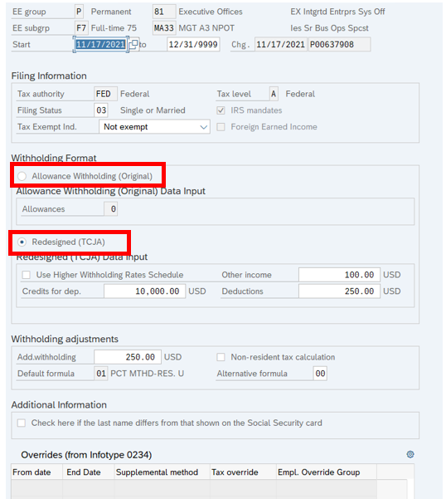

There are no impacts to the ‘Tax Withholding’ service in Employee Self-Service (ESS). Employees will continue to see existing information and options when viewing/maintaining W-4 information in ESS.
Reference PA Alert 2020-01 for any previous W-4 changes and as a guide for transacting federal income tax withholding changes on infotype 0210.

Questions?
If you have any questions regarding Infotype 0210 (Withholding Info W4/W5 US) Enhancements, please submit an HR help desk ticket using the “personnel administration” category.

