***Please distribute this alert to any users within your agency who are responsible for Form I-9, Employment Eligibility Verification.***

**Enhancements to Form I-9 Onboarding System - Employee Profile and User Action Menus**

* Information regarding enhancements to the Employee Profile and User Action Menu in the Form I-9 onboarding system.

As previously communicated in [PA Alert 2020-13 (Enhancements to Form I-9 Onboarding System)](https://www.hrm.oa.pa.gov/Alerts-and-Transactions/Documents/Pers%20Admin%20Alerts/PA_Alert_2020_13_Tracker_I9_UI_Upgrade.docx), phased enhancements will be released to the onboarding system that supports the Form I-9 process through Quarter 1 of CY 2021.

This alert is a result of recent notification that a new release of enhancements will be deployed on October 21, 2020. These upgrades will continue to modify the platform to a more modern look and feel and provide a more intuitive interface.

The October 2020 enhancement release will include updates to the following modules:

* Create New Employee Profile Module
* View Saved Employee Profile Module
* Create New I-9 Module
* User Action Menu

All modules scheduled for update are currently present in the Form I-9 system and are simply receiving look and feel updates. While the functionality of these modules remains unchanged, the redesign will require users to navigate differently while using the application. Please refer to the below sections for more information on each module update.

**Note:** Not all users will have access to all modules scheduled for update. Individual user permissions will determine which modules and actions are available.

**Create New Employee Profile Module (HRSC users only)**

The changes to the Create a New Employee Profile module are look and feel only. The fields previously available will remain in approximately the same location and layout.

Two new “Advanced Search” buttons will appear below the “Worksite” and “I-9 Manager” fields. These replace the ‘magnifying glass’ icons available in the prior version. No information has been provided regarding a difference in functionality of these buttons from the prior advanced search feature. It is expected that any changes to the look and feel of the advance search feature should be intuitive and comparable to prior functionality.

The floating “Save/Create I-9”, “Save” and “Cancel” buttons in the prior verison have been replaced by affixed “Cancel” and “Save & Continue” buttons at the bottom of the module.

*Create New Employee Profile*

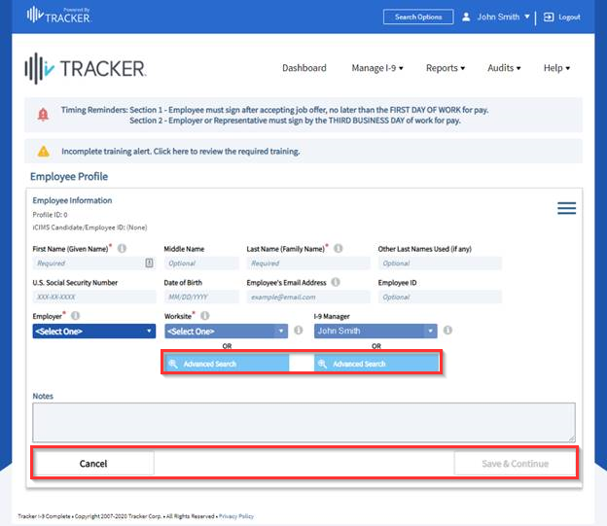

**View Saved Employee Profile Module (I-9 Verifiers and HRSC users)**

Similar to the “Create a New Employee Profile” module, the “View Saved Employee Profile” module will also undergo a look and feel change.

Two new “Advanced Search” buttons will appear below the “Worksite” and “I-9 Manager” fields. These replace the ‘magnifying glass’ icons available in the prior version. No information has been provided regarding a difference in functionality for these buttons from the prior advanced search feature. Changes to the look and feel of the advanced search feature are intuitive and comparable to prior functionality.

The “View Saved Employee Profile” module’s floating “Save/Create I-9”, “Save” and “Cancel” buttons in the prior verison have been replaced by affixed “Cancel”, “Save Profile” and “Create I-9” buttons at the bottom of the module.

*View Saved Employee Profile*

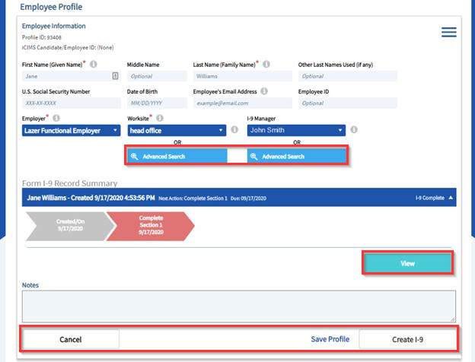

**Create New I-9 Module Update (HRSC users only)**

The Create New I-9 Module will change from a right-hand panel fly-out on the Employee Profile screen to a new page which automatically loads upon a user selecting the “Create I-9” option.

The creation of a new Employee Profile and Form I-9 remains a two-step process, whereby I-9 Managers will first enter the employee’s details into the Employee Profile, then select the appropriate workflow from among the available options to initiate the I-9 process.

**Note:** Most Form I-9 records are automatically created via the automated onboarding process. Only HR Service Center staff should be creating new Form I-9 records if the employee does not participate in the online onboarding tours.

*Create New I-9 Module*

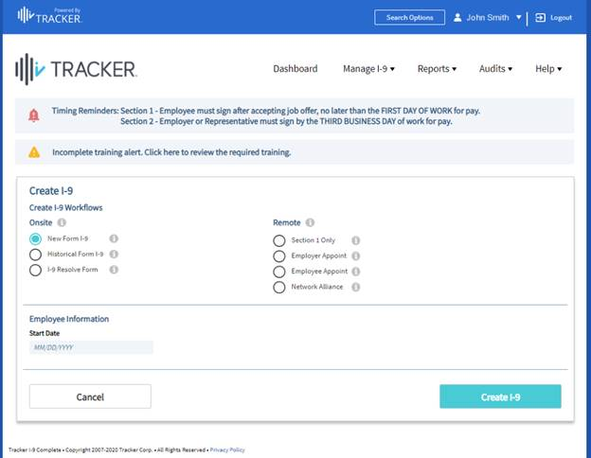

**User Action Menu (I-9 Verifiers and HRSC users)**

I-9 Verifiers who review and complete section 2 of Form I-9 verification requests (#1 below) and users with administrative privileges (#2 below) will receive a look and feel upgrade to the User Action Menu. All action buttons in the current version of the form will be consolidated into an expandable menu located at the top right-hand side of the page.

All actions previously completed by users via the individual action buttons should now be completed by expanding the menu and selecting the desired action from the list.

Users with administrative privileges should follow the same instructions above; the only difference will be that the menu will contain additional ‘administrative’ options not available to other users.

*User Action Menu*

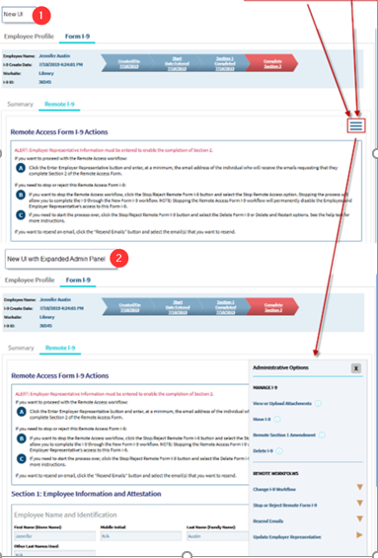

**Questions?**   
If you have any questions regarding the Enhancements to Form I-9 Onboarding System - Employee Profile and User Action Menus, please submit a [**HR help desk ticket**](http://oaiss.state.pa.us/HR-Pay_Help_Desk/) in the personnel administration category.