Please distribute this alert to any users within your agency who are responsible for Personnel Administration.

New Fields for Supplementary Employment Requests
- Information regarding new fields for Supplementary Employment Requests

Effective immediately, employees in agencies supported by the HR Service Center are required to download and complete a new version of the Supplementary Employment Request Form when submitting any new request. The new version of the form can be accessed and downloaded from the Employee Resource Center at http: www.employeeresourcecenter.oa.pa.gov.

The revised form includes a new section with additional questions to ensure greater accuracy in the completion of the form and to gather additional information on the type of employment and any potential work conflicts. The updates to the form will require the requester to respond “Yes” or “No” to the following questions related to the type of supplementary employment they are requesting:

- Company/organization employment
- Self employment
- Volunteer Activity
- Political Activity

If the response to the “Political Activity” question is “Yes”, the form will require the requester to answer two additional questions related to their commonwealth employment:

- Are you in a civil service covered position?
- Are you employed in a position that is funded, in full, by the federal government?

If the response to either question #5 or #6 is “Yes”, the form will automatically populate “Yes” to the potential conflict question (letter C) on the form. Otherwise, the requestor must respond “Yes” or “No” to whether they believe there is a conflict with their commonwealth job duties in question C.

An example of the new section of the form is below:

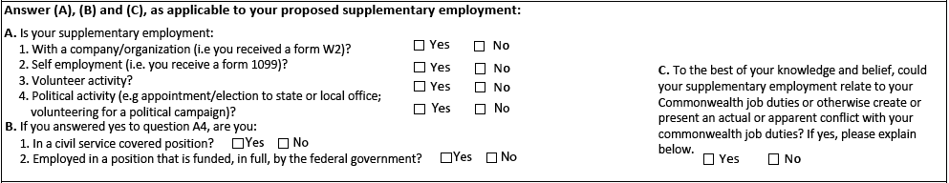

Infotype 0329 (Supplementary Employment)
All new fields on the Supplementary Employment Request Form will have a corresponding field on Infotype 0329 (Supplementary Employment) to record the employee’s “Yes” or “No” response to each question when processed by the HR Service Center:

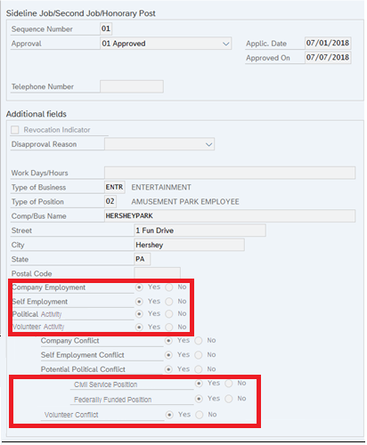

Supplementary Employment Report
The new fields will also be available on the selection screen and in the output results of the Supplementary Employment Standard Report, Transaction Code ‘Y_DC6_14000618’.

Selection screen:
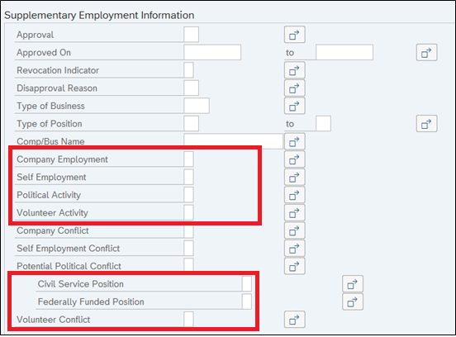

This will enable users to run reports on employee requests that meet certain conditions. For example, users can generate a report to identify employees who responded “Yes” to Self Employment. To identify employees who responded “Yes” to any of the new questions, place an “X” in the corresponding field on the selection screen. This will filter the report to include only those employees who answered “Yes” to that question.

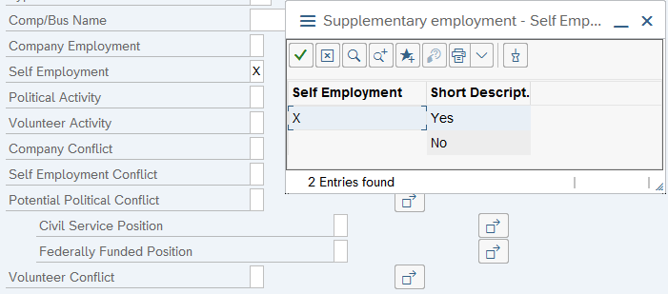
The new fields will not be in the default layout of the output results. Users must manually add the new fields to the results screen and create and save a new layout for future use. After executing the report, users can add the new fields by changing the layout as follows:

- Select the change layout button above the report results:

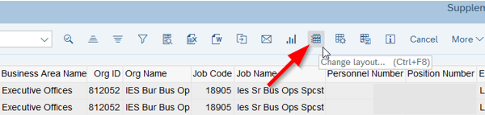

- A pop-up box (Change Layout) will appear. Choose fields in the “Column Set” list and then select the left directional arrow to add the field into the “Displayed Columns” list. Once all fields are added, select the enter button (checkmark) at the bottom of the screen:

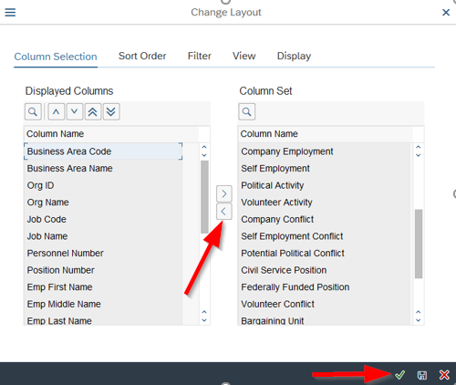

- Once returned to the report results the newly selected fields will be present. To save this layout for future use, select the save layout button above the report results:

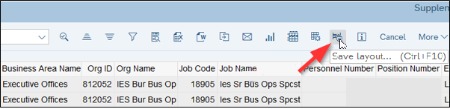

- A pop-up box (Save Layout) will appear. Provide the layout with a name in the “Save Layout” and “Name” fields which will allow the layout to be identified again in the future. Check the “User-specific” checkbox to limit access of the layout to only the user creating the report. Or leave both the “User-specific” and “Default Setting” checkboxes empty to create a global layout available for all users. Users should NOT select the “Default Setting” checkbox since it will change the default layout for all users who access this report. Click the green checkmark to save the layout:

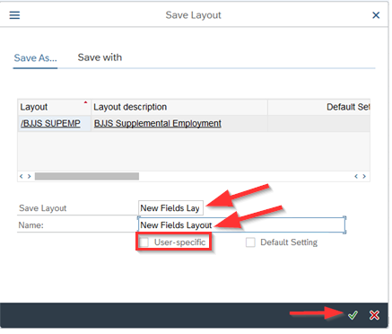

Questions?
If you have any questions regarding the New Fields for Supplementary Employment Requests, please submit a HR help desk ticket in the personnel administration category.

