Please distribute this alert to any users within your agency who are responsible for Form I-9, Employment Eligibility Verification.

Enhancements to Form I-9 Onboarding System
- Information regarding enhancements to the Form I-9 onboarding system.

On August 26, 2020 agencies supported by the HR Service Center (HRSC) will begin to see changes to the design of the onboarding system that supports the Form I-9 process.

These enhancements will modify the platform to a more modern look and feel and provide a more intuitive interface for users. The changes are not expected to impact core functionality and all current system functions will remain available.

The first set of enhancements released on August 26, 2020 include updates to the I-9 Manager Dashboard.

Additional enhancements will be released in phases through Quarter 1 of 2021 and are expected to modify the Employee Profile and Sections 1, 2 and 3 of the electronic Form I-9. Further information will be distributed for each release as it becomes available.

I-9 Manager Dashboard

All sections present in the previous version of the I-9 Manager Dashboard are available in the upgraded version. The names of two sections (Form I-9 Task Due and Remote Access I-9 Records Task Due) have been changed, but the functionality of each is identical to the prior version.

The table below displays all available sections in the I-9 Manager Dashboard and provides the prior and current section name.

Prior Section Name | Current Section Name
Form I-9 Task Due | Tasks Summary
Most Recently Visited Records Requiring Action | Most Recently Visited Records Requiring Action
Remote Access I-9 Records Task Due | Remote I-9 Center
Organization Wide Summary | Organization Wide Summary

Note: The number of available sections will vary based on the role of the user accessing the Form I-9 system.

Main Menu and Notification Panel
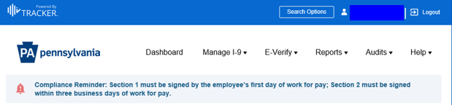

To enable easy access to each of section, icons for each module have been placed at the top of the dashboard and will automatically scroll the page down to the desired section with a single-click.

Dashboard Module Icons
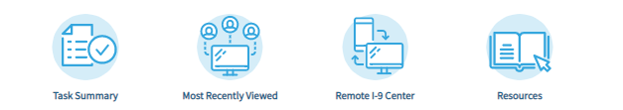

Note: The navigation options depicted above in the main menu and module icons will vary based on the role of the user accessing the Form I-9 system.

Task Summary
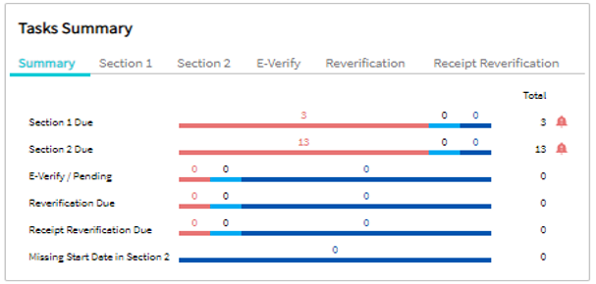

Most Recently Visited Records Requiring Action
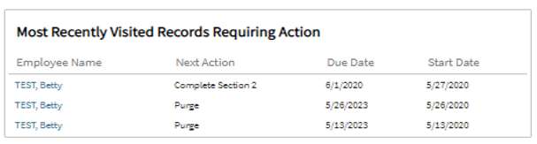

Remote I-9 Center
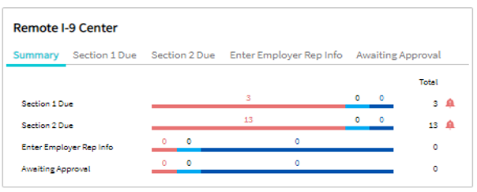

Organization Wide Summary
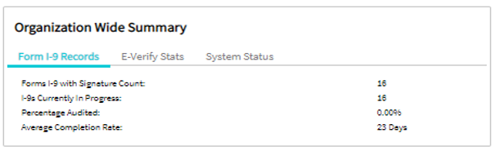

Guide for I-9 Verifiers

The Guide for I-9 Verifiers has been revised to show the updated I-9 Manager Dashboard and user navigation for Form I-9 processing. All I-9 verifiers with active workflow will receive a separate notification with a link to the revised guide. Additionally, a link to the guide will continue to be available in the email reminder sent to supervisors and I-9 verifiers for Section 2 completion.

Please keep in mind core procedures for completing Form I-9 are not changing and will remain as follows:
- Employee completes Section 1 of Form I-9 during Tour 1 of the online orientation.
- Upon Section 1 being signed, an email reminder to complete Section 2 is sent to the I-9 Verifier.
- Agency I-9 Verifier completes Section 2 of Form I-9.
- HRSC submits and monitors E-Verify cases.
- Agency contacted if a Tentative Non-Confirmation (TNC) result is received.

Questions?
If you have any questions regarding the Enhancements to Form I-9 Onboarding System, please submit a HR help desk ticket in the personnel administration category.

