Please distribute this alert to any users within your agency who are responsible for accessing the HR Error Reporting Tool.

Removal of Hyperlinks on the HR Error Reporting Tool

- Information regarding the removal of hyperlinks on the HR Error Reporting Tool

Recently, hyperlinks in the HR Error Reporting Tool which queried “ALL” records were exhausting available system resources and causing application downtime. To rectify this issue, changes have been made to the HR Error Reporting Tool.

Deactivation/Removal of Links
Hyperlinks in the HR Reporting Tool that produced results for “ALL” errors of a specific type have been deactivated or removed completely from the tool.
Deactivated:
- All links located at the center of the tools main page:

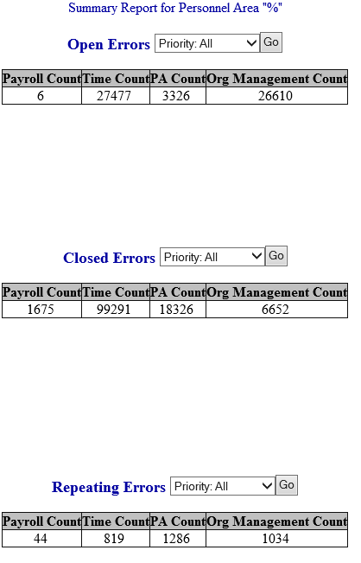

Removed:

- All hyperlinks within error types located at the top of the left-hand navigation panel (Open Errors, Closed Errors and Repeating Errors), with the exception of “Custom Search” links.
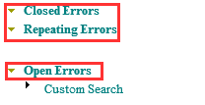

- All hyperlinks within error types located at the bottom of the left-hand navigation panel (Payroll Data Errors, Time Data Errors, PA Data Errors and Org Management Data Errors) that provided results for “ALL” records for the selected error type. All other individual links by error type remain in these sections. Moving forward, these hyperlinks should be used exclusively to obtain error reports.
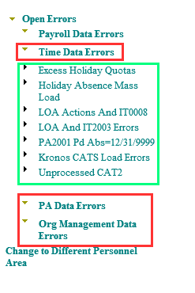

New Method for Report Creation
As noted above, the error types at the bottom of the left-hand navigation pane contain hyperlinks that will need to be used to generate reports.
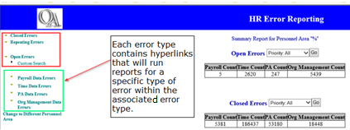

To access the hyperlinks, click directly on the error type needing review. This will expand a list containing the different errors available to report upon:
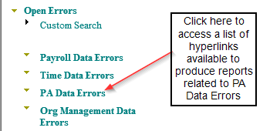

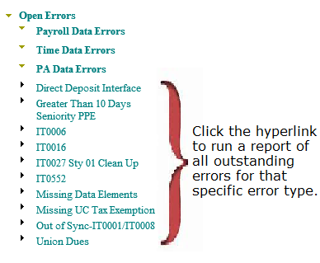
To access all needed errors, multiple reports may need to be run individually. This method of obtaining error reports queries fewer records, reducing strain on the tool’s resources. This should allow for users to obtain results more quickly, while allowing applications to remain online, without interruption.
Questions?
If you have any questions regarding Removal of Hyperlinks on the HR Error Reporting Tool, please submit an HR help desk ticket using the “personnel administration” category.

