Please distribute this alert to any users within your agency who are responsible for personnel administration and processing human resource transactions.

Revised Form W-4 and Infotype 0210 (Withholding Info W4/W5 US) Changes

- Information regarding the Internal Revenue Service’s revised Form W-4 and changes to Infotype 0210 (Withholding Info W4/W5 US).

As a result of the federal tax law change that took place in 2018, the Internal Revenue Service (IRS) has released a revised version of Form W-4 that took effect January 1, 2020. All employees hired with an effective date of January 1, 2020 or later must complete the revised form for withholding federal income tax.
Form W-4
The form is now organized into 5 sections:

- Required Sections:
- Step 1 (Employee Withholding Information)
- Step 5 (Signature)

- Optional Sections:
- Step 2 (Multiple Jobs or Spouse Works)
- Step 3 (Claim Dependents)
- Step 4 (Other Adjustments)

While Steps 2 through 4 are optional, completing them may help to ensure that federal income tax withholdings more accurately match federal income tax liabilities.
Other major form changes include:
- The “Allowances” field used to determine tax withholding amounts in prior versions of Form W-4 has been eliminated. Individuals must now provide specific amounts to account for dependents, other income and deductions.

- The previous filing statuses of “Single”, “Married” and “Married, withhold at a single higher rate” have been replaced with the following statuses:
  - Single or Married filing separately
  - Married filing jointly (or Qualifying widow(er))
  - Head of household

Infotype 0210
IT0210 has been modified to accommodate the new fields in the revised form. IT02010 will now populate with one of two versions of the infotype based on the effective date of the transaction. The prior version of the infotype will display for any changes with a start date before 01/01/2020. The new version that is displayed below will populate for any transactions with a start date of 01/01/2020 or later.

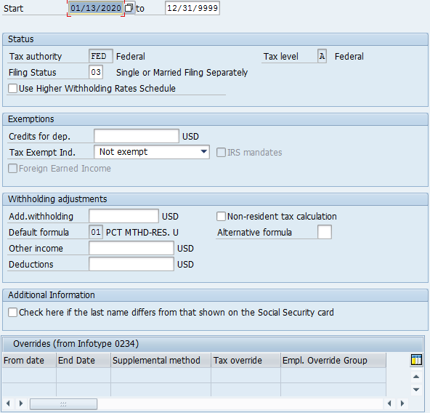

The infotype records currently in the system with a start date prior to 01/01/2020 will remain unchanged. It is recommended that all new submissions of Form W-4 for changes to withholdings be made using the revised form going forward and transacted utilizing the new version of IT0210.

As a guide for transacting federal income tax withholding changes, the following mapping may be used to assist in completion of the IT0210:

IT0210 Field | 2020 W-4 Form Field | IT0210 Notes
Filing Status | Filing Status | 03 = Single or Married filing separately  04 = Married filing jointly (or Qualifying widow(er))  06 = Head of household
Use Higher Withholding Rates Schedule | Multiple Job Indicator | If the Multiple Jobs Indicator field is checked on W-4 Form: Place a check in the "Use Higher Withholding Rates Schedule" checkbox. Otherwise, leave blank.
Credits for dep. | Step 3: Claim Dependents - Line 3 | Enter the dollar amount submitted on line 3 (Total) of the W-4 form in the "Credits for dep." field.
Tax Exempt Ind. | No corresponding field on 2020 W-4. Instructions indicate for the employee to write "Exempt" below line 4(c) if certifying eligibility for exempt status. Furthermore, the employee must file a new W-4 form by February 16, 2021. | If the employee has written the word "Exempt" below line 4(c), place a check in the Tax-Exempt Ind. Checkbox.  If the employee claims exemption and fails to select a filing status, filing status 03 (Single or Married Filing Separately) can be entered into the "Filing Status" field.
Add. Withholding | Extra Withholding | Enter the dollar amount submitted on line 4(c) of the W-4 into the Add. Withholding field.
Other Income | Other income (not from jobs) | Enter the dollar amount submitted on line 4(a) of the W-4 into the Add. Withholding field.
Deductions | Deductions | Enter the dollar amount submitted on line 4(b) of the W-4 into the Add. Withholding field.
Additional Information | N/A | There is no option for the employee to indicate that their name does not match their Social Security Card on the W-4 form. They are instructed to contact the SSA. Leave this field blank.

Current Employees
The IRS has not required that employees with a previous version of Form W-4 on file complete the revised form. However, all employees who wish to modify their W-4 withholdings, on or after 1/1/2020, should do so using the revised version. Those employees who elect not to submit a revised form will continue to have withholdings deducted in accordance with their previously submitted form.

Questions?
If you have any questions regarding Revised Form W-4 and Infotype 0210 (Withholding Info W4/W5 US) Changes, please submit an HR help desk ticket using the “personnel administration” category.

