Please distribute this alert to all users within your agency who are responsible for transactional information in SAP.

Updated Text for Age 50 Retirement Indicator Field

- Information regarding the text update for the Age 50 retirement indicator field

Effective immediately, the text for the Age 50 retirement indicator located on the infotype 9105 (job) and the infotype 9106 (position) detail job attribute tab has been updated to reflect “Age 50/55 Ret Ind”. Below are screen shots reflecting the updated text for each infotype.

Infotype 9105

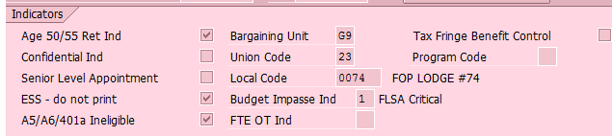

Infotype 9106

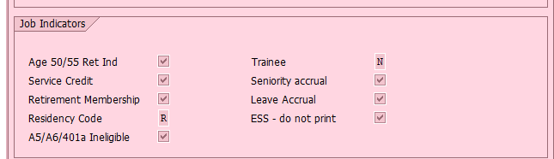

Please Note: The A5/A6/401(a) Ineligible indicator included in the screen shot has been created for Act 2017-5 Pension Reform. Information regarding the creation of this field will be provided at a later date.

Questions?
If you have any questions regarding Updated Text for Age 50 Retirement Indicator Field, please submit an HR help desk ticket in the personnel administration category.

