Please distribute this alert to any users within your agency who are responsible for Form I-9, Employment Eligibility Verification.

New version of Form I-9, Employment Eligibility Verification

- Information regarding a new version of Form I-9, Employment Eligibility Verification

The U.S. Citizenship and Immigration Services (USCIS) has published a new version of Form I-9, Employment Eligibility Verification.

The new version of the Form I-9 with a revision date of “07/17/2017 N” must be used for all new hires on and after September 18, 2017. All previous versions of Form I-9 will be invalid as of that date. The revision date is located in the bottom left corner of the form.

Agency HR offices that use a paper I-9 process have until September 17, 2017 to begin using the new Form I-9 to comply with federal employment eligibility verification requirements. The revised form can be accessed in Employee Self-Service by selecting “Home>Forms” from the home page and referring to the “Talent Management Forms” section.

Prior versions of the Form I-9 cannot be accepted after September 17, 2017.

Changes to the Form I-9 include the following:

- The List of Acceptable Documents has been revised to include a new List C Document, “Consular Report of Birth Abroad (Form FS-240)”. The new document is issued to a U.S. Citizen child born abroad. Form FS-240 is only issued by the Department of State to U.S. Citizens and Noncitizen Nationals. The document will not contain an expiration date.

- Revised Form I-9 Instructions
  - The Department of Justice, Office of Special Counsel for Immigration-Related Unfair Employment Practices has been renamed the Immigrant and Employee Rights Section (IER).

  - The language “the end of” was removed from the phrase “the first day of employment”, which appears on pages 2, 5 and 6.
The updated versions of Form I-9 can be found on the U.S. Citizenship and Immigration Services (USCIS) website and accessed using the links below.

Form I-9 Instructions
Form I-9 (Fillable Version)

Form I-9 (Non-fillable Version)
In order to provide the new version of Form I-9 through the online orientation, the onboarding system has been updated. The new form will be presented to employees and I-9 verifiers starting on Thursday, September 14, 2017.

The new acceptable document, “Consular Report of Birth Abroad (Form FS-240)”, will appear under the List C Document section of the Document Selector that is displayed to I-9 Verifiers when completing in Section 2.

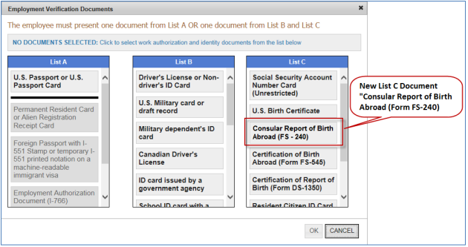

The transition for agencies supported by the HR Service Center will be seamless. Those agencies not supported by the HR Service Center should begin using the new form by the deadline specified above in order to maintain compliance with the federal employment eligibility verification requirements.

Questions?
If you have any questions regarding the New version of Form I-9, Employment Eligibility Verification, please submit an HR help desk ticket in the personnel administration category. You may also call the HR Service Center, Agency Services & Operations Division at 877.242.6007.

