Please distribute this alert to any users within your agency who are responsible for W-2s.

New Infotype to store electronic W-2 information

- Information regarding a new infotype to store electronic W-2 information.

The commonwealth has implemented an electronic option for IRS Form W-2, Wage and Tax Statement. Employees now have an “Election for Online W-2” option under the Payroll Information menu with Employee Self Service (ESS). By choosing the Online Only option, employees agree to retrieve their W-2 form via ESS and will no longer receive a printed copy. Employees who do nothing will continue to receive the printed copy in the mail.

When an employee elects the online option through ESS, infotype 3228 – Online Selection, will be created in SAP.

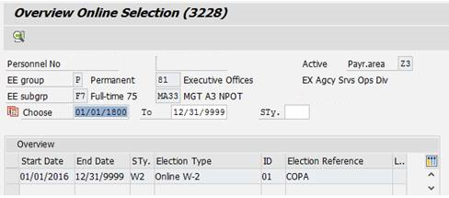

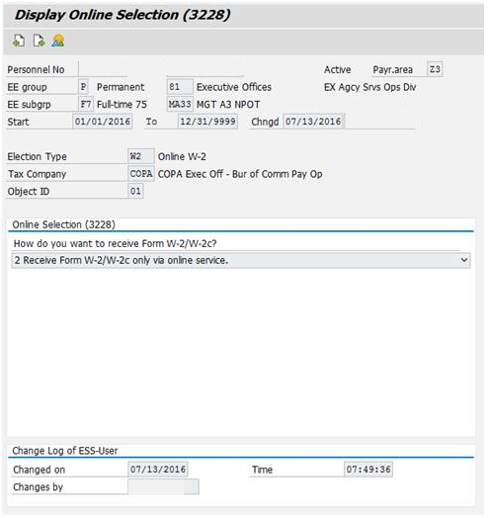

This infotype has been added to the Logged Changes in Infotype report and the following roles have been given access to infotype 3228:
YPC>HR_SERVICE_REP_COPA
YPC>HR_ADMIN_ADVSR_COPA

More information including detailed instructions on how to make the online selection in ESS, will be communicated directly to employees beginning in November as the end of the 2016 tax year approaches.

Questions?
If you have any questions regarding the new infotype to store electronic W-2 information, please submit an HR help desk ticket in the personnel administration category. You may also call the HR Service Center, Agency Services & Operations Division at 877.242.6007.

