Please distribute this alert to any users within your agency who are responsible for transactions and benefit enrollments.

Policy Change for Buy-Up Costs and Supplemental Benefit Eligibility

- Information regarding the policy change for buy-up costs and supplemental benefit eligibility

Effective January 1, 2020, the policy regarding the amount of commonwealth service an employee must obtain prior to enrolling in prescription coverage or adding a dependent onto coverage without paying a buy-up cost is changing from six months to 90 calendar days. This policy change also applies to supplemental benefit eligibility which includes eye, dental, and vision for employees. Please note: This policy does not apply to employees in Pennsylvania State Police (PSP) Cadet positions.

Effective immediately, SAP programming and dynamic action have been updated to capture the change in policy to 90 calendar days (not three months). Existing logic will continue to be utilized in which the system will review the infotype 0041 (Date Specifications) to determine an employee’s benefit eligibility date. An employee’s Z1 Date (Current Service Date) on the infotype 0041 (Date Specifications) is utilized in determining benefit eligibility unless a ZT Date (Benefit Eligibility Control Date) is present. If present, the program will utilize the ZT Date (Benefit Eligibility Control Date).

Existing employees who are currently eligible and enrolled into medical coverage and meet the updated policy criteria effective January 1, 2020, will be automatically enrolled in the prescription and/or supplemental coverage effective January 1, 2020 via an IES program to include any dependent(s) that are currently or future enrolled.

Below are some examples of how the program will update the infotype 0167 (Benefit Plans) for existing employees who meet the updated policy criteria effective January 1, 2020 based on the scenario.

- Scenario #1
  - Permanent full-time employee hired effective 8/5/2019.
  - This employee had no prior commonwealth service. The infotype 0041 (Date Specifications) Z1 Date (Current Service Date) of 8/5/2019 will be utilized by the program to determine benefit eligibility.
  - The employee enrolled in medical coverage upon hire effective 8/5/2019 in employee only coverage.
  - The employee enrolled in prescription and supplemental coverage effective 2/5/2020 which is the employee’s current six-month commonwealth service period requirement (Employee only).

Below is a screen shot of the existing infotype 0167 (Benefit Enrollment) in SAP.

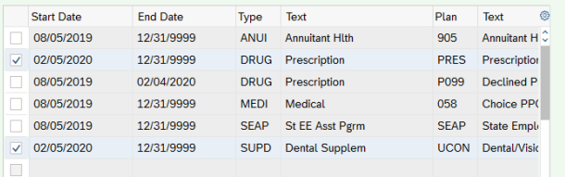

Below is a screen shot of the updated infotype 0167 (Benefit Enrollment) in SAP after execution of the conversion program. The prescription and supplemental enrollments start dates have been updated to reflect 1/1/2020.

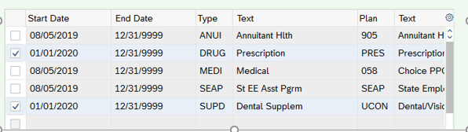

Below are screen shots of the individual records of data located on the plan data and administration tabs on the infotype 167 (Benefit Enrollment) individual record for both the prescription and supplemental records that have been converted on the infotype 0167 (Benefits Enrollment).

Prescription (PRES)
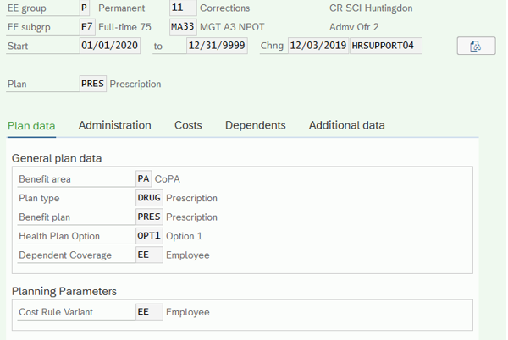

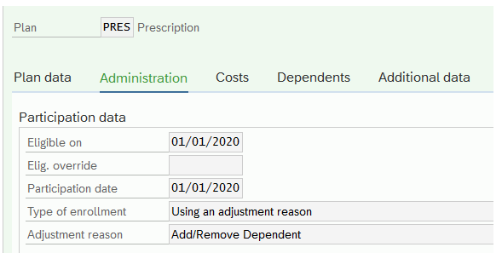

Supplemental (SUPD)
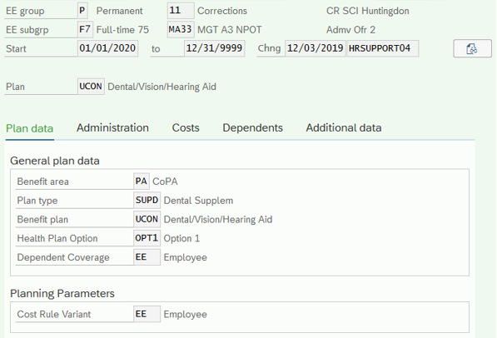

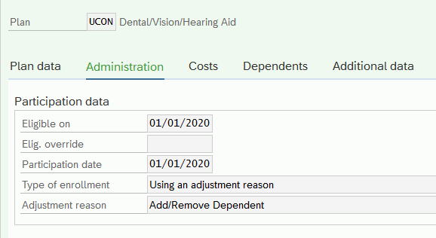

- Scenario #2
  - Perm full-time employee hired effective 8/5/2019.
  - This employee had no prior commonwealth service. The infotype 0041 (Date Specifications) Z1 Date (Current Service Date) of 8/5/2019 will be utilized by the program to determine benefit eligibility.
  - The employee enrolled in medical coverage upon hire effective 8/5/2019 in employee only coverage.
  - The employee enrolled in prescription coverage effective 9/1/2019 (Employee only) prior to reaching the current six-month commonwealth service period requirement and is currently paying a buy-up cost for enrollment in prescription coverage.
  - The employee enrolled dependents in prescription and supplemental coverage effective 2/5/2020 which is the employee’s current six-month commonwealth service period requirement (Employee and family coverage).

Below is a screen shot of the existing infotype 0167 (Benefit Enrollment).

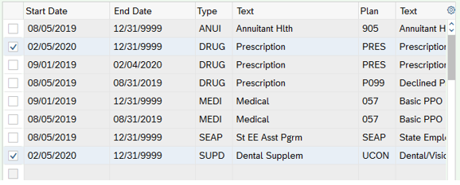

Below is a screen shot of the updated infotype 0167 (Benefit Enrollment) in SAP after execution of the conversion program. The prescription and supplemental enrollments start dates have been updated to reflect 1/1/2020.

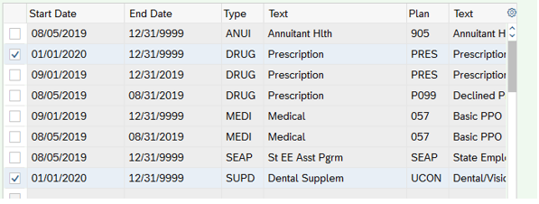

Below are screen shots of the individual records of data located on the plan data, administration, and dependent tabs on the infotype 167 (Benefit Enrollment) individual record for both the prescription and supplemental records that have been converted on the infotype 0167 (Benefits Enrollment).

Prescription (PRES)
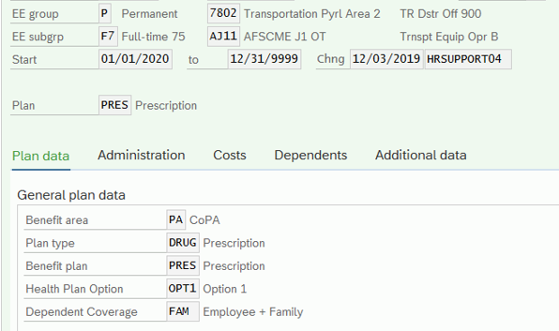

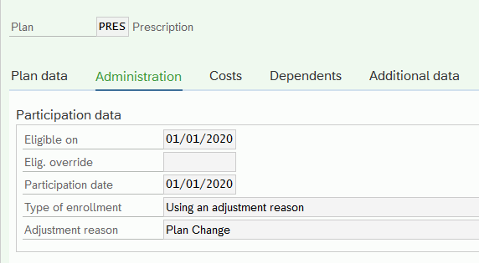

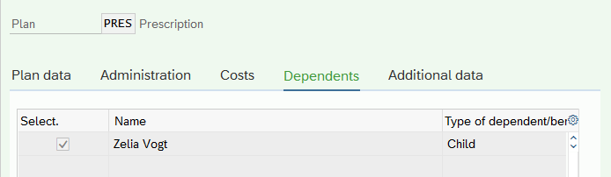

Supplemental (SUPD)
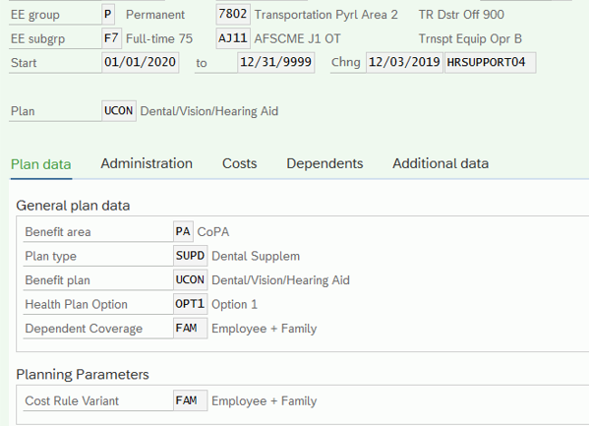

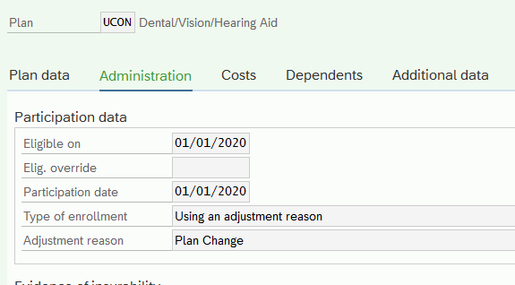

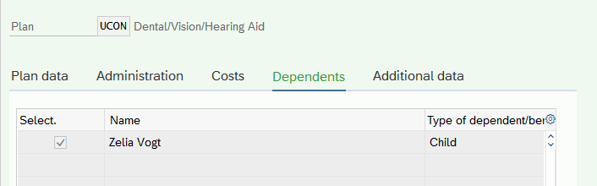

Although Energy Assistance Workers (EAWS) do not have existing medical records in SAP, these individuals will also run through the automated program. If the employee meets the updated policy criteria and has an existing future dated prescription and/or supplemental record in SAP, their prescription and supplemental records will be updated in SAP.

- Scenario #1
  - EAW hired effective 10/15/2019.
  - The employee had no prior commonwealth service. The infotype 0041 (Date Specifications) Z1 Date (Current Service Date) of 10/15/2019 will be utilized by the program to determine benefit eligibility.
  - The employee enrolled in prescription and supplemental coverage effective 4/15/2020 which is the employee’s current six-month commonwealth service period requirement (Employee only coverage).

Below is a screen shot of the existing infotype 0167 (Benefit Enrollment).

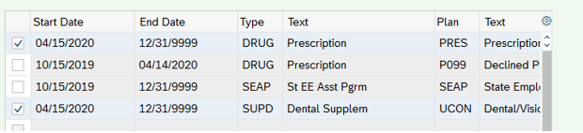

Below is a screen shot of the updated infotype 0167 (Benefit Enrollment) in SAP after execution of the conversion program. The prescription and supplemental enrollments start dates have been updated to reflect 1/13/2020 (90-day period).

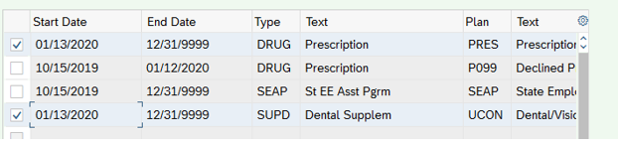

Below are screen shots of the individual records of data located on the plan data and administration tabs on the infotype 167 (Benefit Enrollment) individual record for both the prescription and supplemental records that have been converted on the infotype 0167 (Benefits Enrollment).

Prescription (PRES)
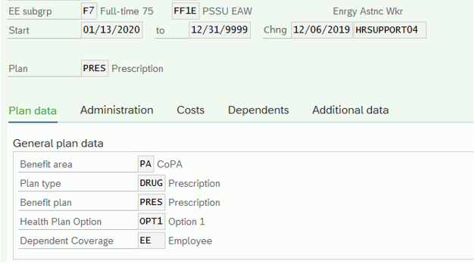

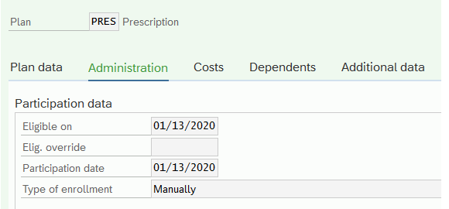

Supplemental (SUPD)
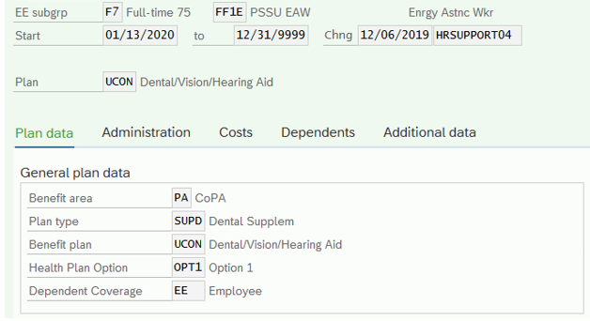

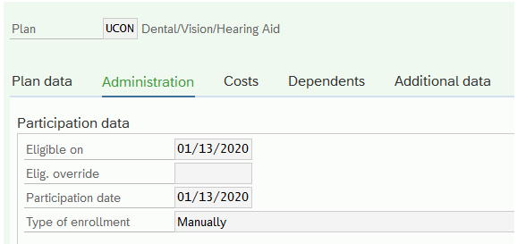

Please note: No manual updates should be executed by the HR Service Center or Independent Agency for existing employees unless the effective date of an action would change causing the benefit eligibility effective date to be changed. IES will continue to execute the program monthly to update existing employee’s records through March 2020.

As a reminder, time worked as an external or non-commonwealth employee does not count towards commonwealth service for benefit purposes.

Questions?

Any policy-related questions regarding the Policy Change for Buy-Up Costs and Supplemental Benefit Eligibility should be sent to the OA, BENHELP email account at ra-benhelp@pa.gov.
If you have any system questions regarding Policy Change for Buy-Up Costs and Supplemental Benefit Eligibility, please submit an HR help desk ticket in the benefits category.

