Please distribute this alert to any users within your agency who are responsible for benefit enrollment review.

Voluntary Benefits for Commonwealth Employees

- Information regarding voluntary benefits for commonwealth employees.

Currently, permanent full time and part-time employees working at least 50% full time hours are eligible for enrollment in voluntary benefits offered by the commonwealth. The current voluntary benefits that are offered to commonwealth employees include the following:

Voluntary Benefit | Vendor
Term Life Insurance | Prudential
Long-Term Disability Insurance | Prudential
Auto and Home Insurance | MetLife

Effective September 1, 2018, the commonwealth’s vendor for home and auto insurance will be changing from MetLife to CoreStream. In addition, the following additional voluntary benefits will be offered to eligible commonwealth employees which include:

Voluntary Benefit | Vendor
Short-Term Disability Insurance | Prudential
Critical Illness Insurance | MetLife

Below are screenshots identifying the appearance of the new voluntary benefits on the employee’s remuneration statement as well as the Infotype 0014 – Recurring Payments/Deductions.

Short-Term Disability Insurance

- Remuneration Statement

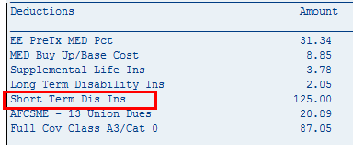
- Infotype 0014 – Recurring Payments/Deductions

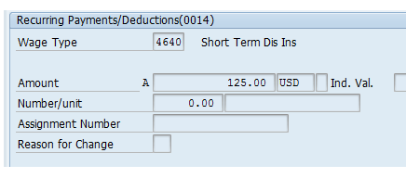

Critical Illness Insurance

- Remuneration Statement

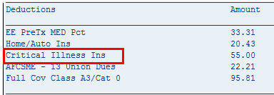

- Infotype 0014 – Recurring Payments/Deductions

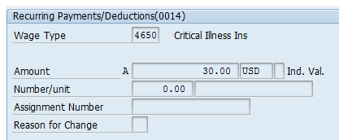

Additionally, the text of the auto/home insurance is being updated to Auto-Additional Vols Bens due to CoreStream’s ofference of additional voluntary benefits in addition to auto/home insurance. Below are screen shots of how the updated text will appear on the remuneration statement as well as the Infotype 0014 – Recurring Payments/Deductions.

- Remuneration Statement

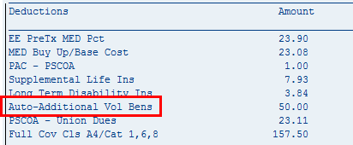

- Infotype 0014 – Recurring Payments/Deductions

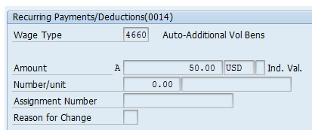

Any policy questions regarding commonwealth voluntary benefits should be directed to ra-benhelp@pa.gov.

Questions?
If you have any questions regarding Voluntary Benefits for Commonwealth Employees, please submit an HR help desk ticket in the benefits category.

