**Guideline for**

**Reviewing Absences**



In accordance with the [*Absence Program Manual, M530.7*](http://www.portal.state.pa.us/portal/server.pt?open=512&objID=716&PageID=224629&mode=2&contentid=http://pubcontent.state.pa.us/publishedcontent/publish/cop_general_government_operations/oa/oa_portal/omd/p_and_p/manuals/items/m530_7.html), agency time advisors are responsible for administering the commonwealth’s absence programs in a manner consistent with established policies. This includes, but is not limited to, verifying eligibility for absences, monitoring error reports, and reviewing approved absences. To do this, time advisors must be aware of and use all absence policy resources including: the [*Personnel Rules, MD505.7*](http://www.portal.state.pa.us/portal/server.pt?open=512&objID=711&PageID=228891&mode=2&contentid=http://pubcontent.state.pa.us/publishedcontent/publish/cop_general_government_operations/oa/oa_portal/omd/p_and_p/management_directives/employee_development_and_utilization/items/505_7.html); *[Absence Program Manual, M530.7](http://www.portal.state.pa.us/portal/server.pt?open=512&objID=716&PageID=224629&mode=2&contentid=http://pubcontent.state.pa.us/publishedcontent/publish/cop_general_government_operations/oa/oa_portal/omd/p_and_p/manuals/items/m530_7.html)*; Executive Board Resolutions; memorandums from the Deputy Secretary for Human Resources and Management; [labor agreements](http://www.hrm.oa.pa.gov/employee-relations/cba-md/Pages/default.aspx); [memoranda of understanding](http://www.hrm.oa.pa.gov/employee-relations/cba-md/Pages/default.aspx); and other absence related [management directives](http://www.portal.state.pa.us/portal/server.pt/community/management_directives/711).

This guideline provides information to be used when auditing absences. **Note**: Although the term “audit” is sometimes used, the types of reviews performed by time advisors do not meet the full definition of an audit. Therefore, the term “review” is used throughout this guideline.

**When to Perform a Review**

The frequency of when to perform a review may be driven by many factors, but some level of review must occur on an annual basis for at least 5% of the agency’s complement. A review could be performed as a result of a tip of possible abuse, a found policy error related to a specific absence type that should be reviewed in other organizations, or a randomly selected organization to simply confirm that policies are being applied correctly.

Although not specifically part of this guideline, error reports must be routinely reviewed and errors must be corrected timely (see also, the [Error Reports](#Error_Reports) section in the [Appendix](#Appendix)). This guideline also does not address reviews that must be performed due to an event, such as, upon an employee’s separation or transfer, as noted in the [E-PAR Guidelines for Time Advisors](http://www.hrm.oa.pa.gov/_layouts/download.aspx?SourceUrl=http://www.hrm.oa.pa.gov/Leave/policies-laws/Documents/epar-time-advisors.docx), or at the end of the leave calendar year.

**How Many Employees Should Be Reviewed**

Traditionally, a review includes only a representative sample of employees, like a sample of both union and management employees and employees in different organizations. A review may include all employees meeting certain conditions, like all employees who used more than three days of sick leave. When reviewing organizations to simply confirm policies, a random selection of employees or different months may be most appropriate.

**What Time Period Should Be Reviewed**

Adjustments can be made retroactive to the point where reliable records are available; however, changes prior to the earliest personal retroactive accounting date should only be made in accordance with the [Statute of Limitations Annual Reset of the Earliest Personal Retroactive Accounting Date and Earliest Personal Recalculation Date on IT0003 (PA Alert 2015-05)](http://www.portal.state.pa.us/portal/server.pt?open=512&objID=4262&&PageID=1958188&level=4&css=L4&mode=2&in_hi_userid=423852&cached=true#PA05). Therefore, for reviews, please only review three years prior to the current date. If there is a need to review records older than three years, consult with the OA, Bureau of Employee Absences and Safety.

If a change is needed for an effective date prior to the earliest personal retroactive accounting date, the change must be entered by the HR Service Center, Agency Services & Operations Division via an [HR help desk ticket](http://oaiss.state.pa.us/HR-Pay_Help_Desk/Login.asp) (more information is available in the [How to Proceed Should an Error be Found](#How_to_Proceed_Should_an_Error_be_Found) section).

**REMINDER**: Although the system will permit changes made to a record prior to the earliest personal retroactive accounting date, changes made will not process during time evaluation (refer to [Time Alerts](http://www.portal.state.pa.us/portal/server.pt?open=512&objID=4259&&SortOrder=5&level=3&parentid=3937&css=L3&mode=2&in_hi_userid=423492&cached=true) and [PA Alerts](http://www.portal.state.pa.us/portal/server.pt?open=512&objID=4262&&SortOrder=3&level=3&parentid=3937&css=L3&mode=2&in_hi_userid=423492&cached=true) regarding adjustments to records greater than three years, three months, and 15 days after the last day of the applicable tax year).

**What to Look for During a Review**

Following are the most common issues to look for during a targeted or routine review (see also, the [Targeted or Routine Absence Review](#Targeted_Routine_Review) section in the Appendix). This list is not all inclusive.

* Is text included on absences that require explanation, and do the remarks indicate that usage was for a reason covered by policy?
* Sick leave:
* medical appointments - reasonable travel and appointment time
* sick family reasons
  + valid family member is listed
  + to care for a sick child, not to watch the family member’s “well” children
* bereavement reasons
  + valid family member is listed
  + number of days, 5 vs. 3 days, depending on family member
  + for grieving and funeral/memorial reasons, not for settling of estates
* Civil leave:
* firefighter, EMT, civil air patrol, or emergency management rescue
  + duties performed when a fire, flood, hurricane, or other disaster was present
  + for firefighting duties
* Red Cross disaster relief volunteer - emergency was declared by the Governor
* Subpoena – reasonable travel time and court attendance
* Administrative leave:
* blood donation - up to four hours a year for regular and platelet donation, not for plasma
* civil service test - reasonable travel and test time (one occasion in each one-half leave calendar year may be granted)
* initial physical examination for entry into the armed forces
* for “other” reasons - Office of Administration approval required

* Is documentation to support the reason for the absence available for review?
* Sick leave:
* medical certification - three or more days of sick leave use, or if during vacation
* domestic partner - verification was provided/shown on benefits infotype prior to absence
* for “legal” guardianship - Court of Common Pleas custody document
* if family member is hospitalized, employee’s presence is medically certified
* Civil leave:
* firefighter, EMT, civil air patrol, or emergency management rescue
  + prior approval was given/documented from the agency head
  + documentation is provided to substantiate dates/times
* subpoena
  + issued from a court covered by policy, not military court
  + issued for a “minor” child (typically, employee must be subpoenaed, but there are some exceptions. Seek guidance from OA, Bureau of Employee Absences and Safety.)
  + subpoenaed as a witness
    - not considered a party to the case
    - not due to supplemental employment
* if paid for services rendered, relinquished to the commonwealth or use unpaid leave
* Military leave (only for agencies where military leave is not administered by the HRSC):
* acceptable documentation, i.e., drill schedule, orders, memo from military commander, was provided to support the absence
* Form DD-214 and *Application for Reemployment from Military Leave of Absences* for absences for duty of more than 30 days
* Union business:
* approval was granted by OA, Bureau of Labor Relations
* up to 6 weeks within a leave calendar year; 3 years would be AO

**What to do if there are Findings**

Absences not used in accordance with policy must be corrected. Before making adjustments, notify the employee and approving authority of the alleged error by providing the finding and recommending a change to correct it. If no explanation is provided within five days, make the recommended correction. If an acceptable explanation is provided, no adjustments should be made.

Absences that may qualify for FMLA/SPF absence should be referred to the agency’s FMLA/SPF Absence Coordinator. Absences showing a possible pattern of abuse should be brought to the supervisor’s attention for further investigation and corrective action as needed.

If a significant number of errors are discovered during a random organizational review, it may be appropriate to add additional employees or months to the review. Depending on the outcome, additional training may be required for employees, timekeepers, and/or supervisors. Leave should be monitored periodically to ensure errors do not continue in that organization. Discipline may be warranted when repeated errors occur after instruction was provided.

**How to Proceed Should an Error be Found**

1. Determine effective date of the change

a. Although reviews prior to the earliest personal retroactive accounting date should not occur, if the change is prior to the earliest personal retroactive accounting date, and the reason for the adjustment meets one of the valid exceptions or approval has been received from OA, Bureau of Employee Absences and Safety, submit an [HR help desk ticket](http://oaiss.state.pa.us/HR-Pay_Help_Desk/Login.asp). To discuss an approval exception, contact OA, Bureau of Employee Absences and Safety Division at [ra-oaleave@pa.gov](mailto:ra-oaleave@pa.gov).

b. BCPO receives a system-generated report when overpayments exceed $300 ($100 for H1 BU). In rare cases of changes prior to the earliest personal retroactive accounting date, notify BCPO. If the change creates an overpayment greater than $5,000, draft an action plan explaining the cause of the overpayment or debt and the corrective action taken to prevent future occurrences, then continue to step 2. **Note**: The action plan must be submitted to OA, Bureau of Employee Absences and Safety, since it is a leave related error.

c. If the change is after the earliest personal retroactive accounting date, continue to 2.

2. Correct employee’s record as appropriate in SAP

a. For complex actions, submit an [HR help desk ticket](http://oaiss.state.pa.us/HR-Pay_Help_Desk/Login.asp)

b. Retroactive termination of benefits can only occur in cases of fraud or due to non-payment of employee contributions and only as determined by PEBTF/OA.

c. If you believe there are extenuating circumstances, contact OA, Bureau of Employee Benefits and Services at [ra-benhelp@pa.gov](mailto:ra-benhelp@pa.gov).

**Where to Get Help**

If the error findings generate policy questions, send an email providing details of the issue to the OA, Bureau of Employee Absences and Safety at [ra-oaleave@pa.gov](mailto:ra-oaleave@pa.gov) for guidance or call 717.346.4667.

If you have system questions on how to correct the entry in SAP, submit an [HR help desk ticket](http://oaiss.state.pa.us/HR-Pay_Help_Desk/Login.asp) in the time category to the HR Service Center, Agency Services & Operations for guidance or call them at 877.242.6007, Option 2.

**Appendix**

**General Information**

There are many types of reports that may be used to generate absence information. For a listing of reports and processing procedures, reference OA, Office for Information Technology website for the [Business Processing Procedures (BPP)](http://www.portal.state.pa.us/portal/server.pt?open=512&objID=4259&&PageID=449839&level=4&css=L4&mode=2&in_hi_userid=423492&cached=true). Additional reports may be found in Appendix G of the [Time Management Processes Manual](http://www.portal.state.pa.us/portal/server.pt?open=512&objID=4259&&PageID=449841&level=4&css=L4&mode=2&in_hi_userid=423492&cached=true).

Most reports can be exported to Microsoft Word, Microsoft Excel, or a text delimited file; some reports give users the option to produce results in a graph format or forward results via email.

Depending on the search criteria, it may be necessary to run the report in the background (reference, [Instructions for Running SAP Reports Background](http://www.hrm.oa.pa.gov/Leave/tools-resources/Documents/instructions-sap-reports-background.pdf" \o "Instructions Run SAP Reports Background.pdf" \t "_blank)). Additional tips on running reports in SAP can be located at <http://eniesrwda01.state.pa.us/gm/folder-1.11.16630> (i.e., Tips and Tricks > Printing > Setting Network Printer To Default In SAP, to set your computer default printer as your SAP printer; Tips and Tricks > General > Creating A Variant, to use the same type of settings/parameters each time a report is run; and Tips and Tricks > Using Layout Functionality in SAP R/3, to change the reporting view of a report).

Questions about SAP reports related to time should be directed to the HR Service Center, Agency Services & Operations Division at 877.242.6007, Option 2, or via an [HR help desk ticket](http://oaiss.state.pa.us/HR-Pay_Help_Desk/Login.asp).

**Error Reports**

All error and warning messages should be reviewed prior to pay processing (reference the [IES website](http://www.portal.state.pa.us/portal/server.pt/community/payroll/4164/calendars/437735) for the current pay processing schedule). If an error is discovered and corrected during the pay processing correction window, request to have time evaluation run by sending an e-mail with the employee’s name and personnel number to the [RA-OATimeEval@pa.gov](mailto:RA-OATimeEval@pa.gov) resource account, to ensure that the error is resolved. Unless it is otherwise noted on the schedule, the correction window is open from 6:00 am to 12:00 noon.

**Time Evaluation Error Message Display (Y\_DC1\_32000670) -** This report is utilized to review all time evaluation error and warning messages. Once a warning message has been reviewed, researched, and corrected, if needed, the message should be marked as reviewed/processed; this will remove the message from the report. All red errors, also known as hard errors, must be corrected and cannot be marked as reviewed on the report. In most cases, red errors will automatically be removed from the report once corrected and time transfer and time evaluation have occurred. Yellow messages may or may not be an error, but should be reviewed for accountability.

**Tips for running report:**

1. Run the report back to the IT0003 date, unless data to be reviewed is for another period. Use the same date range in the “Data Selection Period and Person Selection Period” fields to eliminate employees no longer employed by the specified agency.
2. Enter error search data under the Selection fields (e.g., *Personnel Number*, *Time recording Administrator* (a.k.a., timekeeper code), etc…).
3. Select the *Execute* icon ().



* + Provides links to PA51, IT2001 (), IT2002 (), IT2006 () by selecting the icon.



* + Messages: Blue, standard messages, Yellow, warning but will process; Pink, directional but may result in incorrect pay; Red, hard error will not pay unless corrected.

1. To mark a message as reviewed/processed, select the box to the right of the message and select the *Save* icon (). Note: I**f time eval is retroed for an employee any previously marked messages may be regenerated. *Important:* Do not mark a message as reviewed if the error has not been corrected.**



**HR Error Reporting – Personnel Area –** This tool is utilized to identify payroll, time, personnel administration, benefits, and organization management data errors (reference the [Error Reporting Tool website](http://ipawftroles.state.pa.us/DB_Editor/Reporting/HRErrorReporting/login.asp)). As a reminder, payroll rejections are loaded to the HR Error Reporting tool on Mondays, Tuesdays, and Thursdays; employees locked from payroll are loaded on Wednesdays. Independent agencies not supported by the HR Service Center, should also use this tool.

**Tips for running report:**

1. Enter Personnel Area and Agency Password, and then select *Login*.
2. Select on *Time Data Errors.*
3. Select on category to be reviewed (i.e. Excess Holiday Quotas).
4. Review/correct each error.
5. Select on *Close* to remove error after it has been corrected.
6. Select on *Repeating* to remove a warning message that does not require correction.

**HR Error Reporting – Payroll Count -** All Payroll Count errors must be corrected prior to pay processing.  Any remaining payroll count errors will cause payroll to be rejected and the employee will not be paid.

**Targeted or Routine Absence Review**

**Although there are other absence reports which show absence usage (i.e., PT\_BAL00), the below SAP report is the only one that populates text associated with an absence. Note: This report will not show SPF absences that have been linked to an SPF event.**

**Unlinked SPF Absence Report (Y\_DC1\_32000946) – This report is used to review specific absence types and text attached to an absence (reference** [webpage](http://eniesrwda01.state.pa.us/gm/folder-1.11.39588)**, Time Management > Unlinked SPF Absence Report,** to access the tutorial. Additional information is in [Time Alert 2011-18](http://www.portal.state.pa.us/portal/server.pt?open=512&objID=4259&&PageID=815564&level=4&css=L4&mode=2&in_hi_userid=151745&cached=true).).

**Tips for running report:**

1. Run the report back to the IT0003 date, unless data to be reviewed is for another period.
2. **Enter specific search criteria under the Selection fields** (e.g., *Personnel Number*, *Time recording Administrator* (a.k.a., timekeeper code), etc…).
3. Enter absence type (not wage code) under the Optional Criteria (e.g., ADMN, CIVL, etc…).
4. **Select the *Enter* icon ()** (use the enter key on your keyboard when you receive “Absence Type must begin with a Y” warning message).

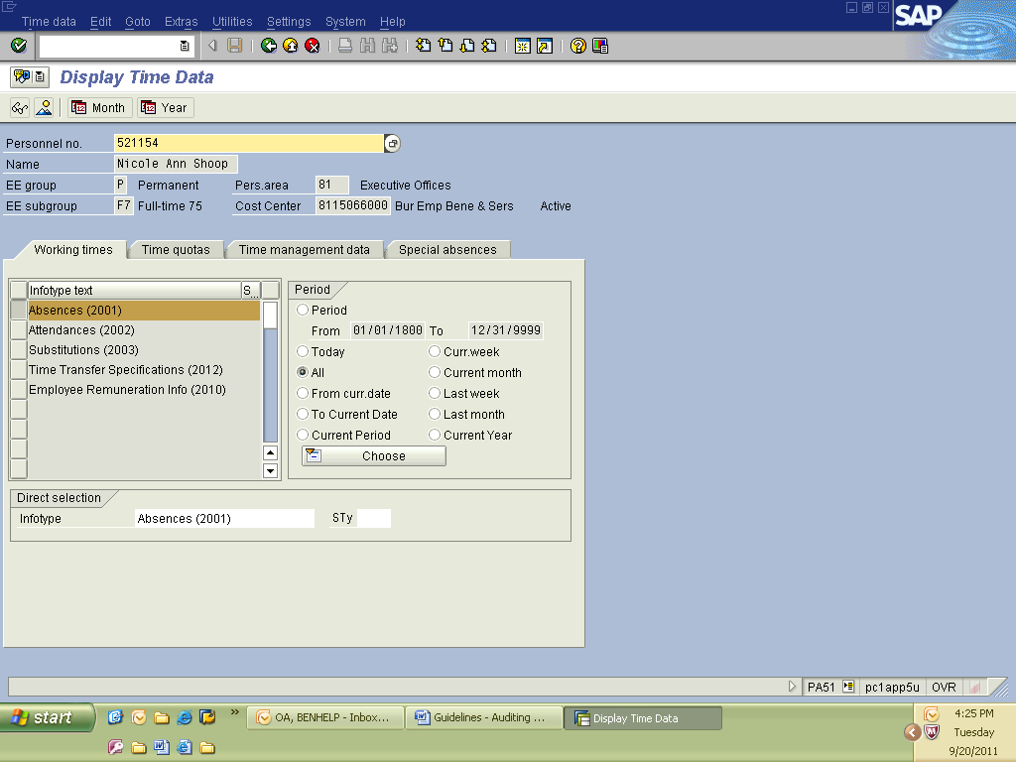

1. **Select the** *Execute* icon ().



1. Use the *Change Layout* icon () to remove/add columns.

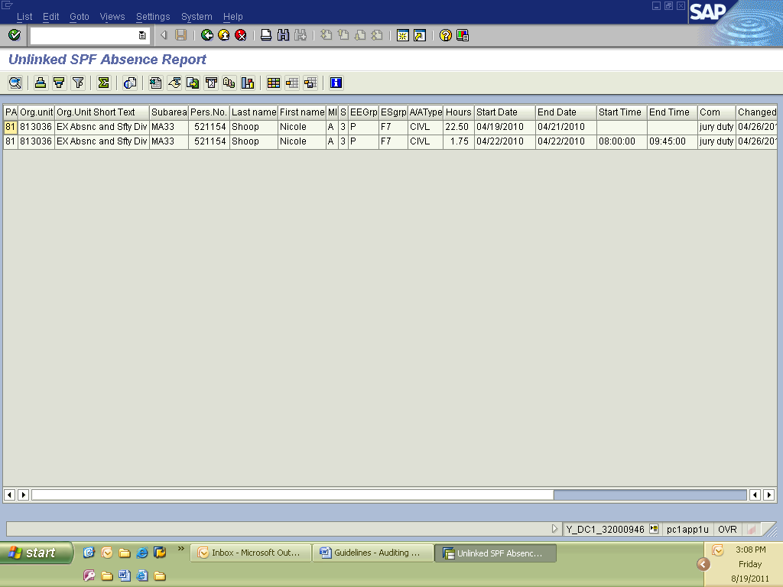

**Note**: This report can be run for an entire agency and from the earliest personal retroactive accounting date to present, provided it is set to execute in the background (reference, [Instructions for Running SAP Reports in Background](http://www.hrm.oa.pa.gov/Leave/tools-resources/Documents/instructions-sap-reports-background.pdf)).

**History of Changes Made to Record**

Although it may not be necessary to run the following reports, they may be helpful when determining what changes, if any, were made to an employee’s record.

**Logged Changes in Infotype Data (S\_AHR\_61016380) –** This report is used to view changes/deletions made to an employee’s record, and is helpful when trying to restore entries accidentally changed or deleted. **Note: Data is archived up to the Earliest Personal Retroactive Accounting Date. If information prior to that date is needed, a request must be sent** via an [HR help desk ticket](http://oaiss.state.pa.us/HR-Pay_Help_Desk/Login.asp).

**Tips for running report:**

1. Select Long-term documents or Short-term documents.
2. Enter a personnel number. Data to be viewed can be further defined by selecting a specific Infotype to be viewed, a specific date, or date range that the records were changed or the personnel number of the user who made a change.
3. Select *Direct output of docs* and deselect *Output in ALV.*
4. Select the *Execute* icon ().



**Infotype Overview for Employee (S\_AHR\_61015471) –** This report is used to review all infotype changes made to an employee’s record for a specific period.

**To run report, follow the below steps**

1. Enter a *Personnel number* to be viewed.
2. Enter a *Validity period* to be viewed.
3. Enter a specific *Infotype* to be viewed or leave blank to view all *Infotypes.*
4. Select the *Execute* icon ().

