How to Link to an IRIS View in Access

- Open an Access Database. At the top of the screen, click on the tab that reads, “External Data”.

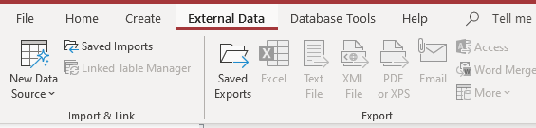

- Click on “New Data Source”, then select “From Other Sources”, and click on “ODBC Database”.

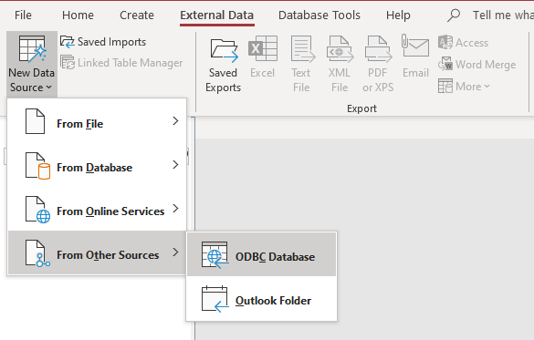

- In the window that pops up, make sure to select “Link to the data source by creating a linked table.” This ensures that the table will be updated, whereas a static table won’t be. Then select “Ok”.

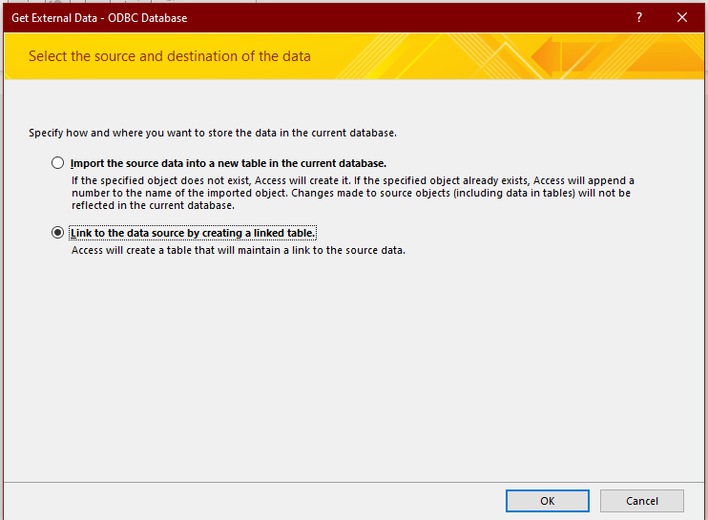

- In the next window that pops up, click on the “Machine Data Source” tab, then select “cmic”. Click “Ok”.

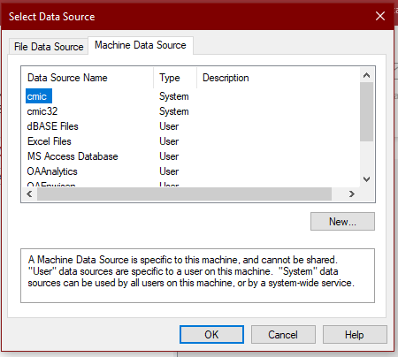

- In the next window that pops up, enter your Oracle username and password.
Remember, your username is your 8-digit personnel number. Click “Ok”.

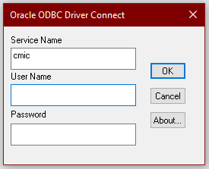

- The next window that pops up contains the list of tables/views you can link to. In this tutorial, we will be linking to the PPI.SAP_AGENCY_INTERFACE_IRIS view. You can link to multiple views at once. Select the views you wish to link to, then click “Ok”.

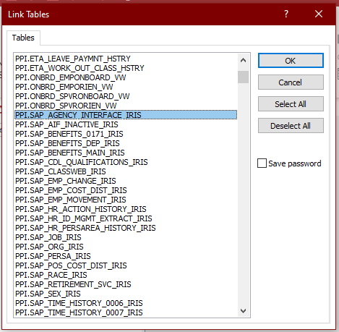

- If you wish to keep all the fields in the view you’re linking to, simply click “Ok” in the next window that pops up.

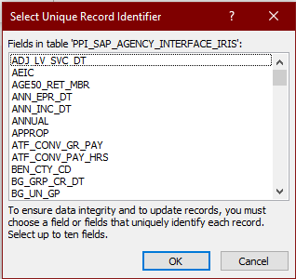

- You’re done! The views you linked to will appear in the list on the left side of the screen.

