LINKING TABLES

- Open query in design view

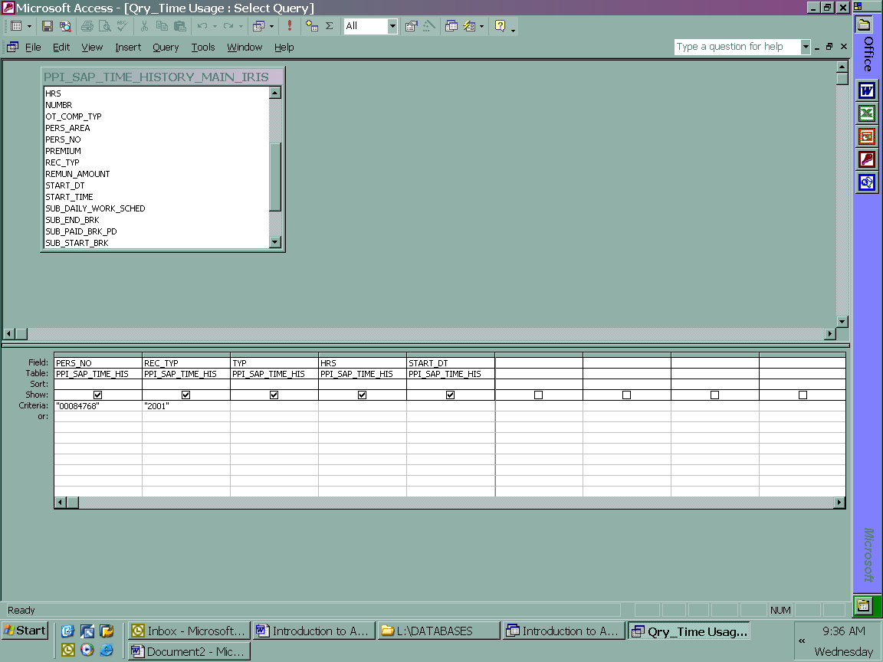
- Select “Show table” Icon
- Add table to be linked to existing table in query
- Close “Show table” box
Show table Icon

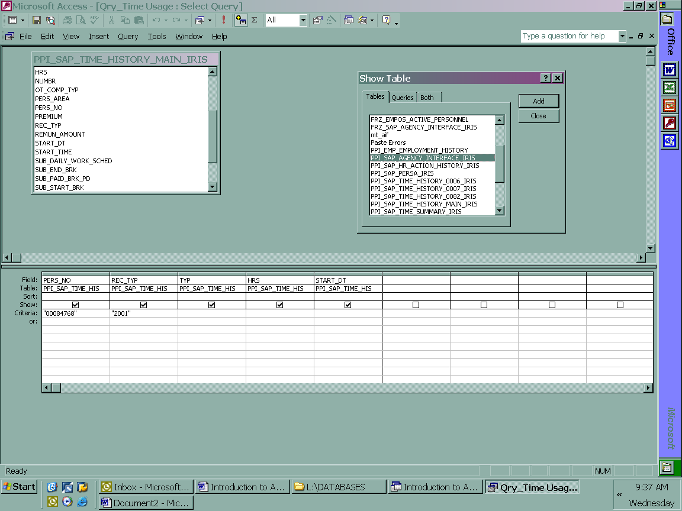
Select Close once table is selected
- Select a unique data field to link the tables together
  - Personnel No (Pers_No) or Position No (Pos_No) are the most common fields
- Highlight the data field in Time History Main table and drag to data field in the Agency Interface table
  - Left click on field name from field name Time History Main table.
  - You will see a little box while you are dragging field to other table
  - Line will appear once tables are joined.
- To view the properties of the join
  - Right click on line that joins tables
  - Menu will pop up.
  - Select “Join Properties”

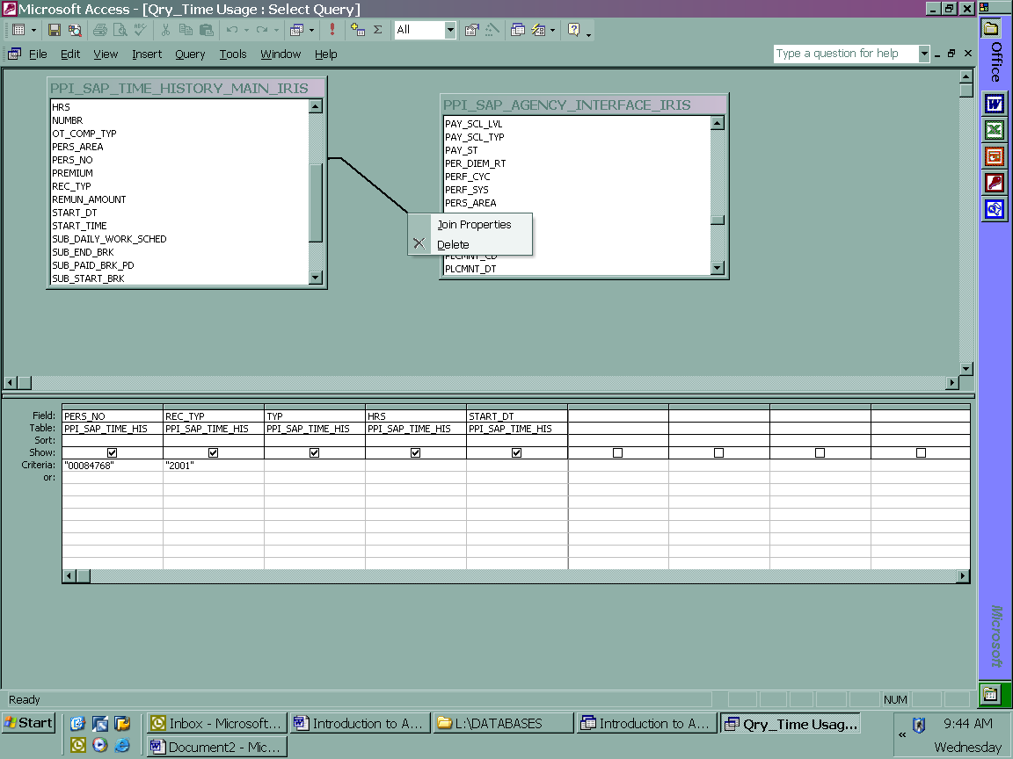

- Join Properties Dialog box pops up
  - Select the proper joining you want.
  - Close dialog box

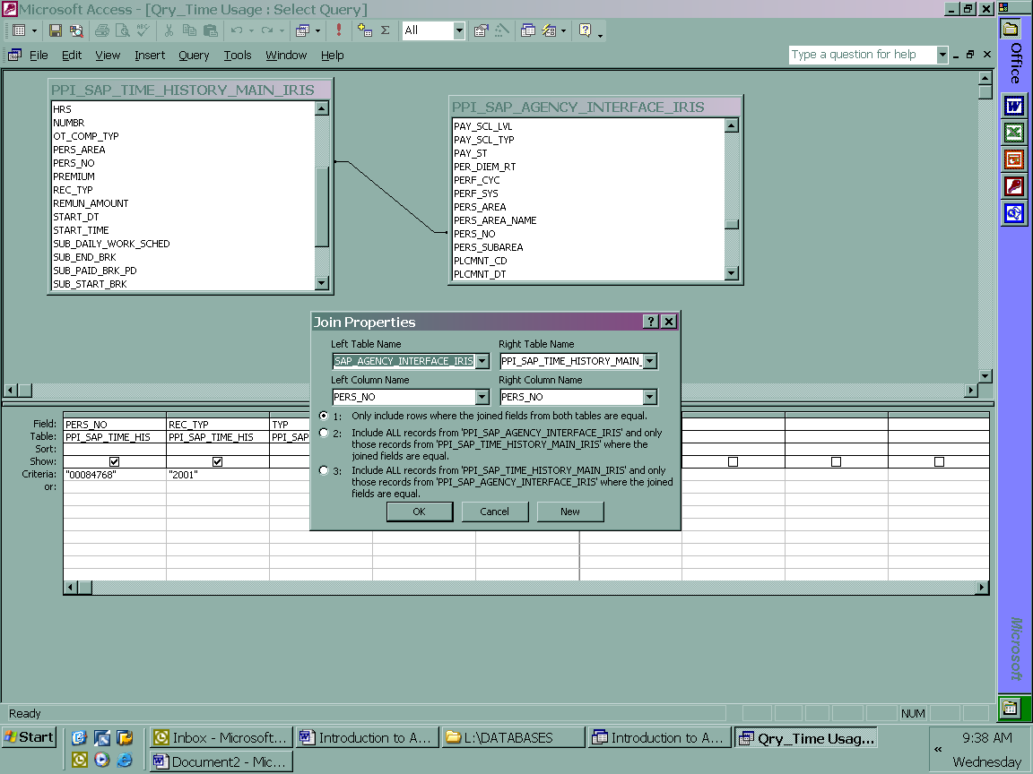
- Select the data fields from the Agency Interface table that you want to add to query
  - EX: last, first, org
- Once you’ve selected all of your data fields
  - Run the data
    - You can chose from the run icon or the datasheet view icon
- If you see results then your report is good
- If your spreadsheet comes up blank then you need to revisit your query’s criteria in the design view
Select the run icon

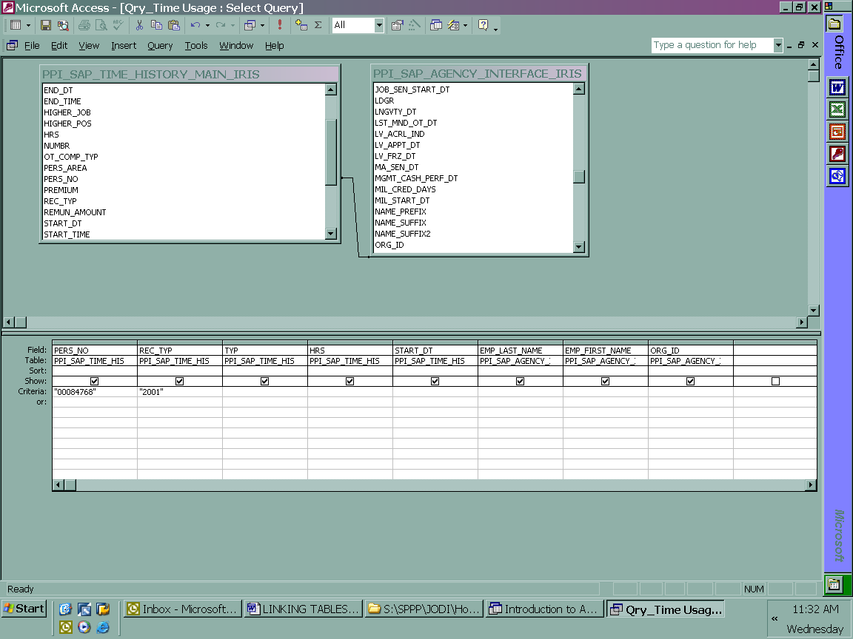
Select from drop down “Datasheet View”

