Updated 07/19/2019
Out of Sync Quota Resource Guide
This guide provides information regarding the generation and research of Out of Sync Quota error messages which appear on the Time Evaluation Messages Display (Y_DC1_32000599).
The review and resolution of out of sync errors is primarily a time advisor function.

Table of Contents
- Introduction
- A Note Regarding Extension Quotas
- Why Out of Sync Quota Errors Occur
- Research Examples
- When and Where to Go for Help
- Historical Information
- Appendix 1 – Comparing Actual and Anticipated Quotas/PT_Bal00 Day Balances

Introduction
Out of Sync Quota messages generate on the last day of the leave calendar year when there is a positive or negative (+/-) difference of greater than .10 between an employee’s anticipated and actual annual and/or sick quotas. * These messages are true errors, not warnings, and could have an impact on an employee’s ability to request leave. Therefore, they should be reviewed and corrected as soon as possible.
One or both error messages below may appear for an employee.
- PB – Out of Sync Annual Quota 10/11
- PC – Out of Sync Sick Quota 20/21

If left uncorrected, an out of sync quota error message will continue to generate at the end of each subsequent leave calendar year. The value of the out of sync errors may differ from year to year since an out of sync error can have multiple causes across multiple years. Therefore, research should always begin with the earliest dated error.

Note: Although an out of sync quota error may generate in one leave calendar year, the cause of the error may have occurred in a prior leave calendar year(s).

Time evaluation must be run upon correction of an out of sync quota error in order for the “PB” and “PC” messages to no longer generate on Time Evaluation Messages Display. Users are unable to mark these messages as reviewed. Reminder: Time evaluation runs nightly.

* Two time types, available for view in PT_Bal00, Day Balances, display differences between anticipated and actual quotas and are the values associated with the PB/PC error.

ZQAF – Annual Qta Diff – LCY End
ZQSF – Sick Quota Diff – LCY End

A Note Regarding Extension Quotas
Extension quotas (quota type 12) generate on the first day of the leave calendar year for the hours over the maximum carry-over balance of the employee’s anticipated annual quota (quota type 10).

At the end of the extension period, any unused extension quota hours are removed from the employee’s actual annual quota (quota type 11) and added to the employee’s anticipated and actual sick quotas (quota type 20 and 21).

If an employee has an out of sync annual quota and also has extension quotas, you must carefully review the extension quotas once the out of sync error has been resolved to ensure the correct extension amount regenerates. In some cases, you may also need to re-save annual leave absences taken during the extension period.

Why Out of Sync Quota Errors Occur
Following are some of the reasons why an employee’s anticipated and actual quotas may be out of sync. Please note that this is not an all-inclusive list.

- Employee changed payroll areas
- User error – quota corrections entered incorrectly
- New Hire/Rehire eligible to anticipate up to one day of annual is hired at end of leave calendar year
- Absences are incorrectly deducting from anticipated quota
- Employee transferred from a permanent position to a non-permanent position and the anticipated quotas were not adjusted
- Absences not resaved when a work schedule change was entered
- Employee is TMS1 or permanent part-time TMS9 and the quotas were not reviewed and adjusted at the end of each leave calendar year
- Employee has more than one line of the same quota type (Ex. Two quota type 20 records)
- Employee is a management employee hired/rehired in the middle of a pay period and the quotas were not reviewed and adjusted
- Employee transferred from an agency with a reciprocal leave agreement and quota corrections were entered incorrectly
- Employee was permanent and separated prior to the Earl.pers.rec.date on IT0003
- A rounding issue involving some accrual rates

Research Examples – *Additional Examples Will Be Added in the Future*

- Employee Changed Payroll Areas

Problem: Employee has out of sync errors for both annual and sick leave totaling 1.59 each for logical date 1/4/19. 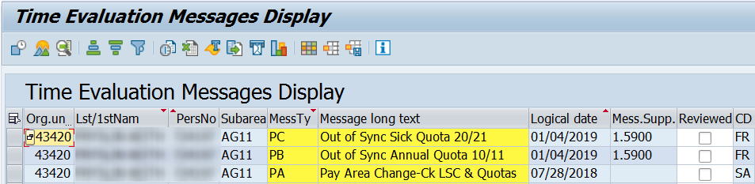
Hint: The employee also has a PA – Pay Area Change – Ck LSC and Quotas message with a logical date of 7/28/18. The employee’s pay area change in the 2018 LCY is the likely cause of the out of sync errors.
Research: A review of IT0001 reveals the employee transferred from DOT (payroll area T2) to Agriculture (payroll area Z3) on 7/28/18.
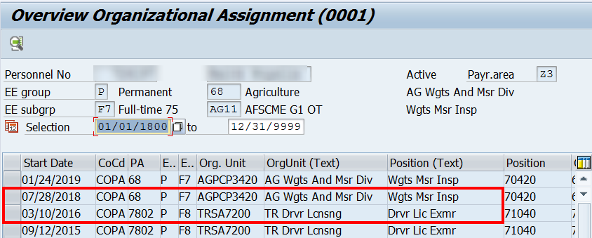
The PT_Bal00 report can be used to compare anticipated and actual quota accruals earned in the leave calendar year.
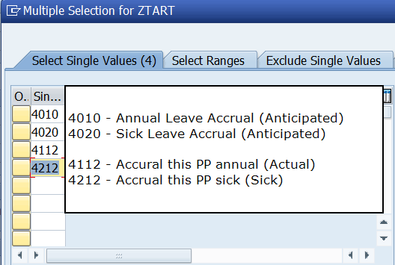
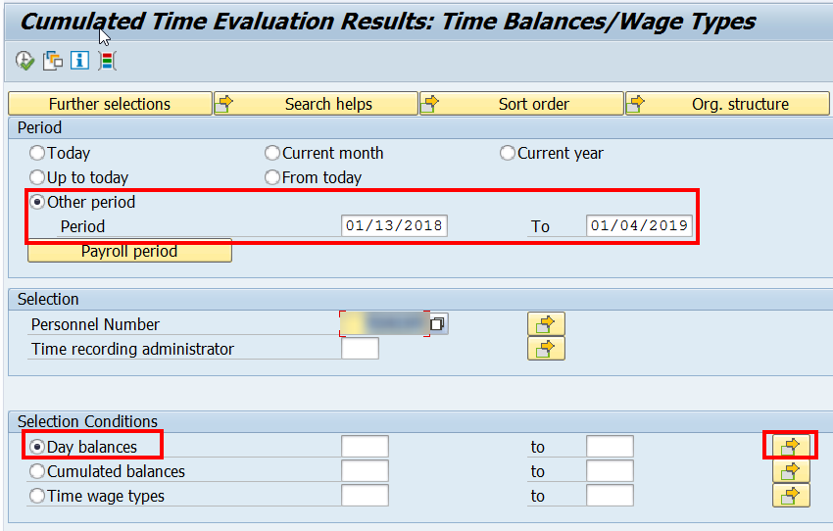
The period selection should reflect the first day of the LCY for the payroll area where the EE was assigned at the start of the LCY through the last day of the LCY for the payroll area where the EE was assigned at the end of the LCY.
Select the multiple selection button for Day Balances to run the report for quota accruals.

Note: Accruals not included in Time Types 4112, 4212:
- Additional annual accruals for no sick leave usage – Use Time Type ZAQ1 or ZAQ2

- Actual annual and sick quotas generated when employee transfers from non-permanent to permanent prior to working 750 hours in calendar year. – Use Time Type 4011 or 4021

- You can also view accruals via the Accrual Information tab on PT50
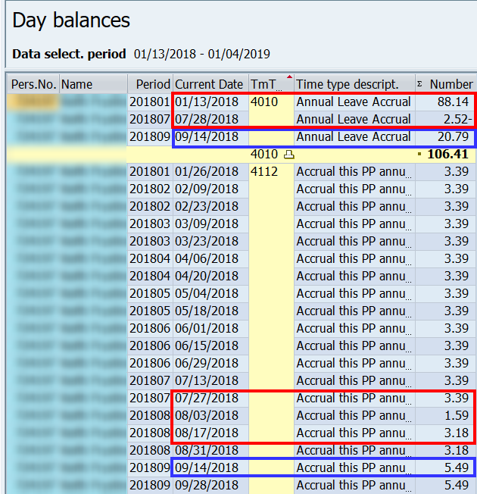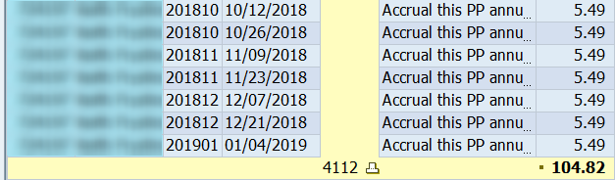
The EE began the LCY on 1/13/18 in payroll area T2 and on 7/28/18 moved to payroll area Z3. On 8/3/18, the EE received one week of accrual for hours worked between 7/28/18 through 8/3/18. The new LCY for payroll area Z3 ends on 1/4/19.
Note: The EE also switched EE subgroups from F8 to F7 on 7/28/18. This change is evident in the removal of 2.52 hours of anticipated quota on 7/28/18 and the EE’s actual quotas changing from 3.39 to 3.18 hours per pay period beginning 8/3/18.
Note: This screenshot shows the results for anticipated and actual annual.
Note: In this example, the EE’s annual accrual rate increased from 4.24% to 7.32 % on 9/14/18.
Compare the results. The total anticipated annual amount 106.41 (Day Balance 4010) is greater than the actual accrual earned 104.82 (Day Balance 4112) in the amount of +1.59.
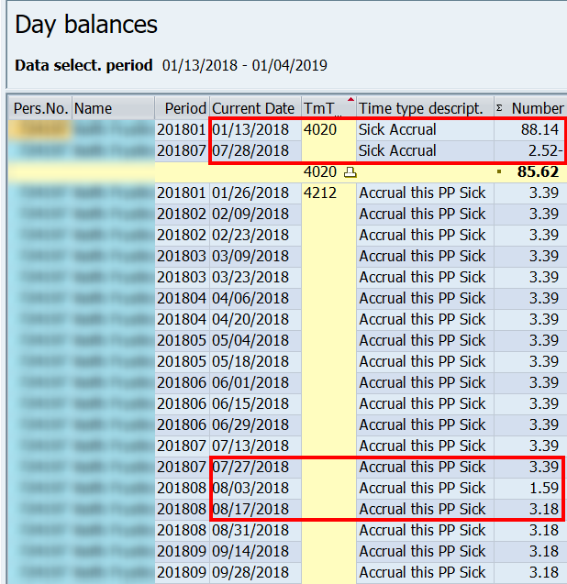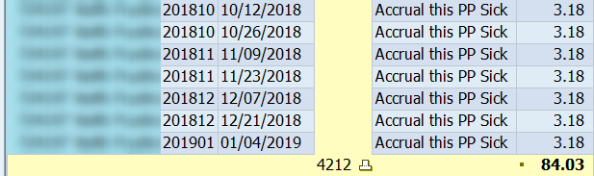
Note: The EE’s sick accrual rate did not change on 9/14/18.
The EE began the LCY on 1/13/18 in payroll area T2 and on 7/28/18 moved to payroll area Z3. On 8/3/18, the EE received one week of accrual for hours worked between 7/28/18 through 8/3/18. The new LCY for payroll area Z3 ends on 1/4/19.
Note: The employee also switched EE subgroups from F8 to F7 on 7/28/18. This change is evident in the removal of 2.52 hours of anticipated quota on 7/28/18 and the EE’s actual quotas changing from 3.39 to 3.18 hours per pay period beginning 8/3/18.
Note: This screenshot shows the results for anticipated and actual sick.
Compare the results. The total anticipated sick accrual amount 85.62 (Day balance 4020) is greater than the actual sick accrual earned 84.03 (Day balance 4212) in the amount of +1.59.
In this example, the employee switched from F8 to F7 on 7/28/18. This change is also reflected in the anticipated sick earnings.
Reason: The anticipated quotas are greater than the actual quotas because anticipated quota is generated at the start of the leave calendar year based on the employee’s payroll area, personnel subarea, leave service credit and weekly working hours. Actual accrual generates each pay period based upon actual hours worked and is generally accurate. In this example the 2018 leave calendar year was shortened by one week (payroll area switch from T2 to Z3).
Resolution: Quota corrections must be entered effective 7/28/14 to remove one week of accrual from the anticipated quotas (QT10/20) to sync them up with the actual quotas (QT11/21).
Once time evaluation runs, the out of sync quota messages should disappear from Time Evaluation Messages Display.
- User Error - Quota Corrections Entered Incorrectly

Problem: Employee has two out of sync quota errors for sick leave totaling 7.50 hours for logical dates 1/5/18 and 1/4/19.

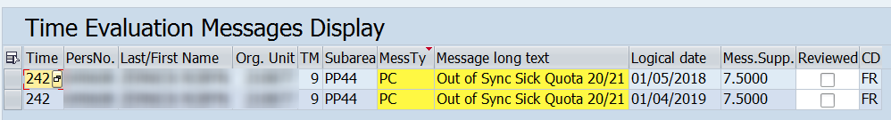

Hint: Because the value of the out of sync error does not change from year to year, it is very likely the cause of the error occurred in the 2017 leave calendar year, which is a good place to begin researching.

Research: A review of IT2013 (Quota Corrections) shows the likely cause of the out of sync error. Multiple quota corrections were entered effective 8/1/2017 due to leave donations. The employee should have matching quota correction records for both quota type 20 and quota type 21. For one of the quota correction entries, the employee’s quota type 20 was increased by 7.50 hours but quota type 21 was increased by 0.00 hours.
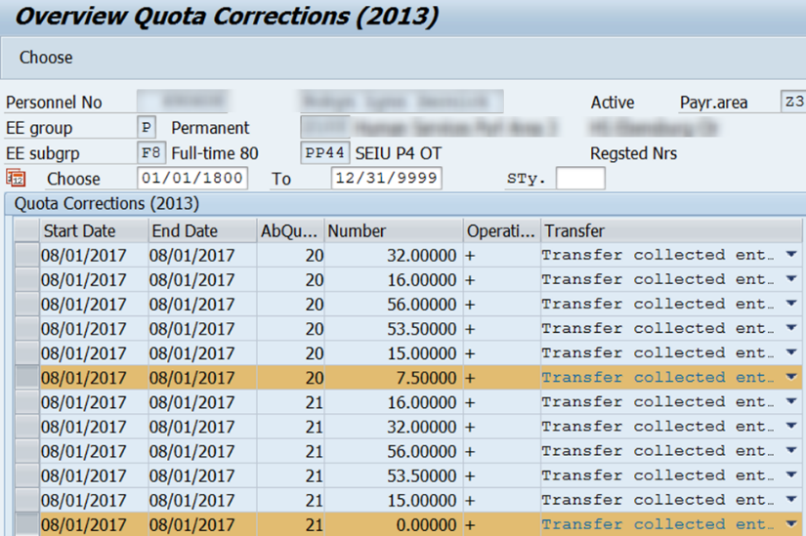

Resolution: Work with the FMLA Specialist to have the quota correction for quota type 21 for 0.00 hours corrected to reflect an increase of 7.50 hours. After time evaluation is requested, the out of sync errors will disappear from the report.

- New Hire/Rehire Eligible to Anticipate Up to One Day of Annual Leave is Hired at End of LCY

Problem: The employee has an out of sync quota error for annual leave totaling 4.96 hours for logical date 1/4/19.
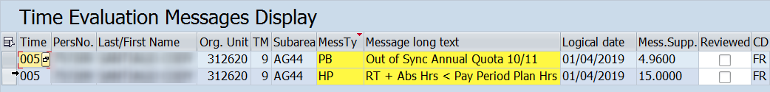

Research: A review of IT0000 reveals the employee is a permanent, full-time employee in bargaining unit G4 and was hired on 12/26/18 in pay area Z3. Based on the employee’s bargaining unit, he is eligible to anticipate up to one full day of annual leave in the first year of employment.
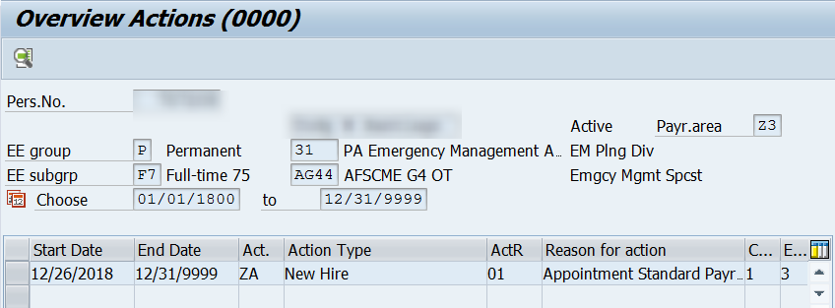

A review of PT_Bal00 results from the date of hire through the end of the LCY show the EE received 7.50 hours of anticipated annual leave (Quota type 10 – Time Type 4010) on 12/26/18. On the last day of the LCY, he earned 2.54 hours of actual annual quota (Quota type 11 – Time Type 4112). The difference is 4.96 hours - the amount of the out of sync error.

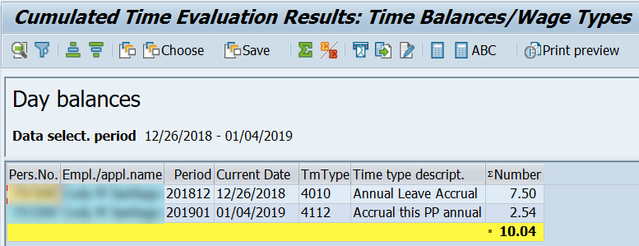

Reason: An employee who is hired near the end of the leave calendar year will not earn a full day of actual quota by the last day of the leave calendar year. Therefore, the system will consider their quotas to be “out of sync” and will generate the out of sync error message. Once the employee earns up to one full day of actual quota, the quotas will no longer be out of sync.

Resolution: DO NOT enter a quota correction to sync the quotas!
Submit an HR/Pay Help Desk Ticket in the Time Category to request the out of sync quota message be cleared from Time Evaluation Messages Display.

NOTE: If time evaluation retros for any reason after the error is marked as reviewed, it will reappear in the Time Evaluation Messages Display.

- Absences are Incorrectly Deducting from Anticipated Quota

Problem: The employee has an out of sync annual quota for -7.49 hours for logical date 1/4/19. The error is likely for a full day (7.50 hour) absence. The difference of .01 is due to rounding.

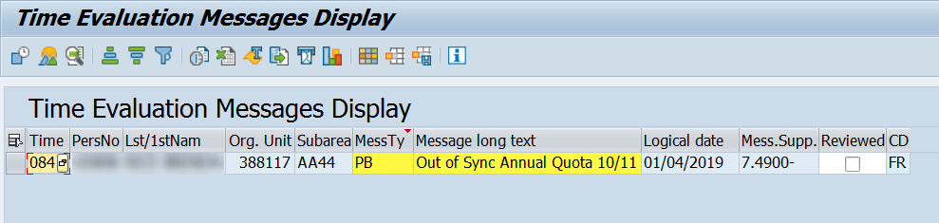

Research: Review IT2006 (Absence Quotas) via PA51 (Display Time Data) to see which absences are deducting from the employee’s quota.

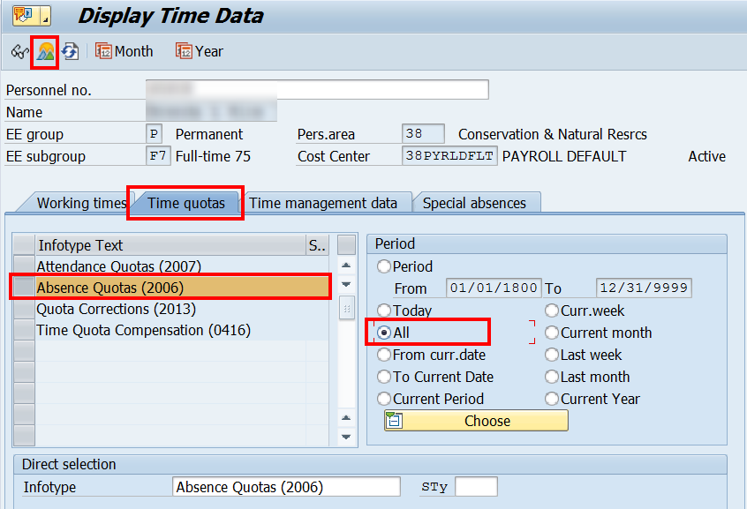

Highlight the quota line associated with the deductions you wish to view and click “Choose.”

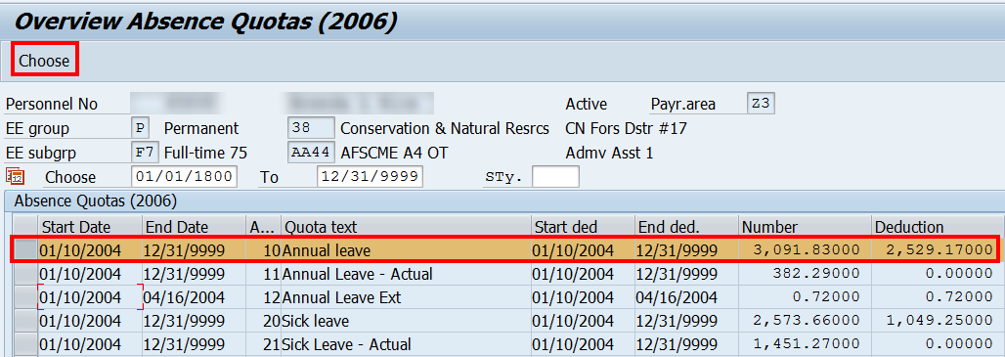

Hint: Absences taken when the employee is/was a Permanent employee will be deducted from the employee’s anticipated quotas (10/20). Absences taken when an employee is/was a Non-permanent* employee show as deductions from the employee’s actual quotas (11/21). Absences taken during the seven pay period extension deduct from the employee’s extension quota (12).
* Exception: Employees who are non-permanent Labor & Industry UC Claim Intermittent Intake Interviewers (job code 06590) receive anticipated quota and will have absences deducted from quotas 10/20.

From the top menu bar, select Goto Deduction (Ctrl +F8). This will open the Display Quota Deduction window, which shows all absences deducting from the quota.

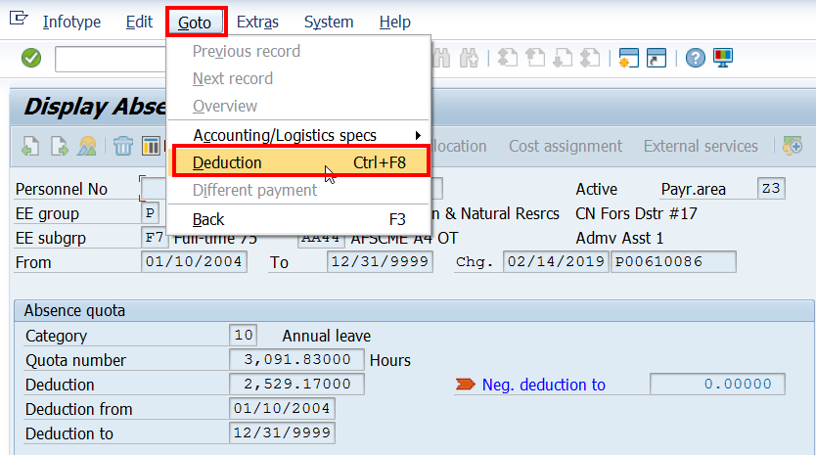

From the Display Quota Deduction window, use the scroll bar to review all the absences to ensure they are deducting correctly. Any absence dates that are listed with a blank field in the “A/A type” column indicate an improper absence deduction.
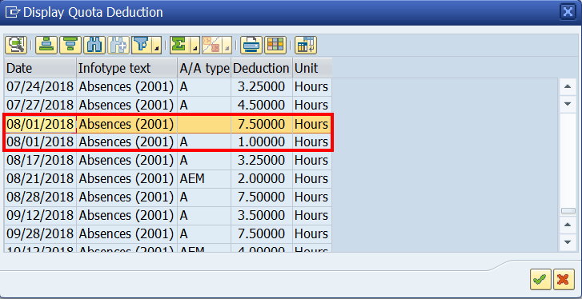
In this example, the employee has two deductions for 8/1/18: 7.50 hours and 1.00 hour. The 7.50 hour absence is missing the A/A type but is still deducting from the employee’s quota.

Reason: It is unknown why these “double-deductions” occur but it is likely due to the modification or deletion of a previously approved absence either in ESS or directly in IT2001. Always review IT2001 to confirm the correct absence type and deduction amount.
Resolution: This error cannot be corrected at the agency level. Submit an HR Help Desk ticket in the Quotas category indicating the dates of absence and the quota type affected. The help desk ticket should include screenshots of the “Display Quota Deduction” screen showing the absence(s) that are not deducting properly. The HR Service Center, Time Services team will likely need to run a program to correct the deductions.

*Additional examples to be added in the future*

When and where to go for help

Field Time Advisors: Work with your Central Agency or Delivery Center Time Advisor if you are unsure how to research or correct an out of sync quota error.

Central Agency/Delivery Center Time Advisors: If you are unsure how to research or correct an out of sync quota error, please contact the HR Service Center’s Time Services team at 1-877-242-6007, Option 2, or submit an HR/Pay Help Desk Ticket in the Time category.

When submitting help desk tickets, please include a detailed explanation of any research you have completed along with any necessary screenshots.

The HR Service Center’s Time Services team will give priority to the resolution of help desk tickets where the out of sync quota error is preventing an employee from requesting leave to which they are entitled, or the employee is separating.
Reminder: Help desk tickets may be hidden from view within the HR help desk application until additional resources are available to review and resolve the out of sync quota errors.

Historical Information
Messages first generated for pay areas Z3/T3 with a logical date of 1/9/2015, the last day of the 2014 leave calendar year. Messages for pay areas Z1, Z2/T2 first generated on the last day of the 2015 leave calendar year with logical dates 1/2/2016 and 1/1/2016, respectively.

Because 2014 was the first leave calendar year that out of sync quota messages generated, the volume and research of out of sync quotas on the Time Evaluation Messages Display report for both the agencies and the HR Service Center was overwhelming. This was in large part due to the fact that some quotas had been out of sync since SAP go-live in 2004.

Early in 2016, the HR Service Center completed an assessment of all out of sync time evaluation errors. A decision was made that for errors in the amount of a full day (7.5/8.0) or less, a quota correction was created to increase/decrease the anticipated quotas, syncing the anticipated quota with the actual quota. In most cases, the effective date used was the day before the logical date of the error, and the user ID attached to the quota correction was either HRSUPPORT or the user ID of a member of the HRSC Time Services staff. As a result of this action, the out of sync error count was dramatically reduced from over 28,000 to under 2,600.

Appendix 1 - Comparing Actual and Anticipated Quota
Step 1: Obtain Balance of Actual Quota(s)
- Use transaction Quota Overview (PT50)
- Enter personnel number
- Always click “All”
- Select the “Absence quotas” tab
- Click “Expand”
- Record the amount of actual quota(s) (Q11/Q21) in the “Rem” column
Step 2: Determine Employee’s Biweekly Accrual Rate(s)
- Use transaction Seniority and Additional Information (ZPAY_HR) to determine annual and sick leave accrual rate (percentage)
  - Enter personnel number
  - Click “OK”
  - Record the biweekly accrual rate(s)
  - Multiply the employee’s biweekly hours by their accrual rate percentage to determine biweekly accrual amount
Step 3: Determine Amount of Anticipated Quota to Be Earned in the Current Leave Calendar Year

- Count and record the number of pay periods remaining in the current leave calendar year
- Multiply the biweekly accrual rate (Step 2) by the number of pay periods remaining in the current leave calendar year to determine how much anticipated quota the employee will earn between now and the end of the current leave calendar year and record this amount.
Step 4: Add Actual Quota and Amount of Anticipated Quota to Be Earned
- Add the actual quota (Step 1) to the amount of anticipated quota to be earned (Step 3)
- Compare the result to the anticipated quota (Q10/Q20) in the “Rem” column on the PT50
Note 1: If the amount of anticipated quota in the “Rem” column does not equal the final result, check for any future dated absences (PA51, IT2006, “Go To Deductions”), and add them to the remaining anticipated quota balance as they have already been deducted from the total.
Note 2: If the amount of anticipated quota in the “Rem” column does not equal the final result, and it’s during the extension period and the employee has remaining excess annual (Q12) for the current leave calendar year, subtract the remaining excess annual amount from the actual quota result (Step 4).

Time Types – Use for Day Balances on PT_Bal00 (Cumulated Time Evaluation Results)
Time Types for Annual/Combined |  | Time Types for Sick |  | Time Types for Personal  For employees that still earn personal leave
Anticipated Annual Accrual | 4010 | Anticipated Sick Accrual | 4020 | Anticipated Personal | 4030
Actual Annual Accrual | 4112 * | Actual Sick Accrual | 4212 * | Actual Personal Accrual | 4312
Annual Usage Daily | 4016 | Sick Usage Daily | 4026 | Personal Usage Daily | 4036
Combined Usage Daily | 4046 | LT Sick/H1 Usage Daily | 4056 | Add Personal Generated | ZAPL
Last PP Leave Balance Annual | 4111 | Last PP Leave Balance Sick | 4211 | Last PP Leave Balance Personal | 4311
Annual Leave Accrual Rate | ZALR | Sick Leave Accrual Rate | ZSKR | Remaining Pay Periods | ZLAY
Annual Leave – Excess | 4014 | Sick Accrual – Actual | 4021 | Personal Leave Excess | 4032
Ad. Annual Gen. 1st Half | ZAQ1 | * Accruals not included in Time Types 4112, 4212 or 4312:  - Additional annual accruals for no sick leave usage – Use Time Type ZAQ1 or ZAQ2  - Additional personal accruals for no sick leave usage – Use Time Type ZAPL  (For employees that still earn personal leave)  - Actual annual and sick quotas generated when employee transfers from non-permanent to permanent prior to working 750 hours in calendar year. – Use Time Type 4011 or 4021
Ad. Annual Gen. 2nd Half | ZAQ2
Annual Leave Actual | 4011

