Reviewing AWS Buckets
Step 1: Review IT0007 to determine when employee began the AWS schedule (prefixed with BA). The employee began AWS on 4/7/2012.
Note: Each time an employee is placed on a basic schedule (prefixed with BB), the AWS bucket is automatically emptied. Therefore, only research from the most recent date they began AWS.
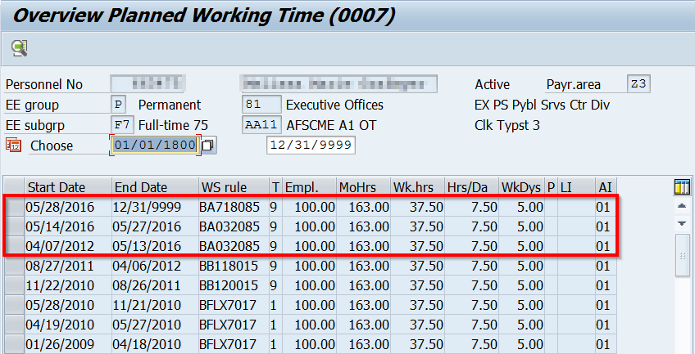
Review each record individually to determine what type of AWS schedule (4-week, 2-week, etc.) the employee was on for each period.
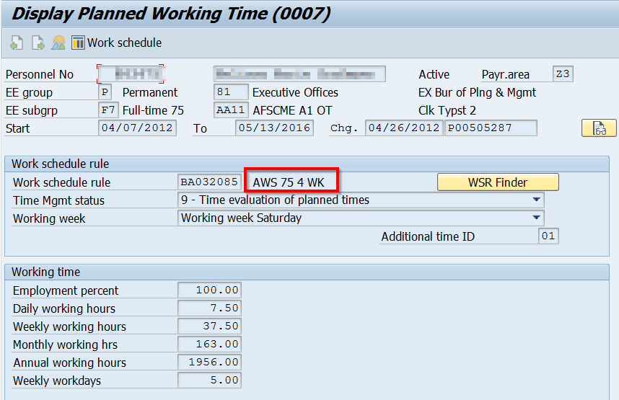
Step 2: Run PT_Bal00 for Day balance 5160 from the first date the employee began AWS through the date of the most recently completed AWS cycle. Note: AWS cycles are determined by the effective date used to place the employee on AWS and the type of AWS schedule (2-week, 4-week, etc.) the employee was placed on.
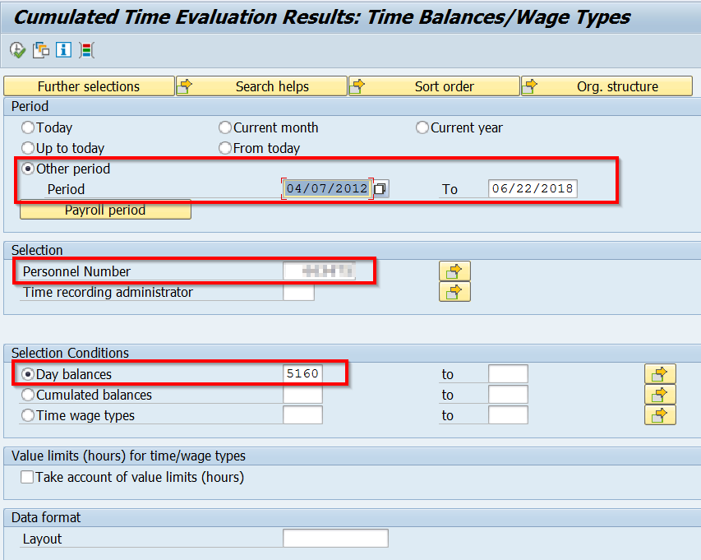

A positive value is displayed for the extra hours the employee worked on a particular day towards the AWS Off day. A value of -7.50 is displayed for each AWS Off day the employee was paid. Scroll to the bottom of the report to see the cumulative results. If there are no errors with the employee’s AWS bucket, then the value of Time Type 5160 will reflect zero at the end of the AWS cycle.
Reminder: The AWS Off day could be used before the hours are earned. If the employee were to separate or be put on a basic schedule before the end of the cycle, the hours used would be recouped.
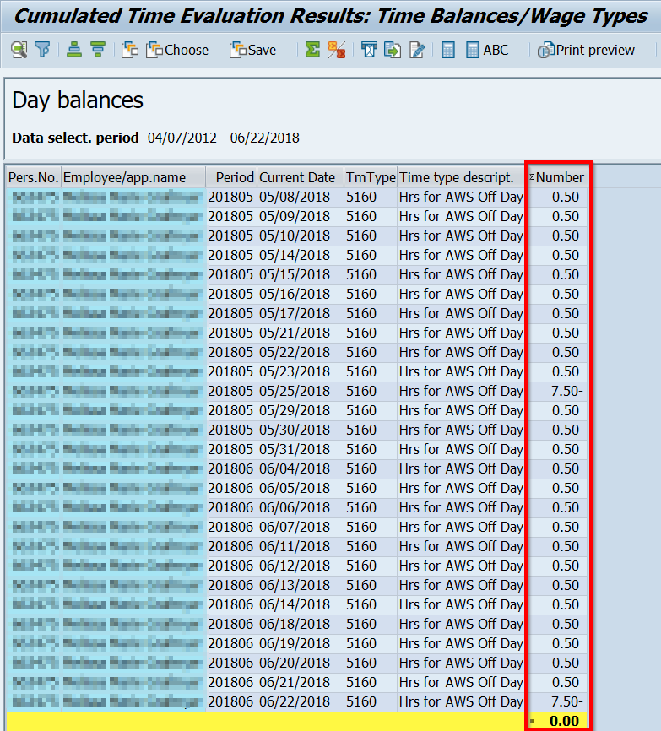
A value other than zero, may indicate that there is an error with the AWS bucket and further research is required to identify the discrepancy and correct as necessary.

Researching AWS Bucket Errors
The following items should be reviewed to find/resolve errors.
- AWS Cycle Total Hours – Identify the AWS cycle(s) where error(s) occurred by running the AWS bucket for smaller periods of time based on AWS cycle dates.
  - For 19/20 AWS cycles, the employee should have 150 hours scheduled in a four-week cycle.
  - For 9/10 AWS cycles, the employee should be scheduled for 75.00 hours in a two-week cycle.
  - For 4/5 AWS cycles, the employee should be scheduled for 37.50 hours in one week.

- IT2003 Substitutions – Were substitutions entered incorrectly? Pay close attention to AWS cycles in which a holiday occurred or if the AWSO day was moved during the AWS cycle.

- Work Schedule Change Effective Dates – Did the employee move to a new AWS or basic work schedule, was the employee placed on a default work schedule due to long-term LWOP (via IT2003 Substitutions), or did the employee separate mid-cycle?
Reminder: If researching a BCPO Exception Report for Work Hrs Adj – Negative Bal or Work Hrs Adj – Positive Bal, the PT_Bal00 may reflect zero (0.00) because the Work Hours Adjustment record is offsetting the true error. Run the AWS cycle through the previous cycle to see if the error occurred prior to the current cycle.
- AWS Bucket Hours at SAP Go-Live – Check IT2012 for time type 5160 to confirm if the correct number of hours were loaded at SAP go-live.
Go-Live dates: Z3/T3 – 1/10/2004
Z2/T2 – 1/17/2004
Z1 – 1/18/2004

