Attachment to Time Alert 2019-05
Important Information Related to Transactions Changes as a Result of Archiving

Transaction: PC00_M99_CWTR (Wage Type Reporter)

Archiving Changes:

Will not display all available data if archived payroll results check box is not selected. This specifically pertains to periods that have been archived.
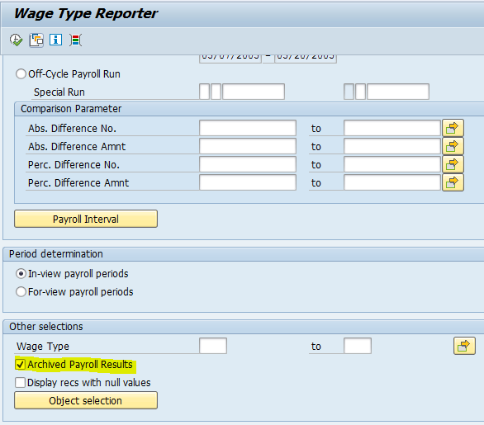

Transaction: PC00_M10_CEDT (Remuneration Statement)

Archiving Changes:

Remuneration Statements are only available for the previous four – five years. Users will be unable to view any pay statements that are related to archived data. The following will be displayed when trying to access an individual’s pay statement for a period that has been archived:
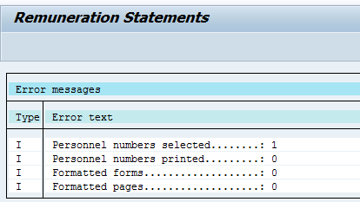

Transaction: PC_Payresult

Archiving Changes:

- Archiving Group Number is Now Present
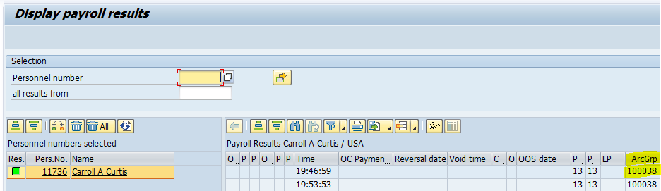

- Results Table Denotes Records are in an Archived Status and the Group Number
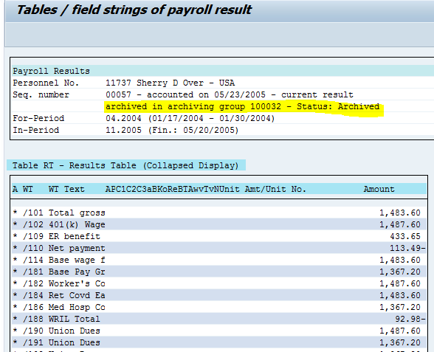

- Tables PCALAC and PCL2 are No Longer Present on Archived Payroll Results

Note the list of tables in the RT table of payroll results prior to the employee’s records being archived:

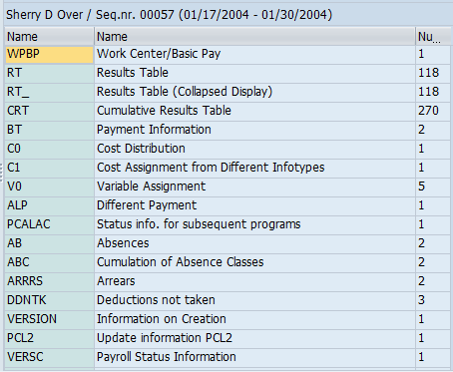
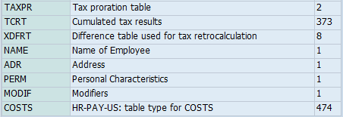

After the employee’s records have been archived:
