Using the Work Schedule Rule Finder Button on IT0007 to Search and Update an Employee’s Work Schedule
The Work Schedule Rule Finder (WSR Finder) button is available on IT0007 in both the PA51 (Display Time Data) and the PA61 (Maintain Time Data) transactions. Accessing the button via PA61 allows the user to search available schedule options and update the employee’s work schedule; whereas, accessing the button via PA51 only displays the work schedule options available.
This document illustrates how to use the WSR Finder button in PA61 to search and update an employee’s work schedule.
NOTE: The meal period is not included in the standard display of the WSR Finder, but the layout presented should be changed to include it. Instructions for creating a default layout to include the meal period begin on Page 13 of this document. The following instructions illustrate how to use the WSR Finder button AFTER a default layout has been created:

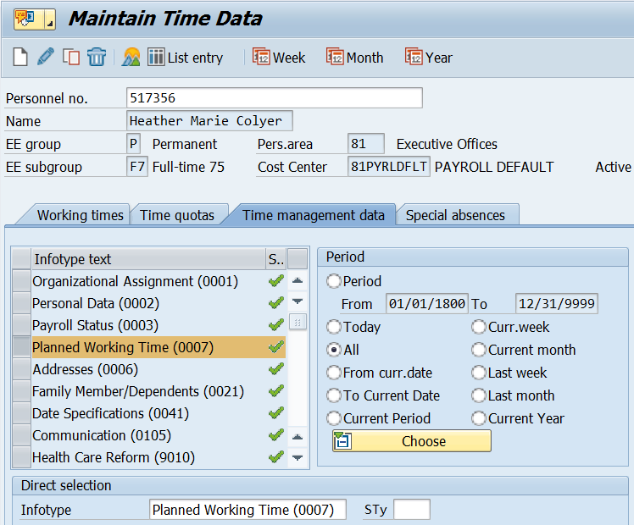
Access the WSR Finder by selecting Planned Working Time (0007) in the Time Management Data tab and selecting the Overview icon OR by directly entering “0007” in the Direct Selection Infotype field.

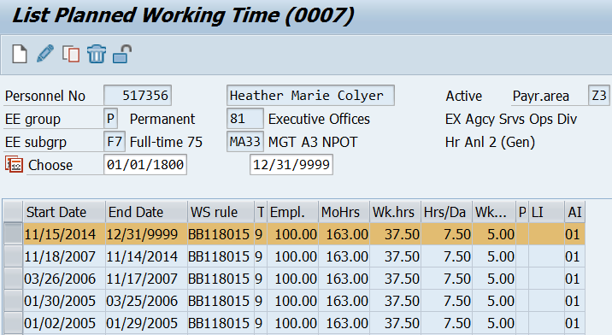
Select the most recent work schedule rule on IT0007 and then select the Copy  icon.
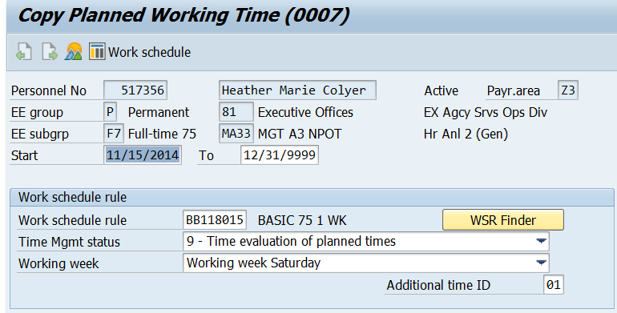
Select WSR Finder to continue.

The Work Schedule Rule Finder box is displayed. Select “Set Values” to define the work schedule criteria. Data can also be directly entered into the Work Start, End of work, Planned working hrs fields, Start of break and End of break fields.
In this example, the “Set Values” option was used.

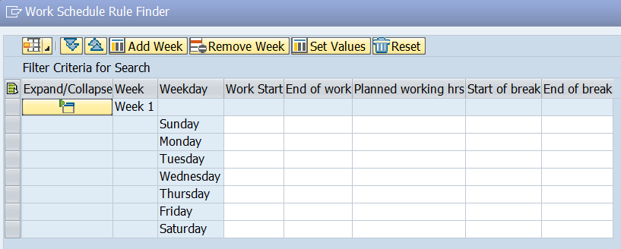
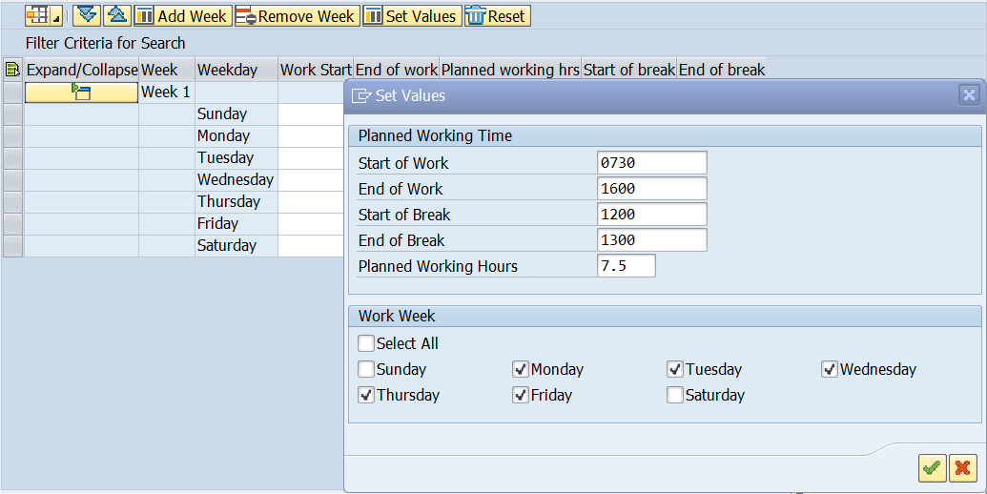
In the “Set Values” box, enter the work schedule criteria to be searched. In this example, the schedule being searched is a Basic Monday - Friday schedule of 7.5 hours daily from 0730 – 1600 with a one hour meal period from 1200-1300. Select the green check mark to apply the search criteria.

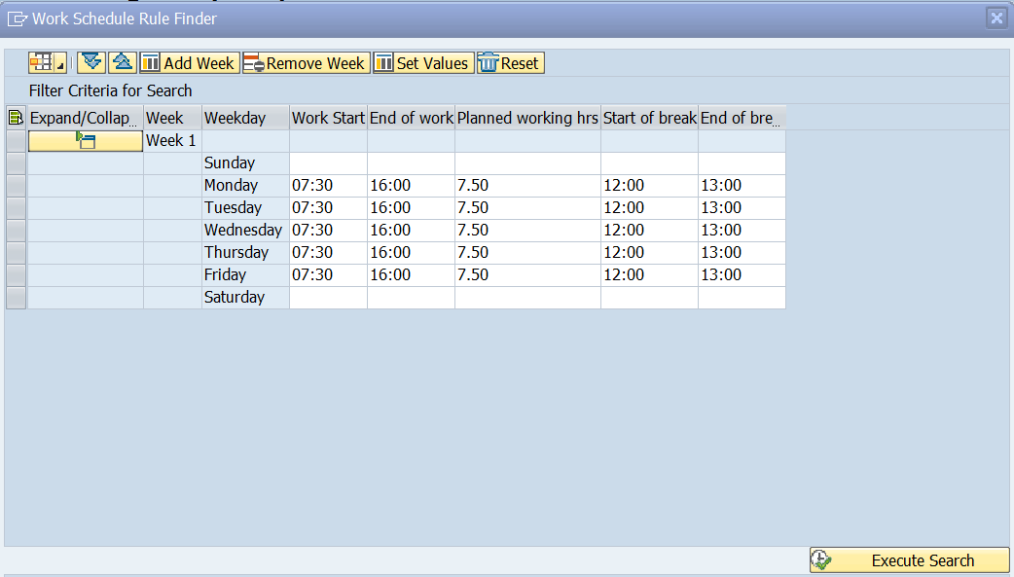
The work schedule criterion is added to the WSR Finder box. Select the “Execute Search” button to complete the search.

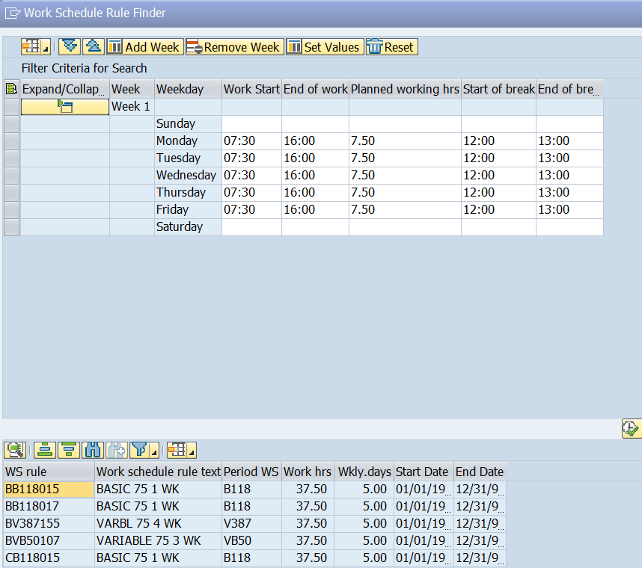
The search results are displayed. In this example, Variable schedule options were also returned because the search criteria requested matches Week 1 of these schedules. NOTE: Expand the Work schedule rule column to view the entire work schedule rule.
To view a schedule, select a work schedule rule, and then select the Details icon.

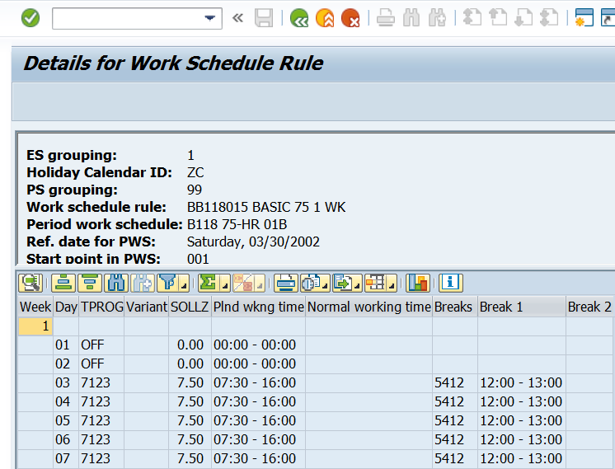
The schedule, including the meal period, is displayed. Select the back arrow to return to the previous screen.
Continue to view the details for each work schedule until the desired schedule is found.

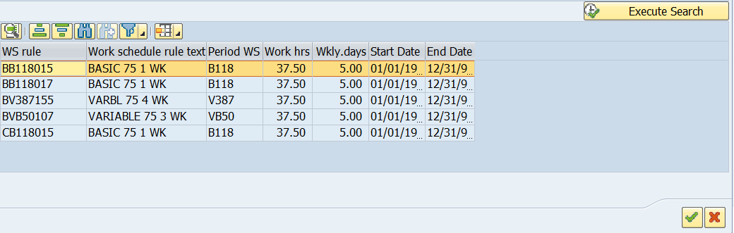
To change the employee’s work schedule to the desired schedule, highlight the work schedule rule and select the green check mark .

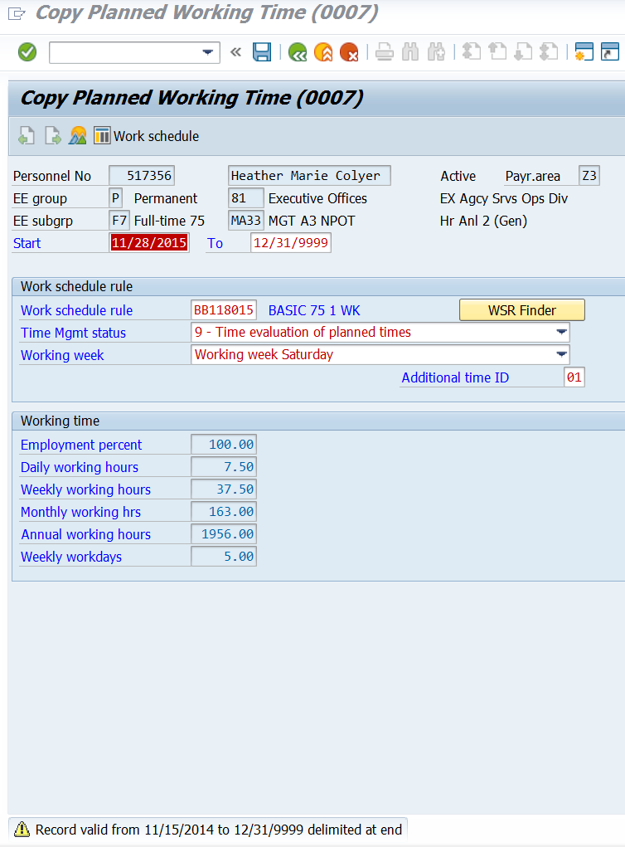
REMINDER: Work schedule changes should not be done retroactively!
Change the Start date to the date the schedule is to be changed (beginning of a pay period) and select the green check mark . Note the warning message displayed at the bottom of the screen. Select the Save icon to save the change.
NOTE: Future dated absences must be reviewed and may need to be resaved or adjusted in order to reflect the correct number of hours charged based on the new schedule change.
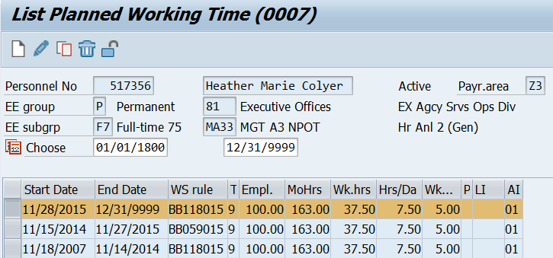
The work schedule for this employee was changed beginning 11/28/15.

Using the WSR Finder to Search for AWS, Rotating and Variable Schedules
First, determine the appropriate starting point by using the Valid Starting Point Dates spreadsheet. Note: The Valid Starting Point Dates spreadsheet contains valid start dates for pay area Z2. To calculate a valid starting point for pay areas Z1/Z3, users should:
- Determine the begin date for the work schedule change (first day of a pay period)
- Using the appropriate schedule rotation (Weeks), find the first date greater than the desired begin date for the work schedule change.
- Use the formula:
(Step B result – Step A result) + 1
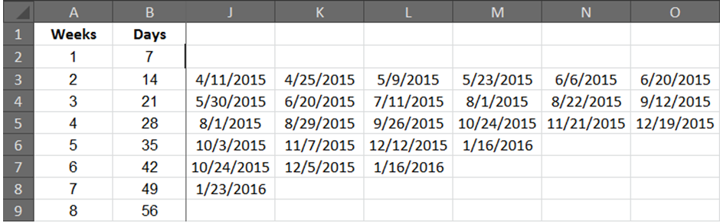
Following is an example of the calculation for a Z3 starting point for a four week AWS cycle beginning on December 12, 2015:
Step A = 12/12/15
Step B = 12/19/15
Step C = (12/19/15 – 12/12/15) + 1
= 7 + 1
= 8
Starting point 08 would be used for a four week AWS cycle beginning on 12/12/15 where the AWSO day occurs in the fourth week of the cycle.
Follow the same steps to search for an AWS schedule as you would for a Basic schedule using the Work Schedule Rule Finder (WSR Finder) button on IT0007 via PA51/PA61. Additional weeks can be added by selecting “Add Week” within the WSR Finder box.
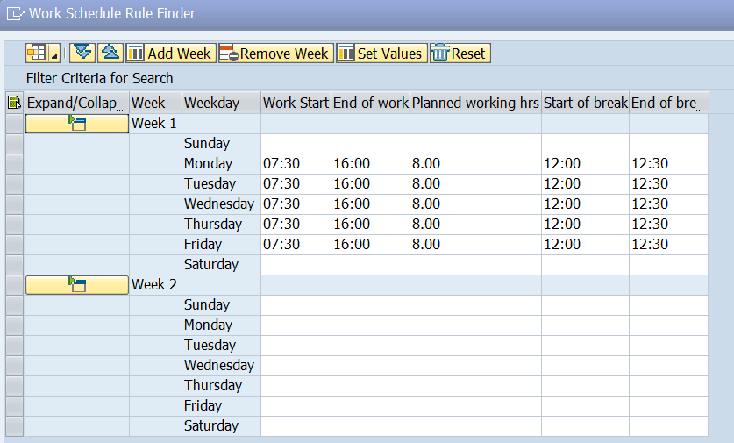
Select “Add Week” to add additional weeks to the rotation.
Select the “Week 2” line and then “Set Values” to add the schedule criteria for that week. Add the third and fourth weeks in the same manner.
Deselect the AWS OFF day In Week 4. In this example, Friday will be the AWSO day. Select to continue.

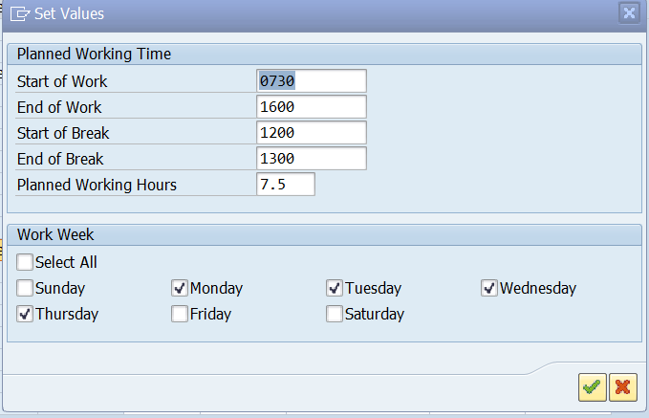

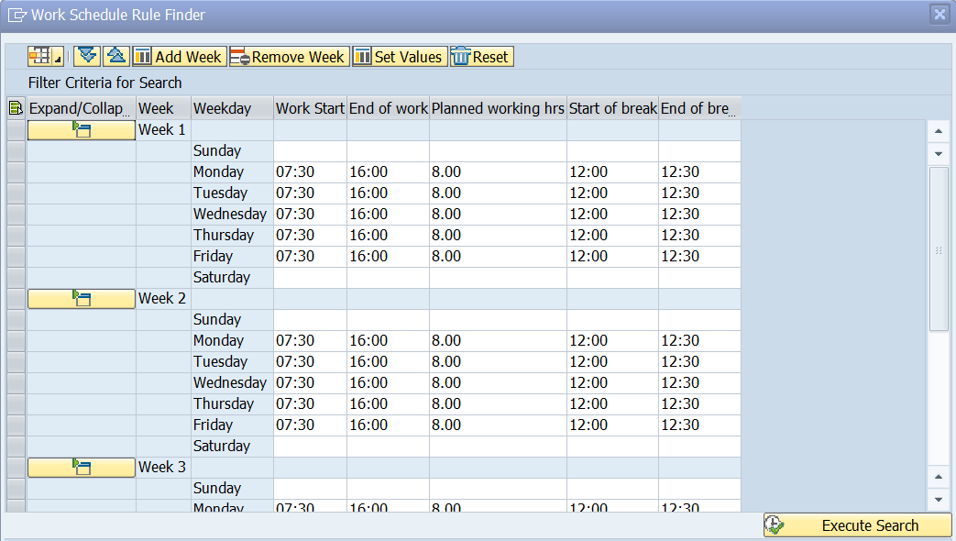
Select the Execute Search icon to search for schedules matching the criteria. Only configured schedules that match the criteria entered and the employee’s holiday calendar will be displayed. In this example, the employee is on a ZC holiday calendar.

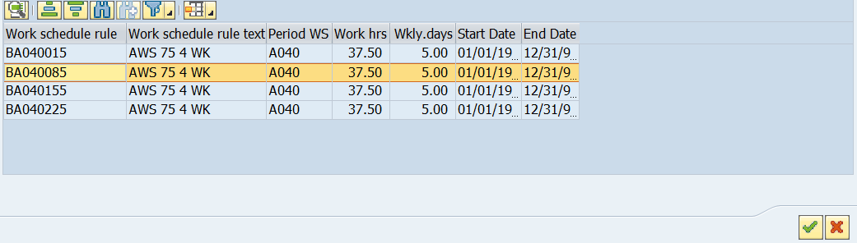
Expand the Work schedule rule column to view the entire schedule. View a schedule by selecting it and then selecting the details icon.
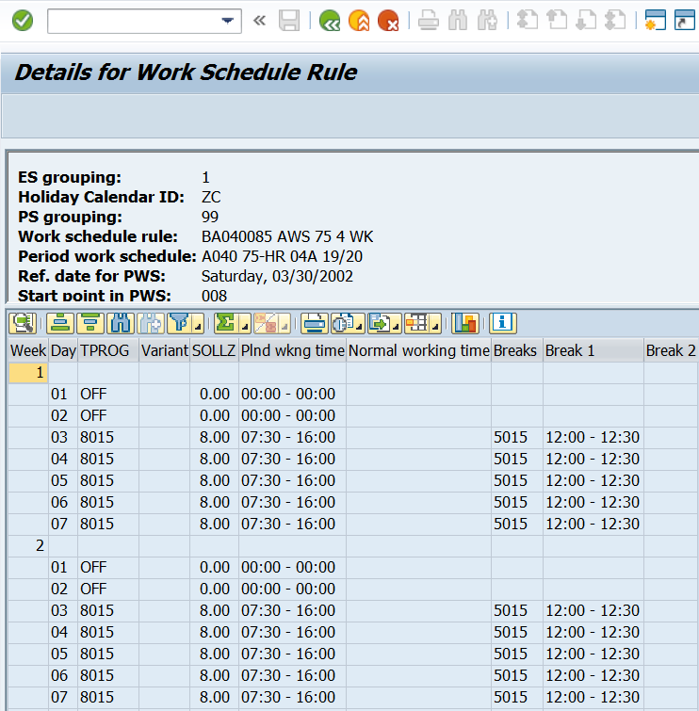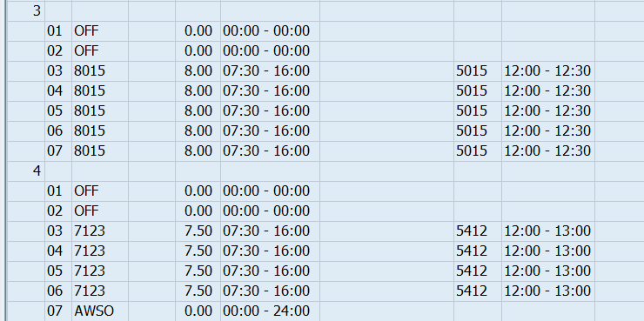
The Details for Work Schedule Rule box appears.
Note the AWSO day is on Friday in Week 4. The meal period is 1200-1230 in Weeks 1-3 and 1200-1300 in Week 4.
Select the back arrow to return to the previous screen.
To change the work schedule rule, select the desired schedule and then select the green check mark .

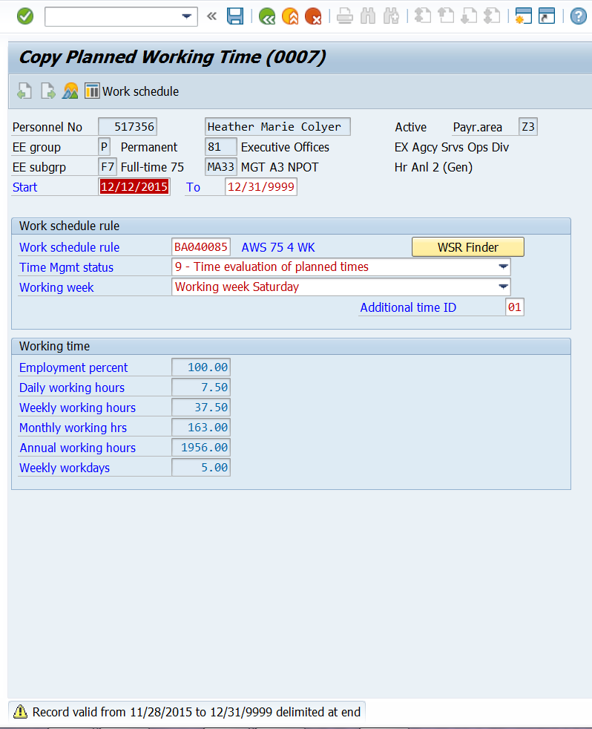
REMINDER: Work schedule changes should not be done retroactively!
Change the Start date to the date the schedule is to be changed (beginning of a pay period) and select the green check mark . Note the warning message displayed at the bottom of the screen. Select the Save icon to save the change.
NOTE: Future dated absences must be reviewed and may need to be resaved or adjusted in order to reflect the correct number of hours charged based on the new schedule change.

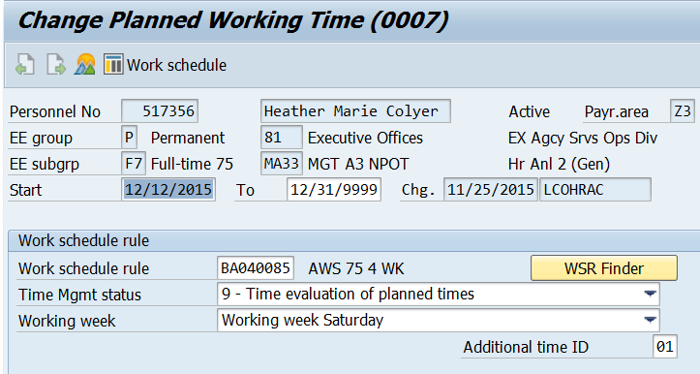
View the work schedule to confirm accuracy by selecting “Work schedule.”
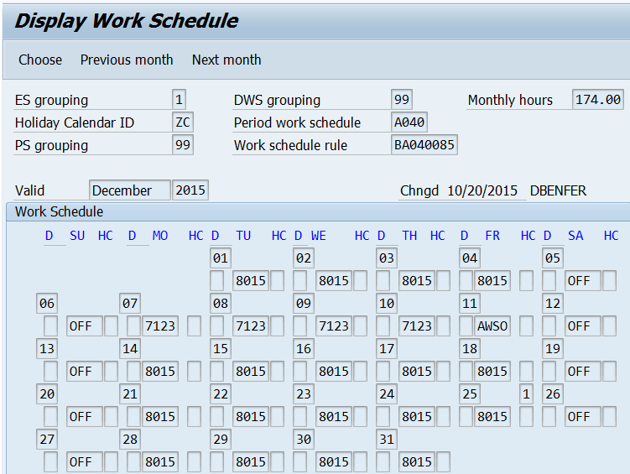
The 4 week cycle begins on 12/12/15. To view the remainder of the cycle, select “Next month.” Note the AWSO day falls on Friday in Week 4 of the cycle, confirming that the correct starting point was selected.
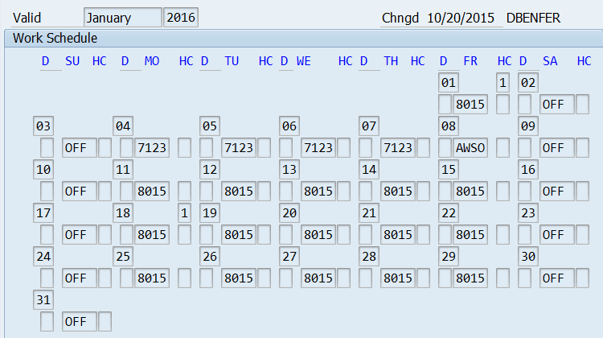

Creating a Default Layout to Include the Meal Period (Start of break and End of break) Fields
The “Start of break” and “End of break” (meal period) fields are not part of the standard display. Before using the Work Schedule Finder for the first time, a default layout should be created to include the meal period. This only needs to be done once, and can be completed via PA51 or PA61. It is not necessary to create a separate layout in each transaction. Following are instructions on how to create a default layout to add these fields:
Access the WSR Finder by selecting Planned Working Time (0007) in the Time Management Data tab and selecting the Overview icon OR by directly entering “0007” in the Direct Selection Infotype field.

Select the most recent work schedule rule on IT0007 and then select the Copy icon.
Select WSR Finder to continue. The Work Schedule Rule Finder box is displayed.

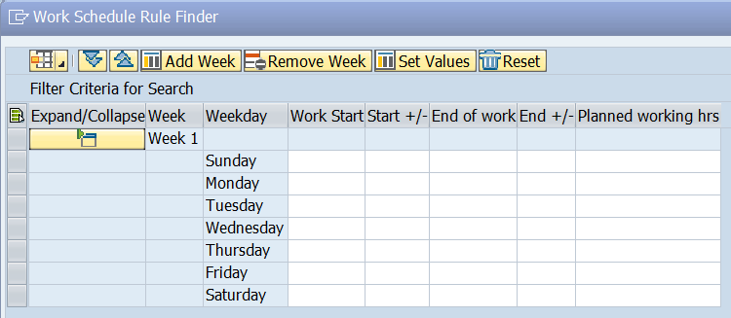

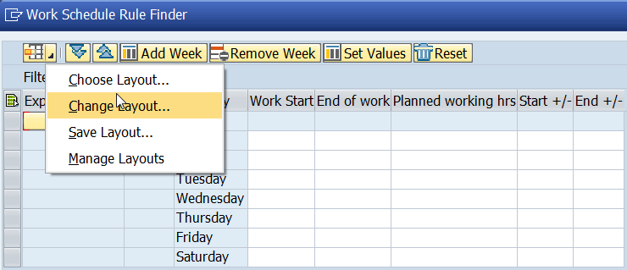
Click on the lower right corner of the “Choose layout…” icon to display the drop down menu choices. Select “Change Layout.”
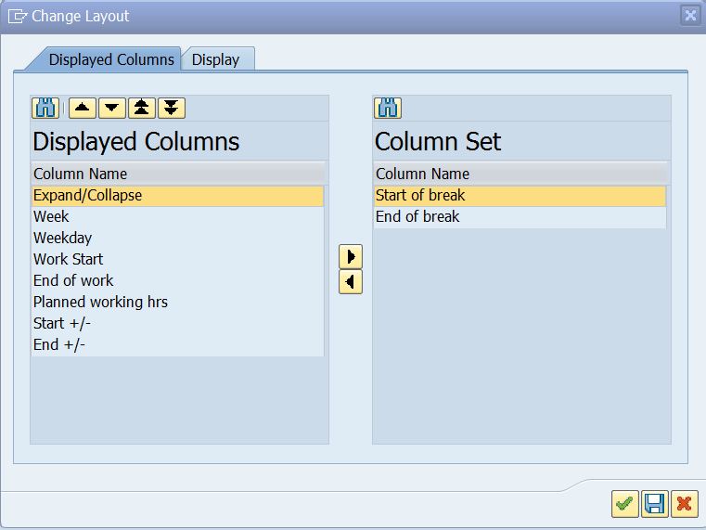
The “Change Layout” box is displayed. Select “Start of break” from the “Column Set” section and then select “Show Selected Fields (F7) “ to add your selection to “Displayed Columns.” Repeat this process to add “End of break.”
Remove “Start +/-“ and “End +/-“ by selecting each
and then selecting “Hide Selected Fields (F6)” . Select the “Save” icon to save your layout changes.
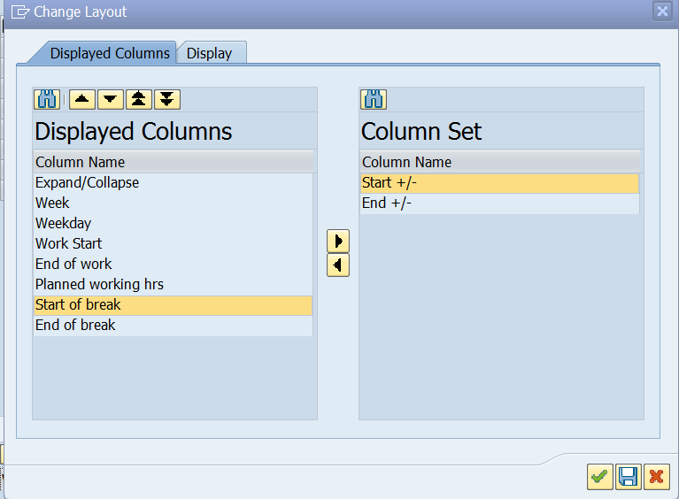
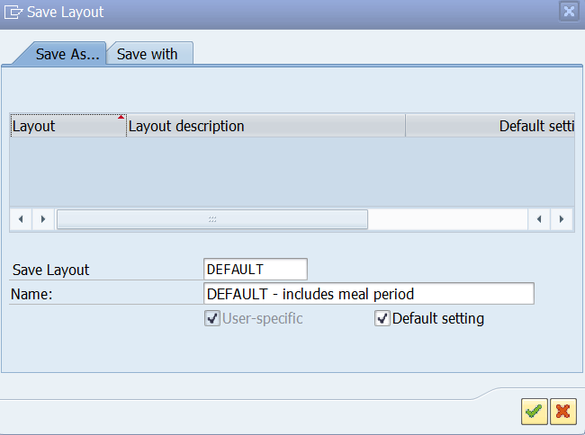
The “Save Layout” box is displayed. Add a name for the layout in the “Save Layout” block. Define the name in the “Name” block. Select the “Default setting” block to make this your default layout. Select the green checkmark to apply your changes .

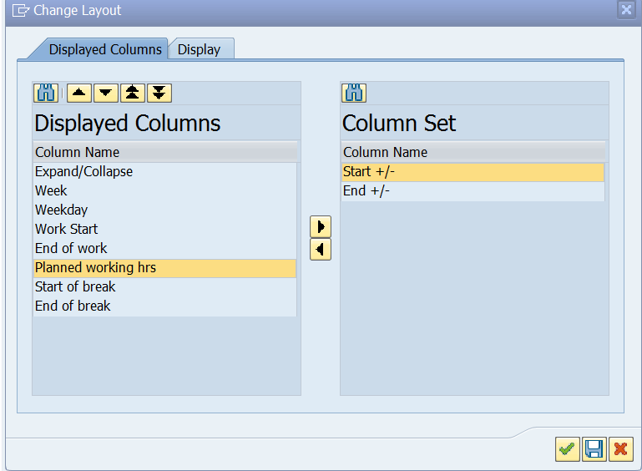
The “Change Layout” box is displayed. Select the “Close” icon  in the upper right corner.
Close out of the session and return to the initial PA51/PA61 screen.

This screenshot shows what the layout will look like after you’ve updated it.

Return to Page 1 of this document to begin using the WSR Finder button.

