Unlinked SPF Absence Report
(Y_DC1_32000946)

Instructions for viewing the unlinked SPF absence report:

- The report is located under the Time Advisor role in SAP.

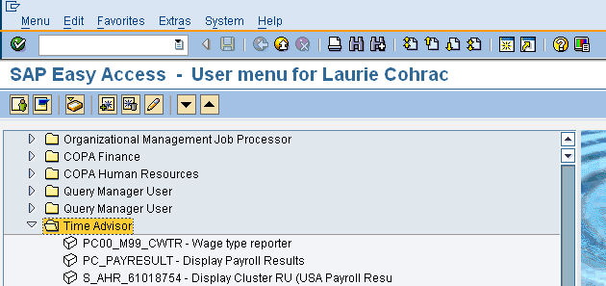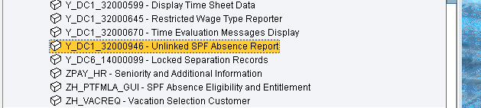

- Double click on the Unlinked SPF Absence Report. The screen shot below shows the initial screen. The “Period” defaults to “Other period”. A date range may be entered, or you may choose one of the other selections. Add your agency number in the “Personnel area” block and enter a specific Absence Type(s) in the “Optional Criteria” block. Click the “Execute” button located in the upper left corner to run the report. NOTE: if running the report for a large period of time, you may want to run it in the background. Instructions for running an SAP reports in the background are available.

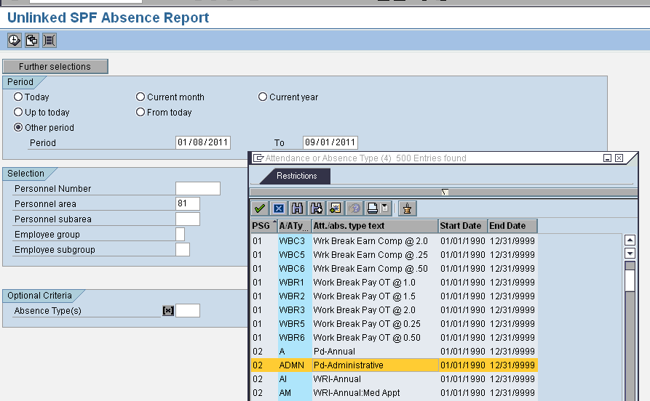

- A yellow error message, (Absence Type must begin with a Y), will be displayed. Bypass this message by clicking on the green check mark in the upper left corner of the screen and the report will run.

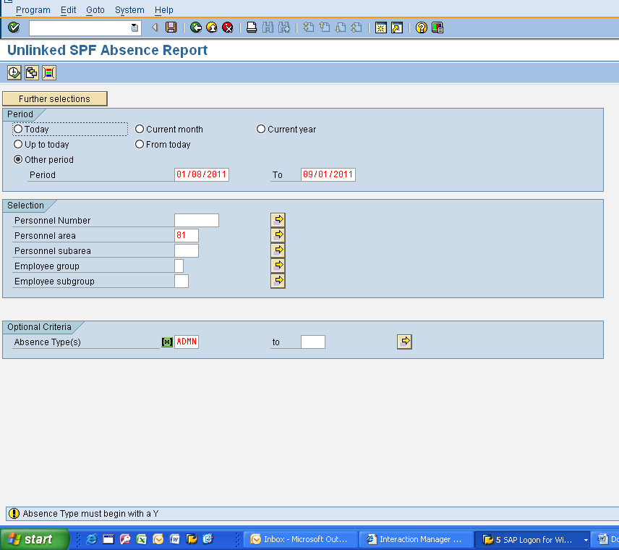

- Following is an example of the report results:

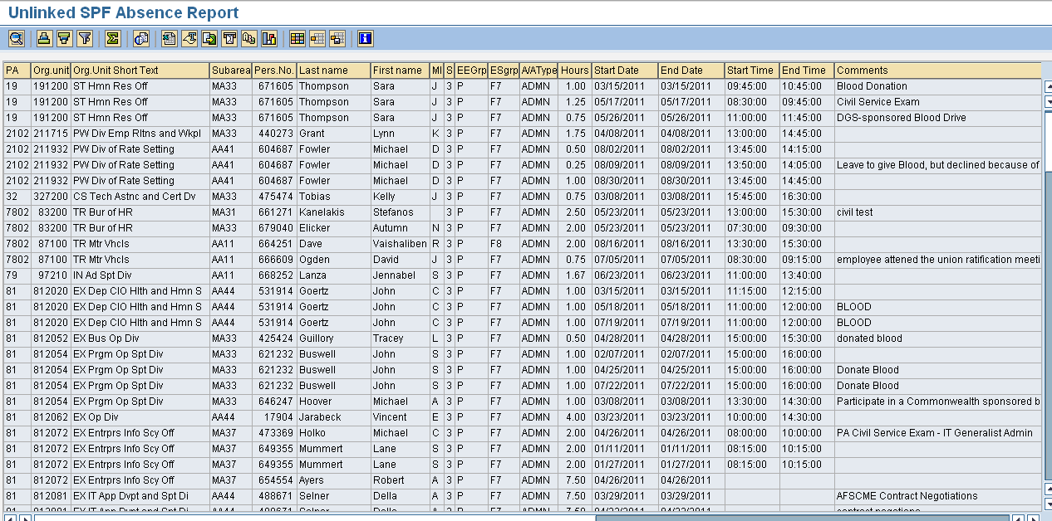

Note: results will be displayed for all employees within the agency during the date range for which the report was run even if the employee(s) has since left the agency.

Questions?
If you have any questions regarding these instructions, please submit an HR help desk ticket in the time category. You can also call the HR Service Center, Agency Services & Operations Division at 877.242.6007, Option 2.

