This guide provides information regarding the generation and research of Leave Service Credit (LSC). LSC determines the rate at which an employee accrues leave. Employees earn one LSC at the end of each pay period, provided they were paid at least one hour during the pay period. Employees also earn one LSC at the end of each pay period while absent on a long-term unpaid military absence with benefits and/or work-related disability leave of absence. Prior to 1979, employees only earned one month of LSC if they were paid for at least 10 days during the month.

Who is Responsible for the Research and Correction of LSC?
It is the agency time advisor’s responsibility to analyze and adjust LSC in SAP. Therefore, when an employee is rehired, transfers from an agency with a reciprocal agreement, is considered a dual employee, or transfers between payroll areas, LSC should be verified and adjusted accordingly.

What Periods of Employment Count Towards LSC?
LSC includes ALL periods of service in an active pay status as a commonwealth employee in the executive, legislative, and judicial branches of state government and where a reciprocal leave agreement exists, except service in specific job classifications. Military service prior to commonwealth employment and/or service in another public jurisdiction are not eligible. To determine periods of service that count towards LSC, reference, 530.7 Absence Program Manual, Updated Appendix M – Reciprocal Leave Agreements, and MD 505.7 Personnel Rules.

What Form Can Be Completed to Document Prior Employment?
During the Onboarding process, employees are asked a series of questions to determine if they had prior service. If the employee indicates that they may have had prior service, the employee is encouraged to complete the Employee Prior Service Form via www.myworkplace.pa.gov (select the Employee Resource Center tile, then search “Employee Prior Service Form”. Employees are instructed to return the completed form to their agency Human Resources Office on their first day of work.

Upon receipt of the Form, agency time advisors should verify all prior service worked under the Prior Service section of the form and determine the total service credits earned (based on pay periods). Credits previously earned can be verified via SAP or IPPS (prior to SAP Go-Live).

How Do I Review Leave Service Credit Previously Earned in IPPS or SAP?
An employee’s LSC balance can be viewed in SAP using several transactions. Details and instructions on running each transaction are provided under the Leave Service Credit Earned via SAP Appendix. To review leave service credit earned and/or employment periods prior to the SAP Go-Live date, reference the step-by-step instructions under the Leave Service Credit Earned via IPPS Appendix. SAP “Go-Live” Dates occurred on 1/18/2004 for Z1 pay group; 1/17/2004 for Z2/T2 pay group; and 1/10/2004 for Z3/T3 pay group.

Note, if credits were not previously maintained in IPPS or SAP, the Leave Service Credit Worksheet located on the OA, Leave website, may be used to convert dates of service into total pay periods of credited service. The worksheet should be used in conjunction with the Employee Prior Service Form to determine how many total LSCs should be added to SAP upon the employee’s rehire or transfer date.

How Do I Adjust Leave Service Credit in SAP?
LSC is maintained in SAP as total number of pay periods. Unlike quota corrections where adjustments are made to increase or decrease the existing quota by a certain amount, LSC adjustments are made to replace the existing LSC value with a new value going forward. The effective date used to reset an employee’s LSC will typically be the most recent date of hire or a date prescribed in a grievance or arbitration award.

If a LSC adjustment should have been entered for an effective date that is prior to the Earl.pers.rec.date on IT0003 (Payroll Status), submit a Help Desk. The HR Service Center, Time Services staff will adjust the employee’s LSC as of the current Earl.pers.rec.date and determine if any additional quota adjustments are required as a result of the retroactive adjustment.

When an employee is Rehired and their most recent separation date in SAP is prior to the “Earl.pers.rec.date” found on Display Time Data (PA51), Payroll Status (IT0003), LSC may need to be reset as of the most recent date of hire in SAP if the employee worked in a classification that was NOT excluded from earning LSC.

When an employee Transfers from an agency with a Reciprocal Leave Agreement and worked in a classification that was NOT excluded from earning LSC, the period(s) of employment must be verified and the LSC must be reset as of the most recent date of hire in SAP.

When an employee is assigned to more than one active commonwealth position, they are Considered a Dual Employee. SAP maintains separate records of their employment with each agency by assigning two different personnel numbers. If the employee earns LSC in both positions, adjustments to grant LSC earned at one agency may be necessary each time an employee returns from a period of leave without pay at the second agency. This ensures that the employee is earning quota at the appropriate rate if they hold a job classification that is eligible to earn quota.

When an employee Transfers between Payroll Areas, an error message (PA – PayArea Change – Ck LSC & Quotas) is generated and appears on the Time Evaluation Messages Display report (Y_DC1_32000670). A review of the Cumulated Time Evaluation Results (PT_BAL00) Report for day balances 6015 and 6017 for dates surrounding the employee’s transfer must be reviewed to ensure LSC generated appropriately.

Reference How to Reset Leave Service Credit for instructions and processes on how to adjust an employee’s LSC.

Where to Get Help?
Policy related questions should be directed to ra-oaleave@pa.gov.

System related questions should be directed to OA, Time Services via an HR help desk ticket in the time category or call the HRSC, Time Services team at 877.242.6007, Option 2. Field time advisors should direct any questions to their Central Agency Time Advisor.

Leave Service Credit Earned via SAP
Time Accounts (PT_DOW00)
Time Accounts (PT_DOW00) will display an employee’s LSC as total pay periods as of the current date. Timekeepers and Time Advisors can access this transaction.

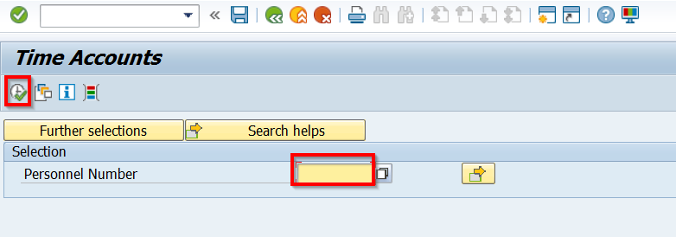
Access the report by entering the transaction code in the Command Field box or by selecting it from the User Menu.
Enter the personnel number of the employee and select execute .

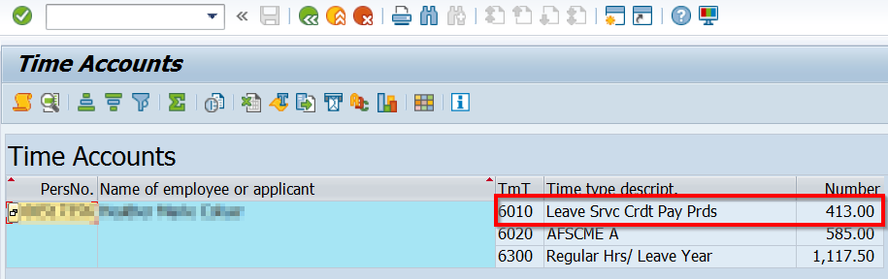
The report will display total pay periods of LSC as of the current date.

Time Statement (PT61)
The Time Statement (PT61) will display an employee’s LSC as years and pay periods. LSC can be viewed for a specific date or a date range. Timekeepers and Time Advisors can access this transaction.

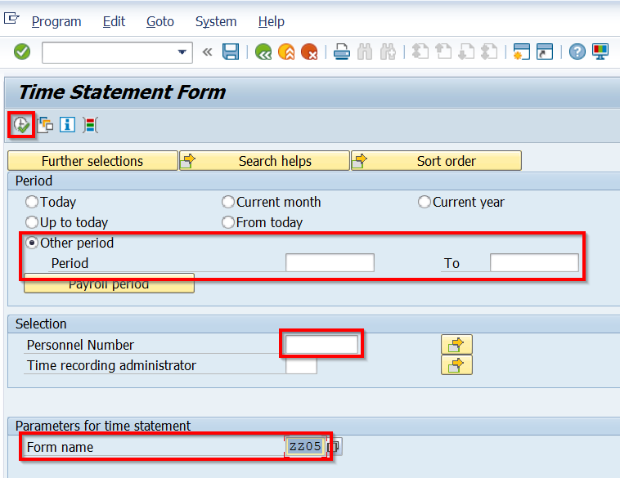
Access the report by entering the transaction code in the Command Field box or by selecting it from the User Menu.
Select “Other Period” and enter the date or date range you wish to view. Results will appear through the most recent date time evaluation ran.
Enter the personnel number.
Change the form name to reflect “ZZ05”.
Execute .

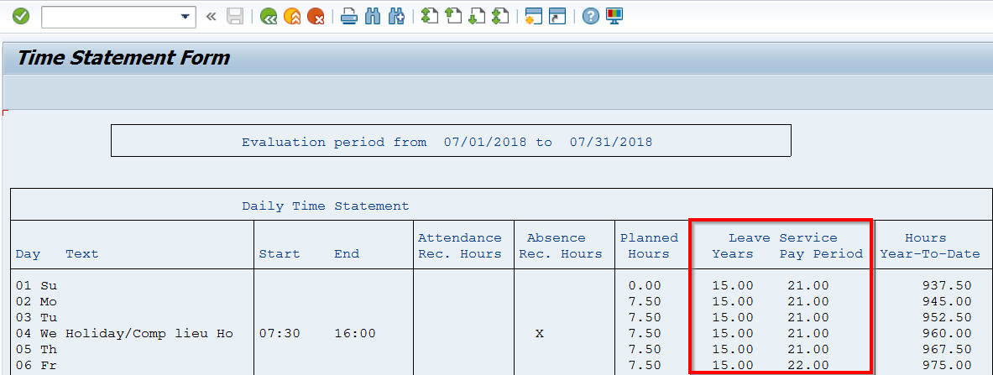
Note that one pay period of leave service is credited on the last day of the pay period, provided the employee worked one hour in the pay period.

Seniority and Additional Information (ZPAY_HR)
Seniority and Additional Information (ZPAY_HR) will also display an employee’s LSC as years and pay periods. Information provided on this screen updates after payroll has processed for the employee’s pay area. Only Time Advisors can access this transaction.
Access the report by entering the transaction code in the Command Field box or by selecting it from the User Menu.
Enter the personnel number and click OK.

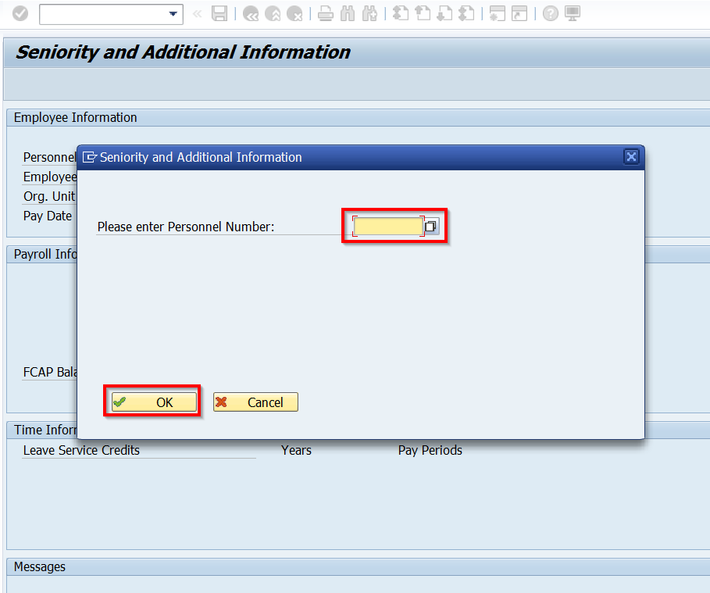
LSCs appear under the Time Information section.
The results from the most recent pay date will appear. Use the drop-down arrow to view past pay date results.
REMINDER: Results on this screen update after payroll processed.

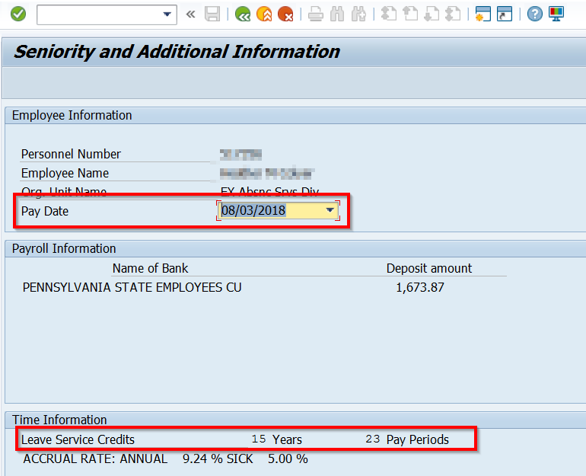

Cumulated Time Evaluation Results (PT_BAL00)
Cumulated Time Evaluation Results (PT_BAL00) is a report used to research and view a variety of time data. LSC can be tracked and researched on PT_BAL00 using Day Balances 6015 (Leave Serv. Credit Years) and 6017 (Leave Serv. Credit PP’s). Timekeepers and time advisors have access to this transaction. Note, using Day Balance 6010 (Leave Service Credit Pay Periods) will produce a result of earned credit for each pay period.

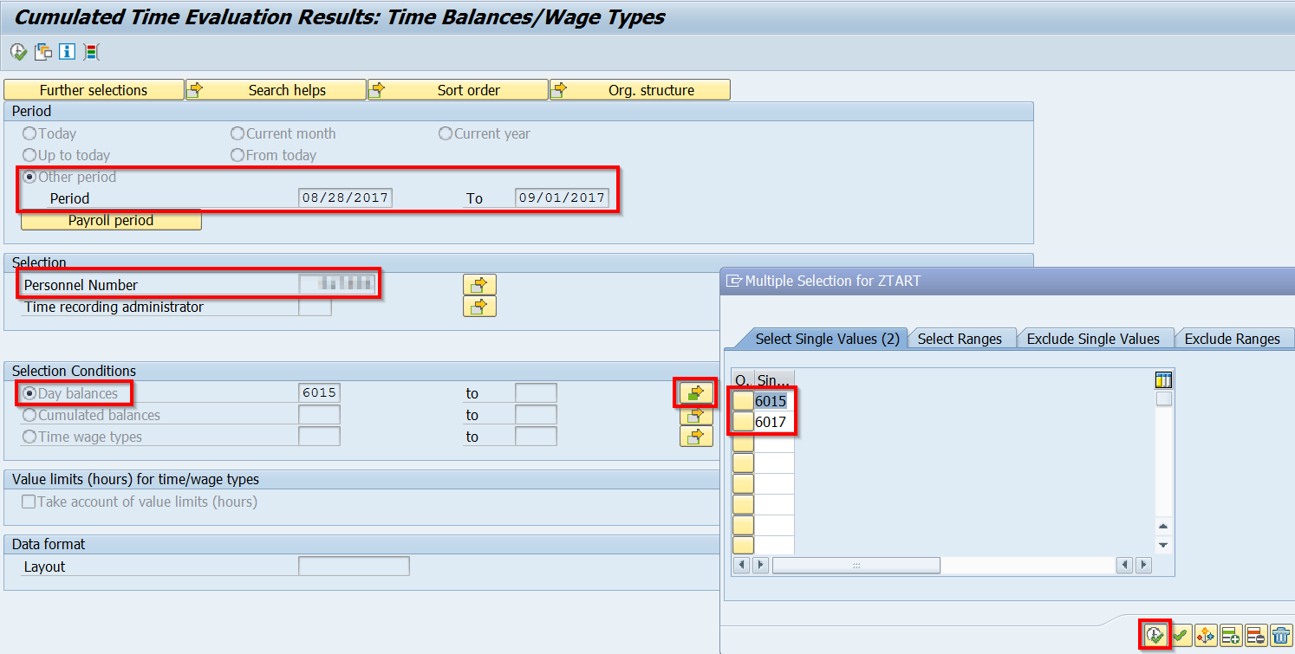
Access the report by entering the transaction code in the Command Field box or by selecting it from the User Menu.
Select “Other Period” and enter the date or date range you wish to view. Results will appear through the most recent date time evaluation ran.
Enter the personnel number.
Select the Day balances radio button and click the Multiple Selection button to enter 6015 and 6017). Select copy to accept the values.
Select Execute to run the report.
A Note About Dates:
Use the same start and end date to view LSC as of a specific date, such as last day of employment.

Use a date range if you want to see how an employee’s LSC generated during a specific period, such the pay periods before and after a payroll area switch.

If using the 6010 Day Balance, a date range from the most recent hire date or SAP Go-Live date through the current date will provide results for each pay period where credit was earned. If the employee recently had a reset of LSC, a result more than one will show.
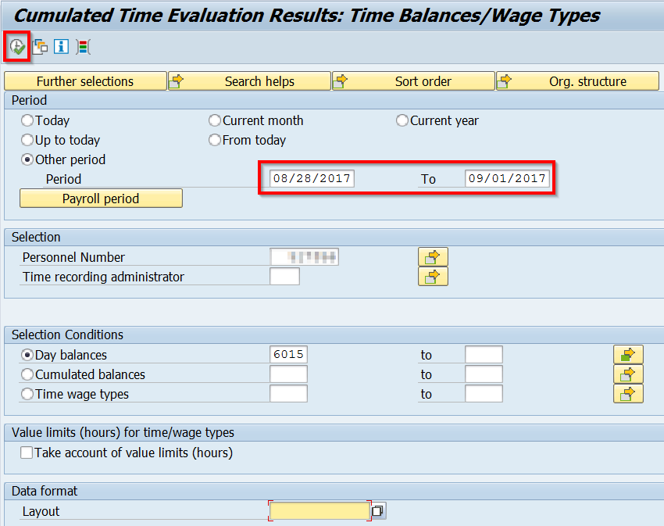
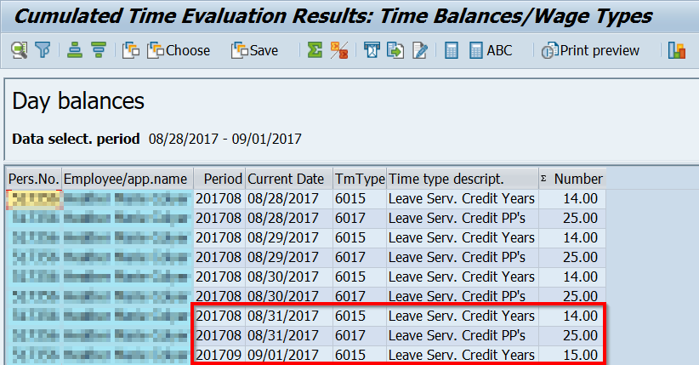
The 6015 and 6017 time types work together. Once the value of 6017 (LSC PP’s) equals 26, the 6015 (LSC Years) time type will increase by one. LSC is granted on the last day of the pay period.
In this example, the employee had 14 years and 25 pay periods of LSC on 8/31/2017. At the end of the pay period on 9/1/2017, they received one LSC, resulting in 15 years of LSC.

Leave Service Credit Earned via IPPS
Access to the IPPS Legacy Screens can be requested by completing the HRISD Authorization Request Form.

The IPPS Time and Attendance History Screens, Transaction PTA113, will reflect LSC earned prior to the SAP Go-Live date. If PTA113 does NOT provide the LSC balance, the employment history screens should be reviewed to determine if the employee worked in a job classification that was eligible to earn LSC.

The IPPS Employment History Screens, Transaction PET115, will reflect employment periods by agency. To view the details of the employment history, including job classifications and transaction codes, view Transaction PET116.

Enter your Oracle UserID (8 digits) and Password, then click Submit. On the next screen, enter the employee’s EmpNo (6 digits), then click PTA113.

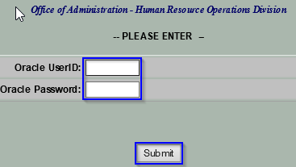

Time and Attendance History Screens
To view previously earned LSC, enter the employee’s personnel number in the EmpNo field (6 digits), then select PTA113.

Leave Balance and Seniority Data, Transaction PTA055 and PTA056, will also provide an employee’s LSC balance.

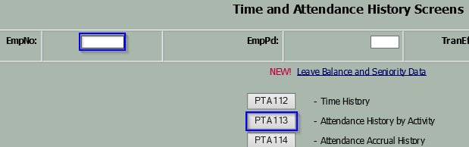

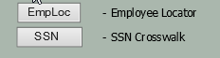
The Employee Locator and SSN Crosswalk can be used to identify previously assigned personnel numbers.

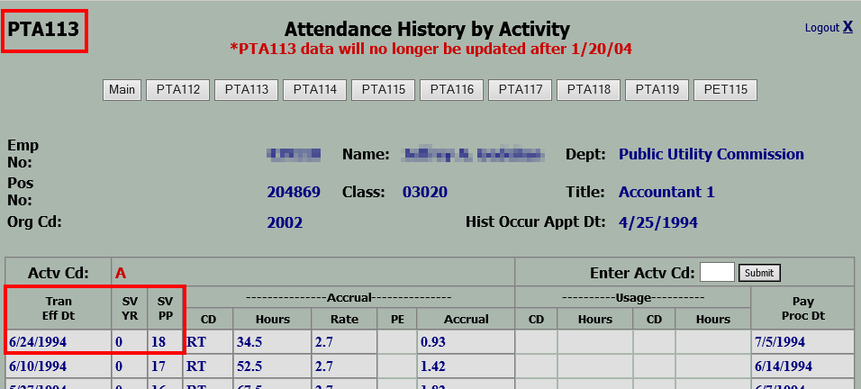
In this example, the employee accrued a total of 18 pay periods of LSC as of 6/24/1994.

Employment History Screens
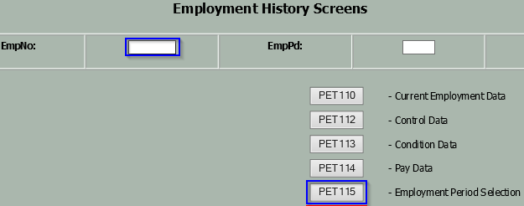
To view previous commonwealth employment, enter the employee’s personnel number in the EmpNo field (6 digits), then select PET115.

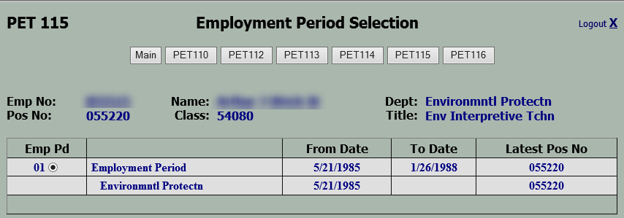
To view the details of the employment period, select PET116.

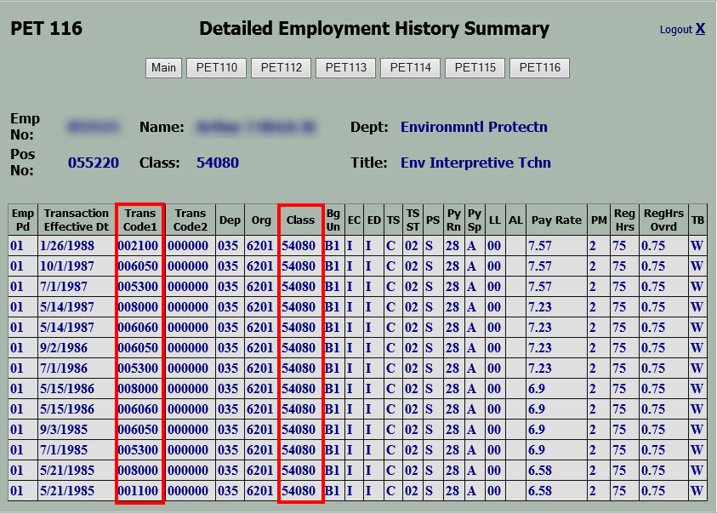
Transaction Codes and Special Factors may be used to translate codes identified in the Trans Code1 and Trans Code2 columns.

The Class column provides the job classification assigned as of the date listed in the Transaction Effective Dt column. Use this information in conjunction with the LSC Worksheet to determine the number of LSCs the employee earned during that time.

How to Reset Leave Service Credit
LSC is maintained in pay periods only. To convert a “years and pay periods” value to a total “pay periods” value, multiply the number of years by 26 and add in any remaining pay periods.

Example: Convert 12 years, 15 pay periods into total pay periods.
12 years x 26 pay periods/year = 312 pay periods
312 pay periods + 15 pay periods = 327 total pay periods

Once the employee’s LSC value has been determined, time transfer type 6010 (Reset Leave Service Credit) is used to replace the existing LSC value with the new value. The adjustment is done using transaction PA61 (Maintain Time Data), Infotype 2012 (Time Transfer Specifications), Sty 6010.

Resetting LSC due to Rehire
As a courtesy, the HR Service Center identifies rehired employees who meet this criteria and will manually update LSC records of impacted employees to grant LSC previously earned in SAP for an employment period that ended prior to the “Earl.pers.rec.date on IT0003. Time advisors are notified via a closed HR/Pay Help Desk Ticket that a rehired employee’s LSC has been reviewed and reset as appropriate.

In the event an employee is missed by the HR Service Center, time advisors can run the Cumulated Time Results (PT_BAL00) report in SAP for day balances 6015 and 6017 in order to obtain the employee’s LSC balance as of the most recent date of separation. This information is then used to reset the employee’s LSC as of the most recent date of hire. Reference Process to RESET LSC in SAP for step-by-step instructions on how to reset LSC in SAP.

Suggested Text on the Action: The employee was rehired xx/xx/xxxx and the most recent separation date of xx/xx/xxxx is prior to the earliest retro date on IT0003. As a result, LSC earned in the previous employment period does not carry forward and must be manually reset. IT2012 record has been entered to reset LSC effective the rehire date to reflect xx pay periods of LSC.

Resetting LSC due to Reciprocal Leave Agreement
Upon receipt of the Employee Prior Service Form, which was completed during Onboarding, the time advisor must contact the former agency’s time advisor to confirm the dates of employment, any periods of leave without pay, and if the job classification(s) held were eligible to earn LSC.

- The time advisor will then use the information gathered to complete the LSC Worksheet to determine the total pay periods of LSC that must be given to the employee.

- The time advisor must complete Section 2 of the Employee Prior Service Form and update the employee’s LSC in SAP. Reference Process to RESET LSC in SAP for step-by-step instructions on how to reset LSC in SAP. The completed Employee Prior Service Form, the LSC Worksheet, and any other supporting documentation, such as an email from the former time advisor, MUST BE filed in the employee’s Electronic Official Personnel File (eOPF). A copy should also be provided to the employee.

Suggested Text on the Action: The employee transferred from [AGENCY] on xx/xx/xxxx. As a result, LSC earned in previous employment period(s) must be manually reset. IT2012 record has been entered to reset LSC effective the rehire date to reflect xx pay periods of LSC.

Resetting LSC due to Dual Employment
Agency time advisors can only view the record assigned to their agency; therefore, agency time advisors must work together to obtain LSCs earned in the other agency. You can identify a dual hire employee as one who has a RefPersNo in SAP. National Guard Members are NOT considered dual hires, so this information does not apply to them. As a reminder, although employees may also earn leave quota in each position, quota balances do not transfer between positions.

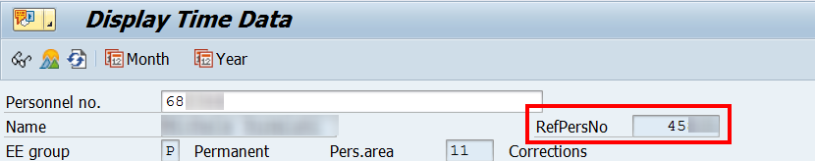

- The time advisor in Agency A must contact the time advisor in Agency B and request a screenshot of Cumulated Time Evaluation Results (PT_BAL00) using day balances 6015 (Leave Serv. Credit Years) and 6017 (Leave Serv. Credit PP’s) for the last day the employee was in an active pay status at Agency B.

- The time advisor for Agency A follows the steps to reset the employee’s LSC to include the LSC earned in Agency B. The effective date of the adjustment will be the employee’s date of hire or rehire if they are a new employee with Agency A, OR the date they return from leave without pay at Agency A. Reference Process to RESET LSC in SAP for step-by-step instructions on how to reset LSC in SAP.

Suggested Text on the Action: The employee is considered a dual hire and returned to work after a period of long-term LWOP; reference other P00xxxxxx. As a result, LSC earned in both positions must be manually reset. IT2012 record has been entered to reset LSC as of xx/xx/xxxx to reflect xx pay periods of LSC.

Resetting LSC due to Payroll Area Transfer
When an employee transfers from one payroll area to a different payroll area, the transfer is defined as a Preferred or Unpreferred transfer based on the effective date of the transaction.

For a Preferred transfer, the effective date is the first day AFTER the losing payroll area’s pay period ends. If the transfer was NOT effective on the first day after the losing payroll area’s pay period ends, an extra line of history should be recorded on PA51, IT0001, that reflects the 1st day AFTER the losing payroll area’s pay period ends. If the extra line of history on IT0001 does not exist, the employee’s LSC may be incorrect. Reference Process to RESET LSC in SAP for step-by-step instructions on how to reset LSC in SAP.

For a Preferred and Unpreferred Transfer - IT0001 Updated Correctly, the employee will receive one LSC for the full pay period worked in the losing agency and they will receive one LSC for the half pay period worked in the gaining agency. Employees are entitled to one LSC if they have worked/been paid for at least one hour in each pay period/payroll area. No LSC adjustment is needed.

Note, when an employee transfers with a Preferred Date from Payroll Area Z2 to Payroll Area Z1, the employee will receive one LSC on the last day of the Z2 payroll area. They will also receive one LSC on the last day of the Z1 payroll area. This is because the employee is active on the last day of the pay period for each payroll area. Unless the employee works at least one hour on the first day of the transfer (Saturday) in the new agency (payroll area Z1), the additional LSC must be removed. Note: The effective date used to rest the employee’s LSC in this scenario must always be the first day of the new agency’s pay period (Sunday).

For an Unpreferred Transfer – IT0001 Not Updated Correctly, the system may not generate LSC for the losing payroll area at the time of transfer. In this case, an adjustment is required to grant the missing LSC to the employee. The effective date should reflect the date the missing LSC would have been earned (usually the last day of the losing agency’s pay period).

Suggested Text on the Action: The employee switched payroll areas on xx/xx/xxxx; Unpreferred Transfer. As a result, the employee is missing one LSC and the LSC must be manually reset. IT2012 record has been entered to reset LSC effective the last day of the losing agency’s pay period to reflect xx pay periods of LSC.

Process to RESET LSC in SAP
Transaction PA61 (Maintain Time Data).
- ENTER the personnel number.
- From the “Working times” tab, select “Time Transfer Specifications (2012). You can also type “2012” in the Direct Selection Infotype field.
- Enter “6010” in the STy field.
- Enter the effective date. Ensure that the same date is used for both the “From” and “To” dates.
- Select “Create” .
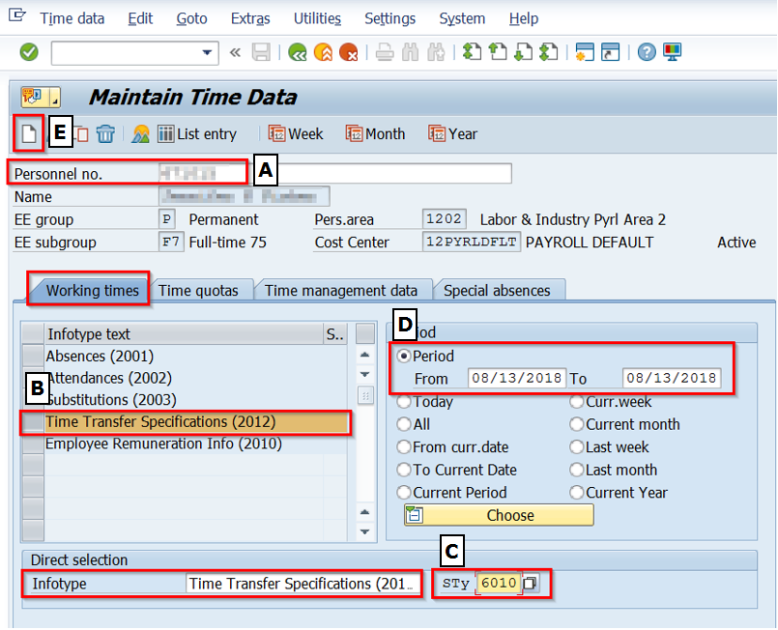

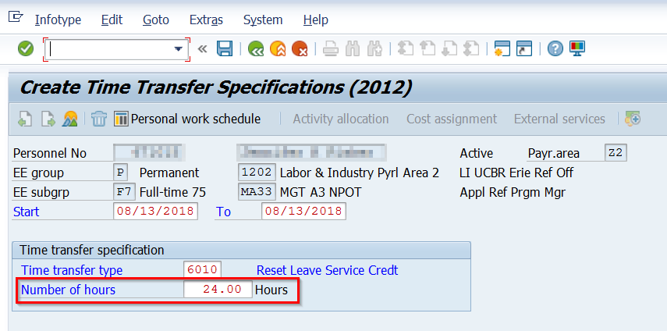
Enter the new LSC value in the “Number of hours” field.
Note: Although the field states “Hours”, it represents “pay periods” of LSC.

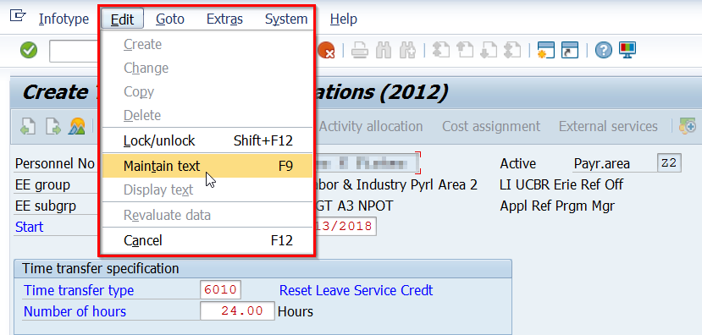
REMINDER TO MAINTAIN TEXT!
From the menu bar, follow the path “Edit” then “Maintain Text”. The F9 key can also be used to access the text screen.
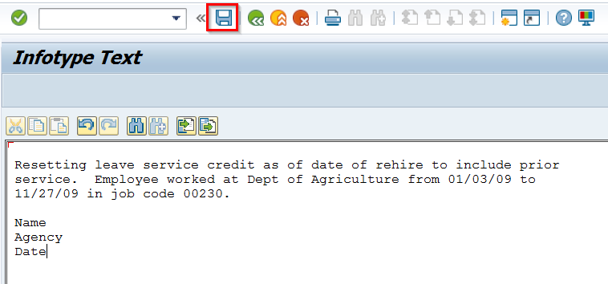
Ensure the text includes enough details to explain the reason for the adjustment, the user’s name, agency, and the date the adjustment is entered. Reference suggested text in the specific Process section below.
After entering the text, select “Save” (Ctrl+S).
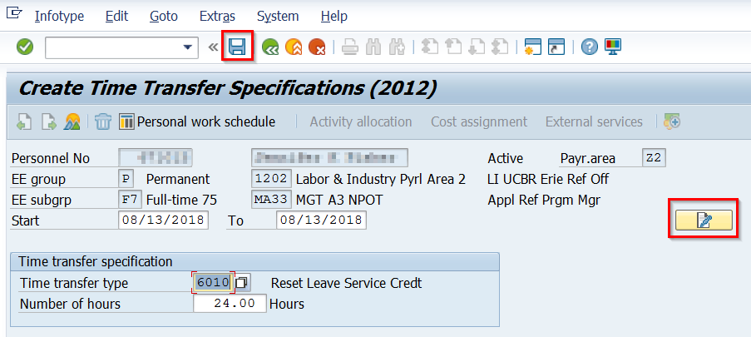
Note the text icon indicates that text has been saved.
Click “Save” to complete the adjustment.
The employee’s LSC and quotas (if applicable) will update after nightly time evaluation runs.

