Emergency FMLA Expansion Act Absences
Systems Overview

Quota Extensions
The deadline to use quota extended from leave calendar year 2019 has been postponed. This includes annual/combined, personal, compensatory and holiday extensions. The 2019 extended quotas will be available for use through the 7th pay period in 2021. Additionally, 2020 excess leave will extend as normal through the 7th pay period in 2021. These deadlines may be extended further should the current state of emergency continue beyond these dates. Employees will be given a minimum 60-day notice to use extended leave.
ESS Leave Request

- Influenza dropdown is presented for the new absence types (ES, ESF, ESA and ECC) but is not validated.
- A pop-up box notifying the user that the absence will be granted contingent upon eligibility and compliance with the requirements of the Act will be presented when selecting one of the new absence types (ES, ESF, ESA and ECC). User must acknowledge by selecting “Yes” to proceed with the absence request. Selecting “No” returns the user to the entry screen and to select a different absence type.

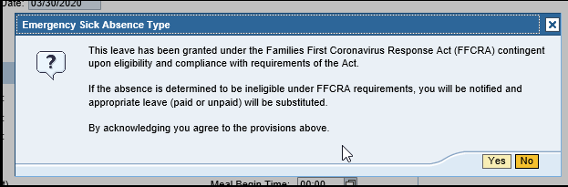

- For absence type ESF, two new relationships have been added the dropdown for Family Relationships.
  - Childcare – if using ESF for childcare purposes. Enter COVID-19 in Other Remarks.
  - Other – if using ESF to care for another individual and family relationship does not exist in the dropdown, select “Other.” User must enter Remarks indicating specific relationship.
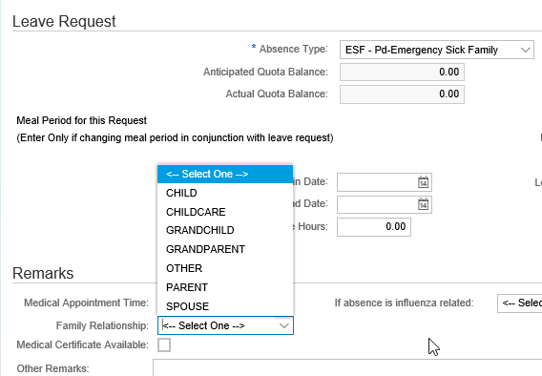
Workflow
The new absence types (ES, ESF, ESA and ECC) follow the same process as FMLA absence requests. The absence request will be sent to the Supervisor and FMLA Specialist simultaneously. The Supervisor can acknowledge the request and add remarks but cannot approve the request. All approvals will be handled by the FMLA Specialist.
Full Time Evaluation
- Kronos
  - New absence types (ES, ESF, ESA and ECC) will be available in Kronos. Effective 10/4/2020, these absence types have been replaced with the following:
    - COVID (no quota deduction)
    - COVID-ES (deducts from quota)
    - COVID-ESF (deducts from quota)
    - COVID-ECC (deducts from quota)
    - COVID-ESA (deducts from quota)
- PLCB Point of Sale (POS)
  - Absences will be entered as Code 72 (ADMN) in POS. Absence will pass to the Error Table for PLCB staff to review and update to appropriate absence type (ES, ESF, ESA and ECC).
- ZIPY
  - New absence types (ES, ESF, ESA and ECC) will be available in ZIPY.
    - For absence type ESF, relationship/remarks will need to be entered via ESS or directly to IT2001.
PTFMLA Workbench
- New event – “FMLA-Emergency Childcare”
  - The following absence types can be linked by the FMLA Coordinator to this event
    - ESF
    - ECC
    - The following Y absences types: YA, YCMP, YH, YUFO, YC, YP

- Eligibility requirement
- At least 30 calendar days of service since their most recent date of hire
- Not a separate entitlement - Does not add an additional 12 weeks to the 12 weeks in a 12-month period.
- First 10 days of entitlement must be coded to paid/unpaid Y absence types noted above or ESF and linked. Note: Employees cannot use ECC for the first 10 days of absence.
Workers’ Compensation Claim Form, ESS/SAP
Updates to the Workers’ Compensation claim reporting form for all five event types in SAP follow:
- Nature of Injury - Code 83 for COVID-19
- Cause of Injury - Code 83 for Pandemic

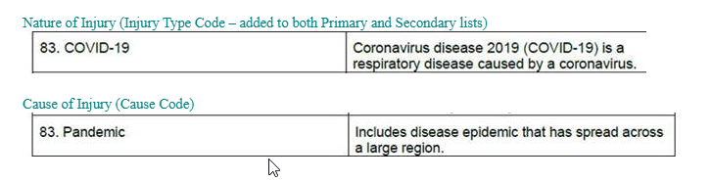

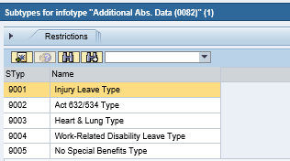

Reporting

- New absence types are available in standard and custom SAP time reports

Manual Processes

- Employees on BNOHR work schedules or employees with TMS 0
  - Quotas must be manually created via PA61/IT2006 and PA61/IT2013
    - Submit HDT
- Per Diem Employees
  - Non-leave accruing; cannot create quotas. Absences must be manually tracked by Agency to ensure policy compliance and avoid over usage of absence types.
    - Submit HDT
      - Include start/end date of absence(s), absence type/wage type and daily compensation amount from IT0008
        - HRSC creates CM to request payment via IT2010
- Employee Subgroup (P7/P8)
  - Quotas were loaded, and hours zeroed out. Hours will be manually loaded via PA61/IT2013 based upon the number of hours the employee worked in the previous 6-month period (per Emergency FMLA Expansion Act) for employees who are NOT working a consistent schedule.
    - Submit HDT upon part-time employee’s need to use absence to have quota hours loaded.
  - HR Service Center Time Services Division will run a weekly report to identify employees hired after 4/1/2020 and remove quota.
    - Submit HDT upon part-time employee’s need to use absence to have quota hours loaded.
- Emergency Responders and Healthcare Providers are not eligible for ESF and ECC entitlement for childcare per the policy.
  - QT23 will be zeroed out
    - HR Service Center Time Services Division will run a weekly report to identify employees hired after 4/1/2020 and remove ECC quota.
- Employee’s shift spans midnight and wants to use ES, ESF, ESA absence on 3/31/2020 or ECC on 4/10/2020.
  - Substitution(s) needed to change shift(s) because the absence date is before the quota effective date.
    - Submit HDT

Things to Keep in Mind
- New hires after 4/1/2020 receive the same entitlement for absence types ES, ESF, ESA and ECC (must meet 30+ day service requirement) no matter their date of hire.
  - Example – FT EE hired in July; quota would be loaded for 75/80 hours
- If an employee separates and there is a remaining balance, no quota payout will occur.
  - If employee is rehired in 2020, any remaining quota is available for use.
- An employee on an AWS work schedule must use another available leave type for hours above the standard 7.5/8.0-hour schedule.
- Absence types ES, ESF, ESA and ECC count as hours worked for:
  - Overtime
  - Leave Accrual
  - Leave Service Credit
  - Seniority
  - Clothing Allowance Entitlement
- Absence types ES, ESF, ESA and ECC are not retirement covered
- Higher Class and Management Employees
  - Higher class differential will pay at 100% for absence types ES, ESF, ESA and ECC if higher class eligibility is met. In other words, an employee could receive 2/3’s pay for the absence and 100% pay for the higher-class differential.

