Please distribute this alert to any users within your agency who use the NEOGOV, Applicant Tracking System.

July 2021 NEOGOV Enhancements

- Information regarding the July 2021 release of enhancements to the NEOGOV Applicant Tracking System.

The following enhancements were released to Career Pages the evening of Thursday, July 29, 2021, and are currently in effect for all applicants:

- Career Pages: Email Verification Improvements
- Career Pages: Help Chatbot

Career Pages: Email Verification Improvements
NEOGOV has introduced a more consistent and streamlined approach to the email verification process for applicants. As previously communicated in TA Alert 2021-01 – January 2021 NEOGOV Enhancements, all applicants are required to verify their email address before applying to any job on the Governmentjobs.com platform.

As a reminder, applicants will be required to verify their email address when creating an account, logging in (only applicable to existing applicants with non-verified accounts) or changing their email address. Applicants will not be able to proceed with submitting an application until the verification is complete.

The initial verification process of receiving and entering a six-digit verification code has been replaced with a link that applicants must simply click on to verify ownership of the email account they have entered. The link will be valid for 60 minutes once it is sent.

Additionally, applicants that utilize the Facebook login and do not have their email linked will be required to enter an email address on their account and verify it before proceeding with the application.

Below are example screenshots of the verification process when applicants change their email address. In this scenario, applicants are immediately prompted to verify their new email address after the change is saved in their account settings.

Verification Prompt
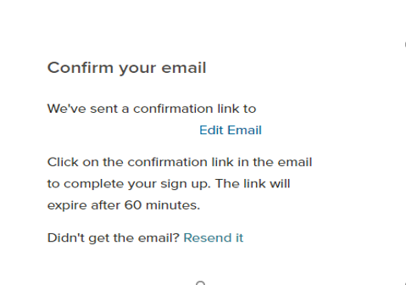

Verification Email
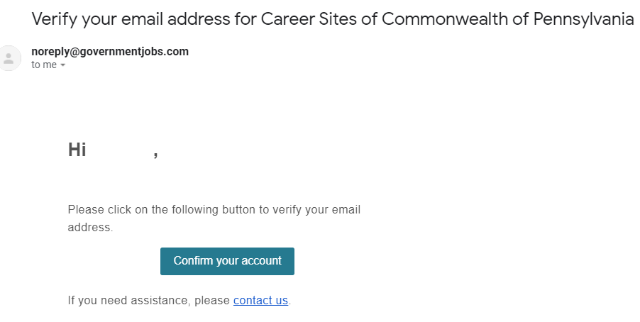

Account Verified Confirmation Message
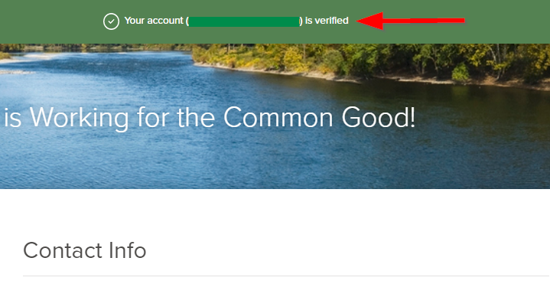
Career Pages: Help Chatbot
A new Chatbot feature is available across the entire Governmentjobs.com platform to assist applicants with login issues. Applicants can use this virtual agent to obtain instructions and find solutions to issues that could be causing login problems.

The Chatbot will automatically appear when the system recognizes that an applicant is having difficulties logging in such as after a failed login attempt. The virtual agent is designed to respond with information according to the applicant’s inputs and feedback entered in the chat box.

If needed, applicants can continue to contact NEOGOV Applicant Support at 855.524.5627 Monday through Friday from 9AM to 8PM Eastern Standard Time.

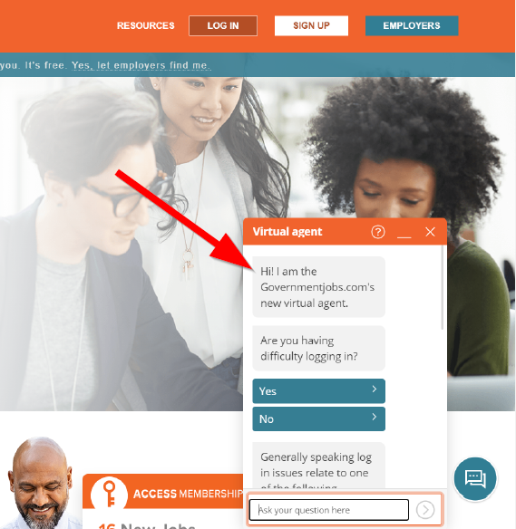

Questions?
If you have any questions regarding the July 2021 NEOGOV Enhancements, please submit an HR/Pay Help Desk ticket under the ‘HR Application Support’ category.

