Please distribute this alert to any users within your agency who use the NEOGOV, Applicant Tracking System.

November 2020 NEOGOV Enhancements

- Information regarding the November 2020 release of enhancements to the NEOGOV Applicant Tracking System.

The following enhancements were released to Insight, OHC and Career Pages in November 2020 and are now available to all users and applicants:

OHC: View Job Specs
OHC users can now view all Job Specs and related details by selecting “Job Specs” from the “Jobs” dropdown within the Online Hiring Center (OHC).

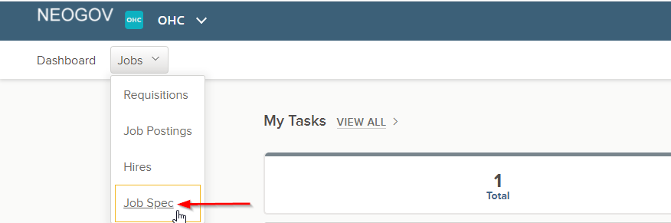

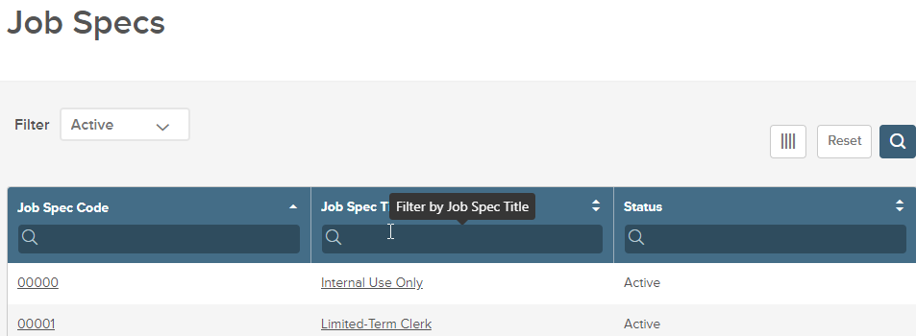

Insight: Refer Candidates to Multiple Requisitions in Bulk
A new eligible list feature allows Insight Users to refer candidates to up to 10 requisitions at a time. Please keep in mind, requisitions must still be associated with the Exam Plan the candidate is being referred from in order for the requisition to appear as an option.

The Insight user will now select the checkbox next to the applicable requisition(s), or the “All Requisitions” option if the number of associated requisitions is 10 or less, and then select the “Go” button. If multiple requisitions are chosen, the referral confirmation page that presents next will display each selected requisition and the lists of candidates being referred. Once the lists are confirmed, the user should select the “Refer” button to generate the referred list.

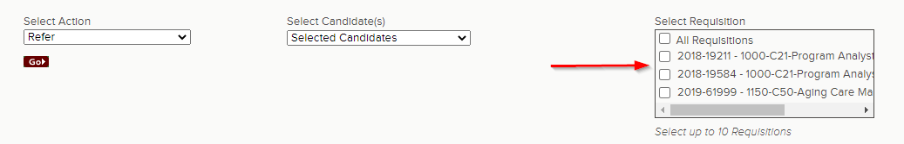

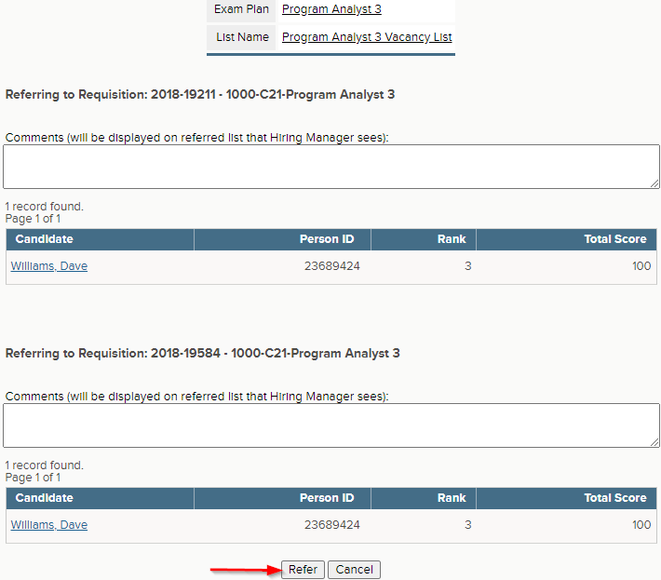

Insight: Auto-Send Rejection Notices for Auto-Scored Evaluation Steps
A new evaluation step feature allows Insight Users to automatically send notice templates to candidates who fail a scored Supplemental Questionnaire evaluation step. As part of this feature, users can select which notice template they want applicants who fail the step to receive. Multiple notice templates cannot be selected.

Please keep in mind this option will only enable when the step type is “Supplemental Questionnaire” and the “Evaluate On” field is “Scored”. This feature will not be available for any other step type or when a Supplemental Questionnaire evaluation step is pass/fail.

NOTE: Users should NOT enable this feature and leave the default setting to “No” when configuring a scored Supplemental Questionnaire evaluation step. Users should continue to manually generate notices since in most cases different notice templates are used to inform candidates of their specific reason for failure.

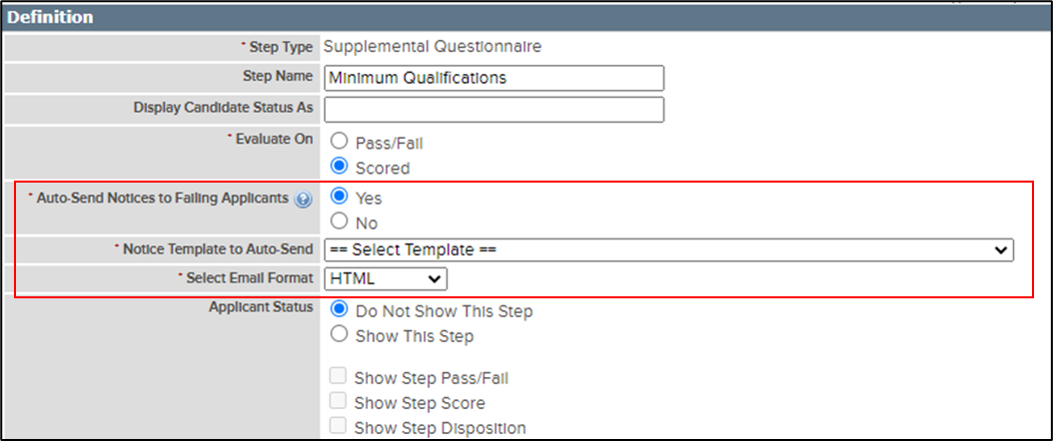

Insight: New Job Postings Rich Text Editor
The job posting add/edit page includes an enhanced Rich Text Editor (RTE) for an improved user experience and provides new functionality that enables users to:
- Change text colors
- Clear formatting changes
- Insert tables
- Undo/redo changes

NOTE: Text color should NOT be changed at this time. The OA, Bureau of Talent Acquisition will be providing further guidance on text formatting that is compliant with ADA policies and requirements.

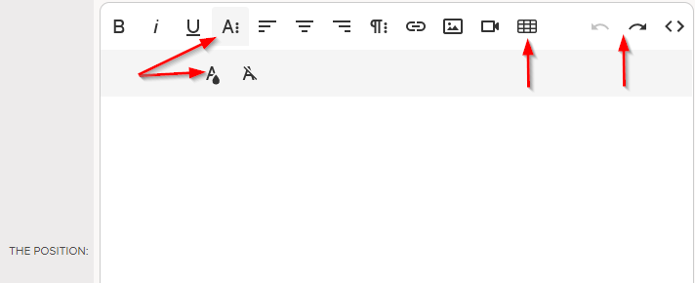
Career Pages: Links to Postings on Job Alerts
Job Alerts (i.e. Job Interest Cards) that candidates receive after subscribing to one or more job categories now include direct links to each individual job posting instead of a single link to the job opportunities page.

Career Pages: Incomplete Job Application Alert
Candidates will now receive automated email notifications when they have incomplete job applications saved in their applicant account. The automated email notice reminds candidates to complete the job application and submit before the posting closes. Notifications will be sent to the candidate’s email and applicant inbox beginning on the third day before the job posting close date and each day thereafter until the posting closes. Candidates will receive separate email notices for each incomplete job application.

Questions?
If you have any questions regarding the November 2020 NEOGOV Enhancements, please submit an HR/Pay Help Desk ticket under the ‘HR Application Support’ category.

