E-PAR Processing for Position Review Actions:
Guide for Request Submitters

Commonwealth of Pennsylvania

Office of Enterprise Systems and Data Analytics
311 Finance Building
Harrisburg, PA 17120
Purpose: This user guide is intended to provide instruction to agency staff who will be responsible for submitting E-PARs in relation to the application/removal of the Position Review Task to positions.

Table of Contents
Accessing the E-PAR System 3
Initiating a Position Review E-PAR 4
Completing a Position Review E-PAR Form 6
Request to Add the Position Review Task to a Position 6
(Optional) Supervisor Review 7
Request to Delimit the Position Review Task from a Position 9
Case Resolution Notifications 10
Approval 10
Disapproval 11

Accessing the E-PAR System

Navigate to https://oaiss.state.pa.us/par/EntryForm.asp to access the E-PAR System.

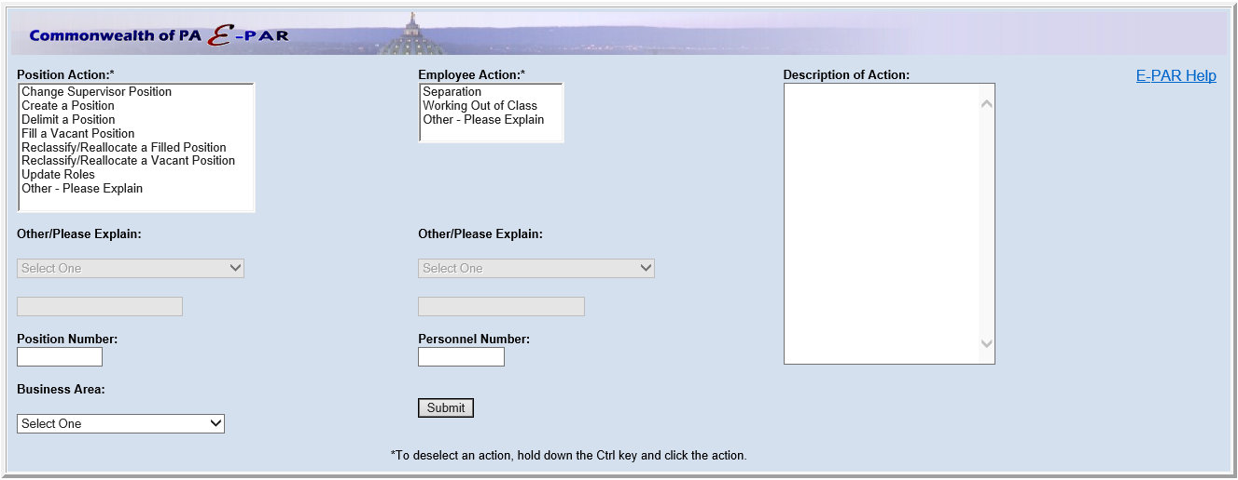

Initiating a Position Review E-PAR

To begin the process of submitting a Position Review E-PAR, select “Other – Please Explain” from the “Position Action” list. Then select “Position Review” from the “Other/Please Explain” dropdown:

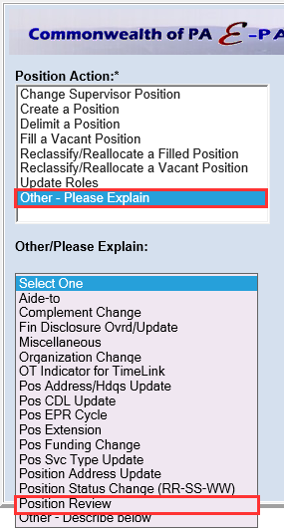

Type the position number requiring the Position Review Task addition/removal into the “Position Number” field.

(Where applicable) Select the appropriate business area for the position in question from the “Business Area” dropdown.

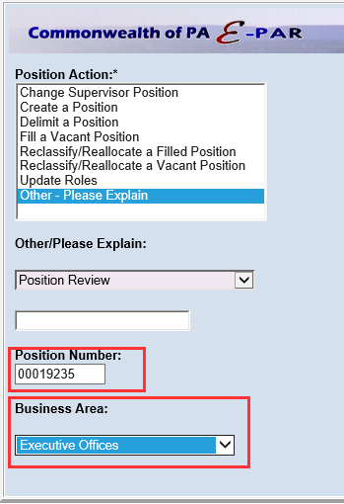
Click “Submit”.

Completing a Position Review E-PAR Form

Once the Entry Form is submitted, the Other_Delimit E-PAR Form, used to request the Position Review Task Addition/Removal, will display.

Request to Add the Position Review Task to a Position

The following fields must be completed prior to the submission of a request to add a Position Review Task to a position:

Start Date: Start Date is not required and will be entered by the OA-Bureau of Organization Management upon completion of the request.
Description: Request that the task, by name (“Position Review Task”), be applied to the position. Confirm the position number to which the task should be applied and provide additional details as to why the task is being requested.
*Submit to: Select HR Office from dropdown
HR Email: RA-OABOCCREQUEST@pa.gov will automatically populate as the only available option
Click Submit to move the request to the next step of the process.

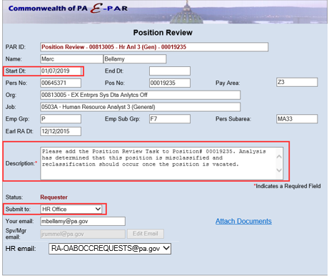

(Optional) Supervisor Review
*If agency procedure requires a secondary review prior to submission of the E-PAR for final approval, “Supervisor/Manager” may be selected from the “Submit to” dropdown. The appropriate recipient can be selected by clicking the “Edit Email” button and completing a name search. The E-PAR can then be submitted.
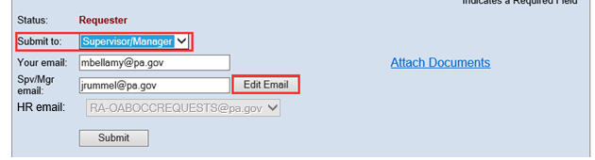

Once submitted, the e-mail address entered in the “Supv/Mgr email” field will receive an e-mail with a link to “Review PAR”.

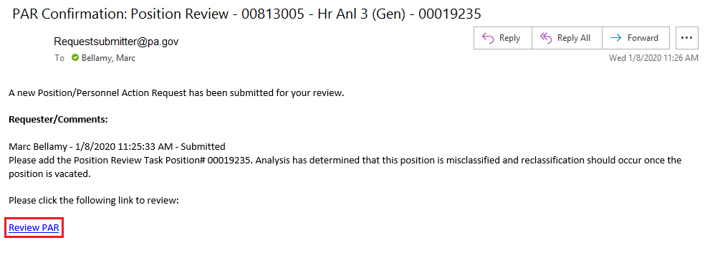

Upon clicking the link, the E-PAR will be displayed in read only format. The supervisor/manager reviewer should review the E-PAR to ensure completeness and accuracy. Once review is complete, the supervisor/manager reviewer should enter comments in the “Description” field that sufficiently explain the action being taken with the E-PAR. Then utilize the “Action” and “Submit to” (and associated) field(s) should be updated to complete one the following options:
- “Disapprove” the E-PAR
  - Notification to the Requester and all prior Supv/Mgr reviewers will be sent by default.
- “Approve” the E-PAR
  - If required by agency procedure, the E-PAR can be sent to another Supervisor/Manager reviewer.
  - The E-PAR can be moved to HR Office for final approval.
- “Move To” the E-PAR
  - The E-PAR can be returned to the Requester for update/changes
  - If required by agency procedure, the E-PAR can be sent to another Supervisor/Manager reviewer.
  - The E-PAR can then be moved to HR Office (RA-OABOCCREQUEST@pa.gov should be the only available selection as the resource account) for final approval.
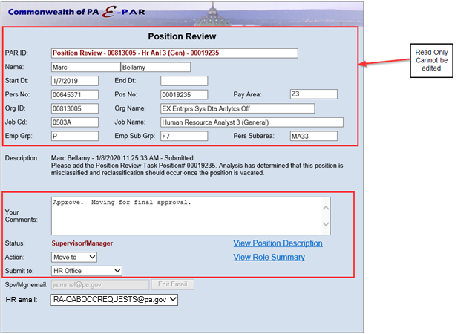
Once all fields are complete the E-PAR may be submitted.

Request to Delimit the Position Review Task from a Position

The following fields must be completed prior to submission of a request to delimit a Position Review Task on a position:

End Date: End Date is not required and will be entered by the OA-Bureau of Organization Management upon completion of the request.
Description: Request that the task, by name (“Position Review Task”), be delimited from the position in question. Confirm the position number from which the task should be delimited and provide additional details as to why the task should be delimited.
*Submit to: Select HR Office from dropdown
HR Email: RA-OABOCCREQUEST@pa.gov will automatically populate as the only available option

Click Submit to move the request to the next step of the process.

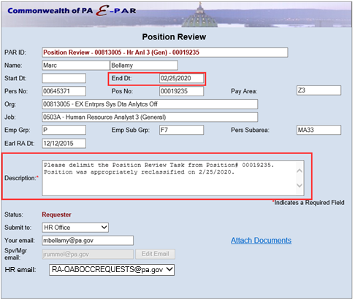

*If agency procedure requires a secondary review prior to submission for final approval, see instructions above, in the “Addition of Position Review Task to a Position” section, regarding how to submit the E-PAR to Supervisor/Manager.

Case Resolution Notifications

Approval
Once the request has been transacted in SAP, the HR Office representative will place the E-PAR in a “Complete PAR” status. When submitting in this status, there are notification options available to the HR Office representative:
- Notify only the Requester
- Notify the Requester and all Supervisors/Managers
- Do not notify anyone
Depending on the option selected by the HR Office Representative, and automated notification including a summary of the E-PAR will be e-mailed to the selected audience:
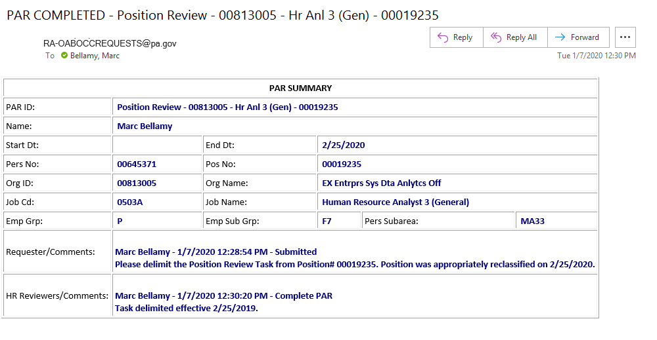

Disapproval
If a request is disapproved the HR Office representative will place the E-PAR in a “Disapprove” status. When submitting in this status, the only notification option available to the HR Office representative is “Requester and All Supv/Mgr Reviewers”. Meaning, once submitted, all individuals who took action on the E-PAR will receive notification via e-mail of the disapproval. The disapproval notice should provide sufficient information for those receiving the notice to understand why it was disapproved and to take necessary corrective action if needed.

