Please distribute this alert to any users within your agency who use the NEOGOV, Applicant Tracking System on a regular basis.

Vacant ITDC Positions to Business Area 81

- Information regarding the transition of vacant Information Technology Delivery Center positions to Business Area 81.

All vacant Information Technology Delivery Center (ITDC) positions will transition to Business Area 81 in SAP and NEOGOV, effective Saturday, 2/29/2020. Movement of the vacant positions will mitigate potential issues with reassigning prospective employees after hire.

New Requisitions
On Monday, 03/02/2020, new requisitions for vacant ITDC positions must be created under the assigned organization within Business Area 81. Positions will no longer be visible under the former agency organization and business area.

Pending Requisitions
If there is a selected candidate for a requisition associated with a vacant ITDC position, it is recommended that the hire in NEOGOV be fully processed prior to the position transitioning.

Otherwise, requisitions for vacant ITDC positions submitted prior to the position’s transition to Business Area 81 must be cancelled and resubmitted under the new organization and business area.

If the requisition is not recreated under the appropriate organization within Business Area 81, users will receive an incurable error when generating the hire form for selected candidates. This error will not allow users to proceed with the hire action and prevent them from submitting the request. This system validation serves as a safeguard to block users from submitting hire action requests with positions that might no longer be valid.

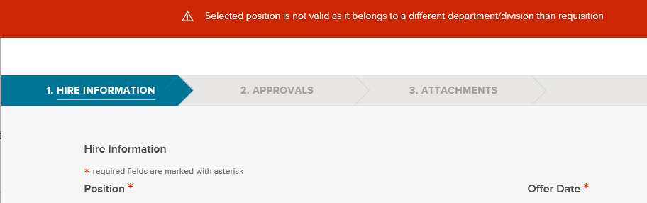

Users can utilize the copy function to expedite recreating the requisition. This will simplify the process and eliminate the need to complete each field on the requisition form. After copying the requisition, users will need to update the Department/Division field and reselect the position(s) in the Position field.

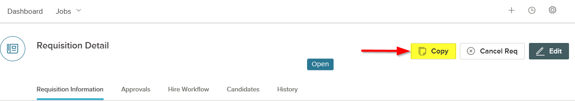

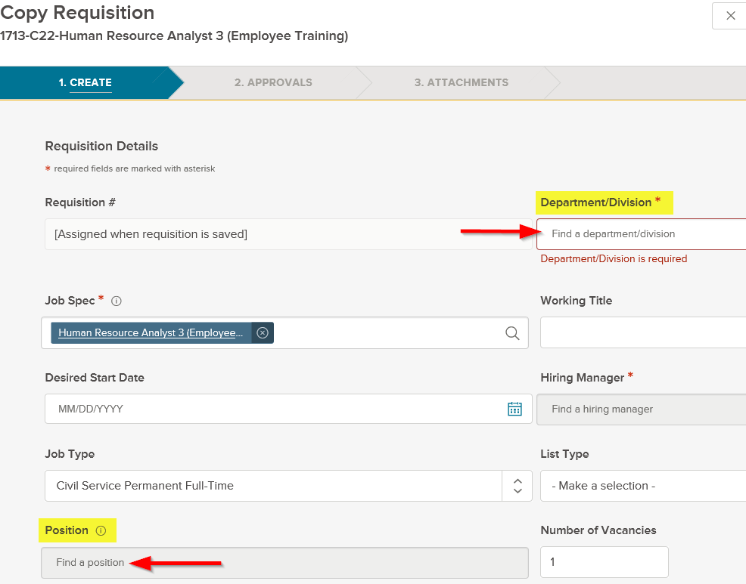

The requisitions will not need to route through any approvals assuming all necessary approvals were obtained on the initial requisition. However, the requisition number for the cancelled requisition should be added in the comments field.

If the requisition is for an external posting, users should notify the Bureau of Talent Acquisition (BTA) at the email address, ra-cs-vpapa@pa.gov, after the requisition has been submitted. BTA will link the requisition to the exam plan and refer candidates if necessary. Otherwise, HRDC Insight Users must assign the requisition(s) to the applicable exam plan and refer candidates as needed.

Questions?
If you have any questions regarding the Vacant ITDC Positions to Business Area 81, please submit an HR/Pay Help Desk ticket under the ‘Applications Support’ category.

