Please distribute this alert to any users within your agency who use the NEOGOV, Applicant Tracking System on a regular basis.

Master Profile Employee Status Field

- Information regarding a change to the “Employee Status (API)” field on the Applicant Master Profile.

Effective Monday, December 23, 2019, the Applicant Master Profile “Employee Status (API)” field, which is populated with employment related data from SAP, will show a value of “Separated” for candidates who are former Commonwealth employees and have an active application. The status change will also appear on all eligible lists and referred lists that display this field.

Please note this field will continue to show the previous status of “Withdrawn” for former employees who do not have an active application on file. The status will update accordingly when future applications are evaluated by the master profile integration.

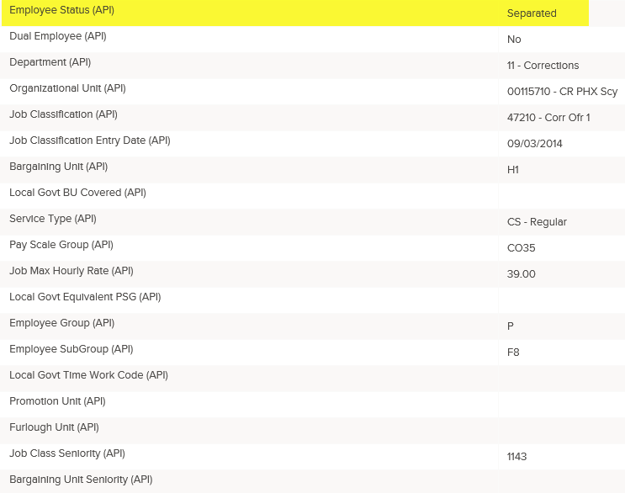

Questions?
If you have any questions regarding the Master Profile Employee Status Field, please submit an HR/Pay Help Desk ticket under the ‘HR Application Support’ category.

