Please distribute this alert to any users within your agency who use the NEOGOV, Applicant Tracking System on a regular basis.

July 2019 NEOGOV Enhancements

- Information regarding the July 2019 release of enhancements to the NEOGOV Applicant Tracking System.

On July 16, 2019, the following enhancements were released to the Insight and Online Hiring Center (OHC) environments:

Insight: Hires Awaiting Authorization – Authorize Action
Insight users can now authorize hires from the Insight Dashboard or Hires List page by selecting the new “Authorize” link under the “Actions” column. After clicking on the “Authorize” action users will be automatically directed to the “Hire Edit” page where they can select the “Save and Authorize” button to authorize the hire.

Insight Dashboard (Insight Dashboard > Hires)
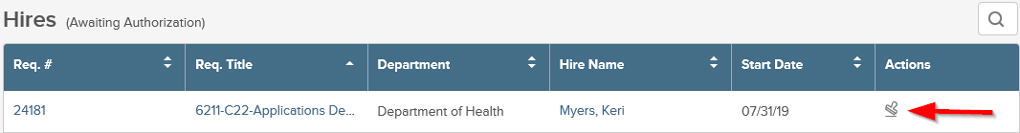

Hires List (Insight Dashboard > Lists > Hired > Awaiting Authorization)
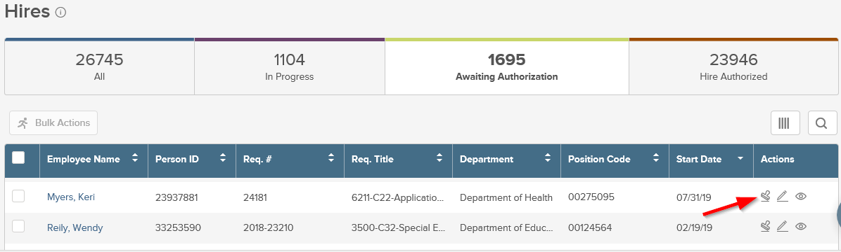

Insight: Task Notices – Sender Email Address
All task emails sent from the Exam Plan will now come from the email address info@neogov.com rather than the sender’s email address. The “From” name will continue to display the name of the user who created or edited the task and generated the notice. This change should resolve recent delivery issues and ensure emails are not marked as spam.

OHC: Notice Template Merge Field – Interview Scheduling Deadline Date
OHC Users now have the option to select the merge field “Interview Schedule Deadline Date” under the “Referred List – Interview” drop-down when configuring notice templates. The new merge field will automatically populate the deadline date for candidate self-scheduling. If there are multiple deadline dates for the interview schedule, the merge field will populate the earliest date. For example, the merge field would populate 07/14/2019 as the deadline date for an interview schedule with deadline dates of 07/14/2019, 07/15/2019 and 07/18/2019.

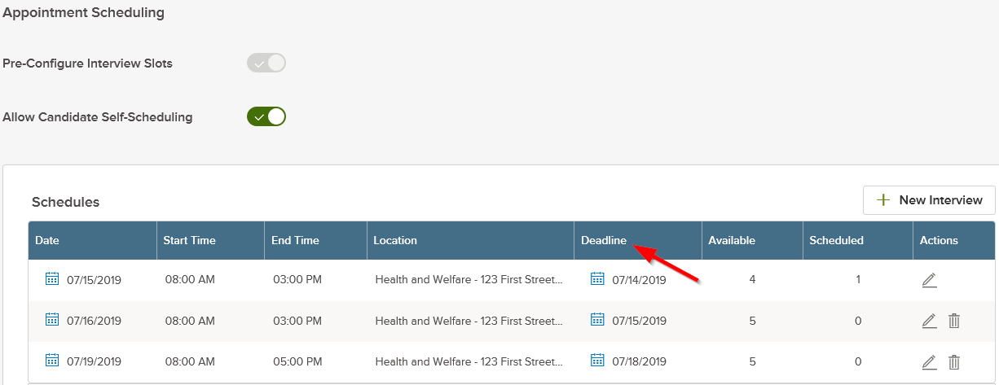

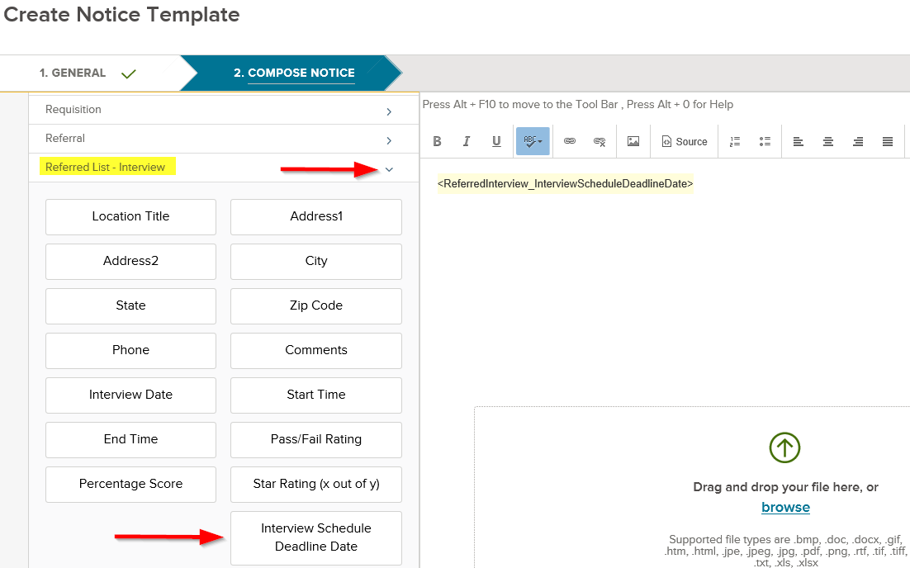
Questions?
If you have any questions regarding the July 2019 NEOGOV Enhancements, please submit an HR/Pay Help Desk ticket under the ‘Applications Support’ category.

