Unified Self Service (USS)
Unified Self Service is the standardization of NEOGOV’s overall system suite to include a standard enterprise dashboard. This dashboard, the “Unified” dashboard, is utilized as a common launching point across NEOGOV’s entire platform.
All NEOGOV users will see the new Unified dashboard, as the purpose of Unified Self Service is to centralize all activities to one common dashboard.
If you can no longer view or toggle to the OHC dashboard after the update on Monday, July 31st, 2023, you will need to complete OHC tasks and actions using the Unified dashboard.
Below is an overview of the changes involved in NEOGOV’s move to Unified Self Service.

Current OHC Dashboard
Below is the current OHC dashboard where users complete tasks and actions.
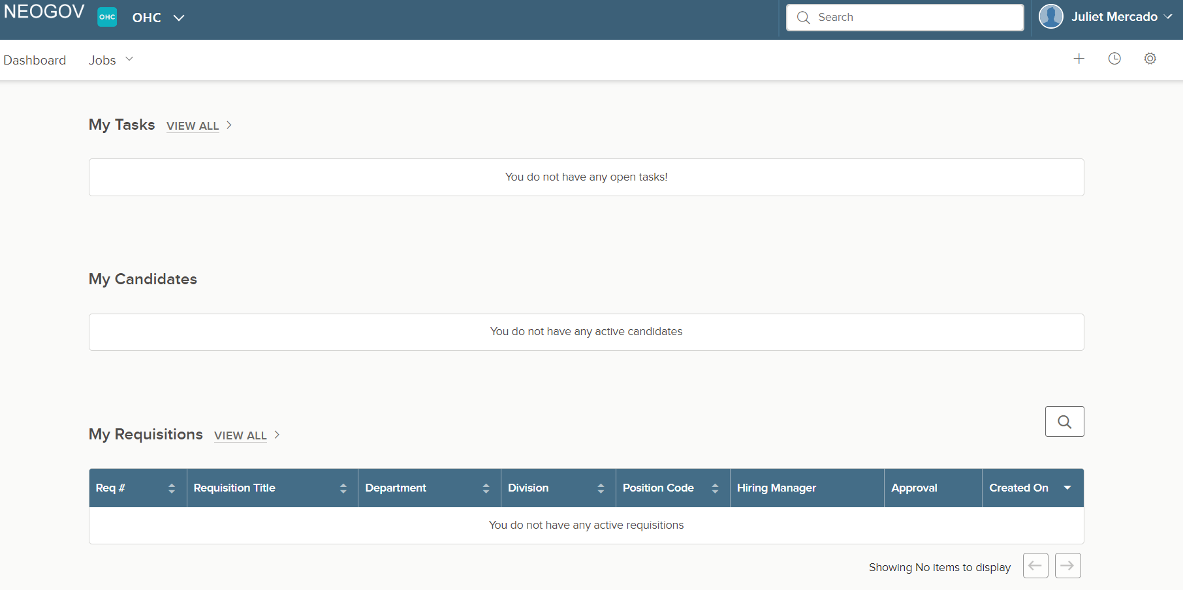
Current Insight Dashboard
Below is the current Insight dashboard. All users with Insight security roles will still be able to use the Insight dashboard.
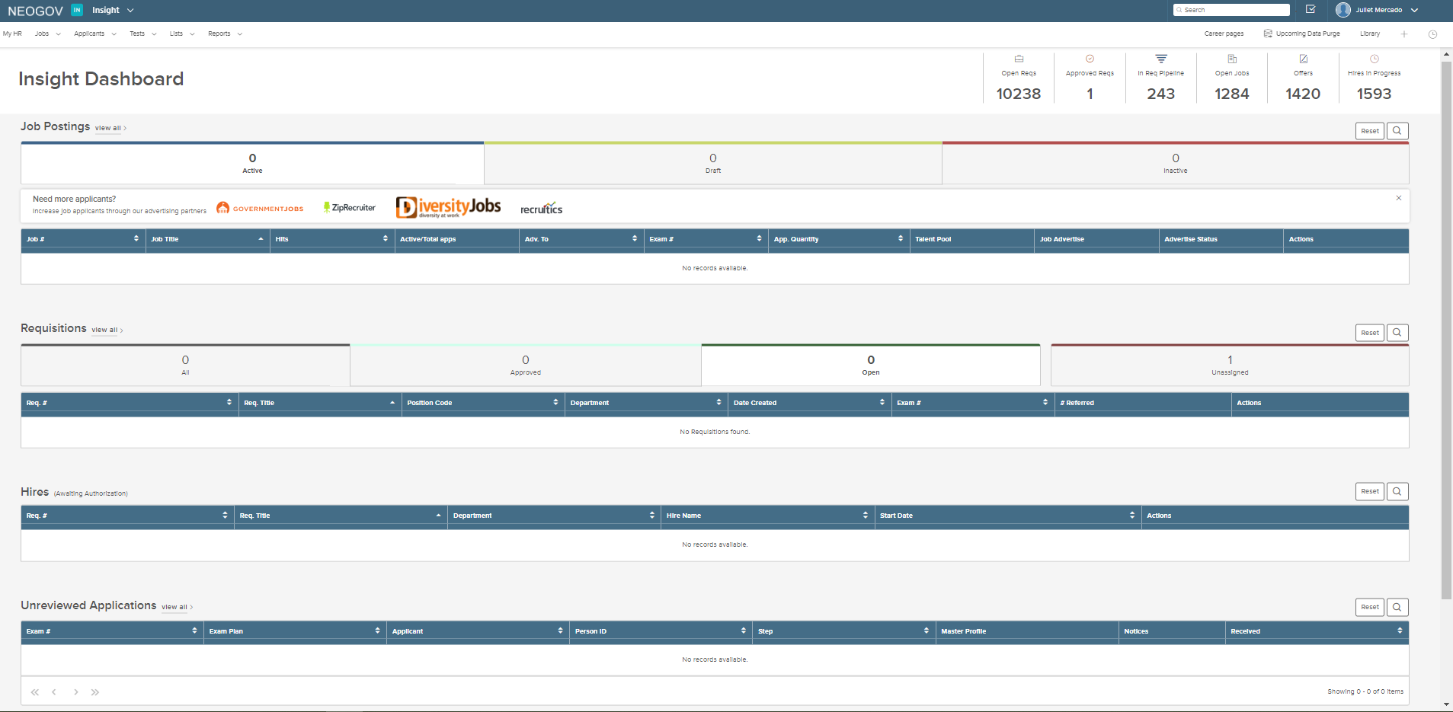
Current Dashboards – Toggle Capabilities
Currently, depending on security roles, users with both Insight and OHC can toggle to and from these dashboards. Users without Insight access do not see the same toggle capabilities.
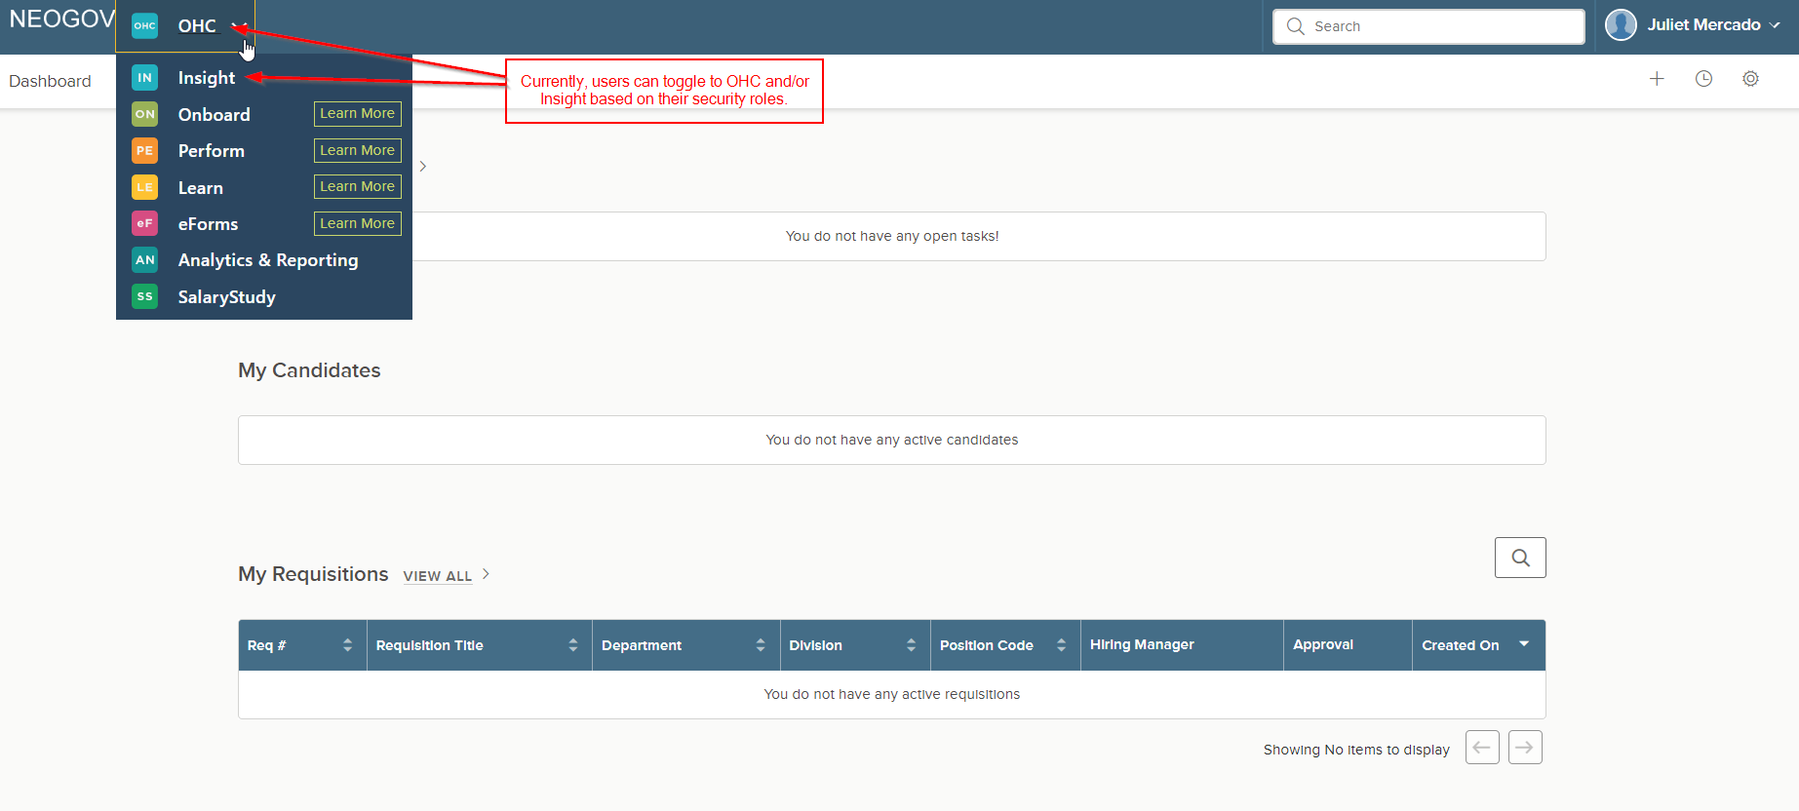

USS Unified Dashboard
All users will see the Unified dashboard because of NEOGOV’s move to Unified Self Service. When first accessing the Unified dashboard, the below popup and step-by-step guide will appear.
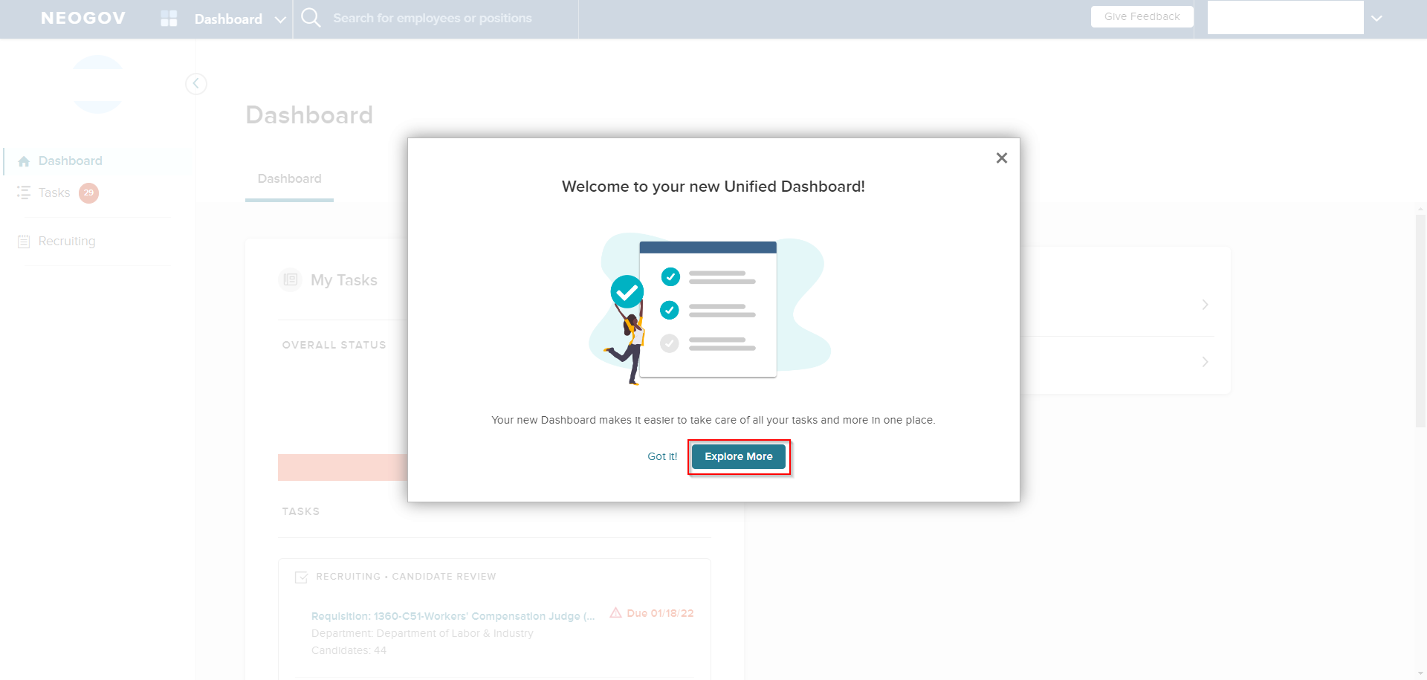
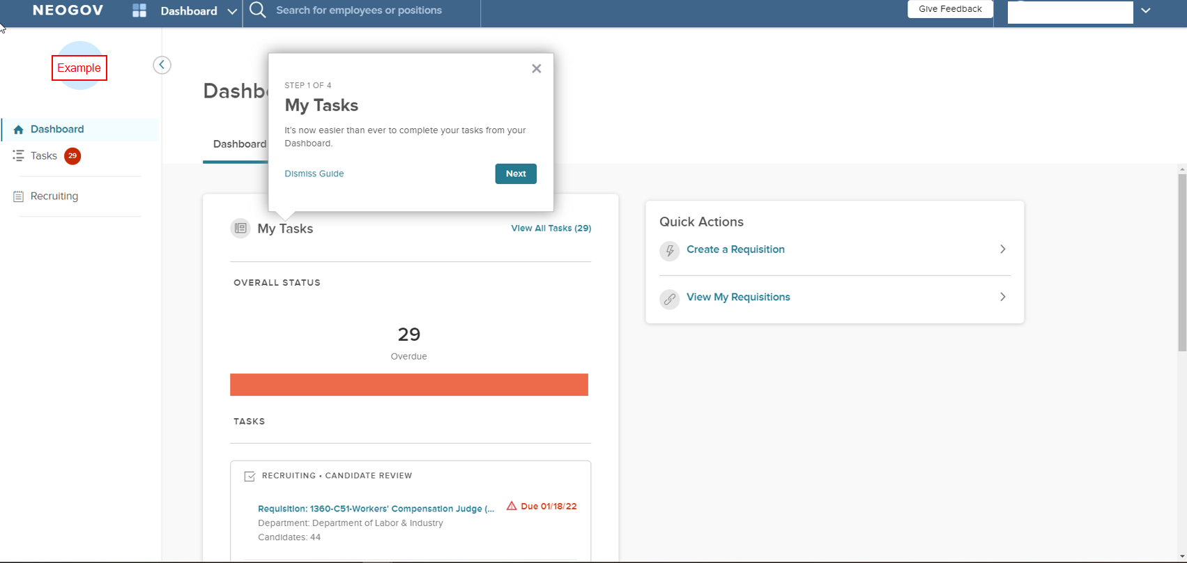
Unified Dashboard – Overview
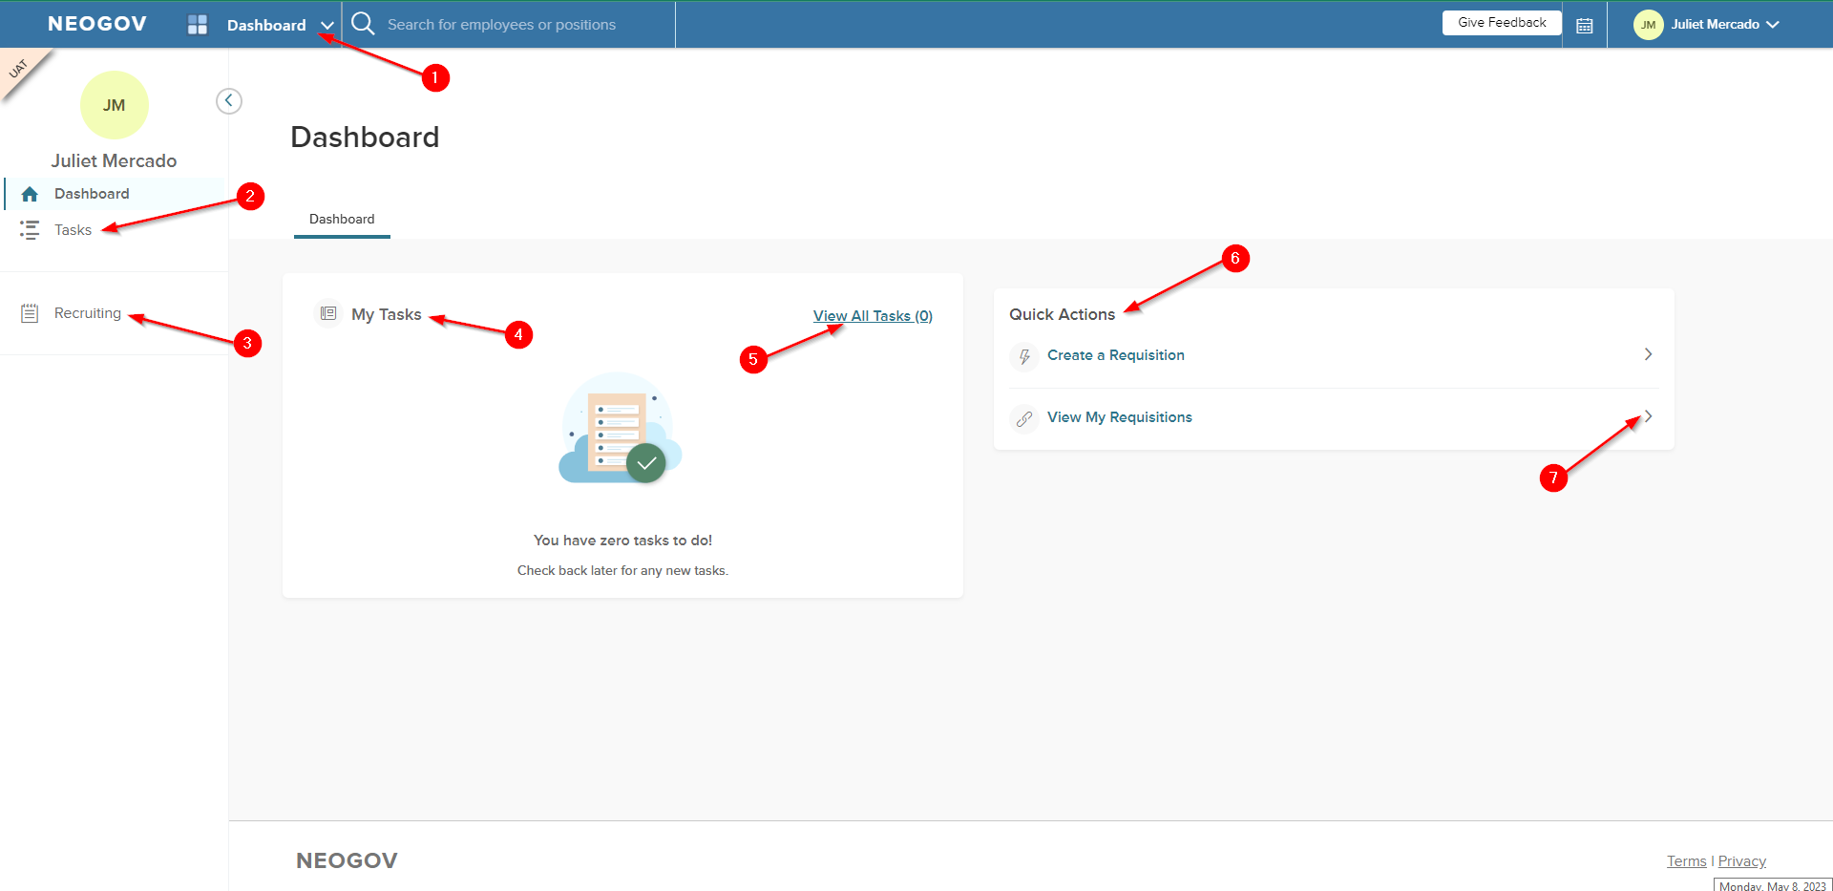
- Unified Dashboard – All users will see this dashboard.
- Tasks page – Select this page to view the full task list.
- Recruiting page – Select this page to view requisitions and hires.
- My Tasks – This widget will display up to 5 tasks with the earliest due dates.
- View All Tasks – Select this link to view all tasks. This will take you to the “Tasks” page.
- Quick Actions – Quick actions will appear based on frequently visited areas. The two possible quick actions are “Create a Requisition” and “View My Requisitions”. If you have not yet created or viewed a requisition, you will not see any actions listed here.
- Selecting a quick action will direct you to the area where the action can be completed.

Unified Dashboard – Toggle Capabilities
If you hover over the Unified dashboard (#1 above), you will find the dashboards you can toggle to based on your user security roles.
All Insight users will be able to toggle to the Insight dashboard.
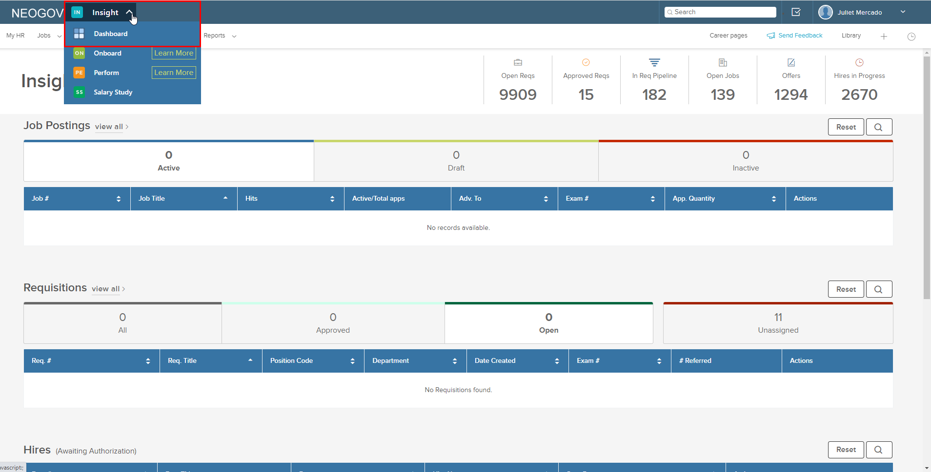

If your screen looks like either of the screenshots below, you can toggle to the OHC dashboard.
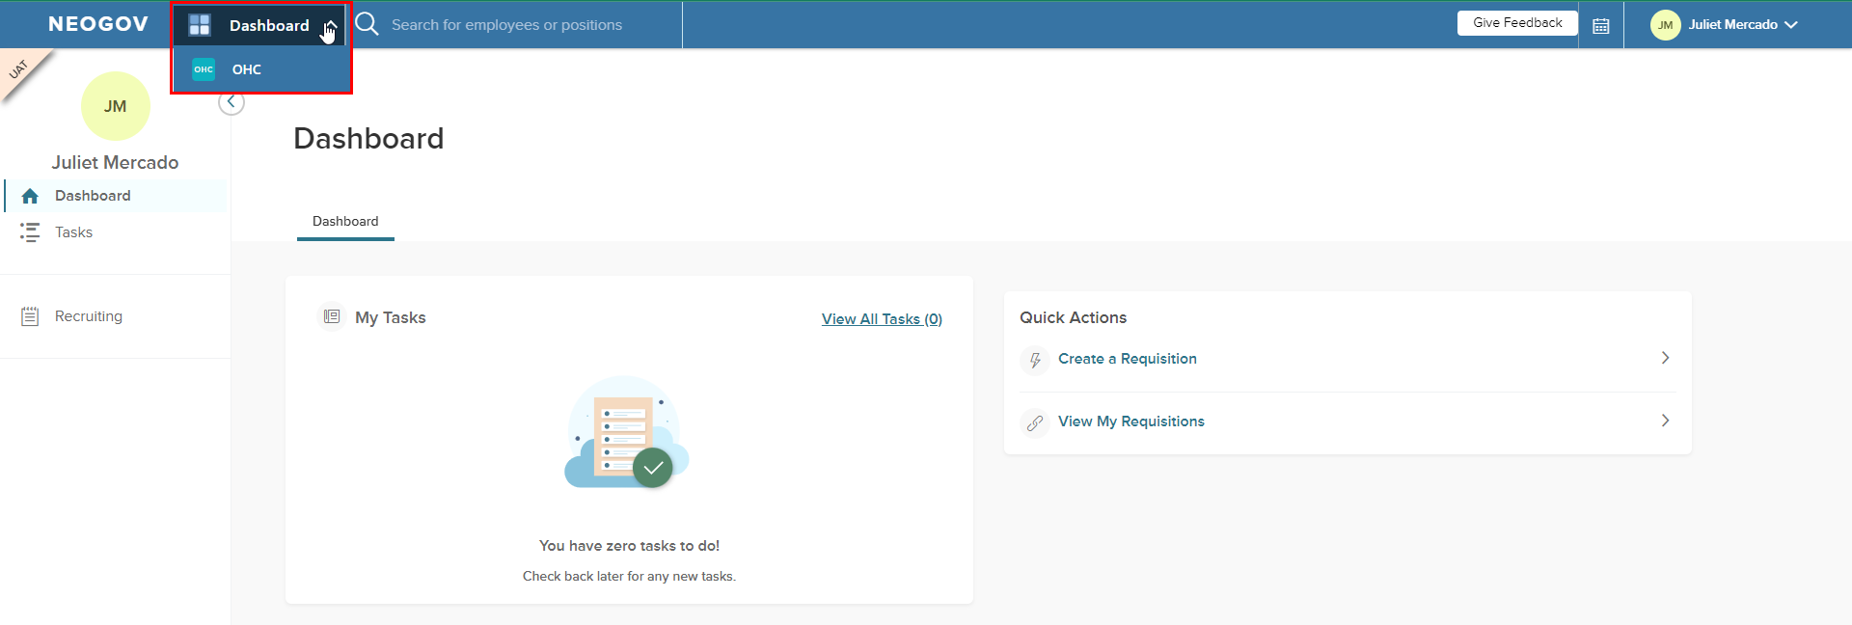
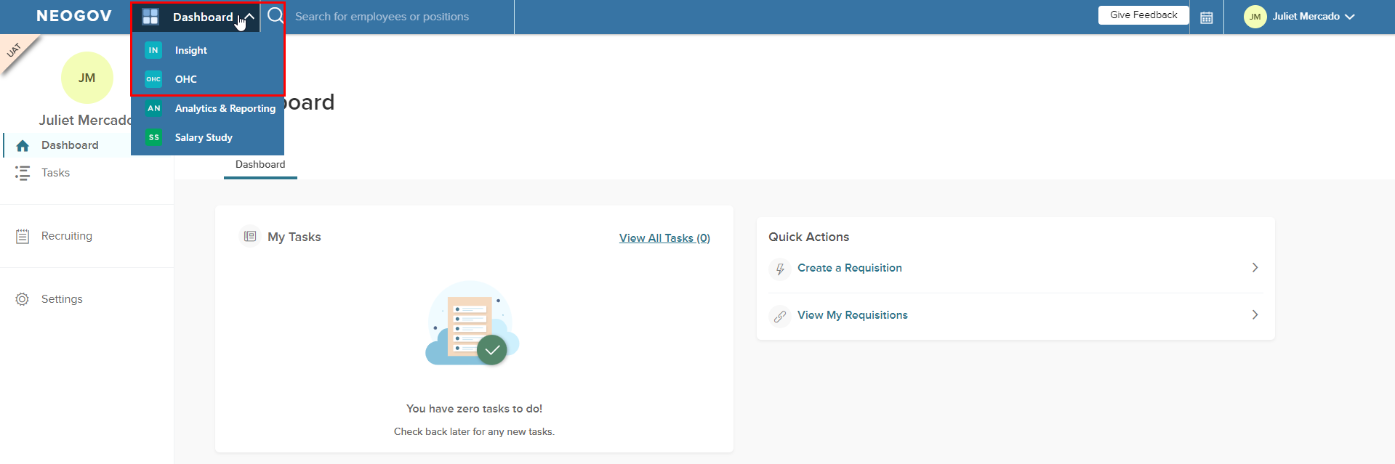
If your screen looks like the screenshot below, you will no longer have access to the OHC dashboard. ALL OHC work is to be completed using the Unified dashboard.
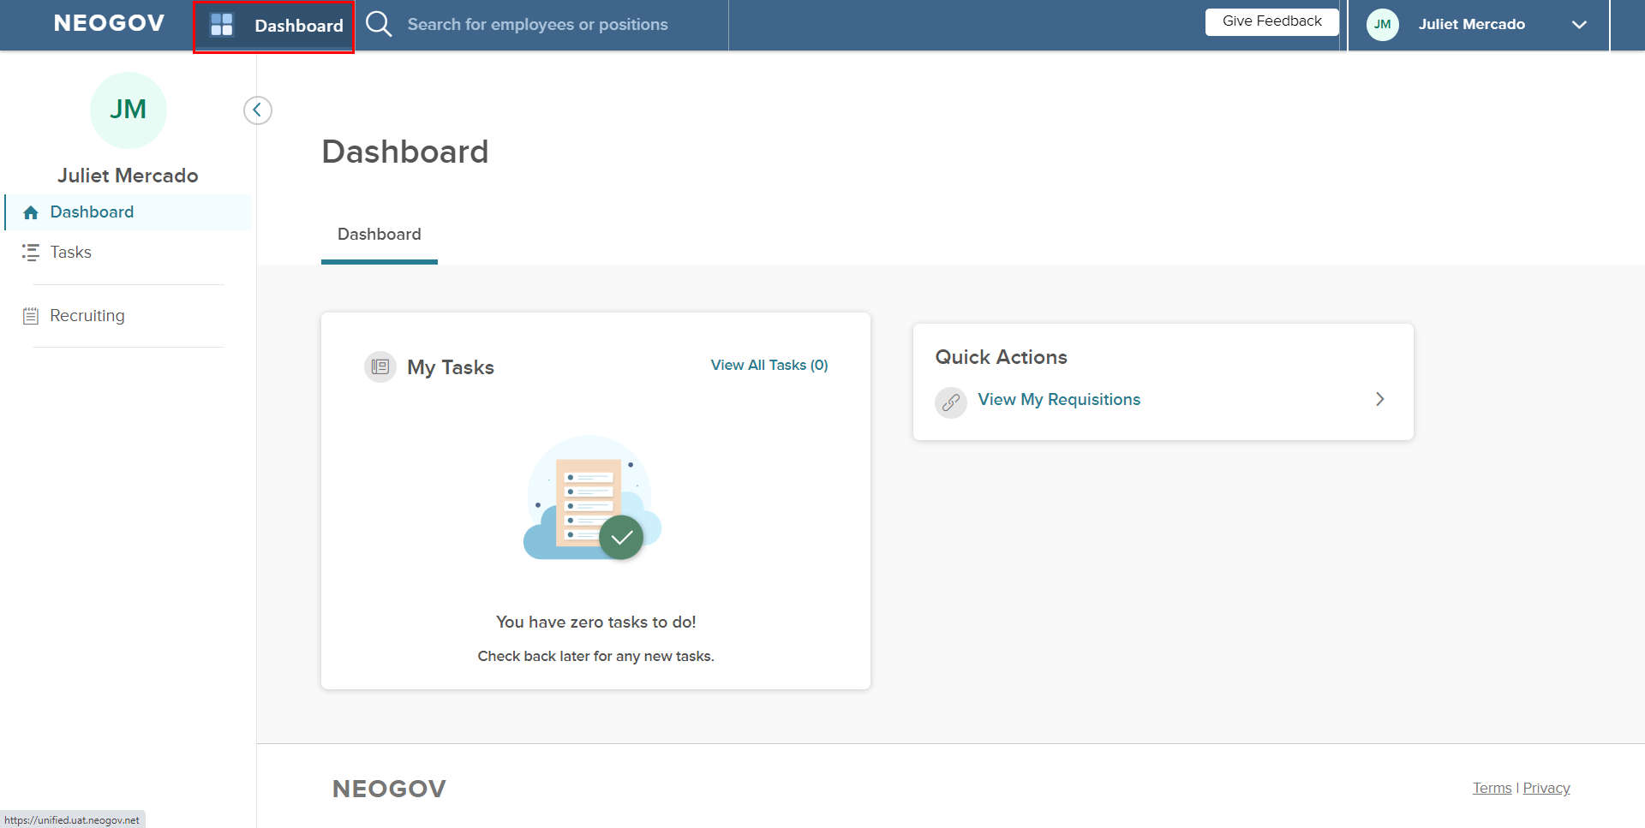
If your screen looks like the above and you do not have toggling capabilities, please continue reading for more information on using the Unified dashboard.

Unified Dashboard – Example with Tasks
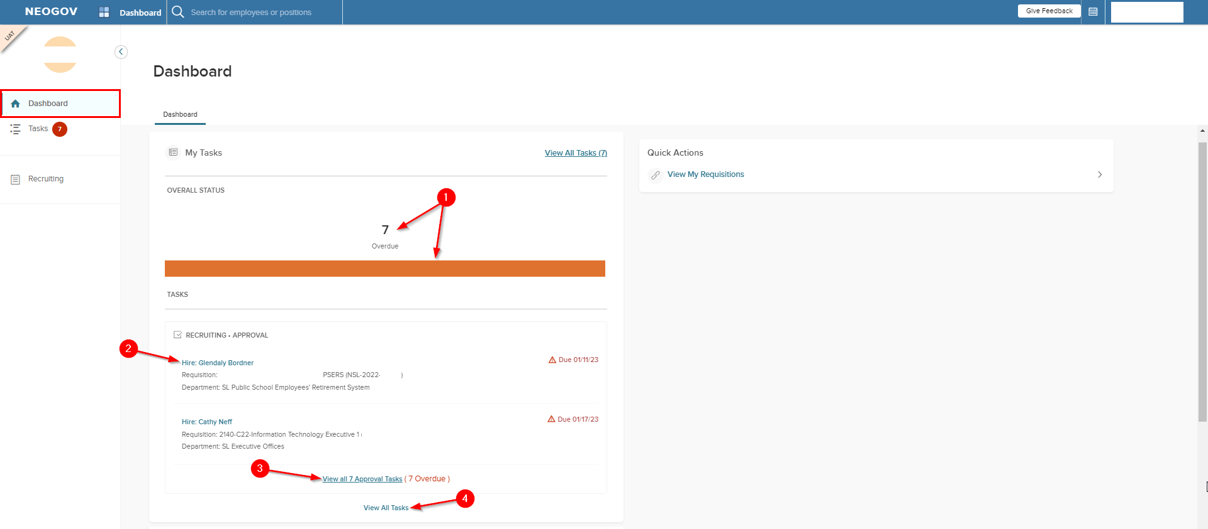
- Selecting the number or the bar will take you to the “Tasks” page.
- Selecting a task will take you directly to the page where the task can be completed.
- Selecting this link will take you to the “Tasks” page to view Approval Tasks.
- Select this link to go to the “Tasks” page and view all tasks.

Unified Dashboard – Selecting a Task from the Dashboard
When selecting the task, you may see the below popup before navigating to the area where the task can be completed.
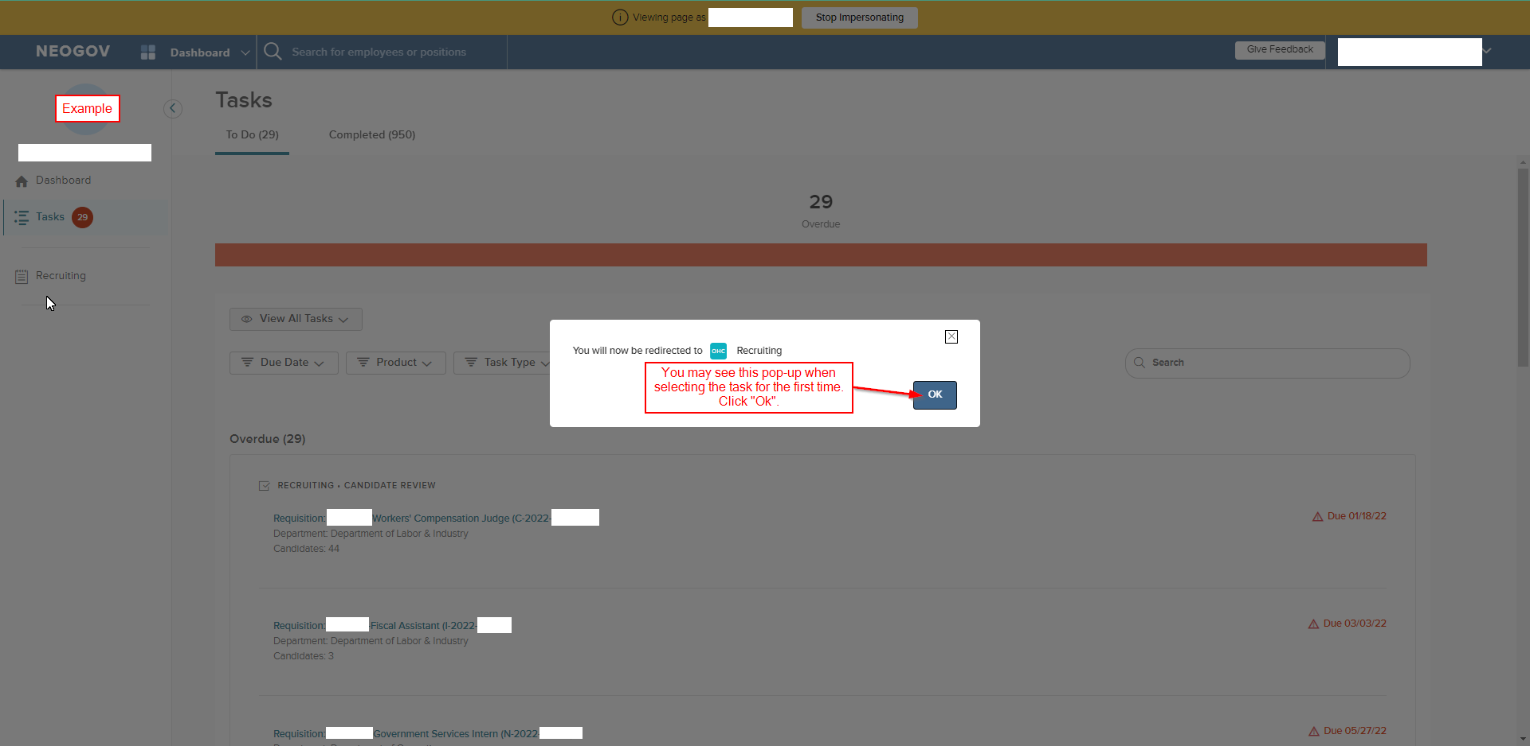
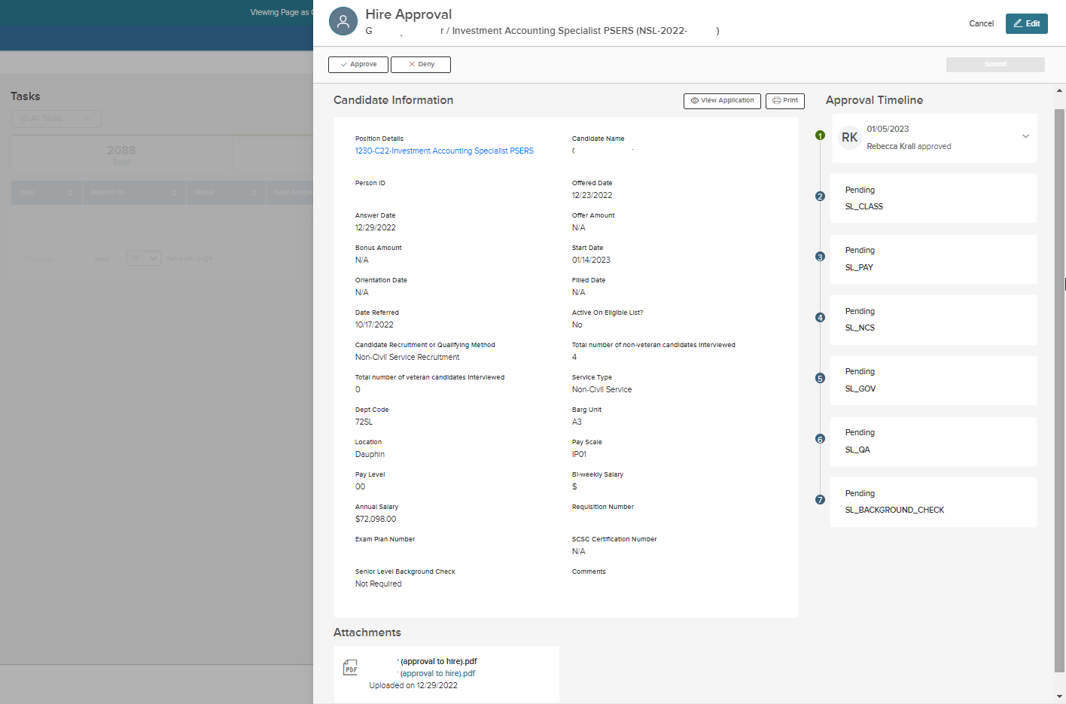

Tasks Page – “To Do” Section
For users who have access to Insight, both OHC and Insight tasks will appear on the Tasks page.
For users who do NOT have Insight access, all OHC tasks will appear on this page.
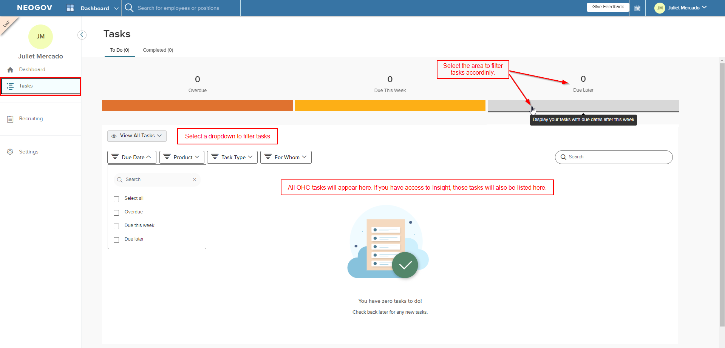

Tasks Page – “To Do” Section – Example with Hire Approval tasks
Select any task to navigate to the page where the task can be viewed or completed.
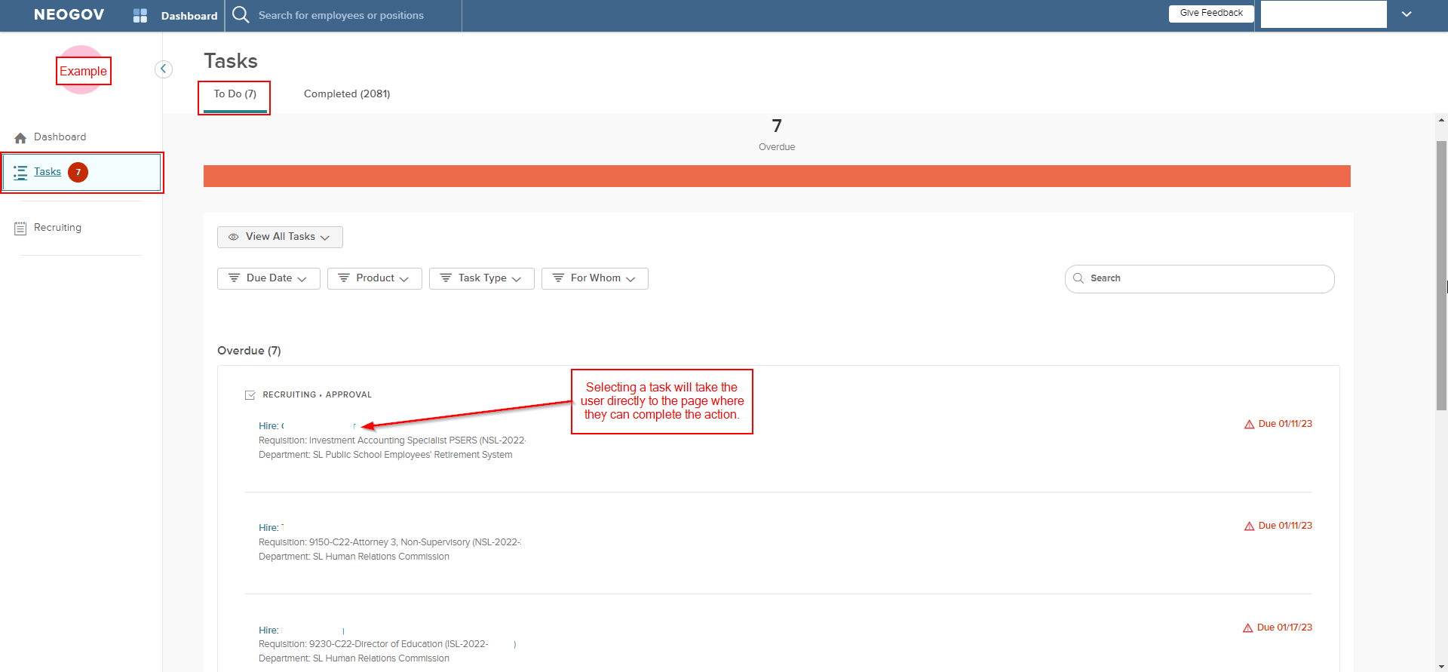

Tasks Page – “To Do” Section – Example with Requisition tasks
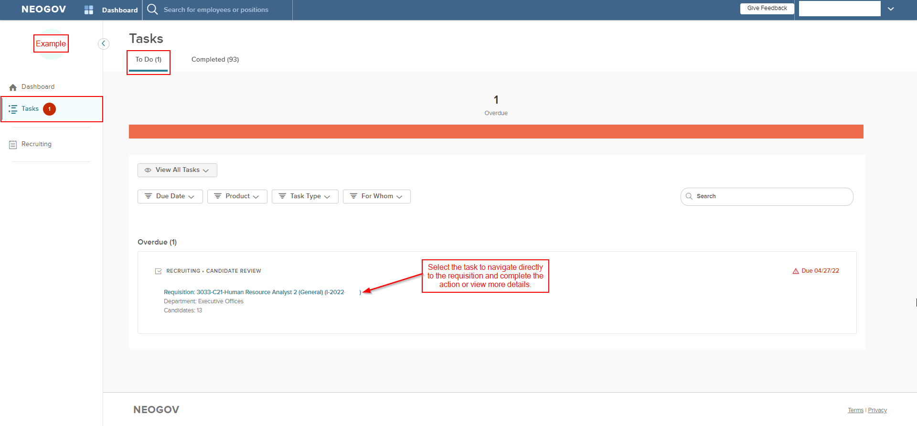

Tasks Page – “To Do” Section – Selecting a requisition
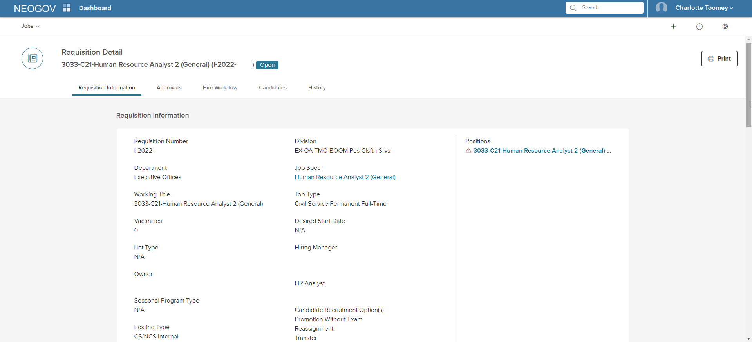

Tasks Page – “Completed” section
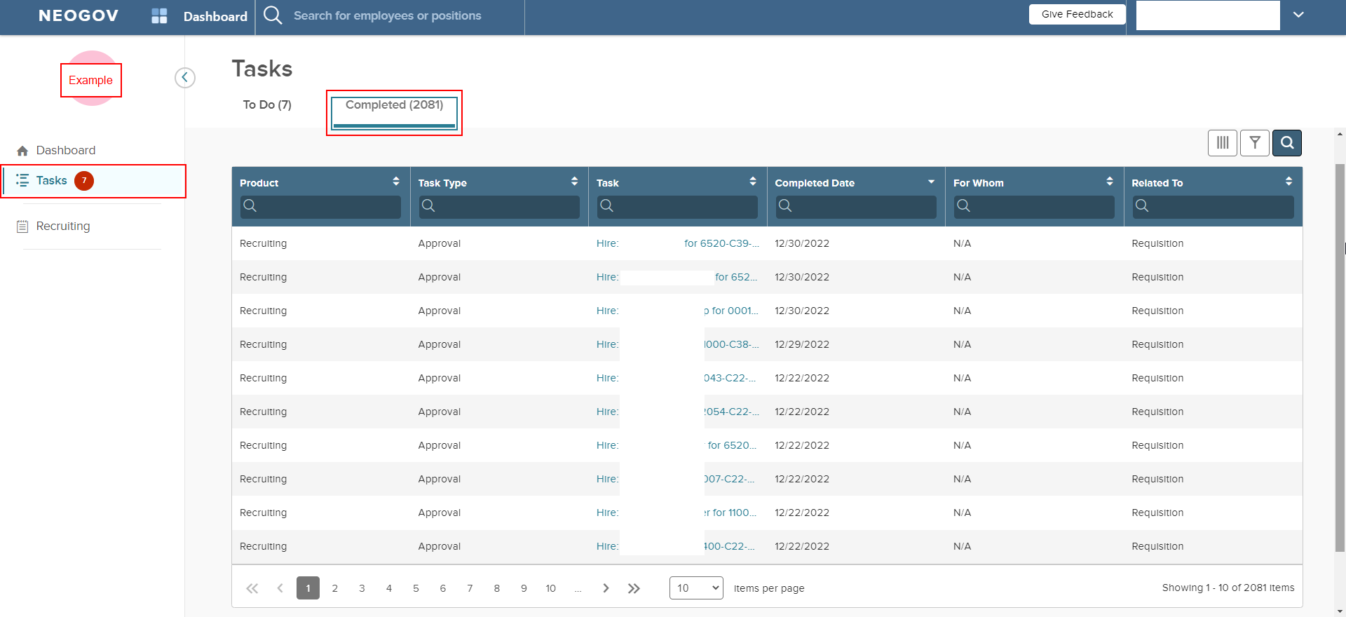

Recruiting Page – “Overview” section
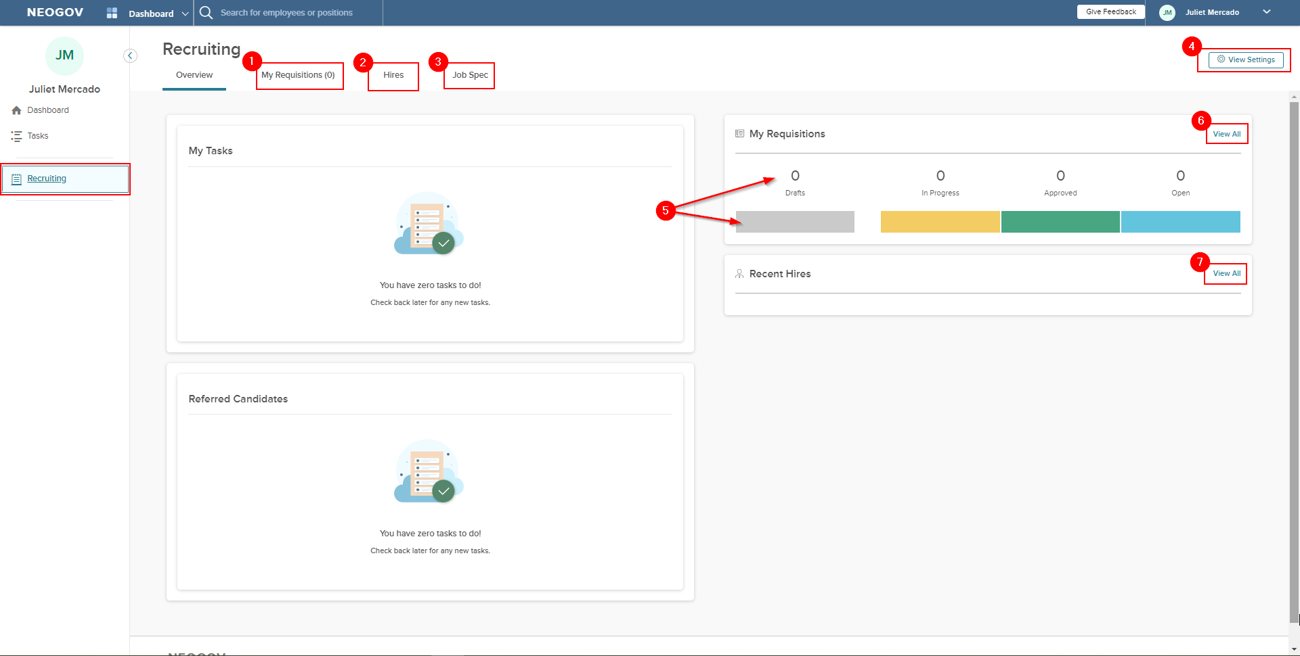
- Select this tab to view requisitions.
- Select this tab to view hires.
- Select this tab to view job specs.
- Select this button to view OHC settings.
- Select the bar or number to navigate to a filtered view of your reqs (e.g., selecting the “Drafts” area will filter reqs to show only drafts).
- Select to view all reqs without a filter.
- Select to view all hires.
NOTE – Options on this screen may vary depending on user security.
Recruiting Page – “View Settings” button (#4 above)
If you select the “View Settings” button (#4 above), you will see the page below. Selecting from the “Jobs” dropdown will show a screen similar to the original OHC suite before the move to USS.
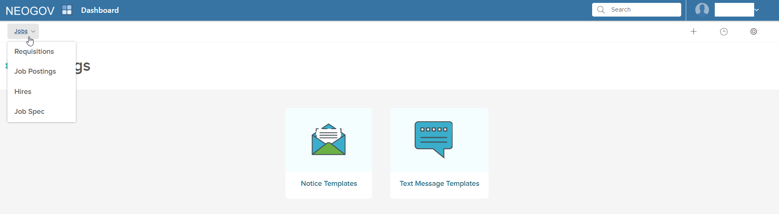
For example, selecting “Requisitions” from the “Jobs” dropdown shows the page below:
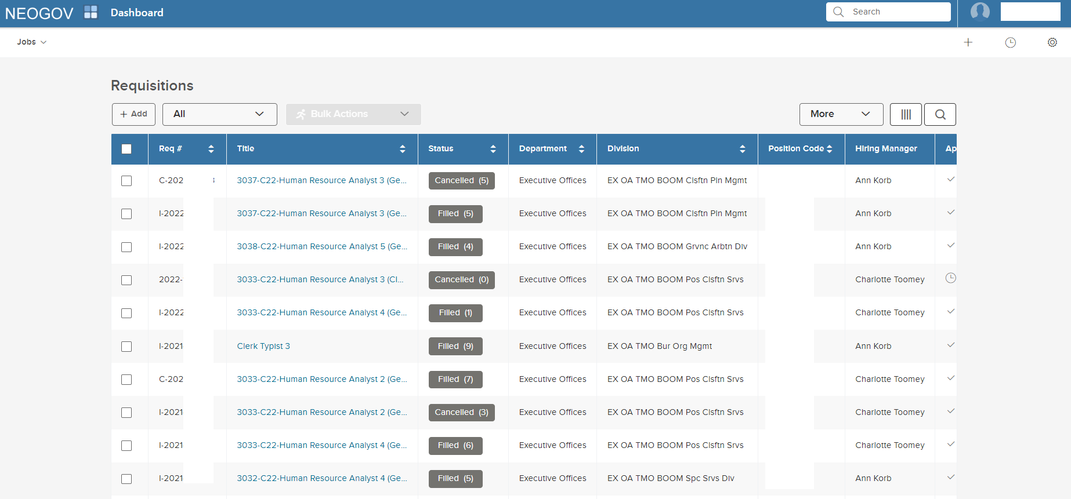
Recruiting Page – “Overview” section – Example with tasks
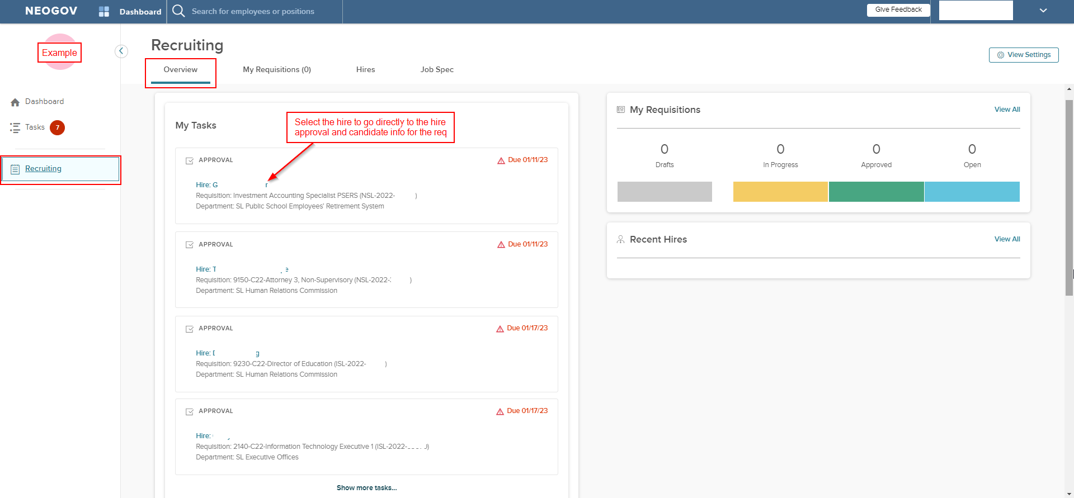

Recruiting Page – “My Requisitions” section
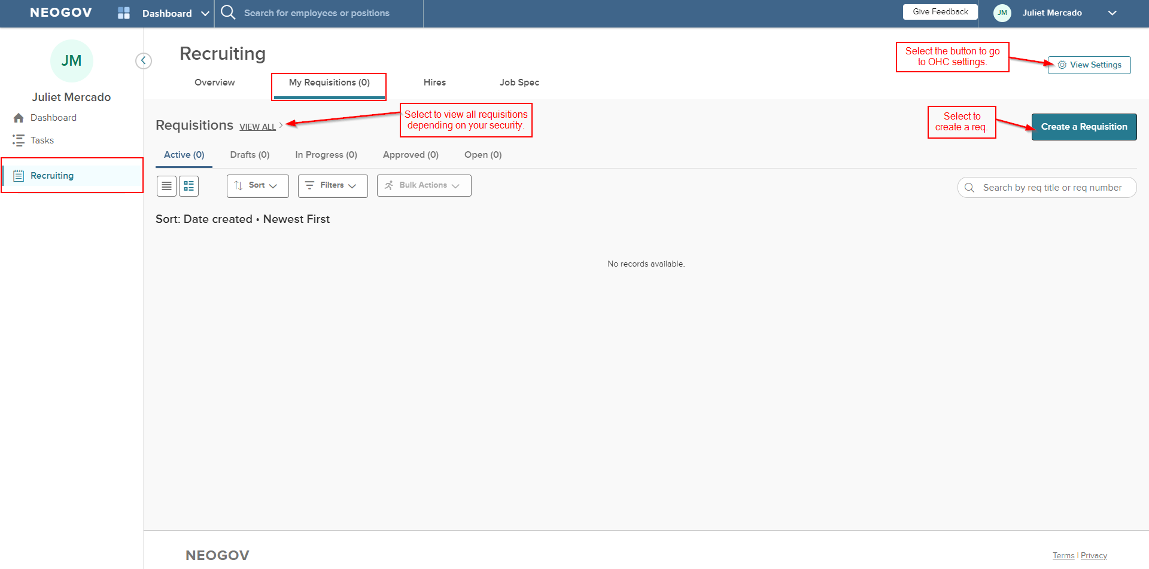

Recruiting Page – “My Requisitions” section – View all requisitions
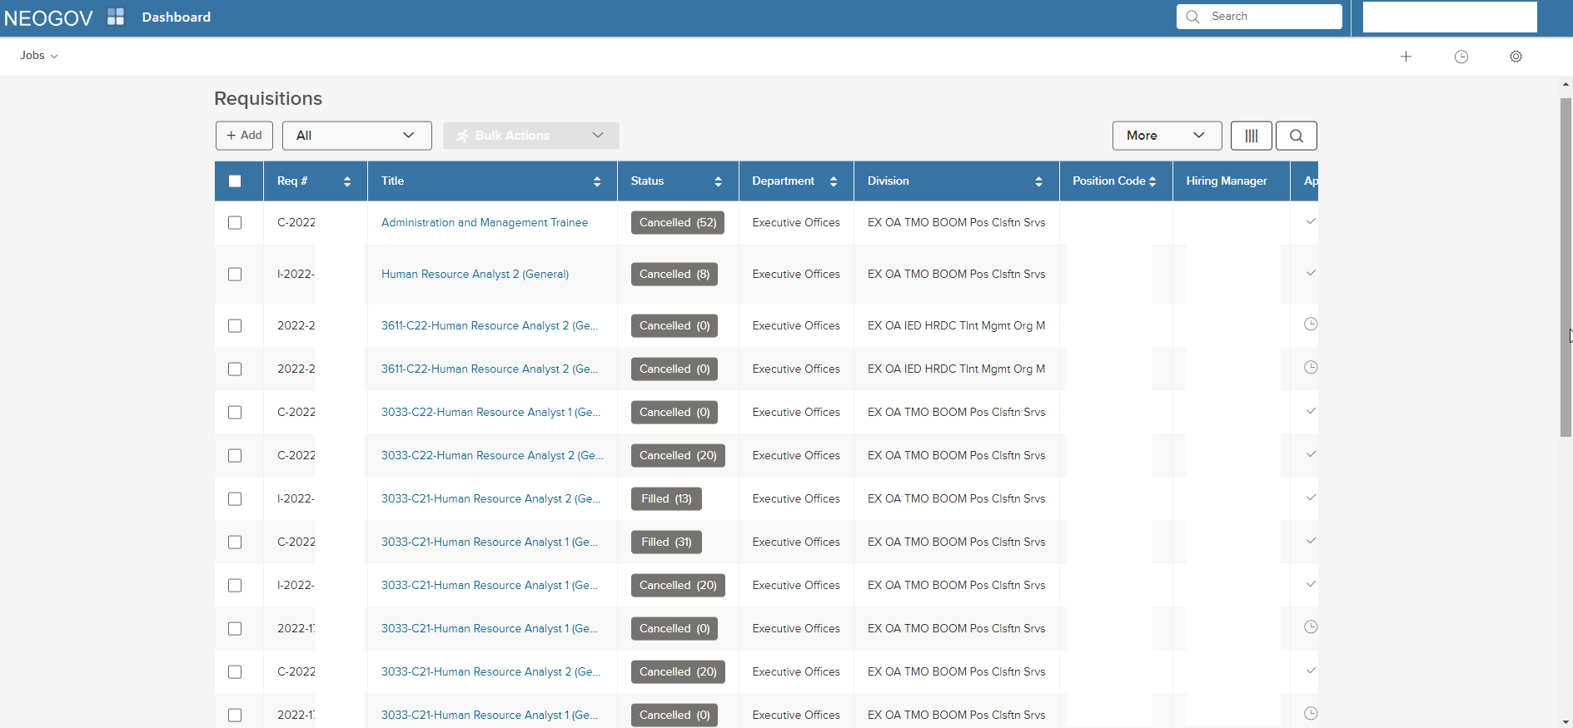

Recruiting Page – “My Requisitions” section – Example with requisitions
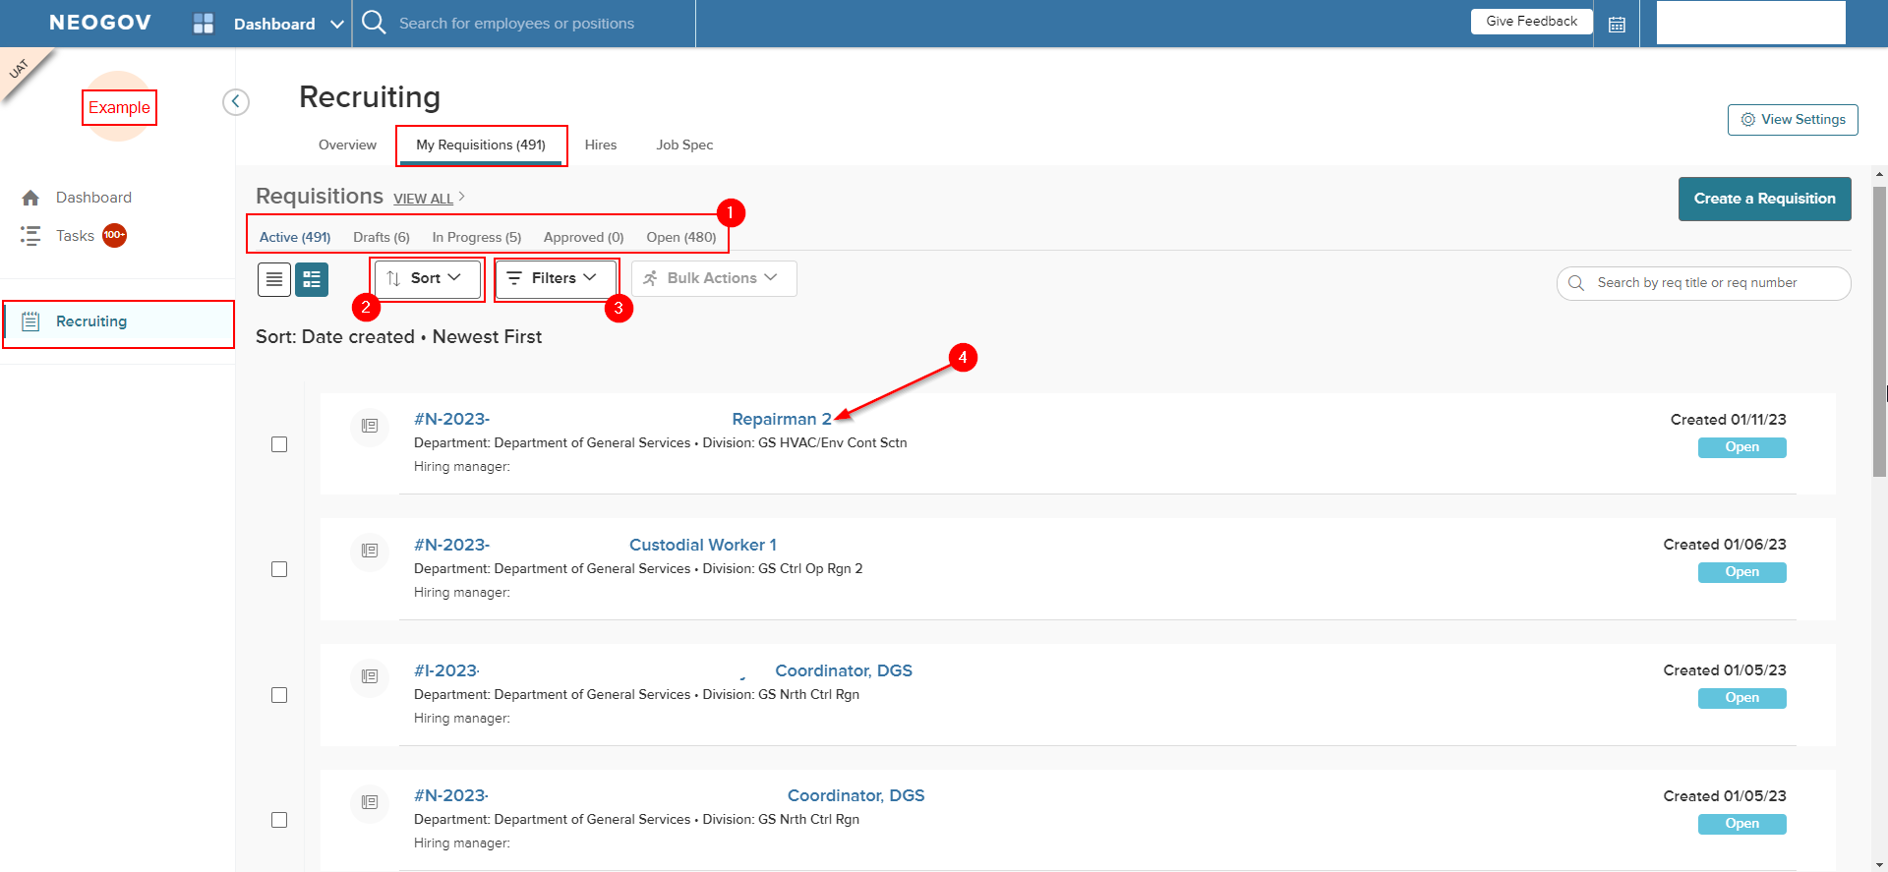
- Select a tab to view assigned reqs by status.
- Select the dropdown to sort reqs.
- Select the dropdown to filter by department or division.
- Assigned reqs are listed here. Select the req to view more information or to complete an action.

Recruiting Page – “My Requisitions” section – Bulk Actions
