Please distribute this alert to any users within your agency who are responsible for FMLA administration.

FMLA Entitlement In SAP/ESS Updated to Reflect 12 Weeks for Bargaining Units K4, K5, K8, L4, R1, R2, T4 and T5.

- Information regarding an update to the FMLA entitlement in SAP/ESS (ZH_PTFMLA_GUI and ESS – FMLA/SPF Eligibility Entitlement) to reflect 12 weeks for Bargaining Units K4, K5, K8, L4, R1, R2, T4 and T5.

Transaction ZH_PTFMLA_GUI and ESS – FMLA/SPF Eligibility Entitlement have been updated to reflect 12 weeks of FMLA entitlement for employees in the following bargaining units K4, K5, K8, L4, R1, R2, T4 and T5.

It was recently discovered that this system update was missed when the contract provisions for these bargaining units were implemented in 2017. FMLA Specialists monitor employee entitlement and usage, therefore this missed requirement in the system should not have a negative impact on employees.

ZH_PTFMLA_GUI:

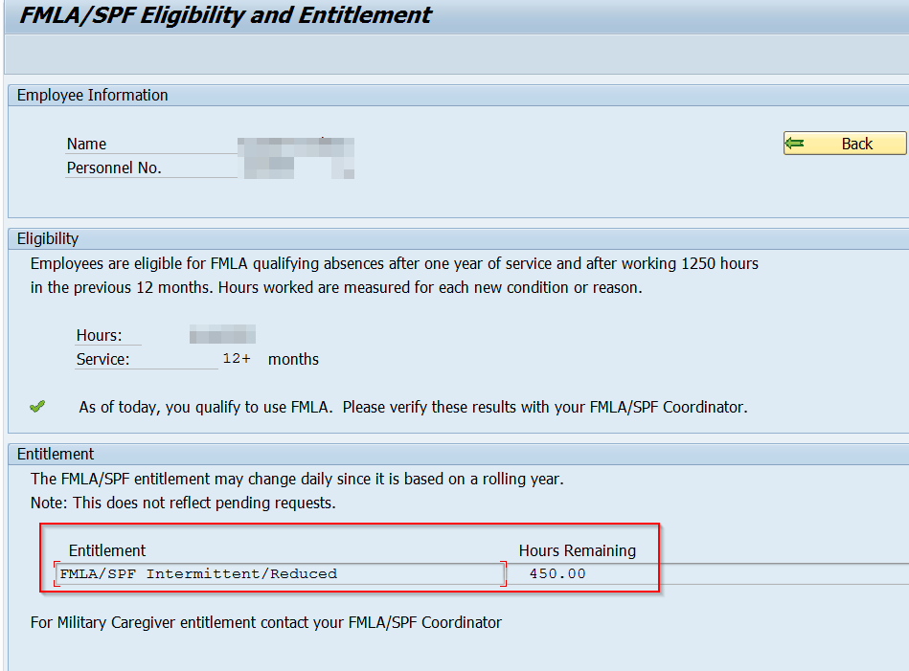

ESS – FMLA/SPF Eligibility Entitlement:

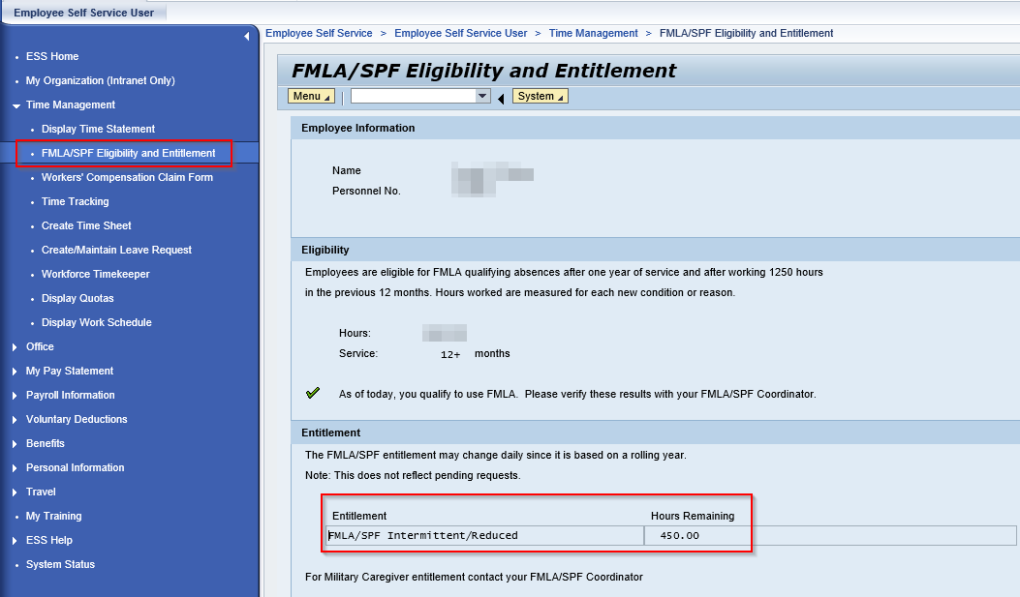

Questions?
If you have any questions regarding this alert, please submit an HR help desk ticket in the SPF category or call the HR Service Center, Time Services team at 877.242.6007, Option 2.

